**A close up of a logo

Description generated with high confidence**Australian Longitudinal Study on Women’s Health  
1921-26 Cohort Summary   
1996–2018

October 2018

Table of Contents

1 Executive Summary 4

2 Introduction 6

2.1 Background 6

2.2 Surveys 6

2.3 Retention 7

3 SURVIVAL CURVES AND COHORT TRAJECTORIES 1996 – 2018 10

3.1 Explanation of survival curves 10

3.2 Explanation of cohort trajectories 11

3.3 Sociodemographic factors 13

3.3.1 Area of residence 13

3.3.2 Country of Birth 14

3.3.3 Education 15

3.3.4 Marital Status 16

3.3.5 Manage on Income 18

3.4 Lifestyle 19

3.4.1 Weight and Body Mass Index (BMI) 19

3.4.2 Smoking 20

3.4.3 Physical Activity 21

3.5 Health 23

3.5.1 Self-Rated Health 23

3.5.2 Health-related Quality of Life – physical functioning and mental health scores 24

3.6 Needing help and providing care to others 29

3.6.1 Needing help 29

3.6.2 Providing care for others 31

4 KEY RESEARCH ACHIEVEMENTS 35

4.1 Publications using data from the 1921-26 cohort 35

4.1.1 Highly cited publications since 1996: 35

4.1.2 Highly cited publications in the last five years include: 37

4.2 Reports prepared using data from the 1921-26 cohort 37

4.2.1 Major Reports: 37

4.2.2 Other reports 39

4.2.3 Other information for women in the 1921-26 cohort 40

4.3 Contributions to Government Policy 40

4.4 Capacity building activities in women’s health research 42

5 References 45

6 APPENDIX A: PUBLICATIONS USING 1921-26 COHORT DATA (from 1998 to 2018) 46

6.1 Abuse 46

6.2 Ageing: Survival, frailty, physical health 46

6.3 Caring 51

6.4 Comorbidity/Multimorbidity 51

6.5 Rural and remote health 52

6.6 Health services systems 53

6.7 Intergenerational issues 56

6.8 Linked data 58

6.9 Medications 61

6.10 Mental Health 63

6.11 Methods 66

6.12 Non communicable diseases (previously chronic disease) 68

6.13 Quality of life 72

6.14 Social determinants of health 73

6.15 Social factors in health and well-being 74

6.16 Tobacco, alcohol and other drugs 77

6.17 Weight, nutrition and physical activity 78

7 APPENDIX B: REPORTS PREPARED USING 1921-26 COHORT DATA 81

7.1 Major Reports (2006 – 2018) 81

7.2 OTHER REPORTS 82

8 APPENDIX C: 1921-26 cohort participation details, Six Monthly Follow-Up Survey (to May 2018). 84

# Executive Summary

The Australian Longitudinal Study on Women’s Health (ALSWH) is a longitudinal population-based survey of over 60,000 Australian women in four cohorts. This report is a summary of data for 12,432 women in the cohort born 1921-26 who completed the baseline survey in 1996 (aged 70-75 years), and surviving women for each survey point up to May 2018 (aged 92-97). The data therefore represent changes in the population for women who survive to different ages.

**Sociodemographic characteristics:** Over the 20+ years of the study, the majority of women in this cohort have resided in cities or inner regional areas, with less than 10% living in outer regional or remote/very remote areas. In 1996, when the women were aged 70 to 75 years, some 35% were widowed, with this proportion rising to over 80% by 85 to 90 years. Women who were married or in a defacto relationship at Survey 1 had a small but statistically significant survival advantage over other women.

**Lifestyle:** Most women were in the healthy weight (50%) or overweight (33%) BMI categories at the start of the study. These proportions did not change greatly over time, with some women becoming underweight, replacing previously underweight women who died. Underweight women had a much greater mortality rate (lower survival) than healthy weight or overweight women. Survival was also lower among women who were obese in comparison to those who started the study with a BMI in the healthy weight range.

At Survey 1, most women were lifetime non-smokers (62%), with 30% classified as ex-smokers, and 8% as current smokers. There were large differences in survival for smokers compared to non-smokers. Non-smokers were around twice as likely to survive 20 years from the start of the study, compared to smokers. In addition, ex-smokers continued to have a survival disadvantage even after 20 years.

Physical activity declined over the course of the study as the women aged. In terms of survival, any level of physical activity was better than none, with some additional advantage for high levels.

**Self-rated health:** The percentage of the women who rated their health as fair or poor increased over the study period. Women who rated their health as “fair” or “poor” at Survey 1 had much worse survival than women who rated their health as “good”. Women who rated their health as “very good” or “excellent” at Survey 1 had the best survival with around 50% of these women surviving at least 20 years (to age 90-95). Likewise higher scores on physical functioning were associated with better survival. Low mental health scores, indicating psychological distress, were associated with lower survival rates.

**Functional abilities and caring:** The percentage of women who reported needing help from others for daily tasks due to long-term illness rose fourfold, from less than 10% at age 70 to 75 years to around 40% by age 90-95. However women were also likely to be caring for someone else due to that person’s illness, disability or frailty. At age 70-75, women were twice as likely to be caring for someone else than needing care for themselves. Later in life this ratio was reversed first as women’s own needs for help increased, and then as their role in caring for others diminished. Those who needed help with daily activities at the start of the study had a much higher mortality rate than those who did not report such needs. The relationship between providing care to others and survival is more complex due to the periodic and varying nature of caregiving across later life.

**Potential policy implications:** Data from earlier surveys highlight that most older women were in good, very good or excellent health during this part of their lives (when they were in their seventies), with high or moderately high levels of physical functioning and low rates of psychological distress. The women were also making important contributions to their families and communities, shown here in relation to their roles in caring for others. These data have implications for policies concerning healthy and active ageing which look to optimise quality of life in older age and develop social and physical environments that support older people and allow them to maximise their activity and participation. Good health in older age is a significant resource not only for the woman herself, but also for her family and community. The economic contributions of these women must not be underestimated.

Healthy behaviours are key drivers of health in older age, and significant determinants of longevity. This cohort entered adulthood prior to the global rise in the incidence of obesity. Few women were obese, and women’s BMI tended to decrease over time. Underweight is a potential issue for this cohort, particularly as they age and may represent a loss of lean body mass and poor nutrition. These underweight women are less likely to have survived.

The findings also underscore the importance of physical activity for older women, with even small levels conferring survival benefit. There is however a strong trend for women to become increasingly inactive in later life, with such sedentary behaviour heralding a poor prognosis. Physical activity programs for older people can be tailored to their functional capacity, and can help improve strength and balance, reduce falls and improve independence and overall wellbeing.

The women who remain in the study at age 92-97 represent exceptional members of their cohort who have survived to very old age, and who still have good prospects for survival into their late 90’s and to 100 years or more.

# Introduction

## Background

The Australian Longitudinal Study on Women’s Health (ALSWH) is a longitudinal population-based survey examining the health of around 60,000 Australian women. The Study follows women in four age cohorts, and a summary of selected data from the cohort born 1921-26 (now aged 92-97) who were first surveyed aged 70-75 in 1996 is presented here.

The 12,432 women in the 1921-26 cohort were recruited from the name and address database of the Australian Health Insurance Commission (now Medicare Australia). Sampling was random, except that women living in rural and remote areas were sampled at twice the rate of women in urban areas, in order to capture the heterogeneity of health experiences of women living outside metropolitan areas. The cohort was surveyed six times between 1996 and 2011, and has been surveyed every six months since November, 2011. These women are now in their nineties, and bi-annual surveys provide insight into the factors affecting the longevity and on-going health and health care needs of those who are still alive.

This report contains two sections: the first discusses factors associated with survival of women in this cohort and their trajectories over time on a range of health-related measures, and the second part outlines the key research achievements. Details of publications, reports and cohort participation rates are included as appendices.

## Surveys

The 1921-26 cohort receive mailed pen and paper surveys. Some participants elect to complete their surveys over the telephone. Telephone interviews are conducted with trained project assistants based at the University of Newcastle.

The surveys conducted between 1996 and 2011 were sent to the women every three years and contained questions on a broad range of health-related themes, including:

* Physical, social and emotional functioning (SF-36 Health related quality of life measure)
* Medically diagnosed conditions and symptoms
* Use of health care services
* Degree of difficulties with activities of daily living and need for assistance with activities of daily living
* Sight and hearing difficulties
* Falls
* Physical activity, height and weight
* Demographics and living circumstances

Information is also collected as to whether the women had help to complete the survey (based on the participant’s answers), or if the survey was completed by another person on behalf of the participant (by proxy).

The six monthly follow-up (6MF) of the 1921-26 cohort commenced November 2011. Subsequent surveys are sent on a rolling basis, six months after the return of the previous survey. So if a participant returned the first six monthly survey in December 2011, their second six monthly follow-up survey was mailed in June 2012.

The six monthly follow-up surveys contain a set of core questions to minimise participant burden. As far as possible, the survey questions are not subject to change, which ensures longitudinal integrity. The survey content and format are approved by the Human Research Ethics Committees at the University of Newcastle and the University of Queensland.

## Retention

Numbers are declining in the 1921-26 cohort due to death and increasing frailty. Between 1996 and May 2018, 9,304 (75%) of the original 12,432 participants in the cohort died, and 1,570 (13%) have requested no more surveys (mainly due to frailty as reported to the research team by the participant or proxy). To ensure the best possible retention in this cohort, intensive follow-up and tracking procedures are used, including use of the National Death Index to identify those participants who have died. The Australian Life Tables for 2014-161 show that women aged 92 will live, on average, a further 4.1 years and women aged 97 will live, on average, a further 2.8 years. Of the 1558 participants who are currently alive and still eligible to receive surveys, some will turn 100 between 2021 and 2026.

To date, each six month follow up (6MF) survey has been completed by over 80% of the eligible participants (See Table 2). At 6MF Survey 1, 9% withdrew from further surveys and a further 3% withdrew at each of 6MF Survey 2 or 6MF Survey 3. At each subsequent survey 1-3% of women have withdrawn or indicated that they would prefer to skip the survey and do the next one, and between 2-4% have died since the previous survey.

Details of survey dates and response rates for the main Surveys and the six-month surveys are shown in Table 2‑1 and Table 2‑2 respectively.

Table 2‑1 ALSWH 1921-26 cohort schedule of surveys and response rates 1996 to 2011

|  | **Survey 1** | **Survey 2** | **Survey 3** | **Survey 4** | **Survey 5** | **Survey 6** |
| --- | --- | --- | --- | --- | --- | --- |
| Year (YYYY) | 1996 | 1999 | 2002 | 2005 | 2008 | 2011 |
| Age range (years) | 70-75 | 73-78 | 76-81 | 79-84 | 82-87 | 85-90 |
| Response Rate (N) | 12,432 | 10,434 | 8,647 | 7,158 | 5,561 | 4,055 |

Table 2‑2 ALSWH 1921-26 cohort six-month follow up (6MF) survey completions 2011 to 2018

| **Year** | **Survey (close)\*** | **Age range** | **Deceased** | **Withdrawn** | **Total ineligible** | **Total eligible** | **Surveys completed** | **Response (%)** |
| --- | --- | --- | --- | --- | --- | --- | --- | --- |
| **2012** | 6MF 1 (May) | 86-91 | 5532 | 2334 | 7866 | 4566 | **3430** | **75.1** |
| **2012** | 6MF 2 (Nov) | 86-91 | 5927 | 2363 | 8290 | 4142 | **3260** | **78.7** |
| **2013** | 6MF 3 (May) | 87-92 | 6227 | 2409 | 8636 | 3796 | **2842** | **74.9** |
| **2013** | 6MF 4 (Nov) | 87-92 | 6620 | 2347 | 8967 | 3465 | **2473** | **71.4** |
| **2014** | 6MF 5 (May) | 88-93 | 6947 | 2294 | 9241 | 3191 | **2118** | **66.4** |
| **2014** | 6MF 6 (Nov) | 88-93 | 7288 | 2181 | 9469 | 2963 | **1964** | **66.3** |
| **2015** | 6MF 7 (May) | 89-94 | 7617 | 2102 | 9719 | 2713 | **1726** | **63.6** |
| **2015** | 6MF 8 (Nov) | 89-94 | 7962 | 1967 | 9929 | 2503 | **1524** | **60.9** |
| **2016** | 6MF 9 (May) | 90-95 | 8261 | 1875 | 10,136 | 2296 | **1362** | **59.3** |
| **2016** | 6MF 10 (Nov) | 90-95 | 8591 | 1740 | 10,331 | 2101 | **1247** | **59.4** |
| **2017** | 6MF 11 (May) | 91-96 | 8873 | 1678 | 10,551 | 1881 | **1062** | **56.5** |
| **2017** | 6MF 12 (Nov) | 91-96 | 9203 | 1534 | 10,737 | 1695 | **979** | **57.8** |
| **2018** | 6MF 13 (May) | 92-97 | 9302 | 1546 | 10,848 | 1584 | **877** | **55.4** |
| **2018** | 6MF 14(Nov^) | 92-97 | 9304 | 1570 | 10,874 | 1558 | **403** | **25.9^** |

*This is the nominal closing date, and is also when the next 6MF survey is deployed (however, if a participant returns their survey after this date, it is still accepted).

^ This survey period is still open, and death data are incomplete.Complete data for every survey, including questions and responses, are listed in the ALSWH data books, available at: [here](http://www.alswh.org.au/for-researchers/data/data-books)

ALSWH will continue to provide support for women to complete six-monthly follow-up surveys. These support activities include:

* The option to complete the survey by telephone in one or two sessions. It is anticipated that the proportion of telephone interviews will increase over time.
* The option for the participant to ask a family member, carer or other trusted person to complete the survey on their behalf (a proxy completion).
* Provision of a ‘not this time’ option, whereby participants who are not feeling well enough at one survey time point can elect to skip a survey and do the next.
* Provision of surveys to women living in residential aged care, wherever possible.

# SURVIVAL CURVES AND COHORT TRAJECTORIES 1996 – 2018

## Explanation of survival curves

Survival curves for women grouped according to characteristics recorded at Survey 1 in 1996 show the associations between these characteristics and how much longer the women lived, on average. For example, Figure 3-1 shows the survival curves for women with different levels of education.

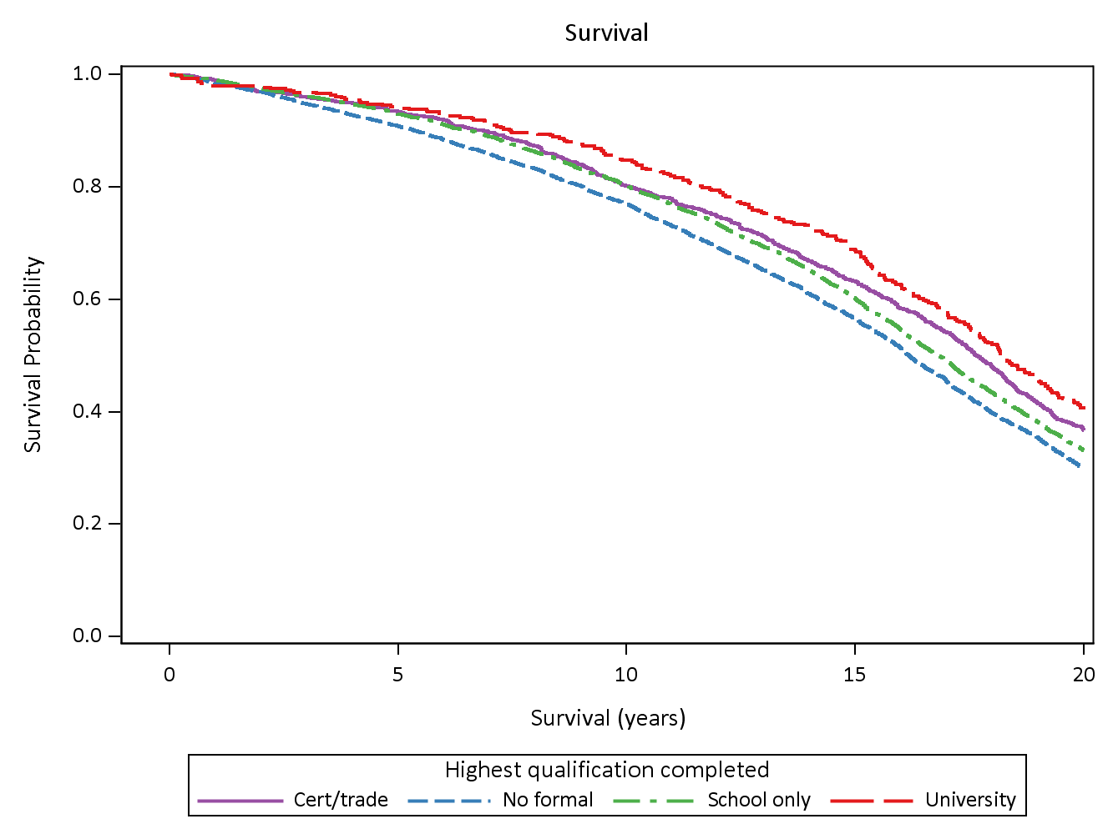Figure 3‑1 Survival curves for the period 1996-2016 for groups of women defined by the highest level of education reported at Survey 1.

At Survey 1 100% of the women were alive, but gradually over time some died. Twenty years later about 30% of those with no formal qualifications (the lowest dashed line) were still alive and 70% had died. This compares with 40% alive (and 60% had died) among the women with university education (top line with long dashes). In this example, the difference in survival was only statistically significantly different for the women with no formal qualifications; the other groups were more similar.

The survival curves were produced using the Kaplan Meier method and are shown for a period of twenty years from Survey 1.

## Explanation of cohort trajectories

The cohort trajectories reflect the women’s responses to questions asked in the three-yearly surveys during the years 1996 to 2013 and the six-monthly follow-up (6M FU) surveys since then. The trajectories are only shown for those questions that were asked at all these surveys.

Two trajectories are shown. One is based on the responses from women who responded to every survey, that is, they were still alive and completing surveys up until the most recent one. The other is based on the responses from every woman who completed that survey. These two trajectories are illustrated in Figure 3-2 which shows the percentage of women who were married or in a de-facto relationship, as opposed to those who were widowed, divorced or separated.

Line graph illustrating the percentages of women who were married or in a de-facto relationship for all women who completed each survey (open circles) and for the women who completed every survey (+ signs). See below for more information.**Figure 3‑2 Percentages of women who were married or in a de-facto relationship (as opposed to those who were widowed, divorced, separated or never married) for all women who completed each survey (open circles) and for the women who completed every survey (+ signs).**

The open circles and plus signs show the percentages at each survey and the vertical lines are 95% confidence intervals. At Survey 1 in 1996 57% of the women were married (while 35% were widowed and the others were divorced, separated or never married). Among the much smaller group who continued to participate until the most recent survey (n=640), 64% were married and (28% were widowed) at Survey 1. Both trajectories go down over time as fewer women remain married (as more are widowed). The lines converge as many of the women who completed the early surveys die or cease to participate in the surveys, and those who survive and continue to complete the surveys provide the data.

For some other survey variables, data from the six-month follow-up surveys are different from and more variable than the data from Surveys 1-6. This may be due to the surveys being shorter and more frequent as well as changes in the format.

With each survival curve or cohort trajectory, an example survey question has been included – however, the wording of questions has sometimes changed from survey to survey, and the example question is intended as a guide only. Full surveys and summary data for each follow-up are available at alswh.org.au

Some questions were only asked at Survey 1 as they could not change (e.g. country of birth) or were unlikely to change (e.g. highest level of education). Others were asked at several surveys but the responses did not change much over time (e.g. [area of residence](http://www.alswh.org.au/images/content/pdf/Cohort_summaries/ALSWH_1921-2_%20cohort_summary.pdf)). For these characteristics, only survival curves are presented (for groups based on Survey 1 responses). For other characteristics which varied over time, both cohort trajectories and survival curves are presented.

## Sociodemographic factors

### Area of residence

QUESTION: What is your residential postcode?

From their Survey 1 responses women were categorised as living in a major city (68%), an inner regional area (21%), an outer regional area (9%), or a remote of very remote area (1%) according to the ARIA+ classification. The percentages of women living in these area of residence categories [remained stable over time](http://www.alswh.org.au/images/content/pdf/Cohort_summaries/ALSWH_1921-2_%20cohort_summary.pdf), so no trajectories are shown. **Figure 3‑3** shows the survival curves for these women.

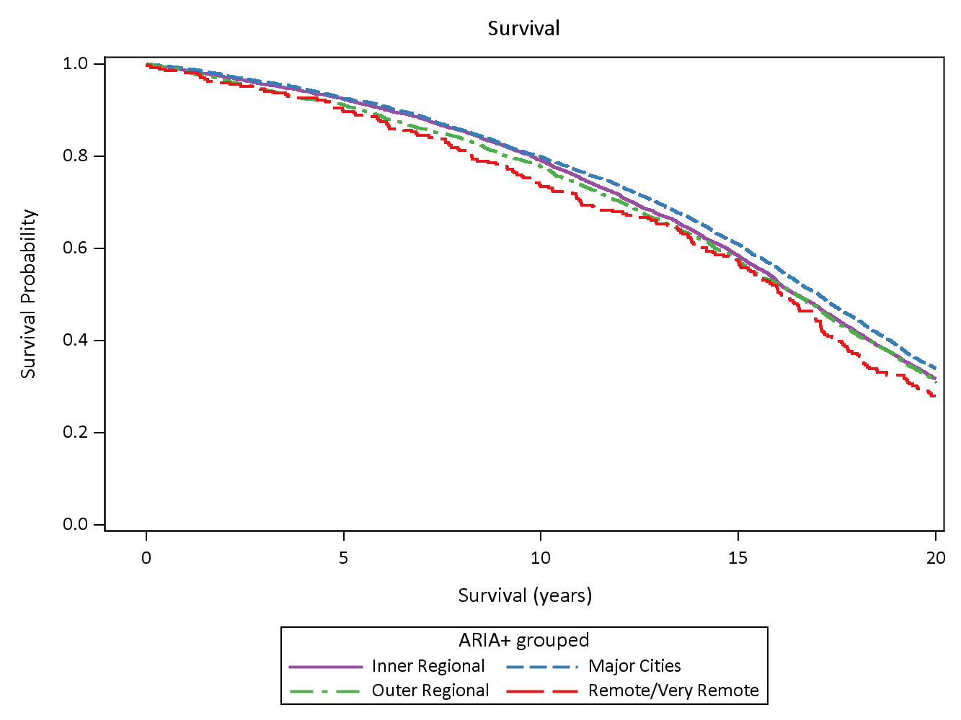**Figure 3‑3 Survival curves for the period 1996-2016 for groups of women defined by area of residence at Survey 1.**

Women living in major cities had slightly higher survival rates and those in remote or very remote areas had poorer survival, but the differences were not large.

### Country of Birth

QUESTION: In which country were you born?

The responses were categorised as: Australian born (73%), born in another English-speaking country (14%), and born elsewhere (13%). **Figure 3‑4** shows the survival patterns over the subsequent 20 years.

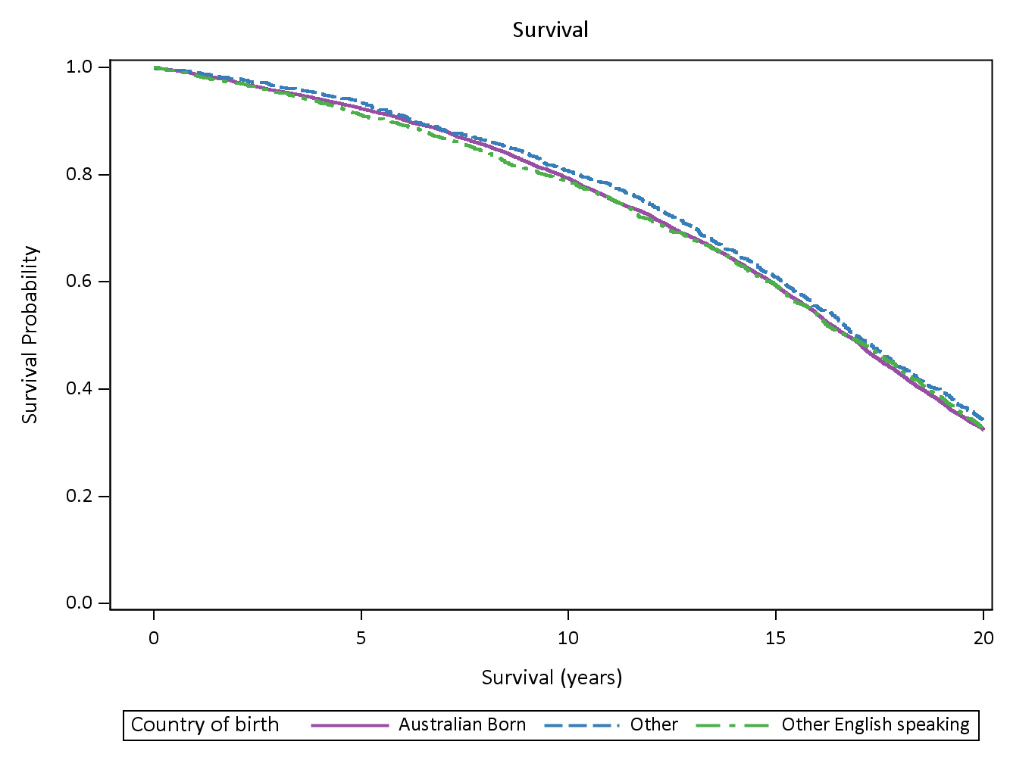**Figure 3‑4 Survival curves for the period 1996-2016 for groups of women defined by area of residence at Survey 1.**

Survival rates were similar for all country of birth categories.

### Education

QUESTION: What is the highest qualification you have completed?

Survey 1 responses were grouped as follows: no formal qualification (33%), school certificate or higher school certificate (51%), certificate or trade qualification (12%), and university degree (4%). The survival curves are shown in **Figure 3‑5**.

**Figure 3‑5 Survival curves for the period 1996-2016 for groups of women defined by highest qualification at Survey 1**

Women with no formal qualifications (lowest dotted line) had significantly lower survival rates than those in the other groups. While survival rates improved with increasing levels of education, the differences between the groups were not statistically significant.

### Marital Status

QUESTION: What is your present marital status?

* Married
* De facto
* Widowed
* Separated
* Divorced
* Never married

These categories were combined into two groups: women with partners (married or de facto), and those without partners (widowed, separated, divorced or never married). **Figure 3‑6** shows the percentages of women in each of these groups at each survey.

Graph illustrating the percentages of women who were married or in a de-facto relationship for all women who completed each survey (open circles) and for the women who completed every survey (+ signs). See above and below for more information.**Figure 3‑6 Percentages of women who were married or in a de-facto relationship (as opposed to those who were widowed, divorced, separated or never married) for all women who completed each survey (open circles) and for the women who completed every survey (+ signs).**

At Survey 1 in 1996, 57% of the women were married (while 35% were widowed and the others were divorced, separated or never married). Among those who continued to participate until the most recent survey (n=640), 64% were married and (28% were widowed) at Survey 1. Both trajectories go down over time as fewer women remain married (as more are widowed). The trajectories converge as many of the women who completed the early surveys die or cease to participate in the surveys, and those who survive and continue to complete the surveys provide the data.

Figure 3‑7 shows the survival curves, comparing partnered women with those who were already widowed at Survey 1, or were never married, or separated or divorced.

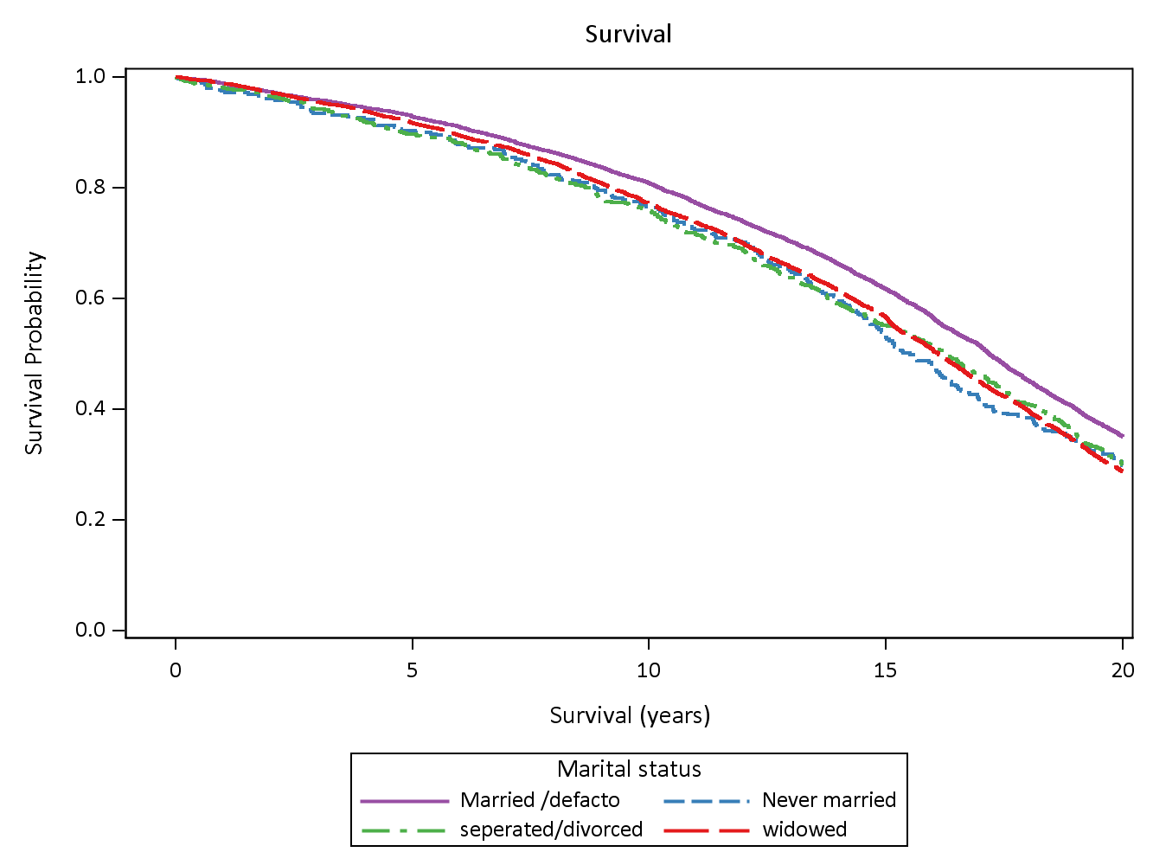

Figure 3‑7 Survival curves for the period 1996-2016 for groups of women defined by marital status at Survey 1

Women who were partnered at survey 1 had significantly higher survival rates than women in the other groups.

### Manage on Income

QUESTION: How do you manage on the income you have available?

* It is impossible
* Difficult all the time
* Difficult some of the time
* Not too bad
* It is easy

At Survey 1 in 1996, when the women were aged 70-75, 22% responded ’easy’, 51% ‘not too bad’, 20% ‘difficult some of the time’ and 7% said ‘difficult all of the time’ or ‘impossible. Over time these proportions did not vary greatly, so trajectories over time are not shown.

**Figure 3‑8** shows the survival curves, comparing women who responded ‘easy/not too bad’, ‘sometimes difficult’ or ‘difficult always/impossible’ at Survey 1.

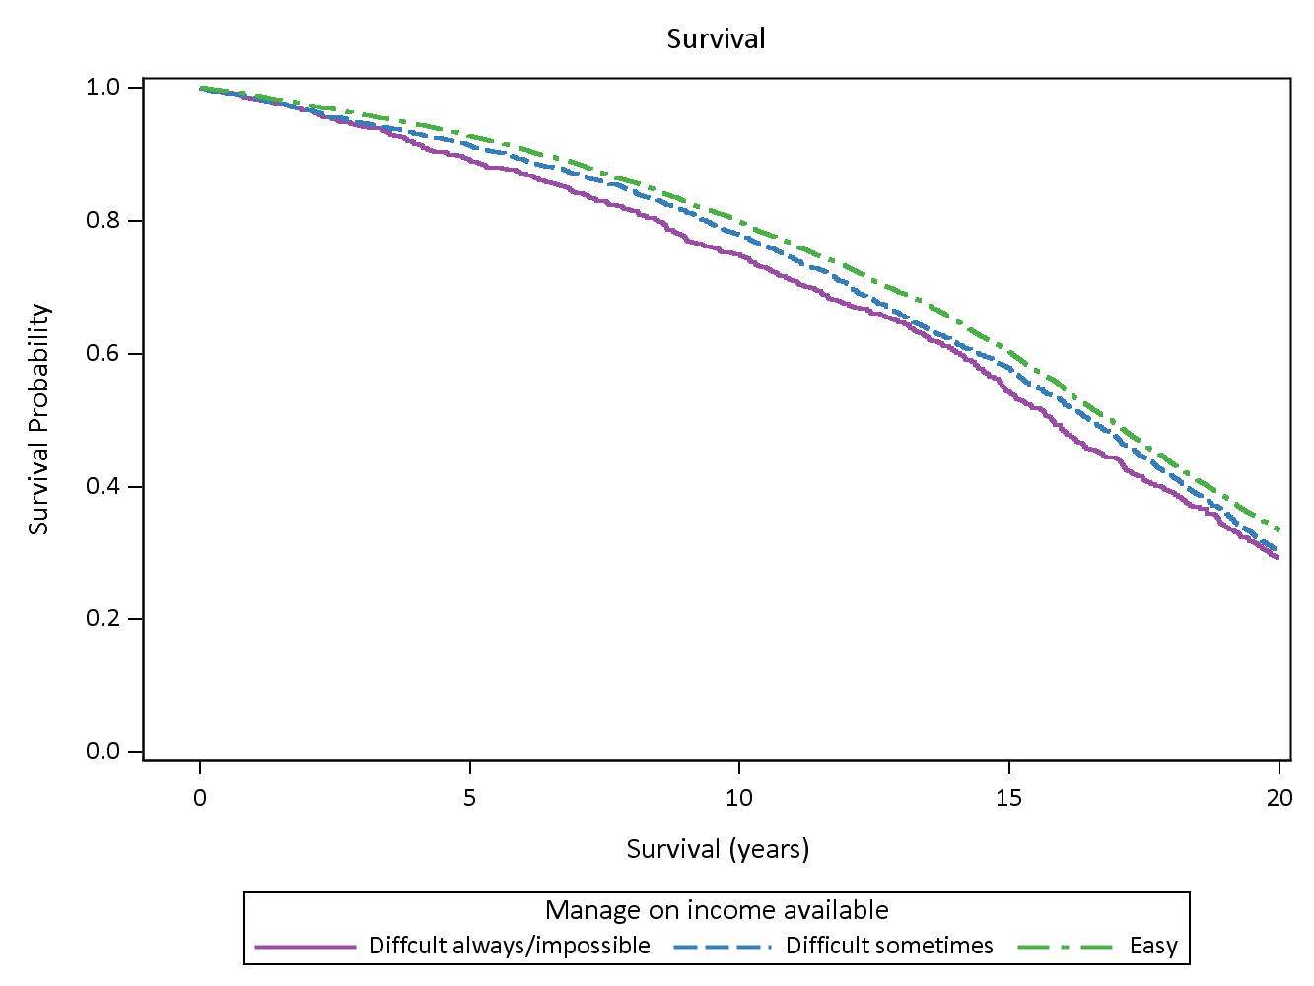**Figure 3‑8 Survival curves for the period 1996-2016 for groups of women defined by their responses at Survey 1 to the question about managing on their available income.**

Women who reported ‘easy/not too bad’ (the top dashed-dotted line) had significantly better survival rates than those in the other categories.

## Lifestyle

### Weight and Body Mass Index (BMI)

QUESTION: How tall are you without shoes?

QUESTION: How much do you weigh without clothes or shoes?

BMI [weight (kg)/height (m)2] is calculated from responses to both questions and categorised (according to the World Health Organisation classification) as: underweight, BMI < 18.5; healthy weight, 18.5<= BMI < 25; overweight 25 <= BMI < 30; or obese BMI>=30.

At Survey 1 in 1996, 3% of the women were underweight, 50% were in the healthy weight range, 33% were overweight, and 14% were obese. These proportion did not change much over time and the mean BMI remained constant, so trajectories over time are not shown.

**Figure 3‑9** shows the survival curves, comparing women in each of the BMI categories at Survey 1.

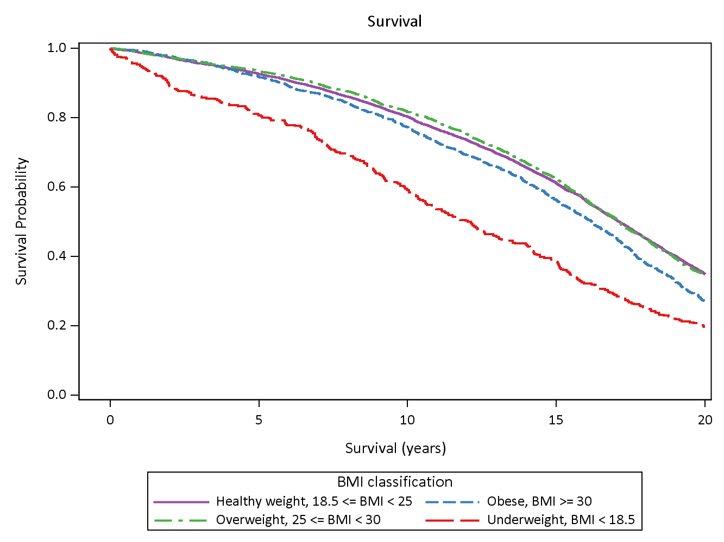**Figure 3‑9 Survival curves for the period 1996-2016 for groups of women defined by their BMI category at Survey 1.**

Underweight women (long dashed lines) had significantly poorer survival than the other groups. However women in the obese category (short dashed lines) also had poorer survival than the other two groups (healthy weigh and overweight) who had similar survival rates.

### Smoking

QUESTIONS: Women were asked a series of questions including: whether they had ever smoked; if they have ever smoked, at what age they started; if they used to smoke when they had given up; if they currently smoked, how many cigarettes they smoked and how frequently.

From their answers to these questions at Survey 1 women were classified as current smokers, ex-smokers or never smokers. At Survey 1, 62% of women reported never smoking, 30% were ex-smokers and 8% smoked regularly or occasionally. The questions were not asked at every survey, but among those women who responded to Survey 6 the percentages were: 71% never smokers, 27% ex-smokers and 2% current smokers. **Figure 3‑10** shows that earlier deaths among smokers could explain these changes as those who never smoked became a larger proportion of those alive and able to respond to Survey 6.

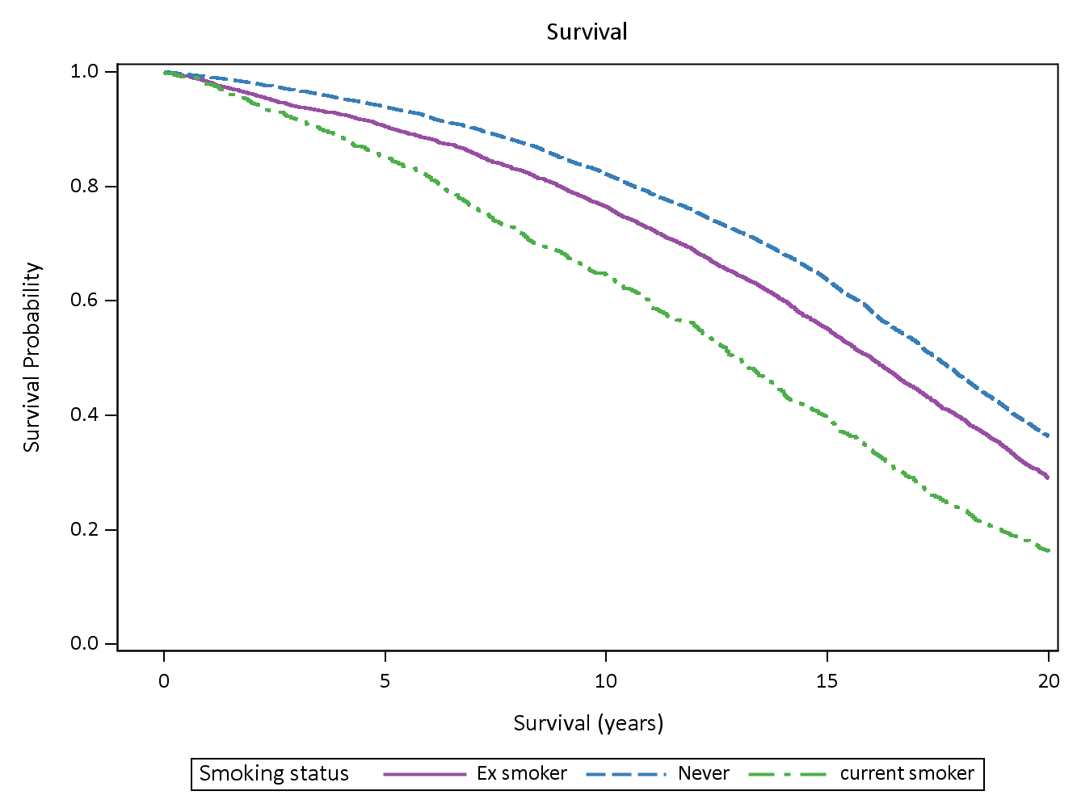**Figure 3‑10 Survival curves for the period 1996-2016 for groups of women defined by their smoking status at Survey 1.**

Survival rates were lowest for women who smoked at Survey 1, higher for ex-smokers and significantly higher for never smokers.

### Physical Activity

QUESTION: How many times did you do each type of activity last week? Only count the number of times when the activity lasted for 10 minutes or more.

* Walking briskly (for recreation or exercise, or to get from place to place)
* Moderate leisure activity (like social tennis, moderate exercise classes, recreational swimming, dancing), or more vigorous leisure activity (that makes you breathe harder or puff and pant)
* Vigorous work in the house or garden (like vacuuming, mopping, cleaning windows, digging, mowing, etc.)

Questions were asked consistently from Survey 2 and the responses were used to categorise women as: inactive, low level of physical activity, moderate level, or high level of physical activity. Physical activity questions are not asked in the six-monthly surveys. The percentage of women in each category over Surveys 2 - 6 are shown in Figure 3‑11 (from the 2014 summary for this cohort).

Figure comparing the amount of physical activity from Survey 2 to Survey 6. See above and below for more information.**Figure 3‑11 Physical activity from Survey 2 to Survey 6.**

The percentage of women classified as inactive increased from 34% at age 73 to 78 years (Survey 2) to 59% by 85 to 90 years (Survey 6). Although the figure for moderate or high levels of physical activity declined over the study period, almost 20% of women were still in this category at age 85 to 90 years.

Figure 3‑12 shows the survival curves for women classified by their level of physical activity at Survey 2.

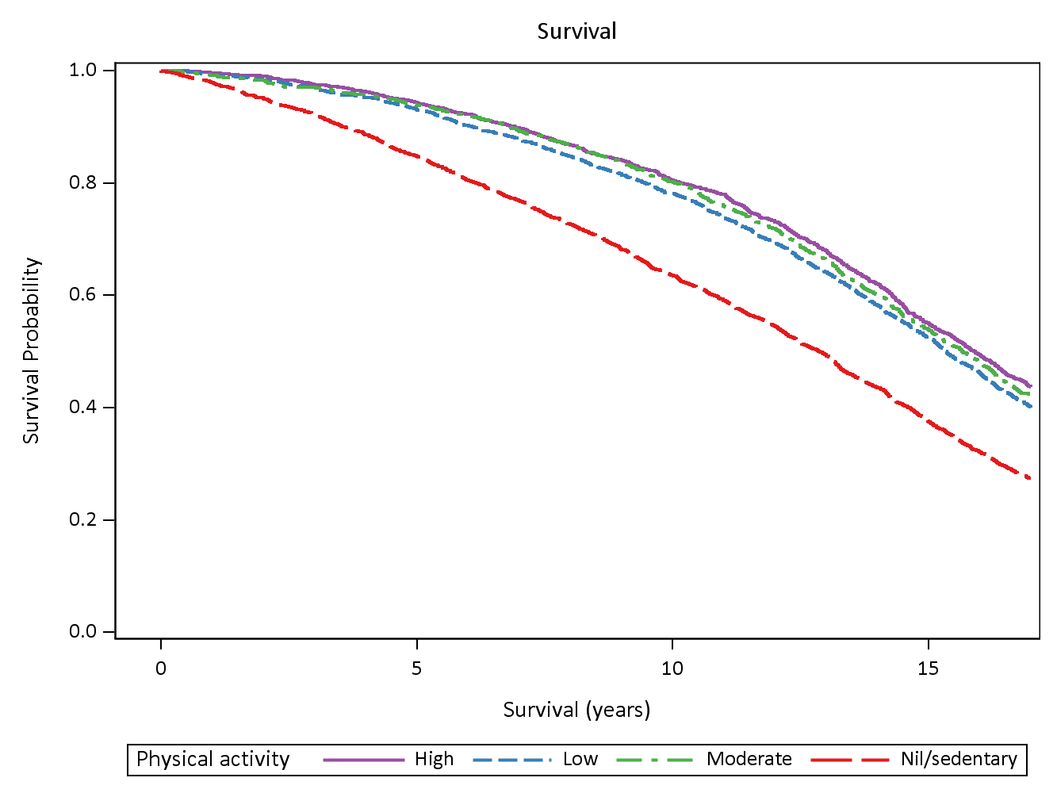**Figure 3‑12 Survival curves for the period 1996-2016 for groups of women defined by their level of physical activity at Survey 2.**

Women who were inactive (the nil/sedentary group) at Survey 2 has substantially lower survival rates than women in the other groups, and those in the high activity group had slightly higher survival than women in the intermediate groups.

## Health

### Self-Rated Health

QUESTION: In general, would you say your health is:

* Excellent
* Very good
* Good
* Fair
* Poor

These categories were grouped into: excellent/very good, goof, fair/poor. At Survey 1, 33% of women rated their health as ‘excellent’ or ‘very good’, 39% as ‘good’, and 28% as ‘fair’ or ‘poor’. By the most recent follow-up survey these percentages were 18%, 41% and 41% respectively.

**Figure 3‑13** shows the trajectories for the women who rated their health as ‘fair’ or ‘poor’.

Graph illustrating the percentages of women who rated their health as ‘fair’ or ‘poor’, for all women who completed each survey (open circles) and for the women who completed every survey (+ signs).**Figure 3‑13 Percentages of women who rated their health as ‘fair’ or ‘poor’, for all women who completed each survey (open circles) and for the women who completed every survey (+ signs).**

The percentage of women who classified their health as ‘fair’ or ‘poor’ increased steadily over the study period, with a sharp increase in the percentage “fair/poor” between Survey 6 and Six-month follow-up 1. Compared to all the women who completed Survey 1, women who went on to complete every survey were less likely to report ‘fair’ or ‘poor’ health.

Self-rated health is a very good predictor of survival, as shown in **Figure 3‑14**.

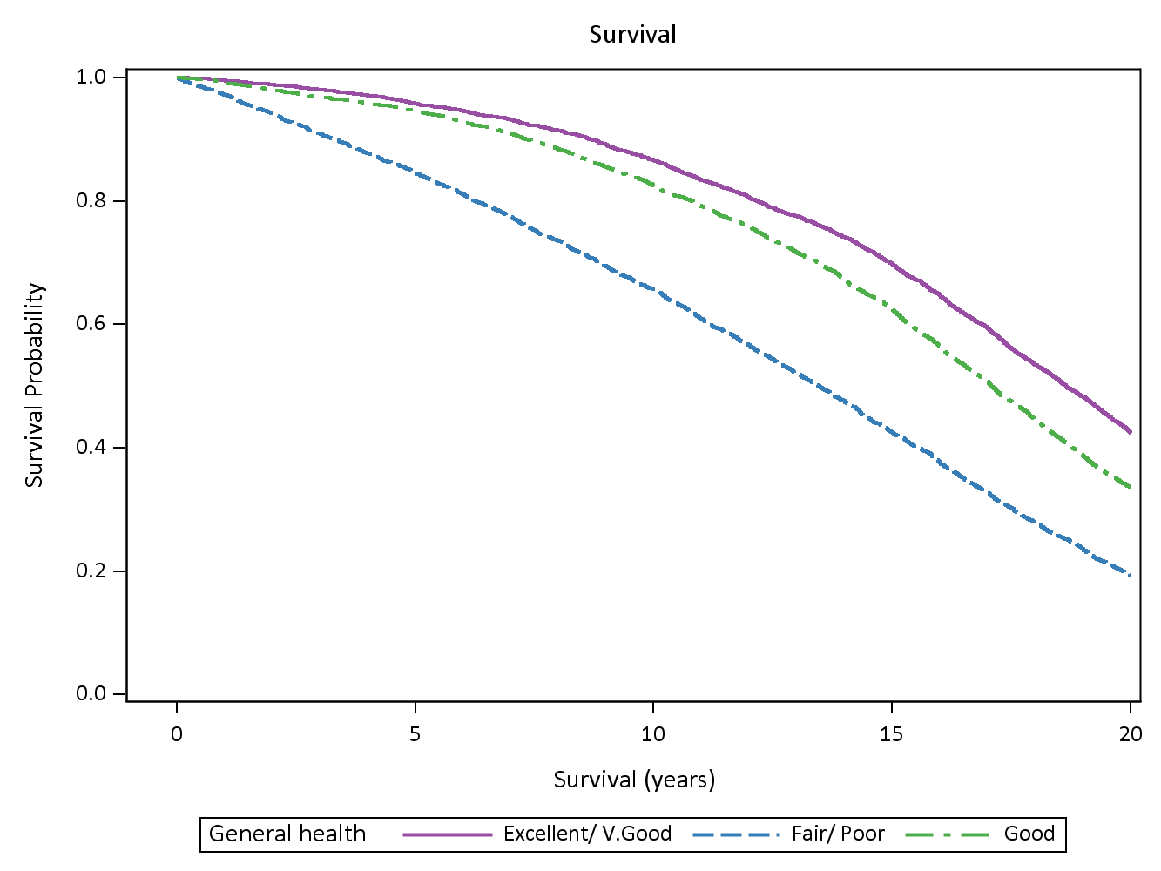 **Figure 3‑14 Survival curves for the period 1996-2016 for women grouped by their self-rated health at Survey 1.**

Women who rated their health as ‘fair’ or ‘poor’ at Survey 1 had the significantly lowest survival rates, and those who rated their health as ‘excellent’ or ‘very good’ had significantly higher survival rates.

### Health-related Quality of Life – physical functioning and mental health scores

Scores on the SF-36 are used to measure Health-related quality of life, with two of the main sub-scales being physical functioning (as a marker of physical health) and mental health (Ware et al, 1993). All scales are positively scored so that higher scores represent better outcomes.

**Physical functioning**

QUESTION: The following questions are about activities you might do during a typical day. Does your health now limit you in these activities? If so, how much?

* Vigorous activities such as running, lifting heavy objects, participating in strenuous sports
* Moderate activities, such as moving a table, pushing a vacuum cleaner, bowling or playing golf
* Lifting or carrying groceries
* Climbing several flights of stairs
* Climbing one flight of stairs
* Bending, kneeling or stooping
* Walking more than one kilometre
* Walking half a kilometre
* Walking 100 metres
* Bathing or dressing yourself

(Response options: Yes, limited a lot; Yes, limited a little; No, not limited at all).

The responses are used to calculate a summary score ranging from 0 to 100 with higher scores indicating better physical functioning. **Figure 3‑15** shows the trajectories for mean scores over time.

Graph illustrating the mean scores for physical functioning for all women who completed each survey (open circles) and for the women who completed every survey (+ signs).**Figure 3‑15 Mean scores for physical functioning for all women who completed each survey (open circles) and for the women who completed every survey (+ signs).**

Mean scores for physical functioning declined at each survey and also over time for women who responded to every survey. Women who completed all surveys had better physical functioning at earlier surveys when compared to all women who commenced the study.

**Figure 3‑16** shows the survival curves for women grouped into quintiles based on their scores at Survey 1.

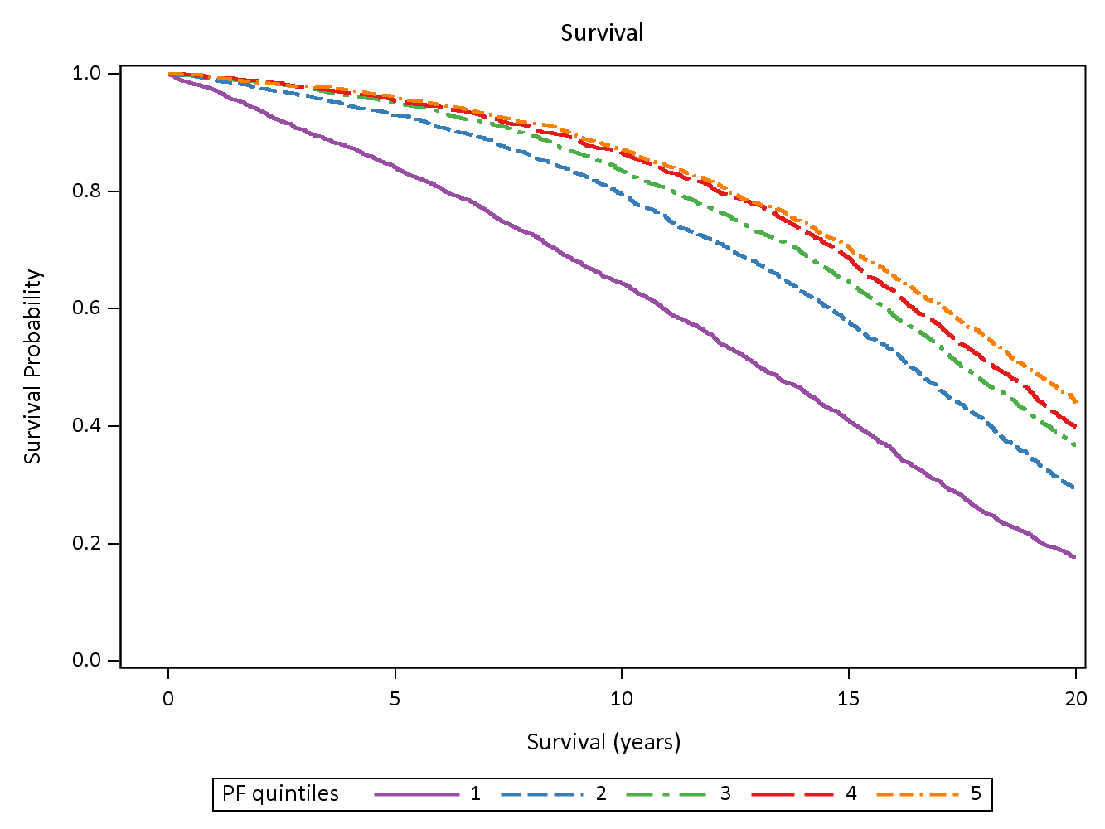 **Figure 3‑16 Survival curves for the period 1996-2016 women grouped by quintiles of their physical functioning scores health at Survey 1 (1 = lowest 20% of scores, and 5 = highest 20% of scores).**

Survival rates strongly reflected the physical functioning scores with each quintile group having statistically significantly poorer survival than the higher quintile group (except that groups 3 and 4 were not significantly different.

**Mental health**

QUESTION: For each question, please give the one answer that comes closest to the way you have been feeling. How much of the time during the past four weeks:

* Have you been a very nervous person
* Have you felt so down in the dumps that nothing could cheer you up
* Have you felt calm and peaceful
* Have you felt down
* Have you been a happy person

(Response options: All of the time, most of the time, a good bit of the time, some of the time, a little of the time, none of the time)

The responses are used to calculate a summary score ranging from 0 to 100. Scores <= 52 indicate psychological distress2,3. The trajectories are shown in **Figure 3‑17**.

Graph illustrating the percentages of women with low mental health index scores; for all women who completed each survey (open circles) and for the women who completed every survey (+ signs). See above and below for more information.**Figure 3‑17 Percentages of women with low mental health index scores; for all women who completed each survey (open circles) and for the women who completed every survey (+ signs).**

Over time the percentages of women with low mental health scores (i.e. scores ≤52 which indicate psychological distress) increased. Notably, women who completed every survey were much less likely to have low mental health scores at the early surveys.

**Figure 3‑18** shows the survival curves for women categorised by their mental health scores at Survey 1.

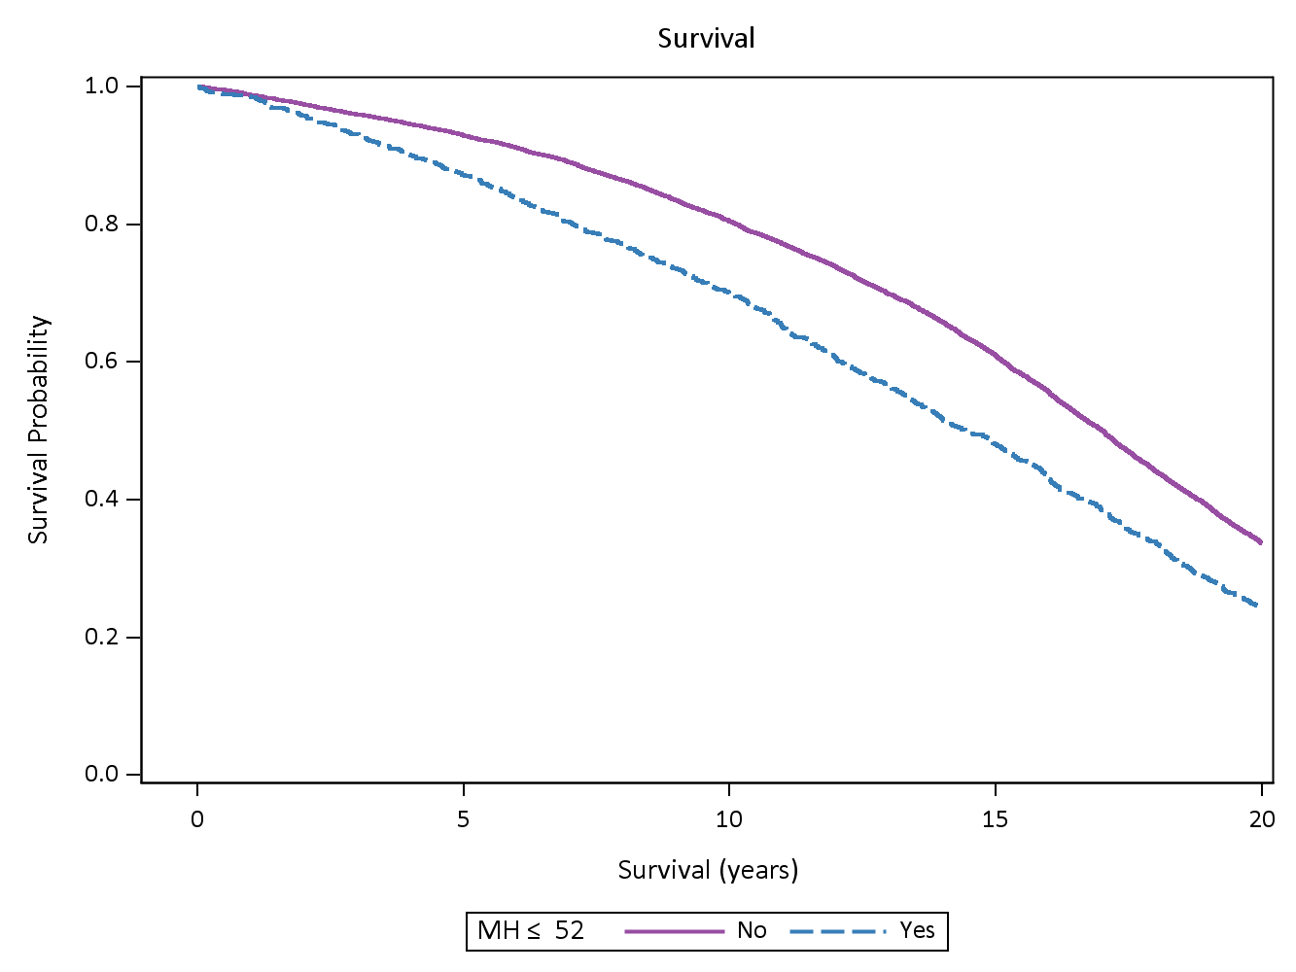**Figure 3‑18 Survival curves for women with mental health scores <= 52 and >52 at Survey 1.**

Women with mental health scores < 52 at Survey 1 had poorer survival rates.

## Needing help and providing care to others

### Needing help

QUESTION: Do you regularly NEED help with daily tasks because of long-term illness, disability or frailty (e.g., personal care, getting around, preparing meals etc.)?

**Figure 3‑19** shows the trajectories for the percentages of women needing help with daily tasks. The reason for the increase associated with the change to six-monthly surveys is unknown but possibly relates to the change in format.

Graph illustrating the percentage of women needing help with daily tasks because of long term illness, disability or frailty; for all women who completed each survey (open circles) and for the women who completed every survey (+ signs). See above and below for more information.**Figure 3‑19 Percentage of women needing help with daily tasks because of long term illness, disability or frailty; for all women who completed each survey (open circles) and for the women who completed every survey (+ signs).**

The percentage of women who reported needing help for daily tasks due to long-term illness, disability or frailty rose from 9% at Survey 1 when they were aged 70 to 75 years to 39% at the most recent six-monthly survey. Women who completed all surveys had less need for help when compared to all women in the cohort.

Women who needed help with daily tasks at Survey 1 had much poorer survival than other women, as shown in **Figure 3‑20**.

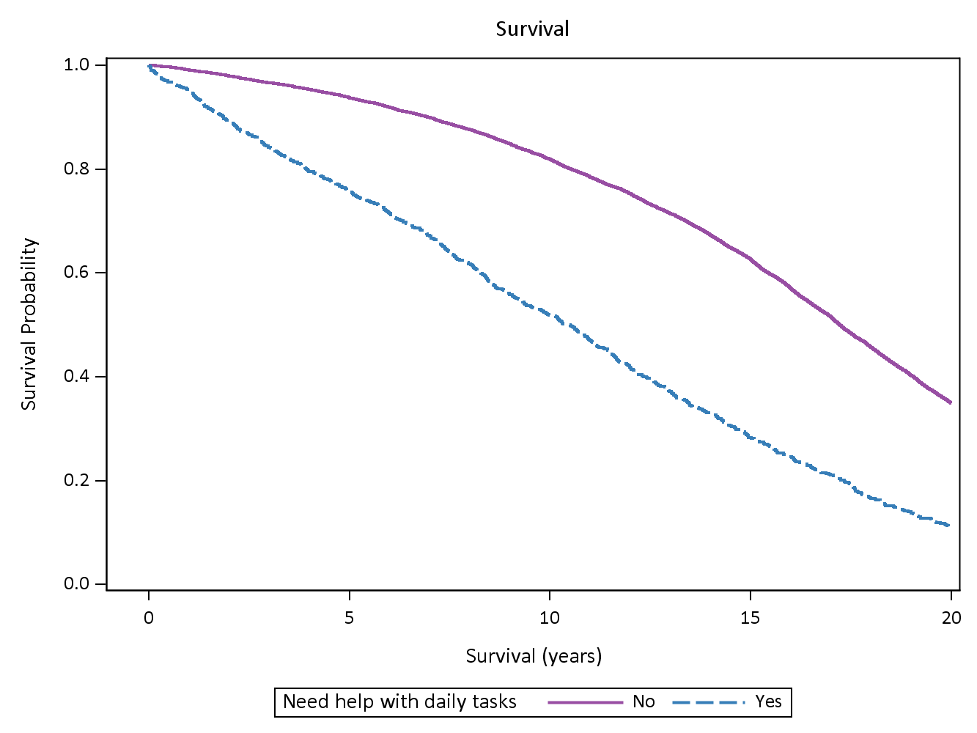**Figure 3‑20 Survival curves for the period 1996-2016 for women grouped according to whether or not they needed help with daily tasks because of long term illness, disability or frailty at Survey 1.**

### Providing care for others

QUESTION: Do you regularly PROVIDE care or assistance (e.g., personal care, transport) to any other person because of their long-term illness, disability or frailty?

* Yes, for someone who lives with me
* Yes, for someone who lives elsewhere
* No, I do not provide care

Over time the percentage of women who reported regularly providing for someone because of their long-term illness, disability or frailty increased and then declined – see **Figure 3‑22** and 3-22.

Graph illustrating the percentage of women who reported caring for another person because of long term illness, disability or frailty who lives with them; for all women who completed each survey (open circles) and for the women who completed every survey (+ signs).**Figure 3‑21 Percentage of women who reported caring for another person because of long term illness, disability or frailty who lives with them; for all women who completed each survey (open circles) and for the women who completed every survey (+ signs).**

The percentage of women who reported caring for another person living with them increased from 7% at Survey 2 to 13% at Survey 4 when they were aged 79 to 84 years, followed by a consistent decrease in later years.

Graph illustrating the percentage of women who reported caring for another person because of long term illness, disability or frailty; for all women who completed each survey (open circles) and for the women who completed every survey (+ signs). See above and below for more information.**Figure 3‑22 Percentage of women who reported caring for another person because of long term illness, disability or frailty; for all women who completed each survey (open circles) and for the women who completed every survey (+ signs).**

The percentage of women who reported caring for another person increased from 17% at Survey 2 to 26% at Survey 4 when they were aged 79 to 84 years, followed by a consistent decrease in later years.

Survival curves for women who did or did not provide care to someone else at Survey 1 are shown in **Figure 3‑23** and **Figure 3‑24**.

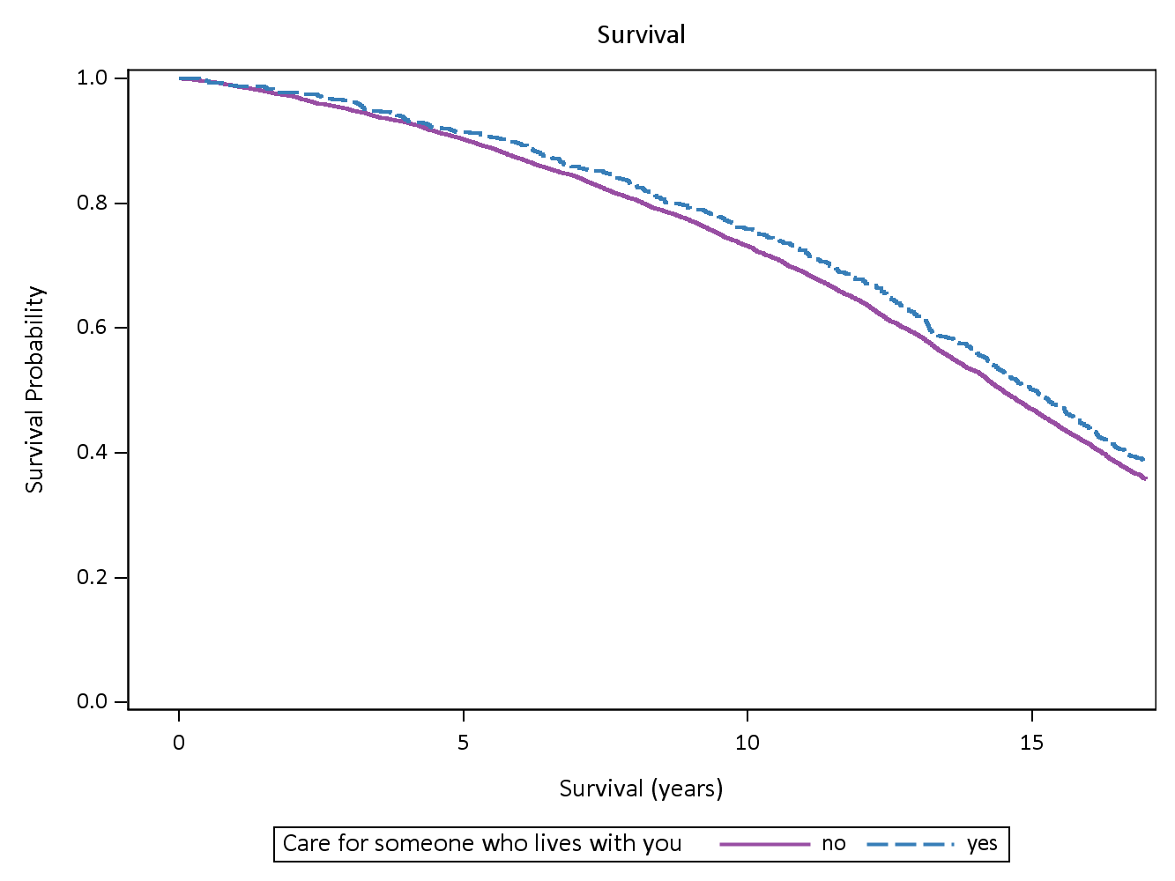**Figure 3‑23 Survival curves for the period 1996-2016 for women grouped according to whether or not at Survey 2 they provided care to someone because of long term illness, disability or frailty, who lived with them.**

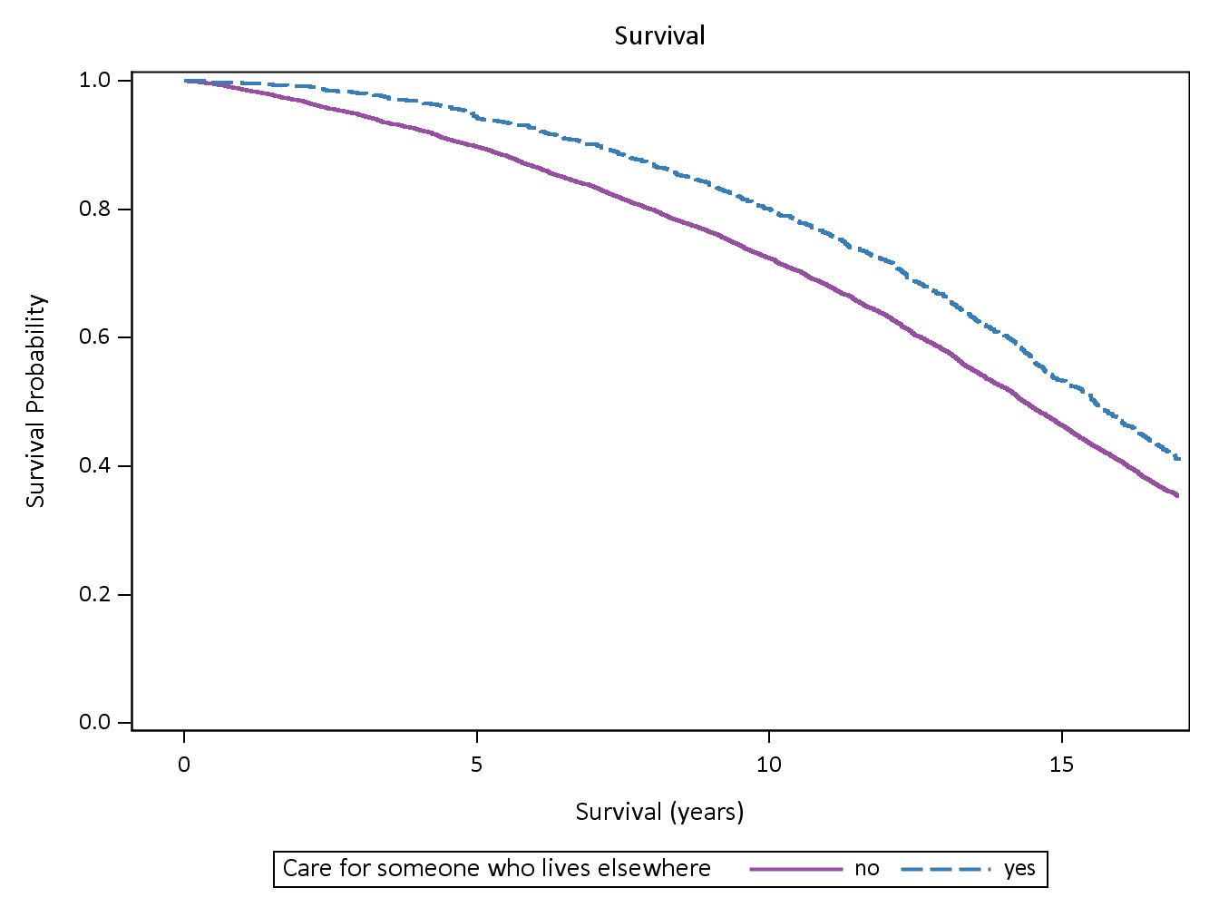**Figure 3‑24 Survival curves for the period 1996-2016 for women grouped according to whether or not at Survey 2 they provided care to someone because of long term illness, disability or frailty, who lived elsewhere.**

There is a slight, but statistically significant, survival advantage for women who were carers for someone living elsewhere at Survey 2. There was no difference in survival for women caring for someone living with them. However given the large amount of change in carer role over the women’s later lives, these comparisons do not reflect the true differences in survival for carers and non-carers.

# KEY RESEARCH ACHIEVEMENTS

## Publications using data from the 1921-26 cohort

Since 1996, over 200 papers using data from the ALSWH 1921-26 cohort have been published. The major themes in these publications are:

* Survival, frailty, and physical health (68 papers)
* Non-communicable disease (chronic conditions) (49 papers)
* Health service use and systems (49 papers)
* Mental health (44 papers)
* Linked data (41 papers)
* Social factors in health and wellbeing (39 papers)
* Methodology (35 papers)
* Weight, nutrition and physical activity (32 papers)
* Intergenerational issues (29 papers)
* Medications (22 papers)
* Quality of Life (16 papers)
* Health in rural and remote areas (15 papers)
* Tobacco, alcohol and other drugs (13 papers)
* Social determinants of health (8 papers)
* Comorbidity/multimorbidity (7 papers)
* Abuse (6 papers)
* Caring (6 papers)

(*Note:* A publication may reflect more than one major theme).

Themes with high rates of citations (i.e., in peer reviewed journals, reports for government etc., as recorded by Google Scholar) were *Social factors in health* (14 papers cited more than 40 times); *Health service use and systems* (12 papers cited more than 40 times); *Mental health* (10 papers with more than 40 citations); Weight, nutrition and physical activity (8 papers cited more than 40 times); and Survival, frailty and physical health (7 papers with more than 40 citations).

### Highly cited publications since 1996:

Leaking urine: Prevalence and associated factors in Australian women. 1999. Neurourology and Urodynamics, 18(6); 567-577. Citations = 243.

This paper presented data on the prevalence of urinary incontinence across the original three cohorts of women. The proportion of women with reporting leaking urine was 13% (18-23 years), 36% (45-50 years), 35% (70-75 years). Subsequent papers have looked at the incidence and impact of urinary incontinence.

Updating the evidence on physical activity and health in women. 2007. American Journal of Preventive Medicine, 14(4); 380-391. Citations = 199

This paper reviewed findings on physical activity and prevention of cardiovascular disease, diabetes and cancer in women from prospective cohort studies conducted 1997-2006. They found strong evidence that physical activity has a role in prevention, but no evidence of additional benefits of vigorous intensity physical activity.

The World report on ageing and health: A policy framework for healthy ageing. The Lancet, 2016, 2145-2154. Citations = 194

This paper highlights key findings and recommendations from the 2015 WHO report on ageing and health. Four priority areas for action are noted – aligning health systems to the older populations they serve, ensuring the systems are developed to provide long-term care, providing opportunities for growing old in age-friendly environments, and improving measurement, monitoring and understanding of healthy ageing.

Attrition in longitudinal studies: Who do you lose? 2006. Australian and New Zealand Journal of Public Health, 30(4); 353-361. Citations = 182.

This paper examined loss to follow-up in the three original cohorts. The findings were used to target follow-up procedures, and to understand the effect of non-death attrition on the representativeness of the cohort. The analyses have been repeated and updated to provide good characterisation of the cohort over time and to reduce the effects of bias in study findings.

Disorders of breathing and continence have a stronger association with back pain than obesity and physical activity. 2006. Australian Journal of Physiotherapy, 52(1); 11-16. Citations = 172.

This paper examined associations between back pain, breathing difficulty and incontinence, with the suggestion of a common pathophysiological link between these three common symptoms.

The profile of women who consult alternative health practitioners in Australia. 2003. Medical Journal of Australia, 179(6); 297-300. Citations = 158.

This study identified the high prevalence use of complementary and alternative practitioners by women across Australia. Many subsequent studies have provided more in-depth analyses of how and why women use these services.

Validity of self-report screening scale for elder abuse: Women's Health Australia study. The Gerontologist, 2003; 43(1): 110-120. Citations = 123.

This paper established the methods for assessing vulnerability to elder abuse which are used in ALSWH.

Self-rated health and a healthy lifestyle are the most important predictors of survival in elderly women. 2008. Age & Ageing, 37(2); 194-200. Citations = 127.

This paper showed that current health and health related behaviours were stronger predictors than social factors of relatively early mortality among older women. The results underscored the importance of adopting a healthier lifestyle, by doing more exercise and not smoking, and showed how these health behaviours can continue to be of benefit even in later life. Subsequent papers further quantified the mortality risks for particular conditions and comorbidities and modifiable health behaviours in later life.

The problems of sleep for older women: Changes in health outcomes. 2003. Age and Ageing, 32(2); 154-163. Citations = 79.

This paper is one in a series which examined the prevalence, incidence and health impacts of sleeping difficulties among older women. The paper underscored the importance of sleeping difficulties for older women and the impact on their health-related quality of life. Further studies of the association between sleeping difficulty and mortality suggest that much of the mortality risk associated with sleeping difficulty can be explained by comorbid conditions.

### Highly cited publications in the last five years include:

* van der Hoorn M, Tett S, de Vries O, Dobson A & Peeters G. The effect of dose and type of proton pump inhibitor use on risk of fractures and osteoporosis treatment in older Australian women: A prospective cohort study. Bone, 2015, 81, 675-682. (31 citations)
* Brown W, Pavey T & Bauman A. Comparing population attributable risks for heart disease across the adult lifespan in women. British Journal of Sports Medicine, 2015, 49(16); 1069-1076. (33 citations)
* Schofield M, Powers J & Loxton L. Mortality and disability outcomes of self-reported elder abuse: A 12-year prospective investigation. Journal of the American Geriatric Society, 2013; 61(5): 679-685. (57 citations)
* Rich J, Chojenta C & Loxton D. Quality, rigour and usefulness of free-text comments collected by a large population based longitudinal study - ALSWH. 2013. PLoS ONE, 8; Art. No e68832. (34 citations)
* Koloski N, Jones M, Wai R, Gill R, Byles J & Talley N.Impact of persistent constipation on health related quality of life and mortality in older community dwelling women. 2013. American Journal of Gastroenterology, 108(7); 1152-1158. (52 citations)
* Peeters G, Dobson A, Deeg D & Brown WJ. A life-course perspective on physical functioning in women. 2013. Bulletin of the World Health Organization, 91(9): 661-670. (42 citations)

All publications using data from the 1921-21 cohort are listed in in Appendix A.

## Reports prepared using data from the 1921-26 cohort

### Major Reports:

Since 2001, ALSWH has prepared over 30 reports for the Department of Health that have used data from the 1921-26 cohort, including 11 major reports. One major report in 2010, focussed on the health of older women in Australia. These reports, listed in full in Appendix B, have included the following research areas:

**Informal caregiving:** This report examined patterns of caregiving across the lifecourse. Older women (from the 1921-26 cohort) provided care for grandchildren, as well as providing care to another because of illness, disability or frailty. The socio-demographic factors associated with patterns of care giving across women’s later life, and the impact of caregiving on the wellbeing of caregivers and their health service use was also presented. (This report will be formally released in October 2018).

**Future health service use and cost:** Data from the cohort was used to identify trends in women’s health status, risk and behaviour over the next twenty years, and to predict need for care and potential health service use in 2013. A summary of the report is available [here](https://www.alswh.org.au/images/content/pdf/major_reports/ResearchSummary_2016-Major-Report.pdf)

**Use, access to, and impact of Medicare services for Australian women:** Understanding how Medicare services are used at different life stages can guide and improve the provision of health services. In this report, women’s survey data were linked to Medicare Benefits Scheme (MBS) data to provide detailed information on how and when women use health services, and the costs of these services, throughout the life course. A summary of the report findings is available [here](https://www.alswh.org.au/images/content/pdf/major_reports/Major_Report_2017_Lay_Summary_Web.pdf).

**Chronic conditions, physical function and health care use:** Presented data on the increasing prevalence of several major chronic conditions as women age, including arthritis, asthma, diabetes, and cardiovascular conditions. The relationship between chronic disease and decline in women’s physical and mental health related quality of life was examined, as well as related increases in use of general practice consultations. The report also considered the prevalence or comorbidities and the increased rate of death associated with some chronic conditions. The report is available [here](http://www.alswh.org.au/images/content/pdf/major_reports/2015%20ALSWH%20MRJ%20Final.pdf)

**Women, health and ageing:** This report examined changes in women’s health as they aged from their 70s to their 80’s. Over this time, more than half of the women maintained good physical health. Women whose health started low and continued low had lower socio-economic status, were more likely to be overweight or obese, undertook little physical activity, and were current or ex-smokers. These women also had multiple chronic conditions and were heavy users of health services. A small group of women had clear improvements in their physical health, and many of these women had restorative surgery, or were recovering from acute conditions or events. The report also contrasted the effects of different chronic conditions on physical and mental health, social engagement, and health care use. The report is available [here](http://www.alswh.org.au/images/content/pdf/major_reports/2010_women_health_and_ageing_r161.pdf)

**Mental health:** The prevalence of psychological distress decreased with age, except in later old age when it increased slightly. Most (80%) of the 1921-1926 cohort reported ongoing good mental health. While there had been a steady increase in the use of the Better Access Scheme (BAS) to manage psychological distress among all cohorts, by December 2010, only about 3% of the 1921-1926 cohort had claimed for at least one BAS item. The experience of widowhood was associated with a decline in mental health up to four years prior to bereavement, with the lowest mental health reported in the year immediately after the loss. However, within four years of date of widowhood, the women’s mental health had returned to pre-loss levels. Poor mental health in the 1921-1926 cohort was associated with an increased risk of cardiovascular disease and with diabetes and arthritis. The report is available [here](http://www.alswh.org.au/images/content/pdf/major_reports/2013_major%20report%20H.pdf)

**Weight and physical activity:** Both weight and physical activity are important contributors to healthy ageing and the prevention and management of chronic conditions. ALSWH has examined these issues for the 1921-1926 cohort in four major reports in 2006, 2007, 2011 and 2012. The main findings of the reports were that over time, BMI of women in this cohort remained stable, although the percentage of those who were underweight increased. A slightly higher BMI was associated with better survival among older women. Physical activity which met guidelines of 30 minutes of moderate activity on most days decreased as the women aged. Both BMI and physical activity were associated with chronic conditions such as hypertension, heart disease, diabetes, asthma, osteoporosis and arthritis in this cohort. The report is available [here](http://www.alswh.org.au/images/content/pdf/major_reports/2007_major_report_b.pdf)

**Medications:** The prevalence of medication use increased with age and as chronic conditions became more common. The 1921-1926 cohort used more medications than the younger ALSWH cohorts, and were more likely to be using two or more medications in combination. The most common PBS claims were for cardiovascular medications (75% of the 1921-1926 cohort in 2005); alimentary tract medications (57% in 2005); drugs for musculoskeletal conditions (43% in 2005); respiratory system medications (20% in 2005) and antidepressant medications (18% in 2005). The report is available [here](http://www.alswh.org.au/images/content/pdf/major_reports/2008_major_report_c_r144.pdf)

**Area of residence:** Women in the 1921-1926 cohort living in regional and remote areas of Australia had higher death rates than those living in major cities. These higher death rates were associated with lung cancer, chronic obstructive pulmonary disease and ischaemic heart disease, which are often associated with smoking. However, very few of the older women were current smokers, so the higher mortality rate ascribed to these conditions may have been the result of past smoking, exposure to passive smoking or greater exposure to other hazards, such as environmental toxins. The health risk factor that was consistently higher with increasing distance from major cities was obesity. Thus, the prevalence and incidence of conditions associated with obesity, such as diabetes and hypertension, were also consistently higher among women living in regional and remote areas. Use of most health services was higher in major cities than in regional and remote areas. Visits to specialist medical practitioners decreased with increasing distance from major cities, however, there were few differences in hospital admissions. The report is available [here](http://www.alswh.org.au/images/content/pdf/major_reports/2011_rural_remote_and_regional_differences_r163.pdf)

### Other reports

ALSWH data from the 1921-1926 cohort have also been used by researchers to produce reports for various sections of the Department of Health, as well as for other agencies. Recent examples include:

**Health service use at the end of life by older Australian women with chronic conditions.** Dobson A, Waller M, Forder P, Dolja-Gore X, Hockey R, Byles J & Mishra G. Report prepared for the Australian Government Department of Health. May 2018.

This report was prepared for the Palliative Care Section, and used ALSWH survey data and linked administrative data to assess health service and aged care use in the last two years of life for women with dementia, heart disease, stroke or chronic lung disease. The report examined a range of aged care services (including permanent residential care, respite care, and community care) as well as hospital admissions, GP services, specialist services, and pharmaceuticals, and found that use of these services did increase in the last two years of life, particularly the last few months. Dementia was a strong driver of use of residential aged care and GP services, but lower use of community care, hospital and specialist services.

Some other examples include five reports on incontinence (2000, 2001, 2002, 2003 and 2004) and three reports on data provision, paid work and retirement and physical activity and health for the Office for Women, Department of Families, Community Services and Indigenous Affairs (2005 and 2007). A full list is available in Appendix B.

### Other information for women in the 1921-26 cohort

In addition to survey data, data for most women in the cohort can be obtained from administrative data sets through a data linkage authority. This method provides detailed information on women’s health and aged care service use across their later life, and for ascertainment of conditions such as dementia which are difficult to determine from a postal survey.

## Contributions to Government Policy

Findings from the 1921-26 cohort have directly influenced Federal and State Government Policy in several areas. We briefly feature recent notable contributions:

* **2013 New South Wales Government’s Health Framework for Women’s Health** (NSW Ministry of Health, 2013).

Published research from the ALSWH 1921-26 cohort contributed to recommendations for healthy ageing, including accessing health services, managing dementia, osteoarthritis and falls. Key strategies included supporting healthy lifestyles, appropriate mental health services, support for women with a disability or those who are caring for a person with a disability.

* **2010 Australian Government National Women’s Health Policy** (Australian Government Department of Health and Ageing, (now the Australian Government Department of Health) 2010)

Published research from the ALSWH 1921-1926 cohort was cited 18 times in the policy. Evidence from the ALSWH contributed to recommendations concerning chronic conditions (such as asthma and arthritis); health behaviours (physical activity, smoking, alcohol and weight); use of mental health services (such as counselling); the experience of widowhood and the availability of services to assist with older bereaved women’s health, financial and social needs; the impact of comorbid conditions on physical and psychological health and social function; the ability of older women with chronic conditions to manage on their available income; and physical and psychological abuse of older women.

The Policy states that evidence from the ALSWH has confirmed the importance of taking a whole of life approach to women’s heath, preventing the accumulation of health risk factors. Informed by the ALSWH, the Policy identifies the importance of controlling risk factors to prevent chronic disease, as well as promoting physical activity and healthy in later life and targeting mental health and well-being. Arthritis, a condition highlighted by the study as having a particular impact on women’s wellbeing, participation and health care use, is emphasised in the Policy. The Policy also emphasises the social and economic contexts in which women age, with consideration for the experiences of widowed women, women with lower levels of social support, and women ageing in rural areas, as identified in various publications and reports arising from the study. The Policy recognises the study’s role in defining different health needs of older women in rural areas, their poorer access to health care, and their higher mortality rates when compared to urban women. The Policy quotes the study as identifying the importance of homes, social support and active participation in the community as fundamental to older women’s well-being. The policy on older women and violence is also informed by ALSWH data on the prevalence, vulnerabilities and impacts of violence for older Australian women. Extensive research into the needs of older women as carers, the care women receive, and the health of those who care for them, has informed Policy in relation to carers. Research into women’s healthcare use provided rich data to inform Policy on access to primary care, chronic disease management, and Medicare incentives.

* **Choose Health: Be Active. A physical activity guide for older Australians** (Australian Government Department of Veteran’s Affairs and the Department of Health and Ageing (now the Australian Department of Health), 2008).

This guide was prepared by ALSWH Chief Investigator Professor Wendy Brown to provide an evidence-based guide for optimal physical activity for older adults.

* **National Continence Management Strategy**

The study informed the strategy with respect to prevalence, incidence and risk factors for urinary incontinence, the effects of ageing on incontinence, and the impacts of incontinence on the lives of older women. Information from the study informed the preparation of information brochures available on www.bladderbowel.gov.au

Data from the study also informed the development of **“Best practice in the prevention and treatment of constipation in adults under 65 years”.** Available[here](http://www.health.gov.au/internet/main/publishing.nsf/content/continence-ncms-faecalmgmt.htm/$file/pjt23clinical.pdf)

* **National physical activity recommendations for older Australians: Discussion document** (Australian Government Department of Health and Ageing, 2006)

Published research from the ALSWH 1921-1926 cohort was cited in this discussion document which was commissioned from the National Ageing Research Institute.

Data have also been used in numerous submissions by other agencies, for example:

* Older Women’s Network: Older Women’s Network NSW notes on a submission to ALRC Grey Areas—Age Barriers to Work in Commonwealth Laws (IP 41) 28 May 2012
* Mental Health Council of Australia Submission to: The Productivity Commission Inquiry into Aged Care July 2010
* Submission to House of Representatives Standing Committee on Health and Ageing, Inquiry into Obesity in Australia

The study was featured in a special edition of the Australasian Journal of Ageing “Ageing well in Australia”:

[Byles JE](http://www.ncbi.nlm.nih.gov/pubmed?term=Byles%20JE%5BAuthor%5D&cauthor=true&cauthor_uid=22032764), [Dobson A](http://www.ncbi.nlm.nih.gov/pubmed?term=Dobson%20A%5BAuthor%5D&cauthor=true&cauthor_uid=22032764); [Australian Longitudinal Study on Women's Health](http://www.ncbi.nlm.nih.gov/pubmed?term=Australian%20Longitudinal%20Study%20on%20Women's%20Health%5BCorporate%20Author%5D). (2011). **The value of time in longitudinal studies of ageing. Lessons from the Australian Longitudinal Study on Women's Health.** *Australasian Journal of Ageing*. S2; p 6-12. doi: 10.1111/j.1741-6612.2011.00531.x.

This special edition was produced by the Australian Association of Gerontology (AAG) to showcase the latest evidence in ageing research, with a particular emphasis on research funded through the Ageing Well Ageing Productively (AWAP) research grants and the Australian Longitudinal Study of Women's Health, and on contributions to policy and practice outcomes benefiting older Australians in their everyday lives.

## Capacity building activities in women’s health research

Between 1996 and 2018, 21 researchers who based their research on the ALSWH 1921-26 cohort have graduated with a masters or PhD degree. Table 4‑1 outlines these research topics, and highlights the subsequent careers of a few of the researchers. Ten Masters or PhD research students are currently enrolled and undertaking projects using data from the ALSWH 1921-26 cohort

Table 4‑1 ALSWH RESEARCH HIGHER DEGREE STUDENTS COMPLETED USING 1921-26 COHORT DATA

| Student | Topic | Institution | Degree | Completion date | Current position |
| --- | --- | --- | --- | --- | --- |
| Anne Young | General Practitioner utilisation among women in Australia. | The University of Newcastle | PhD | 1999 |  |
| Brendan Goodger | Social support, health status and health care utilization in women aged 70-76 years. | The University of Newcastle | PhD | 2000 | Head of Population Health and Chronic Disease at Central Eastern Sydney Primary Health Care Network. |
| Esben Strodl | Psychological factors associated with frequency of angina and the role of mediating variables | The University of Queensland | PhD | 2002 | Senior lecturer in health psychology and psychotherapy at Queensland University of Technology. Serves as national chair of the APS College of Health Psychologists. |
| Emma Harley | Social support in later life: Cross-sectional and longitudinal analysis of inter-relationships between psychosocial variables in the Women’s Health of Australia study. | Flinders University | PhD | 2004 | Practicing Clinical Psychologist working across the public and private sectors with a range of different clients, including remote indigenous communities, soldiers, peacekeepers and refugees. |
| Karen Furlong | Epidemiology of osteoporosis in Australian women | The University of Queensland | Masters | 2006 |  |
| Dr Sally Price | Carers and psychosocial correlates over time: A longitudinal analysis. | The University of Queensland | Doctor of Psychology | 2006 |  |
| Leah Collins | Investigating quality of life and depression in middle aged and older Australian women with cancer | The University of Melbourne | Doctor of Psychology | 2008 | Clinical and Health Psychologist in private practice in Melbourne. |
| Nadine Smith | Psychological predictors of successful ageing in a cohort of Australian women | The University of Newcastle | Masters | 2001 |  |
| Biopsychosocial correlates of women’s mental health: A longitudinal analysis of self-reported mental health across three generations of Australian women | The University of Queensland | PhD | 2008 | Senior researcher with the New South Wales Bureau of Crime Statistics and Research. |
| Afsoon Hassani Mehraban | An application of the International Classification of Functioning Disability and Health for understanding falls risks among older community women in Australia | The University of Newcastle | PhD | 2008 | Associate Professor, Department of Occupational Therapy, School of Rehabilitation Sciences, Iran University of Medical Sciences, Tehran, Iran. |
| Nur Hafidha Hikmayani | Cardiovascular medication use and health related Quality of Life in older women with diabetes | The University of Newcastle | Master Clinical Epi | 2009 | Member of the Faculty of Medicine, Sebelas Maret University, Indonesia. 2014-17 PhD University College London (explored the dynamics and variations in diabetes care over time in the UK, and the factors associated with glycaemic, blood pressure and lipid target attainment using linked electronic health records) |
| Emma Poulsen | Complementary and alternative medicine use in the Australian baby boomer and older adult populations | The University of Queensland | Doctorate Clinical Health | 2012 | Clinical psychologist and clinical health psychologist with the Ageing Mind Initiative at The University of Queensland. |
| Jeannine Liddell | Participation in the arts and its relation to healthy ageing | The University of Newcastle | PhD | 2012 |  |
| Melissa Harris | When life’s a pain: The relationship between stress and modifiable psychological factors in arthritis | The University of Newcastle | PhD | 2013 | Postdoctoral research fellow at the Research Centre for Generational Health and Ageing |
| Jane Rich | An interdisciplinary investigation into the relationship between drought and mental health in Australia | The University of Newcastle | PhD | 2014 |  |
| Thomas Lo | Arthritis impact over time | The University of Newcastle | PhD | 2015 | Health Economist with the Institute of Health Economics, Edmonton, Canada. |
| Janni Leung | Urban rural differences in health care for women with colorectal, breast and lung cancer | The University of Queensland | PhD | 2015 | Global Addiction Epidemiology Research Fellow at the National Drug and Alcohol Centre (NDARC) at UNSW. |
| Xenia Dolja-Gore | Predictors of mental health services utilisation and costs for Australian women | The University of Newcastle | PhD | 2016 | Research Fellow with the HMRI Public Health Capacity Building Group at the University of Newcastle. |
| Tazeen Majeed | Workforce participation patterns over the life course and the association with chronic diseases – A gendered approach | The University of Newcastle | PhD | 2016 | Postdoctoral research fellow with the Research Centre for Generational Health and Ageing, University of Newcastle |
| Katie de Luca | Arthritis impact over time: A longitudinal exploration of burden of illness, comorbidities (particularly depression), management, and health care costs in older Australian women. | The University of Newcastle | PhD | 2016 | Postdoctoral research fellow in the Department of Chiropractic at Macquarie University. |
| Maha Alsalami | Medication use and mental health in older Australian women | The University of Newcastle | PhD | 2017 |  |
| Robyn Kennaugh | “It’s not how old we are; it’s how we are old”; A salutogenic approach to how older Australian women experience ageing and respond to life stressors | The University of Newcastle | PhD | 2017 |  |

# References

1. Australian Bureau of Statistics, 3302.0.55.001 - Life Tables, States, Territories and Australia, 2014-2016.

2. Silveira E, Taft C, Sundh TV, Waern M, Palsson S, & Steen B. (2005). Performance of the SF-36 Health Survey in screening for depressive and anxiety disorders in an elderly female Swedish population. Quality of Life Research, 14, 1263-1274.

3. Rumph H-J, Meyer C, Hapke U &John U. (2001). Screening for mental health: Validity of the MHI-5 using DSM-IV Axis 1 psychiatric disorders as gold standard. Psychiatry Research, 105, 243-253.

4. Australian Longitudinal Study on Women’s Health. (2013). [1921-26 Cohort Summary 1996-2013](https://www.alswh.org.au/images/content/pdf/Cohort_summaries/ALSWH_1921-2_%20cohort_summary.pdf). Report prepared for the Australian Government Department of Health.

# APPENDIX A: PUBLICATIONS USING 1921-26 COHORT DATA (from 1998 to 2018)

(*Citation details are from Google Scholar, September 2018).

## Abuse

| **Details** | **Authors** | **Citations\*** |
| --- | --- | --- |
| Intimate partner violence adversely impacts health over 16 years and across generations: A longitudinal cohort study. PLoS One, 2017, 12(6); e0178138. | Loxton D, Dolja-Gore X, Anderson A & Townsend N. | 10 |
| Mortality and disability outcomes of self-reported elder abuse: A 12-year prospective investigation. Journal of the American Geriatric Society, 2013; 61(5): 679-685. | Schofield M, Powers J & Loxton L. | 57 |
| 'There's more to life than just walking': Older women's ways of staying healthy and happy. Journal of Aging and Physical Activity, 2006; 14(4): 380-391. | Adamson L & Parker G. | 27 |
| Three year health outcomes among older women at risk of elder abuse: Women's Health Australia. Quality of Life Research, 2004; 13(6): 1043-1052. | Schofield MJ & Mishra G. | 40 |
| Validity of self-report screening scale for elder abuse: Women's Health Australia study. The Gerontologist, 2003; 43(1): 110-120. | Schofield MJ & Mishra GD. | 123 |
| Screening for vulnerability to abuse among older women: Women's Health Australia study. Journal of Applied Gerontology, 2002; 21(1): 24-39. | Schofield MJ, Reynolds R, Mishra G, Powers J & Dobson AJ. | 69 |

## Ageing: Survival, frailty, physical health

| **Details** | **Authors** | **Citations\*** |
| --- | --- | --- |
| Mental health trajectories among women in Australia as they age. Ageing and Mental Health, 2018. DOI:10.1080/13607863.2018.147445 | Tran T, Hammarberg K, Ryan J, Lowthian J, Freak-Poli R, Owen A, Kirkman M, Curtis A, Rowe H, Brown H, Ward S, Britt C & Fisher J. |  |
| Back to my old self and life restarting: Biographies of ageing in Beck’s risk society. Journal of Sociology, 2018; 54(2): 249-263. | Curryer C, Gray M, Byles JE. |  |
| The relationship between spinal pain and comorbidity: A cross-sectional analysis of 579 community-dwelling, older, Australia women. Journal of Manipulative and Physiological Therapeutics, 2017; 40(7): 459-466. | de Luca K, Parkinson L, Haldeman S, Byles J & Blyth F. | 1 |
| Associations between physical activity, medical costs and hospitalisations in older Australian women: Results from the Australian Longitudinal Study on Women’s Health. Journal of Science and Medicine in Sport, 2017; 21(6): 604-608. | Peeters GMEE, Gardiner PA, Dobson AJ & Brown WJ. | 2 |
| Patterns of hospitalization risk for women surviving into very old age: Findings from the Australian Longitudinal Study on Women's Health. Medical Care, 2017; 55(4): 352-361. | Dolja-Gore X, Harris M, Hendig H & Byles JE. | 1 |
| Uptake, prevalence and predictors of ﬁrst-time use for the 75+ Health Assessment Scheme. Australian Journal of Primary Health, 2017; 23(5): 476-481. | Dolja-Gore X, Tavener M, Majeed T, Nair BR & Byles JE. | 1 |
| Improvements in physical function and pain sustained for up to 10 years after knee or hip arthroplasty irrespective of mental health status before surgery: 9,737 middle-aged and 9,292 older women from the Australian Longitudinal Study on Women’s Health. Acta Orthopaedica, 2017; 8(2): 158-165. | Peeters G, Rainbird S, Lorimer M, Dobson A, Mishra G & Graves S. | 5 |
| Walking up to one hour per week maintains mobility as older women age: Findings From an Australian Longitudinal Study. Journal of Aging and Physical Activity, 2017; 25(2): 269-276. | Field B, Cochrane T, Davey R & Kinfu Y. |  |
| Change in physical function among women as they age: Findings from the Australian Longitudinal Study on Women's Health. Quality of Life Research, 2017; 26(4): 981-991. | Leigh L, Byles J & Mishra G. | 2 |
| Associations of guideline recommended medications for acute coronary syndromes with fall-related hospitalizations and cardiovascular events in older women with ischemic heart disease. Journals of Gerontology Series A: Medical Sciences, 2017; 72(2): 259-265. | Peeters G, Tett S, Hollingworth S, Gnjidic D, Hilmer S, Dobson A & Hubbard R. | 7 |
| Cumulative incidence of admission to permanent residential aged care for Australian women – A competing risk analysis. Australian and New Zealand Journal of Public Health, 2017, 42(2); 166-171 | Forder P, Byles J, Vo K, Curryer C & Loxton D. | 1 |
| Joint modelling of the relationship between sleep, disease and mortality, exclusively in a cohort of older Australian women (aged 70-75 years at baseline). Journal of Statistics: Advances in Theory and Applications, 2016; 16(2): 185-254. | Leigh L, Hudson I & Byles J. |  |
| First incident hospitalisation for Australian women aged 70 and beyond: A 10 year examination using competing risks. Archives of Gerontology and Geriatrics, 2016: 64: 29-73 | Harris ML, Dolja-Gore X, Kendig H & Byles JE. | 1 |
| Discordance between self-reported arthritis and musculoskeletal signs and symptoms in older women. BMC Musculoskeletal Disorders Journal, 2016; 17(494): 1-9. | Lo TKT, Parkinson L, Cunich M & Byles J. | 3 |
| Impact of asthma on mortality in older women: An Australian cohort study of 10,413 women. Respiratory Medicine, 2016; 119: 102-108. | Eftekhari P, Forder PM, Majeed T& Byles JE. | 1 |
| End of life hospitalisations differ for older Australian women according to death trajectory: a longitudinal data linkage study. BMC Health Services, 2016; 16(1): 484. | Harris ML, Dolja-Gore X, Kendig H, Byles JE | 2 |
| Changes in housing among older women: Latent class analysis of housing patterns in older Australian women. Urban Studies, 2016; 55(4): 1-17. | Byles J, Curryer C, Vo K, Forder P, Loxton D & McLaughlin D. | 3 |
| Asthma Cycle of Care uptake among Australian older women with asthma. International Medicine Journal, 2016; 46(8): 990-991. | Eftekhari P, Forder P & Byles J. | 1 |
| BMI and Healthy Life Expectancy in old and very old women. British Journal of Nutrition, 2016; 116(4): 692-699. | Leigh L, Jagger C & Byles J. | 3 |
| Associations between statin use and physical function in older adults from The Netherlands and Australia: Longitudinal Aging Study Amsterdam and Australian Longitudinal Study on Women's Health. Drugs & Aging, 2016; 33(6): 437-445. | van Boheemen L, Tett S, Sohl E, Hugtenburg J, van Schoor N & Peeters G. | 3 |
| Stroke, physical function, and death over a 15-year period in older Australian women. Stroke, 2016; 47(4): 1060-1067. | Hubbard I, Vo K, Forder P & Byles J. | 1 |
| The prevalence and cross-sectional associations of neuropathic-like pain among older, community-dwelling women with arthritis. Pain Medicine, 2016; 17(7): 1308-1316. | de Luca K, Parkinson L, Byles J, Lo TKT, Pollard H & Blyth F. | 3 |
| The effect of socioeconomic status across adulthood on trajectories of frailty in older women. Journal of the American Medical Directors Association, 2016; 17(4): 372.e1-372.e3 | Gardiner P, Mishra G & Dobson A | 6 |
| The World report on ageing and health: A policy framework for healthy ageing. The Lancet, 2016; 2145-2154. doi:10.1016/S0140-6736(15)00516-4 | Beard J, Officer A, de Carvalho A, Sadana R, Pot AM, Michel J-P, Lloyd-Sherlock P, Epping-Jordan J, Peeters G, Mahanani WR, Thiyagarajan JA & Chatterji S. | 194 |
| Late life changes in mental health: A longitudinal study of 9,683 women. Aging and Mental Health, 2016; 20(10): 1044-1054. | Leigh L, Byles J, Chojenta C & Pachana N. | 3 |
| Urinary incontinence and social function in older Australian women. Journal of the American Geriatrics Society, 2016; 64(8): 1646-1650. | Vo K, Forder P & Byles J. |  |
| Physical activity in mid-age and older women: Lessons from the Australian Longitudinal Study on Women’s Health. Kinesiology Review, 2016; 5(1): 87-97. | Brown W & Pavey T. | 4 |
| Sleep difficulty and disease in a cohort of very old women. Journal of Aging and Health, 2016; 28(6): 1090-1104. | Leigh L, Hudson I & Byles J | 9 |
| Factors associated with the healthcare cost in older Australian women with arthritis: An application of the Andersen's Behavioural Model of Health Services Use. Public Health, 2016; 134: 64-71. | Lo TKT, Parkinson L, Cunich M & Byles J. | 2 |
| Do factors that predict attrition change across waves in a longitudinal study of older women? Journal of the American Geriatrics Society, 2015; 63(12): 2627-2629. | Gardiner PA, Pachana NA, Mishra GD, Jones M, Byles JE & Dobson AJ. |  |
| A 6-year trend of the healthcare costs of arthritis in a population-based cohort of older women. Expert Review of Pharmacoeconomics & Outcomes Research Journal, 2015; 2: 1-9. (letter to the editor) | Lo T, Parkinson L | 1 |
| Cost of arthritis: A systematic review of methodologies used for direct costs. Expert Review of Pharmacoeconomics & Outcomes Research Journal, 2015; 22: 1-15. | Lo TKT, Parkinson L, Cunich M & Byles J | 1 |
| Validity and responsiveness of the FRAIL scale in a longitudinal cohort study of older Australian women. Journal of the American Medical Directors Association, 2015; 16(9): 781-783. | Gardiner PA, Mishra GD & Dobson AJ. | 33 |
| Long-term consequences of noninjurious and injurious falls on well-being in older women. Journals of Gerontology Series A: Biological Sciences & Medical Sciences, 2015; 70(12): 1519-1525. | Peeters G, Jones M, Byles J & Dobson A. | 7 |
| Associations between medication use and mental health in older women: A cross-sectional analysis of 5,502 women aged 76 to 81. Journal of American Geriatric Society, 2015; 63(6): 1254-1255. (letter to the editor) | Alsalami MO, Forder PM, Milton AH, McEvoy MA & Byles JE. | 1 |
| Multimorbidity patterns are differentially associated with functional ability and decline in a longitudinal cohort of older women. Age and Ageing, 2015; 44(5): 810-816. | Jackson CA, Jones M, Tooth L, Mishra G, Byles J & Dobson A. | 24 |
| Changes in the relationships between Body Mass Index and health outcomes across middle age and older adulthood. Mayo Clinic Proceedings, 2015; 90(7): 903-910. | Peeters G, Herber-Gast G, Dobson A & Brown W. | 2 |
| Acknowledging how older Australian women experience life after stroke: How does the WHO 18-item brief ICF core set for stroke compare? Health Care Women International, 2015; 36(12): 1311-1326. | Tavener M, Thijsen A, Hubbard I, Francis J, Grennall C, Levi C & Byles J. | 3 |
| Sleeping difficulty, disease and mortality in older women: A latent class analysis and distal survival analysis. Journal of Sleep Research, 2015; 24(6): 648-657. | Leigh L, Hudson I & Byles J. | 14 |
| Long-term survival of older Australian women with a history of stroke. Journal of Stroke and Cerebrovascular Disease, 2015; 24(1): 53-60. | Byles J, Francis L, Chojenta C & Hubbard I. | 8 |
| Anticholinergic burden in older women: Not seeing the wood for the trees? Medical Journal of Australia, 2015; 202(2): 91-94. | Parkinson L, Magin P Thomson, A, Byles J, Caughey, G, Etherton-Beer C, Gnjidic D, Hilmer S, Lo T, McCowan C, Moorin, R & Pond D. | 12 |
| The utility of estimating population-level trajectories of terminal wellbeing decline within a growth mixture modelling framework. Social Psychiatry and Psychiatric Epidemiology, 2015; 50(3): 479-487. | Burns RA, Byles J, Magliano DJ, Mitchell P, Anstey KJ. | 3 |
| A study protocol for the profile of pain in older women: Assessing the multi dimensional nature of the experience of pain in arthritis. Chiropractic & Manual Therapies, 2014; 22(28): https://doi.org/10.1186/s12998-014-0028-5 | de Luca K, Parkinson L & Byles J. | 6 |
| Can the International Classification of Functioning, Disability and Health (ICF) be used to understand risk factors for falls in older Australian women? Health, 2013; 5(12A): 39-48. | Mehraban A, Mackenzie L, Byles J, Gibson R & Curryer C. | 2 |
| Age, physical functioning, and affect in midlife and older adulthood. Journal of Gerontology: Psychological Sciences, 2013; 68(3): 395-399. | Windsor TD, Burns RA, Byles JE. | 19 |
| A life-course perspective on physical functioning in women. Bulletin of the World Health Organization, 2013; 91(9): 661-670. | Peeters G, Dobson A, Deeg D & Brown WJ. | 42 |
| Alcohol, hospital admissions and falls in older adults: A longitudinal evaluation. International Psychogeriatrics, 2013; 25(6): 901-912. | Tait RJ, French DJ, Burns RA, Byles JE, Anstey KJ. | 4 |
| Positive components of mental health provide significant protection against likelihood of falling in older women over a 13-year period. International Psychogeriatrics, 2012; 24(9): 1419-1428. | Burns R, Byles J, Mitchell P & Anstey K. | 8 |
| Sitting-time and 9-year all-cause mortality in older women. British Journal of Sports Medicine, 2012; 49: 95-99. | Pavey T, Peeters G & Brown WJ. | 95 |
| Falls, injuries from falls, health related quality of life and mortality in older adults with vision and hearing impairment - Is there a gender difference? Maturitas, 2011; 69(4): 359-364. | Lopez D, McCaul K, Hankey G, Norman P, Almeida O, Dobson A, Byles J, Yeap B & Flicker L. | 84 |
| A self-report home environment screening tool identified older women at risk of falls. Journal of Clinical Epidemiology; 2011, 64(2), 191-199. | Mehranban A H, MacKenzie L & Byles J. | 25 |
| The value of time in longitudinal studies on ageing. Lessons from the Australian Longitudinal Study on Women’s Health. Australasian Journal of Ageing, 2011; 30(Supp 2): 6-12. | Byles J & Dobson A. | 10 |
| Examining the SF-36 in an older population: Analysis of data from the Dynamic Analyses to Optimise Ageing (DYNOPTA) project. Quality of Life Research, 2011; 20(8): 1227-1236. | Bartsch L, Butterworth P, Byles J, Mitchell P, Shaw J & Anstey K. | 26 |
| Living with stairs: Functioning in a large cohort of older Australian men and women. Journal of the American Geriatrics Society, 2011; 59(8): 1560-1562. | McLaughlin D, Leung J, Byles J & Dobson A. | 9 |
| Body mass index and survival in men and women aged 70 to 75 years. Journal of the American Geriatric Society, 2010; 58(2): 234-241. | Flicker L, McCaul KA, Hankey GJ, Jamrozik K, Brown W, Byles J & Almeida OP. | 211 |
| What is a healthy body mass index for women in their seventies? Results from the Australian Longitudinal Study on Women’s Health. Journals of Gerontology - Series A: Biological Sciences and Medical Sciences, 2010; 65A(8): 847-853. | van Uffelen J, Berecki J, Brown WJ & Dobson AJ. | 25 |
| Height loss in elderly women is preceded by osteoporosis and is associated with digestive problems and urinary incontinence. Osteoporosis International, 2010; 21(3): 479-485. | Berecki J, Spallek M, Hockey R & Dobson A. | 27 |
| Regional variation in the survival and health of older Australian women: A prospective cohort study. Australian and New Zealand Journal of Public Health, 2009; 33(2): 119-125. | Vagenas D, McLaughlin D & Dobson A. | 9 |
| Older drivers in Australia: Trends in driving status and cognitive and visual impairment. Journal of the American Geriatrics Society, 2009; 57(10): 1868-1873. | Ross L, Anstey K, Kiely K, Windsor T, Byles J, Luszcz M & Mitchell P. | 57 |
| Self-rated health and a healthy lifestyle are the most important predictors of survival in elderly women. Age & Ageing, 2008; 37(2): 194-200. | Ford J, Spallek M & Dobson A. | 127 |
| Alcohol consumption and physical health-related quality of life in older women using the transformation of SF-36 to account for death. Japanese Journal of Alcohol & Drug Dependence, 2008; 43(2): 97-109. | Furuya H, Young A, Powers J & Byles J. | 4 |
| Updating the evidence on physical activity and health in women. American Journal of Preventive Medicine, 2007; 14(4): 380-391. | Brown WJ, Burton N & Rowan P. | 199 |
| Fit and well at 80: Defying the stereotypes of age and illness. Annals of the New York Academy of Sciences, 2007; 1114: 107-120. | Byles JE. | 9 |
| Factors associated with decline in physical functional health in a cohort of older women. Age & Ageing, 2007; 36(4): 382-388. | Sibbritt D, Byles J & Regan C. | 28 |
| A drink to healthy ageing: The association between older women's use of alcohol and their health-related quality of life. Journal of the American Geriatric Society, 2006; 54(9): 1341-1347. | Byles J, Young A, Furuya H & Parkinson L. | 90 |
| Relations between companion animals and self-reported health in older women: Cause, effect or artifact? International Journal of Behavioral Medicine, 2005; 12(2): 103-110. | Pachana NA, Ford JH, Andrew B & Dobson AJ. | 66 |
| An occupational focus on falls and serious injury among older women in Australia. Australian Occupational Therapy Journal, 2004; 51(3): 144-154. | Mackenzie L, Byles J & Mishra G. | 8 |
| The big picture: The health and wellbeing of three generations of women in rural and remote areas of Australia. Health Sociology Review, 2004; 13(1): 15-26. | Warner-Smith P, Bryson L & Byles J. | 11 |

## Caring

| **Details** | **Authors** | **Citations\*** |
| --- | --- | --- |
| Older women’s expectations of care, reciprocity, and government support in Australia. ‘Am I not worthy?’ Ethics and Social Welfare, 2018; Published online 15 August 2018. | Curryer C, Gray M, Byles J. |  |
| Is use of formal community services by older women related to changes in their informal care arrangements? Ageing & Society, 2014; 34(2): 310-329. | McKenzie S, Lucke J, Hockey R, Dobson A & Tooth L. | 3 |
| Does Government subsidy for costs of medical and pharmaceutical services result in higher service utilization by older widowed women in Australia? BMC Health Services Research, 2012; 12(1): p179. | Tooth L, Hockey R, Treloar S, McClintock C & Dobson A. | 10 |
| Urban–rural comparisons of outcomes for informal carers of elderly people in the community: A systematic review. Maturitas, 2010; 67(2): 139-143. | McKenzie S, McLaughlin D, Dobson A & Byles J. | 15 |
| Impact of cognitive and physical impairment on carer burden and quality of life. Quality of Life Research, 2008; 17(2): 267-273. | Tooth L, Russell A, Lucke J, Byrne G, Lee C, Wilson A & Dobson A. | 47 |
| Experiences of family caregiving among older Australian women. Journal of Health Psychology, 2001; 6: 393-404. | Lee C. | 31 |

## Comorbidity/Multimorbidity

| **Details** | **Authors** | **Citations\*** |
| --- | --- | --- |
| The relationship between spinal pain and comorbidity: A cross-sectional analysis of 579 community-dwelling, older, Australia women. Journal of Manipulative and Physiological Therapeutics, 2017; 40(7): 459-466. | de Luca K, Parkinson L, Haldeman S, Byles J, Blyth F. | 1 |
| Impact of asthma on mortality in older women: An Australian cohort study of 10,413 women. Respiratory Medicine, 2016; 119: 102-108. | Eftekhari P, Forder PM, Majeed T& Byles JE. | 1 |
| Changes in housing among older women: Latent class analysis of housing patterns in older Australian women. Urban Studies, 2016; 55(4): 1-17. | Byles J, Curryer C, Vo K, Forder P, Loxton D & McLaughlin D. | 3 |
| Late life changes in mental health: A longitudinal study of 9683 women. Aging and Mental Health, 2015, doi:10.1080/13607863.2015.1060943 | Leigh L, Byles J, Chojenta C & Pachana N. | 3 |
| The relationship between incontinence, breathing disorders, gastrointestinal symptoms, and back pain in women: A longitudinal cohort study. Clinical Journal of Pain, 2014; 30(2): 162-167. | Smith M D,Russell A Hodges P. | 20 |
| Combining longitudinal studies showed prevalence of disease differed throughout older adulthood. Journal of Clinical Epidemiology, 2012; 65(3): 317-24. | Bielak AAM, Byles JE, Luszcz MA, Anstey KJ. | 4 |
| Weighted multi-morbidity indexes predict mortality, health service use and health-related quality of life in older women. Journal of Clinical Epidemiology, 2008; 6(12): 151-159. | Tooth L, Hockey R, Byles J & Dobson A. | 80 |

## Rural and remote health

| **Details** | **Authors** | **Citations\*** |
| --- | --- | --- |
| First incident hospitalisation for Australian women aged 70 and beyond: A 10 year examination using competing risks. Archives of Gerontology and Geriatrics, 2016; 64: 29-37. | Harris ML, Dolja-Gore X, Kendig H & Byles JE. | 1 |
| Driving in older age: A longitudinal study of women in urban, regional and remote areas and the impact of caregiving. Journal of Women and Aging, 2012; 24(2): 112-125. | Byles JE & Galliene L. | 7 |
| Predictors of Complementary and Alternative Medicine (CAM) use in two cohorts of Australian women International Psychogeriatrics, 2012; 25(1): 168-170. | Poulsen E, Sibbritt D, McLaughlin D, Adams J & Pachana N. | 2 |
| Empirical evidence suggests adverse climate events have not affected Australian women's health and well-being. Australian and New Zealand Journal of Public Health, 2012; 36(5): 452-457. | Powers J, Loxton D, Baker J,Rich J & Dobson A. | 5 |
| Increased bulk-billing for general practice consultations in regional and remote areas, 2002-2008. Medical Journal of Australia, 2011; 195(4): 203-204. | Dolja-Gore X, Byles J, Loxton D, Hockey R & Dobson A. | 7 |
| The management of heart conditions in older rural and urban Australian women. Internal Medicine Journal, 2011; 41(10): 722-729. | Jordan S, Wilson A & Dobson A. | 22 |
| Urban–rural comparisons of outcomes for informal carers of elderly people in the community: A systematic review. Maturitas, 2010; 67(2): 139-143 | McKenzie S, McLaughlin D, Dobson A & Byles J. | 15 |
| Why are death rates higher in rural areas? Evidence from the Australian Longitudinal Study on Women’s Health. Australian and New Zealand Journal of Public Health, 2010; 34(6): 624-628. | Dobson A, McLaughlin D, Vagenas D & Wong K. | 29 |
| Regional variation in the survival and health of older Australian women: A prospective cohort study. Australian and New Zealand Journal of Public Health, 2009; 33(2): 119-125. | Vagenas D, McLaughlin D & Dobson A. | 9 |
| Few urban-rural differences in older carers' access to community services. Australian Health Review, 2008; 32(4): 684-690. | Lucke J, Russell A, Tooth L, Lee C, Watson M, Byrne G, Wilson A & Dobson A. | 16 |
| Fit and well at 80: Defying the stereotypes of age and illness. Annals of the New York Academy of Sciences, 2007; 1114: 107-120. | Byles JE. | 9 |
| Prevalence and characteristics of older Australian women who consult dentists. Australian Journal of Rural Health, 2007; 15(6): 387-388. | Sibbritt D, Byles J & Cockrell D. | 1 |
| Older women in Australia: Aging in urban, rural and remote environments. Australasian Journal on Ageing, 2006; 25(3): 151-157. | Byles J, Powers J, Chojenta C & Warner-Smith P. | 30 |
| The big picture: The health and wellbeing of three generations of women in rural and remote areas of Australia. Health Sociology Review, 2004; 13(1): 15-26. | Warner-Smith P, Bryson L & Byles J. | 11 |
| The decline in bulk billing and increase in out-of-pocket costs for general practice consultations in rural areas of Australia, 1995-2001. Medical Journal of Australia, 2003; 178: 122-126. | Young AF & Dobson AJ. | 52 |

## Health services systems

| **Details** | **Authors** | **Citations\*** |
| --- | --- | --- |
| Rehabilitation and convalescent hospital stay in New South Wales: An analysis of 3,979 women aged 75+. Australian and New Zealand Journal of Public Health, 2017; 42(2): 195-199. | Chojenta C, Byles J & Nair B. |  |
| Associations between physical activity, medical costs and hospitalisations in older Australian women: Results from the Australian Longitudinal Study on Women’s Health. Journal of Science and Medicine in Sport, 2017; 21(6): 604-608. | Peeters GMEE, Gardiner PA, Dobson AJ & Brown WJ. | 2 |
| Patterns of hospitalization risk for women surviving into very old age: Findings from the Australian Longitudinal Study on Women's Health. Medical Care, 2017; 55(4): 352-361. | Dolja-Gore X, Harris M, Hendig H & Byles JE. | 1 |
| The rise and fall in out-of-pocket costs in Australia: An analysis of the strengthening Medicare reforms. Health Economics, 2017; 26(8): 962-979. | Wong CY, Greene J, Dolja-Gore X & van Gool K. | 2 |
| Asthma Cycle of Care uptake among Australian older women with asthma. International Medicine Journal, 2016; 46(8): 990-991. | Eftekhari P, Forder P & Byles J. | 1 |
| First incident hospitalisation for Australian women aged 70 and beyond: A 10 year examination using competing risks. Archives of Gerontology and Geriatrics, 2016; 64: 29-37. | Harris ML, Dolja-Gore X, Kendig H & Byles JE. | 1 |
| End of life hospitalisations differ for older Australian women according to death trajectory: A longitudinal data linkage study. BMC Health Services, 2016; 16(1): 484. | Harris ML, Dolja-Gore X, Kendig H, Byles JE | 2 |
| Changes in housing among older women: Latent class analysis of housing patterns in older Australian women. Urban Studies, 2016; 55(4): 1-17. | Byles J, Curryer C, Vo K, Forder P, Loxton D & McLaughlin D. | 3 |
| A 6-year trend of the healthcare costs of arthritis in a population-based cohort of older women. Expert Review of Pharmacoeconomics & Outcomes Research, 2015; 2: 1-9. 10.1111/jgs.13853. (letter to the editor) | Lo T, Parkinson L | 1 |
| Cost of arthritis: A systematic review of methodologies used for direct costs. Expert Review of Pharmacoeconomics & Outcomes Research, 2015; 22: 1-15. | Lo TKT, Parkinson L, Cunich M & Byles J | 1 |
| Factors associated with higher healthcare cost in individuals living with arthritis: Evidence from the quantile regression approach. Expert Review of Pharmacoeconomics & Outcomes Research, 2015; 15(5): 833-841. | Lo TKT, Parkinson L, Cunich M & Byles J. | 7 |
| The decline of herbal medicine/naturopathy consultations: How research can help further the profession. Australian Journal of Herbal Medicine, 2014; 26(1): 8-9. | Sibbritt D. | 7 |
| Osteoporosis medication dispensing for older Australian women from 2002 to 2010: Influences of publications, guidelines, marketing activities and policy. Pharmacoepidemiology & Drug Safety, 2014; 23(12): 1303-1311. | Peeters G, Tett S, Duncan E, Mishra G & Dobson A. | 13 |
| Is use of formal community services by older women related to changes in their informal care arrangements? Ageing & Society, 2014; 34(2): 310-329. | McKenzie S, Lucke J, Hockey R, Dobson A & Tooth L. | 3 |
| Costs of medicines and health care: A concern for Australian women across the ages. BMC Health Services Research, 2013; 13(1): art 484. | Walkom E, Loxton D & Robertson J. | 11 |
| Good agreement between self-report and centralised hospitalisations data for arthritis related surgeries. Journal of Clinical Epidemiology, 2013; 66(10): 1128-1134. | Parkinson L, Curryer C, Gibberd A, Cunich M & Byles JE. | 11 |
| Accuracy of self-reported medicines use compared to pharmaceutical claims data amongst a national sample of older Australian women. Open Journal of Epidemiology, 2013; 3(1): 25-32. | Dolja-Gore X, Pit S, Parkinson L, Young A & Byles J. | 2 |
| Assessing patterns of use of cardio-protective polypill component medicines in Australian women. Drugs and Ageing, 2013; 30(3): 193-203. | Stewart Williams J, Wallick J, Byles J & Doran C. | 2 |
| Complementary and alternative medicine use among older Australian women – a qualitative study. BMC Complementary and Alternative Medicine, 2012; 12: art 34. | McLaughlin D, Liu C-W & Adams J. | 36 |
| Predictors of Complementary and Alternative Medicine (CAM) use in two cohorts of Australian women. International Psychogeriatrics, 2012; 25(1): 168-170. | Poulsen E, Sibbritt D, McLaughlin D, Adams J & Pachana N. | 2 |
| Sex differences in the use of complementary and alternative medicine in older men and women. Australasian Journal on Ageing, 2012; 31(2): 78-82. | McLaughlin D, Adams J, Sibbritt D & Lui C. | 13 |
| Does Government subsidy for costs of medical and pharmaceutical services result in higher service utilization by older widowed women in Australia? BMC Health Services Research, 2012; 12(1): p179. | Tooth L, Hockey R, Treloar S, McClintock C & Dobson A. | 10 |
| Increased bulk-billing for general practice consultations in regional and remote areas, 2002-2008. Medical Journal of Australia, 2011; 195(4): 203-204. | Dolja-Gore X, Byles J, Loxton D, Hockey R & Dobson A. | 7 |
| The management of heart conditions in older rural and urban Australian women. Internal Medicine Journal, 2011; 41(10): 722-729. | Jordan S, Wilson A & Dobson A. | 22 |
| Women’s uptake of Medicare Benefits Schedule mental health items for general practitioners, psychologists and other allied mental health professionals. Medical Journal of Australia, 2011; 194(4): 175-179. | Byles JE, Dolja-Gore X, Loxton D, Parkinson L & Stewart Williams J. | 19 |
| Does systematically organized care improve outcomes for women with diabetes? Journal of Evaluation in Clinical Practice, 2010; 16(5): 887-894. | Lowe J, Byles J, Dolja-Gore X & Young A. | 11 |
| Older Australian women's use of dentists: A longitudinal analysis over 6 years. Australasian Journal of Ageing, 2010; 29(1): 14-20. | Sibbritt D, Byles J & Tavener M. | 9 |
| Health across generations: Findings from the Australian Longitudinal Study on Women’s Health. Biological Research for Nursing, 2010; 12(2): 162-170. | Lucke J, Brown W, Tooth L, Loxton D, Byles J, Spallek M, Powers J, Hockey R, Pachana N & Dobson A. | 18 |
| Why are death rates higher in rural areas? Evidence from the Australian Longitudinal Study on Women’s Health. Australian and New Zealand Journal of Public Health, 2010; 34(6): 624-628. | Dobson A, McLaughlin D, Vagenas D & Wong K. | 29 |
| A longitudinal analysis of older Australian women's consultations with complementary and alternative medicine (CAM) practitioners, 1996-2005. Age & Ageing, 2009; 38(1): 93-99. | Adams J, Sibbritt D & Young A. | 31 |
| Angina symptoms are associated with mortality in older women with ischemic heart disease. Circulation, 2009; 120(23): 2330-2336. | Berecki-Gisolf J, Humphreys-Reid L, Wilson A & Dobson A. | 23 |
| Few urban-rural differences in older carers' access to community services. Australian Health Review, 2008; 32(4): 684-690. | Lucke J, Russell, Tooth L, Lee C, Watson M, Byrne G, Wilson A & Dobson A. | 16 |
| Impact of cognitive and physical impairment on carer burden and quality of life. Quality of Life Research, 2008; 17(2): 267-273. | Tooth L, Russell A, Lucke J, Byrne G, Lee C, Wilson A & Dobson A. | 47 |
| Costs of medications for older women. Australian and New Zealand Journal of Public Health, 2008; 32(1): 89. | Lowe J, Young A, Dolja-Gore X & Byles J. | 5 |
| Prevalence and characteristics of older Australian women who consult dentists. Australian Journal of Rural Health; 2007; 15(6): 387-388. | Sibbritt D, Byles J & Cockrell D. | 1 |
| Annual health assessments for older Australian women: Uptake and equity. Australian and New Zealand Journal of Public Health, 2007; 31(2): 170-173. | Byles JE, Young A & Wheway V. | 17 |
| Never-married childless women: Health and social circumstances in older age. Social Science and Medicine, 2006; 62(8): 1991-2001. | Cwikel J, Gramotnev H & Lee C. | 60 |
| Trends in health service use for women in Australia with diabetes. Australian and New Zealand Journal of Public Health, 2005; 29(5): 422-428. | Young A, Lowe J, Byles J & Patterson A. | 4 |
| The experience of insomnia among older women. Sleep, 2005; 28(8): 972-979. | Byles J, Mishra G & Harris M. | 48 |
| Urinary incontinence across the lifespan. Neurourology and Urodynamics, 2003; 22(6): 550-557. | Miller YD, Brown WJ, Russell A & Chiarelli P. | 65 |
| Managing urinary incontinence across the lifespan. International Journal of Behavioral Medicine, 2003; 10(2): 143-161. | Miller YD, Brown WJ, Smith N & Chiarelli P. | 34 |
| The profile of women who consult alternative health practitioners in Australia. Medical Journal of Australia, 2003; 179(6): 297-300. | Adams J, Sibbritt D, Easthope G & Young A. | 158 |
| The decline in bulk billing and increase in out-of-pocket costs for general practice consultations in rural areas of Australia, 1995-2001. Medical Journal of Australia, 2003; 178(3): 122-126. | Young AF & Dobson A. | 52 |
| The problems of sleep for older women: Changes in health outcomes. Age and Ageing, 2003; 32(2): 154-163. | Byles J, Mishra G, Harris M & Nair K. | 79 |
| Economic costs of urinary incontinence in community-dwelling Australian women. Medical Journal of Australia, 2001; 174(9): 456-458. | Doran CM, Chiarelli P & Cockburn J. | 80 |
| Health services research using linked records: Who consents and what is the gain? Australian and New Zealand Journal of Public Health, 2001; 25(5): 417-420. | Young A, Dobson A & Byles J. | 69 |
| Determinants of general practitioner use among women in Australia. Social Science and Medicine, 2001; 53(12): 1641-1651. | Young A. | 51 |
| Access and equity in the provision of general practitioner services in Australia. Australian and New Zealand Journal of Public Health, 2000; 24(5): 474-480. | Young A, Dobson A & Byles J. | 50 |
| Women’s satisfaction with general practice consultations. Medical Journal of Australia, 1998; 168(8): 386-389. | Young A, Byles J & Dobson A. | 40 |

## Intergenerational issues

| **Details** | **Authors** | **Citations\*** |
| --- | --- | --- |
| Intimate partner violence adversely impacts health over 16 years and across generations: A longitudinal cohort study. PLoS One, 2017; 12(6): e0178138. | Loxton D, Dolja-Gore X, Anderson A & Townsend N. | 10 |
| The rise and fall in out-of-pocket costs in Australia: An analysis of the strengthening Medicare reforms. Health Economics, 2017; 26(8): 962-979. | Wong CY, Greene J, Dolja-Gore X & van Gool K. | 2 |
| The relationship between SF-6D utility scores and lifestyle factors across three life-stages: Evidence from the Australian Longitudinal Study on Women’s Health. Quality of Life Research, 2017; 26(6): 1507-1519. | Kanesarajah J, Waller M, Whitty J & Mishra G. | 2 |
| Improvements in physical function and pain sustained for up to 10 years after knee or hip arthroplasty irrespective of mental health status before surgery: 9,737 middle-aged and 9,292 older women from the Australian Longitudinal Study on Women’s Health. Acta Orthopaedica, 2017; 8(2): 158-165. | Peeters G, Rainbird S, Lorimer M, Dobson A, Mishra G & Graves S. | 5 |
| Generating qualitative data by design: The Australian Longitudinal Study on Women’s Health qualitative data collection. Public Health Research & Practice, 2016; 23(3): e2631631. | Tavener M, Chojenta C & Loxton D. | 5 |
| The metabolic syndrome and cancer: is the metabolic syndrome useful for predicting cancer risk above and beyond its individual components? Diabetes and Metabolism, 2015; 41(6): 463-469. | Harding JL, Sooriyakumaran M, Anstey K, Adams R, Balkau B, Brennan-Olsen SL, et al. | 14 |
| Physical activity in mid-age and older women: Lessons from the Australian Longitudinal Study on Women’s Health. Kinesiology Review, 2016; 5(1): 87-97. | Brown W & Pavey T. | 4 |
| Long-term ambient air pollution exposure and self-reported morbidity in the Australian Longitudinal Study on Women’s Health: A cross-sectional study. BMJ Open, 2015; 5(10): e008714. | Lazarevic N, Dobson AJ, Barnett AG & Knibbs, LD. | 10 |
| Analytical results in longitudinal studies depended on target of inference and assumed mechanism of attrition. Journal of Clinical Epidemiology, 2015; 68(10): 1165-1175. | Jones M, Mishra G & Dobson A. | 11 |
| Changes in the relationships between Body Mass Index and health outcomes across middle age and older adulthood. Mayo Clinic Proceedings, 2015; 90(7): 903-910. | Peeters G, Herber-Gast G, Dobson A & Brown W. | 2 |
| Do women grow out of risky drinking? A prospective study of three cohorts of Australian women. Drug Alcohol Review, 2015; 34(3): 278-288. | Powers JR, Anderson AE, Byles JE, Mishra G & Loxton D. | 8 |
| The identification of diabetes, heart disease, hypertension and stroke in mid- and older-aged women: Comparing self-report and administrative hospital data records. Geriatrics & Gerontology International, 2016; 16(1): 95-102. | Navin TJ, Stewart-Williams J, Parkinson L, Sibbritt D & Byles JE. | 18 |
| Moderate agreement between self-reported stroke and hospital-recorded stroke in two cohorts of Australian women: A validation study. BMC Medical Methodology Research, 2015; 15(7): 1-10. | Jackson CA, Mishra G, Byles J, Tooth L, Dobson A. | 3 |
| Comparison of anthropometric measures as predictors of cancer incidence: A pooled collaborative analysis of 11 Australian cohorts. International Journal of Cancer, 2015; 137(7): 1699-1708. | Harding J, Shaw, J, Anstey K, Adams R, Balkau B, Brennan-Olsen, Briffa T, Davis TM, Davis WA, Dobson A, Flicker L, Giles G, Grant J, Huxley R, Knuiman M, Luszcz M, MacInnis RJ, Mitchell P, Pasco JA, Reid C, Simmons D, Simons L, Tonkin A, Woodward M, Peeters A & Magliano D. | 16 |
| Weight gain, overweight, and obesity: Determinants and health outcomes from the Australian Longitudinal Study on Women’s Health. Current Obesity Reports; 2014; 3(1: 46-53. | Gomersall S, Dobson A & Brown W | 16 |
| The relationship between incontinence, breathing disorders, gastrointestinal symptoms, and back pain in women: A longitudinal cohort study. Clinical Journal of Pain, 2014; 30(2): 162-167. | Smith M D, Russell A Hodges P. | 20 |
| Environmental correlates of mental health measures for women in Western Australia. Eco Health, 2014; 11(4): 502-511. | Fearnley E, Soares Magalhaes R, Speldewinde P, Weinstein P & Dobson A. | 3 |
| Comparing population attributable risks for heart disease across the adult lifespan in women. British Journal of Sports Medicine, 2015; 49(16): 1069-1076. | Brown W, Pavey T & Bauman A. | 33 |
| Reporting of life events over time: Methodological issues in a longitudinal sample of women. Psychological Assessment, 2011; 23(1): 277-281. | Pachana N, Brilleman S & Dobson A. | 12 |
| Health across generations: Findings from the Australian Longitudinal Study on Women’s Health. Biological Research for Nursing, 2010; 12(2): 162-170. | Lucke J, Brown W, Tooth L, Loxton D, Byles J, Spallek M, Powers J, Hockey R, Pachana N & Dobson A. | 18 |
| Life events and changing physical activity patterns in women at different life stages. Annals of Behavioral Medicine, 2009; 37(3): 294-305. | Brown WJ, Heesch K & Miller Y. | 111 |
| Do incontinence, breathing difficulties, and gastrointestinal symptoms increase the risk of future back pain? The Journal of Pain, 2009; 10(8): 876-886. | Smith MD, Russell A & Hodges PW. | 39 |
| Socioeconomic position and hysterectomy: A cross-cohort comparison of women in Australian and Great Britain. Journal of Epidemiology and Community Health, 2008; 62(12): 1057-1063. | Cooper R, Lucke J, Lawlor DA, Mishra G, Chang J-H, Ebrahim S, Kuh D & Dobson A. | 24 |
| How common is back pain in women with gastrointestinal problems? Clinical Journal of Pain, 2008; 24(3): 199-203. | Smith MD, Russell A & Hodges PW. | 16 |
| Do walking and leisure-time physical activity protect against arthritis in older women? Journal of Epidemiology and Community Health, 2008; 62(12): 1086-1091. | Heesch K & Brown WJ. | 14 |
| Prospective association between physical activity and falls in community-dwelling older women. Journal of Epidemiology and Community Health, 2008; 62(5): 421-426. | Heesch K, Byles J & Brown WJ. | 88 |
| Updating the evidence on physical activity and health in women. American Journal of Preventive Medicine, 2007; 33(5): 404-411. e25 | Brown WJ, Burton N & Rowan P. | 199 |
| Disorders of breathing and continence have a stronger association with back pain than obesity and physical activity. Australian Journal of Physiotherapy, 2006; 52(1): 11-16. | Smith MD, Russell A & Hodges PW. | 172 |
| A comparison of the association between socioeconomic position and cardiovascular disease risk factors in three age cohorts of Australian women: Findings from the Australian Longitudinal Study of Women's Health. Journal of Public Health, 2005; 27(4): 378-387. | Lawlor DA, Tooth L, Lee C & Dobson A. | 9 |

## Linked data

| **Details** | **Authors** | **Citations\*** |
| --- | --- | --- |
| Rehabilitation and convalescent hospital stay in New South Wales: An analysis of 3,979 women aged 75+. Australian and New Zealand Journal of Public Health, 2018; 42(2): 195-199. | Chojenta C, Byles J & Nair B. | 0 |
| Associations between physical activity, medical costs and hospitalisations in older Australian women: Results from the Australian Longitudinal Study on Women’s Health. Journal of Science and Medicine in Sport, 2017; 21(6): 604-608. | Peeters GMEE, Gardiner PA, Dobson AJ & Brown WJ. | 2 |
| Patterns of hospitalization risk for women surviving into very old age: Findings from the Australian Longitudinal Study on Women's Health. Medical Care, 2017; 55(4): 352-361. | Dolja-Gore X, Harris M, Hendig H & Byles JE. | 1 |
| Cumulative incidence of admission to permanent residential aged care for Australian women – A competing risk analysis. Australian and New Zealand Journal of Public Health, 2017; 42(2): 166-171. | Forder P, Byles J, Vo K, Curryer C & Loxton D. | 1 |
| Uptake, prevalence and predictors of ﬁrst-time use for the 75+ Health Assessment Scheme. Australian Journal of Primary Health, 2017; 23(5): 476-481. | Dolja-Gore X, Tavener M, Majeed T, Nair BR & Byles JE. | 1 |
| The rise and fall in out-of-pocket costs in Australia: An analysis of the strengthening Medicare reforms. Health Economics, 2017; 26(8): 962-979. | Wong CY, Greene J, Dolja-Gore X & van Gool K. | 2 |
| First incident hospitalisation for Australian women aged 70 and beyond: A 10 year examination using competing risks. Archives of Gerontology and Geriatrics, 2016; 64: 29-37. | Harris ML, Dolja-Gore X, Kendig H & Byles JE. | 1 |
| Estimating the prevalence of dementia using multiple linked administrative health records and capture–recapture methodology. Emerging Themes in Epidemiology, 2017; 14(1: 1-9. | Waller M, Mishra G & Dobson A. | 1 |
| New-onset diabetes after statin exposure in elderly women: The Australian Longitudinal Study on Women’s Health. Drugs and Ageing, 2017; 34(3): 203-209. | Jones M, Tett S, Peeters GMEE, Mishra G & Dobson A. | 13 |
| End of life hospitalisations differ for older Australian women according to death trajectory: A longitudinal data linkage study. BMC Health Services, 2016; 16(1): 484. | Harris ML, Dolja-Gore X, Kendig H, Byles JE | 2 |
| Changes in housing among older women: Latent class analysis of housing patterns in older Australian women. Urban Studies, 2016; 55(4): 1-17. | Byles J, Curryer C, Vo K, Forder P, Loxton D & McLaughlin D. | 3 |
| Asthma Cycle of Care uptake among Australian older women with asthma. International Medicine Journal, 2016; 46(8): 990-991. | Eftekhari P, Forder P & Byles J. | 1 |
| Improvements in physical function and pain sustained for up to 10 years after knee or hip arthroplasty irrespective of mental health status before surgery: 9,737 middle-aged and 9,292 older women from the Australian Longitudinal Study on Women’s Health. Acta Orthopaedica, 2017; 8(2): 158-165. | Peeters G, Rainbird S, Lorimer M, Dobson A, Mishra G & Graves S. | 5 |
| Associations of guideline recommended medications for acute coronary syndromes with fall-related hospitalizations and cardiovascular events in older women with ischemic heart disease. Journals of Gerontology Series A: Medical Sciences, 2017; 72(2): 259-265. | Peeters G, Tett S, Hollingworth S, Gnjidic D, Hilmer S, Dobson A & Hubbard R. | 7 |
| Associations between statin use and physical function in older adults from The Netherlands and Australia: Longitudinal Aging Study Amsterdam and Australian Longitudinal Study on Women's Health. Drugs & Aging, 2016; 33(6): 437-445. | van Boheemen L, Tett S, Sohl E, Hugtenburg J, van Schoor N & Peeters G. | 3 |
| The Nurses’ Health Study and the Australian Longitudinal Study on Women’s Health: Providing infrastructure for public health research. The American Journal of Public Health, 2016; 106(9): 1533-1534. | Dobson AJ, Byles JE & Brown WJ. |  |
| The identification of diabetes, heart disease, hypertension and stroke in mid- and older-aged women: Comparing self-report and administrative hospital data records. Geriatrics & Gerontology International, 2016; 16(1): 95-102. | Navin TJ, Stewart-Williams J, Parkinson L, Sibbritt D & Byles JE. | 18 |
| Factors associated with the healthcare cost in older Australian women with arthritis: An application of the Andersen's Behavioural Model of Health Services Use. Public Health, 2016; 134: 64-71. | Lo TKT, Parkinson L, Cunich M & Byles J. | 2 |
| A 6-year trend of the healthcare costs of arthritis in a population-based cohort of older women. Expert Review of Pharmacoeconomics & Outcomes Research Journal, 2015; 2: 1-9. (letter to the editor) | Lo T, Parkinson L | 1 |
| The effect of dose and type of proton pump inhibitor use on risk of fractures and osteoporosis treatment in older Australian women: A prospective cohort study. Bone, 2015; 81: 675-682. | van der Hoorn M, Tett S, de Vries O, Dobson A & Peeters G. | 31 |
| Associations between medication use and mental health in older women: A cross-sectional analysis of 5,502 women aged 76 to 81. Journal of American Geriatric Society, 2015; 63(6): 1254-1255. (letter to the editor) | Alsalami MO, Forder PM, Milton AH, McEvoy MA & Byles JE. | 1 |
| Factors associated with higher healthcare cost in individuals living with arthritis: evidence from the quantile regression approach. Expert Review of Pharmacoeconomics & Outcomes Research Journal 2015; 15(5): 833-841. | Lo TKT, Parkinson L, Cunich M & Byles J. | 7 |
| Anticholinergic burden in older women: Not seeing the wood for the trees? Medical Journal of Australia, 2015; 202(2): 91-94. | Parkinson L, Magin P Thomson, A, Byles J,Caughey, G, Etherton-Beer C, Gnjidic D, Hilmer S, Lo T, McCowan C, Moorin, R & Pond D. | 12 |
| Is statin use associated with new joint-related symptoms, physical function and quality of life? The Australian Longitudinal Study on Women’s Health. Arthritis Care & Research, 2015; 67(1): 13-20. | Peeters G, Tett SE, Conaghan PG, Mishra GD & Dobson AJ. | 12 |
| Moderate agreement between self-reported stroke and hospital-recorded stroke in two cohorts of Australian women: a validation study. BMC Medical Methodology Research, 2015; 15(7): 1-10. | Jackson CA, Mishra G, Byles J, Tooth L, Dobson A. | 3 |
| Osteoporosis medication dispensing for older Australian women from 2002 to 2010: Influences of publications, guidelines, marketing activities and policy. Pharmacoepidemiology & Drug Safety, 2014; 23(12): 1303-1311. | Peeters G, Tett S, Duncan E, Mishra G & Dobson A. | 13 |
| Assessing patterns of use of cardio-protective polypill component medicines in Australian women. Drugs and Ageing, 2013; 30(3): 193-203. | Stewart Williams J, Wallick J, Byles J & Doran C. | 2 |
| Accuracy of self-reported medicines use compared to pharmaceutical claims data amongst a national sample of older Australian women. Open Journal of Epidemiology, 2013; 3(1): 25-32. | Dolja-Gore X, Pit S, Parkinson L, Young A & Byles J. | 2 |
| Validity of self-reported osteoporosis in mid-age and older women. Osteoporosis International, 2013; 24(3): 917-927. | Peeters G, Tett S, Dobson A & Mishra G. | 11 |
| Physical activity and all-cause mortality in older women and men. British Journal of Sports Medicine, 2012; 46(9): 664-668. | Brown W, McLaughlin D, Leung J, McCaul K, Flicker L, Almeida O, Hankey G, Lopez G & Dobson A. | 103 |
| Does Government subsidy for costs of medical and pharmaceutical services result in higher service utilization by older widowed women in Australia? BMC Health Services Research, 2012; 12(1): p179. | Tooth L, Hockey R, Treloar S, McClintock C & Dobson A. | 10 |
| An observational study of the discrediting of COX-2 NSAIDs in Australia: Vioxx or class effect? BMC Public Health, 2011; 11: art 892. | Parkinson L, Dolja-Gore X, Gibson R, Doran E, Notley L, Stewart Williams L, Kowal P & Byles J. | 2 |
| Women’s uptake of Medicare Benefits Schedule mental health items for general practitioners, psychologists and other allied mental health professionals. Medical Journal of Australia, 2011; 194(4): 175-179. | Byles JE, Dolja-Gore X, Loxton D, Parkinson L & Stewart Williams J. | 19 |
| Does systematically organized care improve outcomes for women with diabetes? Journal of Evaluation in Clinical Practice, 2010; 16(5): 887-894. | Lowe J, Byles J, Dolja-Gore X & Young A. | 11 |
| Adherence to bisphosphonate treatment by elderly women. Menopause, 2008; 15(5): 984-990. | Berecki-Gisolf J, Hockey R & Dobson A. |  |
| Annual health assessments for older Australian women: Uptake and equity. Australian and New Zealand Journal of Public Health, 2007; 31(2): 170-173. | Byles JE, Young A & Wheway V. | 17 |
| Trends in health service use for women in Australia with diabetes. Australian and New Zealand Journal of Public Health, 2005; 29(5): 422-428. | Young A, Lowe J, Byles J & Patterson A. | 4 |
| The decline in bulk billing and increase in out-of-pocket costs for general practice consultations in rural areas of Australia, 1995-2001. Medical Journal of Australia, 2003; 178: 122-126. | Young AF & Dobson AJ. | 52 |
| Effectiveness of the National Death Index for establishing the vital statistics of older women in the Australian Longitudinal Study on Women's Health. Australian and New Zealand Journal of Public Health, 2001; 24(5: 526-528. | Powers J, Ball J, Adamson L & Dobson A. | 83 |
| Health services research using linked records: Who consents and what is the gain? Australian and New Zealand Journal of Public Health, 2001; 25(5): 417-420. | Young A, Dobson A & Byles J. | 69 |
| Determinants of general practitioner use among women in Australia. Social Science and Medicine, 2001; 53(12): 1641-1651. | Young A. | 51 |

## Medications

| **Details** | **Authors** | **Citations\*** |
| --- | --- | --- |
| New-onset diabetes after statin exposure in elderly women: The Australian Longitudinal Study on Women’s Health. Drugs and Ageing, 2017; 34(3): 203-209. | Jones M, Tett S, Peeters GMEE, Mishra G & Dobson A. | 13 |
| First incident hospitalisation for Australian women aged 70 and beyond: A 10 year examination using competing risks. Archives of Gerontology and Geriatrics, 2016; 64: 29-37. | Harris ML, Dolja-Gore X, Kendig H & Byles JE. | 1 |
| Associations of guideline recommended medications for acute coronary syndromes with fall-related hospitalizations and cardiovascular events in older women with ischemic heart disease. Journals of Gerontology Series A: Medical Sciences, 2017; 72(2): 259-265. | Peeters G, Tett S, Hollingworth S, Gnjidic D, Hilmer S, Dobson A & Hubbard R. | 7 |
| Associations between statin use and physical function in older adults from The Netherlands and Australia: Longitudinal Aging Study Amsterdam and Australian Longitudinal Study on Women's Health. Drugs & Aging, 2016; 33(6): 437-445. | van Boheemen L, Tett S, Sohl E, Hugtenburg J, van Schoor N & Peeters G. | 3 |
| Generating qualitative data by design: The Australian Longitudinal Study on Women’s Health qualitative data collection. Public Health Research & Practice, 2016; 23(3): e2631631. | Tavener M, Chojenta C & Loxton D. | 5 |
| The effect of dose and type of proton pump inhibitor use on risk of fractures and osteoporosis treatment in older Australian women: A prospective cohort study. Bone, 2015; 81: 675-682. | van der Hoorn M, Tett S, de Vries O, Dobson A & Peeters G. | 31 |
| Associations between medication use and mental health in older women: A cross-sectional analysis of 5,502 women aged 76 to 81. Journal of American Geriatric Society, 2015; 63(6): 1254-1255. (letter to the editor) | Alsalami MO, Forder PM, Milton AH, McEvoy MA & Byles JE. | 1 |
| Anticholinergic burden in older women: Not seeing the wood for the trees? Medical Journal of Australia, 2015; 202(2): 91-94. | Parkinson L, Magin P, Thomson A, Byles J, Caughey G, Etherton-Beer C, Gnjidic D, Hilmer S, Lo T, McCowan C, Moorin, R & Pond D. | 12 |
| Is statin use associated with new joint-related symptoms, physical function and quality of life? The Australian Longitudinal Study on Women’s Health. Arthritis Care & Research, 2015; 67(1): 13-20. | Peeters G, Tett SE, Conaghan PG, Mishra GD & Dobson AJ. | 12 |
| Osteoporosis medication dispensing for older Australian women from 2002 to 2010: Influences of publications, guidelines, marketing activities and policy. Pharmacoepidemiology & Drug Safety, 2014; 23(12): 1303-1311. | Peeters G, Tett S, Duncan E, Mishra G & Dobson A. | 13 |
| Costs of medicines and health care: A concern for Australian women across the ages. BMC Health Services Research, 2013; 13(1): art 484. | Walkom E, Loxton D & Robertson J. | 11 |
| Accuracy of self-reported medicines use compared to pharmaceutical claims data amongst a national sample of older Australian women. Open Journal of Epidemiology, 2013; 3(1): 25-32. | Dolja-Gore X, Pit S, Parkinson L, Young A & Byles J. | 2 |
| Assessing patterns of use of cardio-protective polypill component medicines in Australian women. Drugs and Ageing, 2013; 30(3): 193-203. | Stewart Williams J, Wallick J, Byles J & Doran C. | 2 |
| Validity of self-reported osteoporosis in mid-age and older women. Osteoporosis International, 2013; 24(3): 917-927. | Peeters G, Tett S, Dobson A & Mishra G. | 11 |
| Complementary and alternative medicine use among older Australian women – a qualitative study. BMC Complementary and Alternative Medicine, 2012; 12: art 34. | McLaughlin D, Liu C-W & Adams J. | 36 |
| The validity of self-reported cancer diagnoses and factors associated with accurate reporting in a cohort of older Australian women. Cancer Epidemiology, 2011; 35(6): e75-e80. | Stavrou E, Vajdic C, Loxton D & Pearson S-A. | 22 |
| Women’s uptake of Medicare Benefits Schedule mental health items for general practitioners, psychologists and other allied mental health professionals. Medical Journal of Australia, 2011; 194(4): 175-179. | Byles JE, Dolja-Gore X, Loxton D, Parkinson L & Stewart Williams J. | 19 |
| Increased bulk-billing for general practice consultations in regional and remote areas, 2002-2008. Medical Journal of Australia, 2011; 195(4): 203-204. | Dolja-Gore X, Byles J, Loxton D, Hockey R & Dobson A. | 7 |
| An observational study of the discrediting of COX-2 NSAIDs in Australia: Vioxx or class effect? BMC Public Health, 2011; 11: art 892. | Parkinson L, Dolja-Gore X, Gibson R, Doran E, Notley L, Stewart Williams L, Kowal P & Byles J. | 2 |
| A longitudinal analysis of older Australian women's consultations with complementary and alternative medicine (CAM) practitioners, 1996-2005. Age & Ageing, 2009; 38(1): 93-99. | Adams J, Sibbritt D & Young A. | 31 |
| Adherence to bisphosphonate treatment by elderly women. Menopause, 2008; 15(5): 984-990. | Berecki-Gisolf J, Hockey R & Dobson A. | 21 |
| The profile of women who consult alternative health practitioners in Australia. Medical Journal of Australia, 2003; 179(6): 297-300. | Adams J, Sibbritt D, Easthope G & Young A. | 158 |

## Mental Health

| **Details** | **Authors** | **Citations\*** |
| --- | --- | --- |
| Mental health trajectories among women in Australia as they age. Ageing and Mental Health, 2018; DOI:10.1080/13607863.2018.147445 | Tran T, Hammarberg K, Ryan J, Lowthian J, Freak-Poli R, Owen A, Kirkman M, Curtis A, Rowe H, Brown H, Ward S, Britt C & Fisher J. |  |
| Physical activity and quality of life in older women with a history of depressive symptoms. Preventive Medicine, 2016; 91: 299-305. | Heesch KC, van Gellecum YR, Burton NW, van Uffelen JGZ & Brown W. | 8 |
| Improvements in physical function and pain sustained for up to 10 years after knee or hip arthroplasty irrespective of mental health status before surgery: 9,737 middle-aged and 9,292 older women from the Australian Longitudinal Study on Women’s Health. Acta Orthopaedica, 2017; 8(2): 158-165. | Peeters G, Rainbird S, Lorimer M, Dobson A, Mishra G & Graves S. | 5 |
| Generating qualitative data by design: The Australian Longitudinal Study on Women’s Health qualitative data collection. Public Health Research & Practice, 2016; 23(3): e2631631. | Tavener M, Chojenta C & Loxton D. | 5 |
| Moderating effects of social engagement on driving cessation in older women. International Psychogeriatrics, 2016; 28(8): 1237-1244. | Pachana N, Leung J, Gardiner P & McLaughlin D. | 9 |
| Urinary incontinence and social function in older Australian women. Journal of the American Geriatrics Society, 2016; 64(8): 1646-1650. | Vo K, Forder P & Byles J. | 0 |
| Long-term consequences of noninjurious and injurious falls on well-being in older women. Journals of Gerontology Series A: Biological Sciences & Medical Sciences, 2015; 70(12): 1519-1525. | Peeters G, Jones M, Byles J & Dobson A. | 7 |
| Examination of the association between mental health, morbidity, and mortality in late life: Findings from longitudinal community surveys. International Psychogeriatrics, 2015; 27(5): 739-746. | Burns RA, Butterworth P, Browning C, Byles J, Luszcz M, Mitchell P, Shaw J, Anstey KJ. | 2 |
| Associations between medication use and mental health in older women: A cross-sectional analysis of 5,502 women aged 76 to 81. Journal of American Geriatric Society, 2015; 63(6): 1254-1255. (letter to the editor) | Alsalami MO, Forder PM, Milton AH, McEvoy MA & Byles JE. | 1 |
| Late life changes in mental health: A longitudinal study of 9683 women. Aging and Mental Health, 2015; doi:10.1080/13607863.2015.1060943 | Leigh L, Byles J, Chojenta C & Pachana N. | 3 |
| Environmental correlates of mental health measures for women in Western Australia. Eco Health, 2014; 11(4): 502-511. | Fearnley E, Soares Magalhaes R, Speldewinde P, Weinstein P & Dobson A. | 3 |
| A comparison of SF-36 summary measures of physical and mental health for women across the life course. Quality of Life Research, 2014; 23(5): 1515-1521. | Mishra G, Hockey R & Dobson A. | 21 |
| Health-related factors associated with participation in creative hobbies by Australian women aged in their eighties. Arts & Health: An International Journal for Research, Policy and Practice, 2014; 6(2): 132-142. | Liddle J, Parkinson L & Sibbritt D. | 2 |
| Is use of formal community services by older women related to changes in their informal care arrangements? Ageing & Society, 2014; 34(2): 310-329. | McKenzie S, Lucke J, Hockey R, Dobson A & Tooth L. | 3 |
| Prevalence correlates and impact of fecal incontinence among older women. Diseases of the Colon and Rectum, 2013; 56(9): 1080-1086. | Halland M, Koloski N, Jones M, Byles J, Chiarelli P, Forder P, & Talley N. | 28 |
| Utility and acceptability of the Modified Telephone Interview for Cognitive Status (TICS-M) in a longitudinal study of Australian women aged 85-90 years. Journal of the American Geriatric Society (JAGS, 2013; 61(7): 1217-1249. (Letter to the editor) | Baker A, Byles J, Loxton D, McLaughlin D, Graves D & Dobson A. | 3 |
| The impact of socioeconomic status on changes in the general and mental health of women over time: Evidence from a longitudinal study of Australian women. International Journal for Equity in Health, 2013; 12(25): 1-11. | Stewart Williams J, Cunich M, Byles J. | 7 |
| Purpose and pleasure in late life: Conceptualising older women's participation in art and craft activities. Journal of Aging Studies, 2013; 27(4): 330-338. | Liddle J, Parkinson L & Sibbritt D. | 22 |
| Predictors of Complementary and Alternative Medicine (CAM) use in two cohorts of Australian women International Psychogeriatrics, 2012; 25(1): 168-170. | Poulsen E, Sibbritt D, McLaughlin D, Adams J & Pachana N. | 2 |
| Positive components of mental health provide significant protection against likelihood of falling in older women over a 13-year period. International Psychogeriatrics, 2012; 24(9):1419-1428. | Burns R, Byles J, Mitchell P & Anstey K. | 8 |
| Anxiety and depression in adults in their eighties: Do gender differences remain? International Psychogeriatrics, 2012; 24(1): 145-150. | Pachana N, McLaughlin D, Leung J, Byrne G & Dobson A. | 31 |
| Positive components of mental health provide significant protection against likelihood of falling in older women over a 13 year period. International Psychogeriatrics, 2012; 24(9): 1419-1428. | Burns RA, Byles J, Mitchell P, Anstey KJ. | 6 |
| Painting pictures and playing musical instruments: Change in participation and relationship to health in older women. Australasian Journal on Ageing, 2012; 31(4): 218-221. | Liddle J, Parkinson L & Sibbritt D. | 7 |
| Modifiable risk factors associated with faecal incontinence in older community dwelling women. Journal of Gastroenterology and Hepatology, 2011; 26(Supp. 4): 84-88. | Halland M, Koloski N, Jones M, Byles J, Chiarelli P, Forder P & Talley N. | 28 |
| The validity of self-reported cancer diagnoses and factors associated with accurate reporting in a cohort of older Australian women. Cancer Epidemiology, 2011; 35(6): e75-e80. | Stavrou E, Vajdic C, Loxton D & Pearson S-A. | 22 |
| Women’s uptake of Medicare Benefits Schedule mental health items for general practitioners, psychologists and other allied mental health professionals. Medical Journal of Australia, 2011; 194(4): 175-179. | Byles JE, Dolja-Gore X, Loxton D, Parkinson L & Stewart Williams J. | 19 |
| Older women and arthritis: Tracking impact over time. Australasian Journal on Ageing, 2010; 29(4): 155-160. | Parkinson L, Gibson R, Robinson I & Byles J. | 30 |
| Gender differences in social network size and satisfaction in adults in their seventies. Journal of Health Psychology, 2010; 15(5): 671-679. | McLaughlin D, Vagenas D, Pachana N, Begum N & Dobson A. | 94 |
| Self-rated health and a healthy lifestyle are the most important predictors of survival in elderly women. Age & Ageing, 2008; 37(2): 194-200. | Ford J, Spallek M & Dobson A. | 127 |
| Responsiveness of the Duke Social Support Sub-scales in older women. Age and Ageing, 2008; 37(6): 666-672. | Pachana NA, Smith N, Watson M, McLaughlin D & Dobson A. | 30 |
| Performance of the Goldberg Anxiety and Depression Scale in older women. Age & Ageing, 2008; 37(4): 464-467. | Koloski N, Smith N, Pachana N & Dobson A. | 16 |
| The 5 item mental health index predicts the initial diagnosis of stroke in older women. Journal of Women's Health, 2008; 17(6): 979-986. | Strodl E & Kenardy J. | 26 |
| Never-married childless women: Health and social circumstances in older age. Social Science and Medicine, 2006; 62(8); 1991-2001. | Cwikel J, Gramotnev H & Lee C. | 60 |
| The lives of older widowed women. Just Policy, 2006; 39: 23-28. | Byles J & Feldman S. | 4 |
| 'There's more to life than just walking': Older women's ways of staying healthy and happy. Journal of Aging and Physical Activity, 2006; 14(4): 380-391. | Adamson L & Parker G. | 27 |
| Relations between companion animals and self-reported health in older women: Cause, effect or artefact? International Journal of Behavioral Medicine, 2005; 12(2): 103-110. | Pachana NA, Ford J, Andrew B & Dobson A. | 66 |
| The experience of insomnia among older women. Sleep, 2005; 28(8): 972-979. | Byles J, Mishra G & Harris M. | 48 |
| Optimism, health-related hardiness and well-being among older Australian women. Journal of Health Psychology, 2004; 9(6): 741-752. | Smith N, Young A & Lee C. | 83 |
| Three year health outcomes among older women at risk of elder abuse: Women's Health Australia. Quality of Life Research, 2004; 13(6): 1043-1052. | Schofield MJ & Mishra G. | 40 |
| The problems of sleep for older women: Changes in health outcomes. Age and Ageing, 2003; 32(2): 154-163. | Byles J, Mishra G, Harris M & Nair K. | 79 |
| Perceived stress as a predictor of the self-reported new diagnosis of symptomatic CHD in older women. International Journal of Behavioral Medicine, 2003; 10(3): 205-220. | Strodl E, Kenardy J & Aroney C. | 50 |
| The health and social needs of recently widowed older women in Australia. Australasian Journal on Ageing, 2002; 21(3): 135-140. | Feldman S, Byles J, Mishra G & Powers J. | 11 |
| Is anybody listening? The experiences of widowhood for older Australian women. Journal of Women and Ageing, 2000; 12(3): 155-176. | Feldman S, Byles J & Beaumont R. | 38 |
| For richer, for poorer, in sickness and in health: Older widowed women’s health, relationships and financial security. Women and Health, 1999; 29(1): 15-30. | Byles JE, Feldman S & Mishra G. | 41 |

## Methods

| **Details** | **Authors** | **Citations\*** |
| --- | --- | --- |
| Estimating the prevalence of dementia using multiple linked administrative health records and capture–recapture methodology. Emerging Themes in Epidemiology, 2017; 14(1): 1-9. | Waller M, Mishra G & Dobson A. | 1 |
| Generating qualitative data by design: The Australian Longitudinal Study on Women’s Health qualitative data collection. Public Health Research & Practice, 2016; 23(3): e2631631. | Tavener M, Chojenta C & Loxton D. | 5 |
| Discordance between self-reported arthritis and musculoskeletal signs and symptoms in older women. BMC Musculoskeletal Disorders Journal, 2016; 17(494): 1-9. | Lo TKT, Parkinson L, Cunich M & Byles J. | 3 |
| The metabolic syndrome and cancer: Is the metabolic syndrome useful for predicting cancer risk above and beyond its individual components? Diabetes and Metabolism, 2015; 41(6): 463-469. | Harding JL, Sooriyakumaran M, Anstey K, Adams R, Balkau B, Brennan-Olsen SL, et al. | 14 |
| Moderate agreement between self-reported stroke and hospital-recorded stroke in two cohorts of Australian women: A validation study. BMC Medical Methodology Research, 2015; 15(7): 1-10. | Jackson CA, Mishra G, Byles J, Tooth L, Dobson A. | 3 |
| Visualising and modelling changes in categorical variables in longitudinal studies. BMC Medical Research Methodology, 2014; 14: 32. | Jones M, Hockey R, Mishra D & Dobson A. | 11 |
| Factors associated with healthcare cost in older Australian women with arthritis: An application of the Andersen's Behavioural Model of Health Services Use. Public Health, 2016; 134: 64-71. | Lo TKT, Parkinson L, Cunich M & Byles J. | 2 |
| Do factors that predict attrition change across waves in a longitudinal study of older women? Journal of the American Geriatrics Society, 2015; 63(12: 2627-2629. | Gardiner PA, Pachana NA, Mishra GD, Jones M, Byles JE & Dobson AJ. | 0 |
| Validity and responsiveness of the FRAIL scale in a longitudinal cohort study of older Australian women. Journal of the American Medical Directors Association, 2015; 16(9): 781-783. | Gardiner PA, Mishra GD & Dobson AJ. | 33 |
| Factors associated with higher healthcare cost in individuals living with arthritis: Evidence from the quantile regression approach. Expert Review of Pharmacoeconomics & Outcomes Research Journal 2015; 15(5): 833-841. | Lo TKT, Parkinson L, Cunich M & Byles J. | 7 |
| Analytical results in longitudinal studies depended on target of inference and assumed mechanism of attrition. Journal of Clinical Epidemiology, 2015; 68(10): 1165-1175. | Jones M, Mishra G & Dobson A. | 11 |
| Cohort Profile Update: Australian Longitudinal Study on Women’s Health. International Journal of Epidemiology, 2015; 44(5): 1547a-1547f. | Dobson A, Hockey R, Brown W, Byles J, Loxton D, McLaughlin D, Tooth L & Mishra G | 59 |
| The identification of diabetes, heart disease, hypertension and stroke in mid- and older-aged women: Comparing self-report and administrative hospital data records. Geriatrics & Gerontology International, 2016; 16(1): 95-102. | Navin TJ, Stewart-Williams J, Parkinson L, Sibbritt D & Byles JE. | 18 |
| A study protocol for the profile of pain in older women: Assessing the multi-dimensional nature of the experience of pain in arthritis. Chiropractic & Manual Therapies, 2014; 22: 28. | de Luca K, Parkinson L & Byles J. | 1 |
| Environmental correlates of mental health measures for women in Western Australia. Eco Health, 2014; 11(4): 502-511. | Fearnley E, Soares Magalhaes R, Speldewinde P, Weinstein P & Dobson A. | 3 |
| Visualising and modelling changes in categorical variables in longitudinal studies. BMC Medical Research Methodology, 2014; 14: 32. | Jones M, Hockey R, Mishra D & Dobson A. | 11 |
| A comparison of SF-36 summary measures of physical and mental health for women across the life course. Quality of Life Research, 2014; 23(5): 1515-1521. | Mishra G, Hockey R & Dobson A. | 21 |
| Propositional Idea Density in women's written language over the lifespan: Computerized analysis. Cortex, 2014; 55(1): 107-121. | Ferguson A, Spencer E, Craig H & Colyvas K. | 14 |
| Quality, rigour and usefulness of free-text comments collected by a large population based longitudinal study - ALSWH. PLoS ONE, 2013; 8: Art. No e68832. | Rich J, Chojenta C & Loxton D. | 34 |
| Utility and acceptability of the Modified Telephone Interview for Cognitive Status (TICS-M) in a longitudinal study of Australian women aged 85-90 years. Journal of the American Geriatric Society (JAGS), 2013; 61(7): 1217-1249. (Letter to the editor) | Baker A, Byles J, Loxton D, McLaughlin D, Graves D & Dobson A. | 3 |
| Good agreement between self-report and centralised hospitalisations data for arthritis related surgeries. Journal of Clinical Epidemiology, 2013; 66(10): 1128-1134. | Parkinson L, Curryer C, Gibberd A, Cunich M & Byles JE | 11 |
| Validity of self-reported osteoporosis in mid-age and older women. Osteoporosis International, 2013; 24(3): 917-927. | Peeters G, Tett S, Dobson A & Mishra G. | 11 |
| Reporting of life events over time: Methodological issues in a longitudinal sample of women. Psychological Assessment, 2011; 23(1): 277-281. | Pachana N, Brilleman S & Dobson A. | 12 |
| A self-report home environment screening tool identified older women at risk of falls. Journal of Clinical Epidemiology; 2011, 64(2), 191-199. | Mehranban A H, MacKenzie L & Byles J. | 25 |
| Relative survival: A useful tool to assess generalisability in longitudinal studies of health in older persons. Emerging Trends in Epidemiology, 2011; 8: art. no. 3. | Hockey R, Tooth L & Dobson A. | 15 |
| The impact of attrition on the representativeness of cohort studies of older people. BioMed Central Medical Research Methodology, 2010; 10: article 71. | Brilleman S, Pachana N & Dobson A. | 47 |
| Estimates of probable dementia prevalence from population-based surveys compared with dementia prevalence estimates based on meta-analyses. BMC Neurology, 2010; 10(62): 1-12. | Anstey K, Burns R, Birrell C, Steel D, Kiely K & Luszcz M. | 56 |
| Cohort profile: The Dynamic Analyses to Optimize Ageing (DYNOPTA) project. International Journal of Epidemiology, 2010: 39(1): 44-51. | Anstey K, Byles J, Luszcz M, Mitchell P, Steel D, Booth H, Browning C, Butterworth P, Cumming R, Healy J, Windsor T, Ross L, Bartsch L, Burns R, Kiely K, Birrell C, Broe G, Shaw J & Kendig H. | 57 |
| Performance of the Goldberg Anxiety and Depression Scale in older women. Age & Ageing, 2008; 37(4): 464-467. | Koloski N, Smith N, Pachana N & Dobson A. | 16 |
| Weighted multi-morbidity indexes predict mortality, health service use and health-related quality of life in older women. Journal of Clinical Epidemiology, 2008; 61(2): 151-159. | Tooth L, Hockey R, Byles J & Dobson A. | 80 |
| Self-rated health and a healthy lifestyle are the most important predictors of survival in elderly women. Age & Ageing, 2008. 37(2); 194-200. | Ford J, Spallek M & Dobson A. | 127 |
| Transforming the SF-36 to account for death in longitudinal studies with three year follow-up. Medical Care, 2006. 44(10); 956-959. | Bowe SJ, Young A, Sibbritt D & Furuya H. | 9 |
| Attrition in longitudinal studies: Who do you lose? Australian and New Zealand Journal of Public Health, 2006. 30(4); 353-361. | Young AF, Powers J & Bell S. | 182 |
| Three year health outcomes among older women at risk of elder abuse: Women's Health Australia. Quality of Life Research, 2004. 13(6); 1043-1052. | Schofield MJ & Mishra G. | 40 |
| Effectiveness of the National Death Index for establishing the vital statistics of older women in the Australian Longitudinal Study on Women's Health. Australian and New Zealand Journal of Public Health, 2001; 24(5): 526-528. | Powers J, Ball J, Adamson L & Dobson A. | 83 |

## Non communicable diseases (previously chronic disease)

| **Details** | **Authors** | **Citations\*** |
| --- | --- | --- |
| Asthma Cycle of Care uptake among Australian older women with asthma. International Medicine Journal, 2016; 46(8): 990-991. | Eftekhari P, Forder P & Byles J. | 1 |
| New-onset diabetes after statin exposure in elderly women: The Australian Longitudinal Study on Women’s Health. Drugs and Ageing, 2017; 34(3): 203-209. | Jones M, Tett S, Peeters GMEE, Mishra G & Dobson A. | 13 |
| First incident hospitalisation for Australian women aged 70 and beyond: A 10 year examination using competing risks. Archives of Gerontology and Geriatrics, 2016; 64: 29-37. | Harris ML, Dolja-Gore X, Kendig H & Byles JE. | 1 |
| Discordance between self-reported arthritis and musculoskeletal signs and symptoms in older women. BMC Musculoskeletal Disorders Journal, 2016; 17(494): 1-9. | Lo TKT, Parkinson L, Cunich M & Byles J. | 3 |
| Urinary incontinence and social function in older Australian women. Journal of the American Geriatrics Society, 2016; 64(8): 1646-1650. | Vo K, Forder P & Byles J. | 0 |
| Impact of asthma on mortality in older women: An Australian cohort study of 10,413 women. Respiratory Medicine, 2016; 119: 102-108. | Eftekhari P, Forder PM, Majeed T& Byles JE. | 1 |
| Improvements in physical function and pain sustained for up to 10 years after knee or hip arthroplasty irrespective of mental health status before surgery: 9,737 middle-aged and 9,292 older women from the Australian Longitudinal Study on Women’s Health. Acta Orthopaedica, 2017; 8(2): 158-165. | Peeters G, Rainbird S, Lorimer M, Dobson A, Mishra G & Graves S. | 5 |
| Walking up to one hour per week maintains mobility as older women age: Findings From an Australian Longitudinal Study. Journal of Aging and Physical Activity, 2017; 25(2): 269-276. | Field B, Cochrane T, Davey R & Kinfu Y. | 0 |
| The metabolic syndrome and cancer: Is the metabolic syndrome useful for predicting cancer risk above and beyond its individual components? Diabetes and Metabolism, 2015; 41(6): 463-469. | Harding JL, Sooriyakumaran M, Anstey K, Adams R, Balkau B, Brennan-Olsen SL, et al. | 14 |
| Associations of guideline recommended medications for acute coronary syndromes with fall-related hospitalizations and cardiovascular events in older women with ischemic heart disease. Journals of Gerontology Series A: Medical Sciences, 2017; 72(2): 259-265. | Peeters G, Tett S, Hollingworth S, Gnjidic D, Hilmer S, Dobson A & Hubbard R. | 7 |
| Stroke, physical function, and death over a 15-year period in older Australian women. Stroke, 2016; 47(4): 1060-1067. | Hubbard I, Vo K, Forder P & Byles J. | 1 |
| The prevalence and cross-sectional associations of neuropathic-like pain among older, community-dwelling women with arthritis. Pain Medicine, 2016; 17(7): 1308-1316. | de Luca K, Parkinson L, Byles J, Lo TKT, Pollard H & Blyth F. | 3 |
| Sleep difficulty and disease in a cohort of very old women. Journal of Aging and Health, 2016; 28(6): 1090-1104. | Leigh L, Hudson I & Byles J | 9 |
| Factors associated with the healthcare cost in older Australian women with arthritis: An application of the Andersen's Behavioural Model of Health Services Use. Public Health, 2016; 134: 64-71. | Lo TKT, Parkinson L, Cunich M & Byles J. | 2 |
| A 6-year trend of the healthcare costs of arthritis in a population-based cohort of older women. Expert Review of Pharmacoeconomics & Outcomes Research Journal, 2015; 2: 1-9. (letter to the editor) | Lo T, Parkinson L | 1 |
| Cost of arthritis: A systematic review of methodologies used for direct costs. Expert Review of Pharmacoeconomics & Outcomes Research Journal, 2015; 22: 1-15. | Lo TKT, Parkinson L, Cunich M & Byles J | 1 |
| Long-term ambient air pollution exposure and self-reported morbidity in the Australian Longitudinal Study on Women’s Health: A cross-sectional study. BMJ Open, 2015; 5(10): e008714. | Lazarevic N, Dobson AJ, Barnett AG & Knibbs, LD. | 10 |
| Multimorbidity patterns are differentially associated with functional ability and decline in a longitudinal cohort of older women. Age and Ageing, 2015; 44(5): 810-816. | Jackson CA, Jones M, Tooth L, Mishra G, Byles J & Dobson A. | 24 |
| Factors associated with higher healthcare cost in individuals living with arthritis: Evidence from the quantile regression approach. Expert Review of Pharmacoeconomics & Outcomes Research Journal 2015; 15(5): 833-841. | Lo TKT, Parkinson L, Cunich M & Byles J. | 7 |
| Late life changes in mental health: A longitudinal study of 9683 women. Aging and Mental Health, 2015, doi:10.1080/13607863.2015.1060943 | Leigh L, Byles J, Chojenta C & Pachana N. | 3 |
| Changes in the relationships between Body Mass Index and health outcomes across middle age and older adulthood. Mayo Clinic Proceedings, 2015; 90(7): 903-910. | Peeters G, Herber-Gast G, Dobson A & Brown W. | 2 |
| Acknowledging how older Australian women experience life after stroke: How does the WHO 18-item brief ICF core set for stroke compare? Health Care Women Int, 2015, 36(12);1311-1326 | Tavener M, Thijsen A, Hubbard I, Francis J, Grennall C, Levi C & Byles J. | 3 |
| Sleeping difficulty, disease and mortality in older women: A latent class analysis and distal survival analysis. Journal of Sleep Research, 2015, 24(6);648-657 | Leigh L, Hudson I & Byles J. | 14 |
| Long-term survival of older Australian women with a history of stroke. Journal of Stroke and Cerebrovascular Disease, 2015, 24(1);53-60 | Byles J, Francis L, Chojenta C & Hubbard I. | 8 |
| The identification of diabetes, heart disease, hypertension and stroke in mid- and older-aged women: Comparing self-report and administrative hospital data records. Geriatrics & Gerontology International, 2016; 16(1): 95-102. | Navin TJ, Stewart-Williams J, Parkinson L, Sibbritt D & Byles JE. | 18 |
| Moderate agreement between self-reported stroke and hospital-recorded stroke in two cohorts of Australian women: A validation study. BMC Medical Methodology Research, 2015; 15(7): 1-10. | Jackson CA, Mishra G, Byles J, Tooth L, Dobson A. | 3 |
| Comparison of anthropometric measures as predictors of cancer incidence: A pooled collaborative analysis of 11 Australian cohorts. International Journal of Cancer, 2015; 137(7): 1699-1708. | Harding J, Shaw, J, Anstey K, Adams R, Balkau B, Brennan-Olsen, Briffa T, Davis TM, Davis WA, Dobson A, Flicker L, Giles G, Grant J, Huxley R, Knuiman M, Luszcz M, MacInnis RJ, Mitchell P, Pasco JA, Reid C, Simmons D, Simons L, Tonkin A, Woodward M, Peeters A & Magliano D. | 20 |
| Osteoporosis medication dispensing for older Australian women from 2002 to 2010: Influences of publications, guidelines, marketing activities and policy. Pharmacoepidemiology & Drug Safety, 2014; 23(12): 1303-1311. | Peeters G, Tett S, Duncan E, Mishra G & Dobson A. | 13 |
| A study protocol for the profile of pain in older women: Assessing the multi-dimensional nature of the experience of pain in arthritis. Chiropractic & Manual Therapies, 2014; 22: 28. | de Luca K, Parkinson L & Byles J. | 1 |
| Environmental correlates of mental health measures for women in Western Australia. Eco Health, 2014; 11(4): 502-511. | Fearnley E, Soares Magalhaes R, Speldewinde P, Weinstein P & Dobson A. | 3 |
| Comparing population attributable risks for heart disease across the adult lifespan in women. British Journal of Sports Medicine, 2015; 49(16): 1069-1076. | Brown W, Pavey T & Bauman A. | 33 |
| Changes in physical functioning over 6 years in older women: Effects of sitting time and physical activity. European Journal of Ageing, 2014; 11(3): 205-212. | Peeters G, Lips P & Brown W. | 6 |
| Impact of persistent constipation on health related quality of life and mortality in older community dwelling women. American Journal of Gastroenterology, 2013; 108(7): 1152-1158. | Koloski N, Jones M, Wai R, Gill R, Byles J & Talley N. | 52 |
| Prevalence correlates and impact of fecal incontinence among older women. Diseases of the Colon and Rectum, 2013; 56(9): 1080-1086. | Halland M, Koloski N, Jones M, Byles J, Chiarelli P, Forder P, Biostat M & Talley N. | 28 |
| Predictors and persistence of foot problems in women aged 70 years and over: A prospective study. Maturitas, 2011; 68(1): 83-87. | Menz H, Barr E & Brown W. | 39 |
| The management of heart conditions in older rural and urban Australian women. Internal Medicine Journal, 2011; 41(10): 722-729. | Jordan S, Wilson A & Dobson A. | 22 |
| What is a healthy body mass index for women in their seventies? Results from the Australian Longitudinal Study on Women’s Health. Journals of Gerontology- Series A Biological Sciences and Medical Sciences, 2010; 65A(8): 847-853. | van Uffelen J, Berecki-Gisolf J, Brown W & Dobson A. | 25 |
| Estimates of probable dementia prevalence from population-based surveys compared with dementia prevalence estimates based on meta-analyses. BMC Neurology, 2010; 10(62): 1-12. | Anstey K, Burns R, Birrell C, Steel D, Kiely K & Luszcz M. | 56 |
| Height loss in elderly women is preceded by osteoporosis and is associated with digestive problems and urinary incontinence. Osteoporosis International, 2010; 21(3): 479-485. | Berecki-Gisolf J, Spallek M, Hockey R & Dobson A. | 27 |
| Older women and arthritis: Tracking impact over time. Australasian Journal on Ageing, 2010; 29(4): 155-160. | Parkinson L, Gibson R, Robinson I & Byles J. | 30 |
| Angina symptoms are associated with mortality in older women with ischemic heart disease. Circulation, 2009; 120(23): 2330-2336. | Berecki-Gisolf J, Humphreys-Reid L, Wilson A & Dobson A. | 23 |
| Living with urinary incontinence: A longitudinal study of older women. Age and Ageing, 2009; 38(3): 333-338. | Byles JE, Millar C, Sibbritt D & Chiarelli P. | 71 |
| Do incontinence, breathing difficulties, and gastrointestinal symptoms increase the risk of future back pain? The Journal of Pain, 2009; 10(8): 876-886. | Smith MD, Russell A & Hodges PW. | 39 |
| Weighted multi-morbidity indexes predict mortality, health service use and health-related quality of life in older women. Journal of Clinical Epidemiology, 2008; 6(12): 151-159. | Tooth L, Hockey R, Byles J & Dobson A. | 80 |
| How common is back pain in women with gastrointestinal problems? Clinical Journal of Pain, 2008; 24(3): 199-203. | Smith MD, Russell A & Hodges PW. | 16 |
| Economic costs of urinary incontinence in community-dwelling Australian women. Medical Journal of Australia, 2001; 174(9): 456-458. | Doran CM, Chiarelli P & Cockburn J. | 80 |
| Using research to assist women with disabilities in Australia. Australian Social Policy, 2000; 1: 91-99. | Rutnam R. | 0 |
| Leaking urine: Prevalence and associated factors in Australian women. Neurourology and Urodynamics, 1999; 18(6): 567-577. | Chiarelli P, Brown W & McElduff P. | 243 |
| Leaking urine in Australian women: Prevalence and associated conditions. Women and Health, 1999; 29(1): 1-13. | Chiarelli P & Brown W. | 67 |

## Quality of life

| **Details** | **Authors** | **Citations\*** |
| --- | --- | --- |
| The relationship between SF-6D utility scores and lifestyle factors across three life-stages: Evidence from the Australian Longitudinal Study on Women’s Health. Quality of Life Research, 2017; 26(6): 1507-1519. | Kanesarajah J, Waller M, Whitty J & Mishra G. | 2 |
| Urinary incontinence and social function in older Australian women. Journal of the American Geriatrics Society, 2016; 64(8): 1646-1650. | Vo K, Forder P & Byles J. | 0 |
| Physical activity and quality of life in older women with a history of depressive symptoms. Preventive Medicine, 2016; 91: 299-305. | Heesch KC, van Gellecum YR, Burton NW, van Uffelen JGZ & Brown W. | 8 |
| Beyond widowhood: Do prior discovered themes that describe the experiences of older Australian widowed women persist over time? Women’s Health, 2016; 56(7): 827-842. | Kennaugh R, Byles J & Tavener M. | 2 |
| Changes in housing among older women: Latent class analysis of housing patterns in older Australian women. Urban Studies, 2016; 55(4): 1-17. | Byles J, Curryer C, Vo K, Forder P, Loxton D & McLaughlin D. | 3 |
| Change in physical function among women as they age: Findings from the Australian Longitudinal Study on Women's Health. Quality of Life Research, 2017; 26(4): 981-991. | Leigh L, Byles J & Mishra G. | 2 |
| Stroke, physical function, and death over a 15-year period in older Australian women. Stroke, 2016; 47(4): 1060-1067. | Hubbard I, Vo K, Forder P & Byles J. | 1 |
| Physical activity in mid-age and older women: Lessons from the Australian Longitudinal Study on Women’s Health. Kinesiology Review, 2016; 5(1): 87-97. | Brown W & Pavey T. | 4 |
| Long-term consequences of noninjurious and injurious falls on well-being in older women. Journals of Gerontology Series A: Biological Sciences & Medical Sciences, 2015; 70(12): 1519-1525. | Peeters G, Jones M, Byles J & Dobson A. | 7 |
| Acknowledging how older Australian women experience life after stroke: How does the WHO 18-item brief ICF core set for stroke compare? Health Care Women International, 2015; 36(12): 1311-1326. | Tavener M, Thijsen A, Hubbard I, Francis J, Grennall C, Levi C & Byles J. | 3 |
| Is statin use associated with new joint-related symptoms, physical function and quality of life? The Australian Longitudinal Study on Women’s Health. Arthritis Care & Research, 2015; 67(1): 13-20. | Peeters G, Tett SE, Conaghan PG, Mishra GD & Dobson AJ. | 12 |
| Health-related factors associated with participation in creative hobbies by Australian women aged in their eighties. Arts & Health: An International Journal for Research, Policy and Practice, 2014; 6(2): 132-142. | Liddle J, Parkinson L & Sibbritt D. | 2 |
| Painting pictures and playing musical instruments: Change in participation and relationship to health in older women. Australasian Journal on Ageing, 2012; 31(4): 218-221. | Liddle J, Parkinson L & Sibbritt D. | 7 |
| Examining the SF-36 in an older population: Analysis of data from the Dynamic Analyses to Optimise Ageing (DYNOPTA) project. Quality of Life Research, 2011; 20(8): 1227-1236. | Bartsch L, Butterworth P, Byles J, Mitchell P, Shaw J & Anstey K. | 26 |
| Falls, injuries from falls, health related quality of life and mortality in older adults with vision and hearing impairment - Is there a gender difference? Maturitas, 2011; 69(4): 359-364. | Lopez D, McCaul K, Hankey G, Norman P, Almeida O, Dobson A, Byles J, Yeap B & Flicker L. | 84 |
| Volunteering and older women: Psychosocial and health predictors of participation. Ageing and Mental Health, 2010; 14 (8): 917-927. | Parkinson L. | 48 |

## Social determinants of health

| **Details** | **Authors** | **Citations\*** |
| --- | --- | --- |
| The relationship between SF-6D utility scores and lifestyle factors across three life-stages: Evidence from the Australian Longitudinal Study on Women’s Health. Quality of Life Research, 2017; 26(6): 1507-1519. | Kanesarajah J, Waller M, Whitty J & Mishra G. | 2 |
| Walking up to one hour per week maintains mobility as older women age: Findings From an Australian Longitudinal Study. Journal of Aging and Physical Activity, 2017; 25(2): 269-276. | Field B, Cochrane T, Davey R & Kinfu Y. | 0 |
| Change in physical function among women as they age: Findings from the Australian Longitudinal Study on Women's Health. Quality of Life Research, 2017; 26(4): 981-991. | Leigh L, Byles J & Mishra G. | 2 |
| The effect of socioeconomic status across adulthood on trajectories of frailty in older women. Journal of the American Medical Directors Association, 2016; 17(4): 372.e1-372.e3 | Gardiner P, Mishra G & Dobson A | 6 |
| Changes in housing among older women: Latent class analysis of housing patterns in older Australian women. Urban Studies, 2016; 55(4): 1-17. | Byles J, Curryer C, Vo K, Forder P, Loxton D & McLaughlin D. | 3 |
| The World report on ageing and health: A policy framework for healthy ageing. The Lancet, 2016; 2145-2154. doi:10.1016/S0140-6736(15)00516-4 | Beard J, Officer A, de Carvalho A, Sadana R, Pot A M, Michel J-P, Lloyd-Sherlock P, Epping-Jordan J, Peeters G, Mahanani W R, Thiyagarajan J A & Chatterji S. | 197 |
| Socioeconomic position and hysterectomy: A cross-cohort comparison of women in Australian and Great Britain. Journal of Epidemiology and Community Health, 2008; 62(12): 1057-1063. | Cooper R, Lucke J, Lawlor DA, Mishra G, Chang J-H, Ebrahim S, Kuh D & Dobson A. | 24 |
| A comparison of the association between socioeconomic position and cardiovascular disease risk factors in three age cohorts of Australian women: Findings from the Australian Longitudinal Study of Women's Health. Journal of Public Health, 2005; 27(4): 378-387. | Lawlor DA, Tooth L, Lee C & Dobson A. | 9 |

## Social factors in health and well-being

| **Details** | **Authors** | **Citations\*** |
| --- | --- | --- |
| Associations between physical activity, medical costs and hospitalisations in older Australian women: Results from the Australian Longitudinal Study on Women’s Health. Journal of Science and Medicine in Sport, 2017; 21(6): 604-608. | Peeters GMEE, Gardiner PA, Dobson AJ & Brown WJ. | 2 |
| Urinary incontinence and social function in older Australian women. Journal of the American Geriatrics Society, 2016; 64(8): 1646-1650. | Vo K, Forder P & Byles J. | 0 |
| Beyond widowhood: Do prior discovered themes that describe the experiences of older Australian widowed women persist over time? Women’s Health, 2016; 56(7): 827-842. | Kennaugh R, Byles J & Tavener M. | 2 |
| Changes in housing among older women: Latent class analysis of housing patterns in older Australian women. Urban Studies, 2016; 55(4): 1-17. | Byles J, Curryer C, Vo K, Forder P, Loxton D & McLaughlin D. | 3 |
| Moderating effects of social engagement on driving cessation in older women. International Psychogeriatrics, 2016; 28(8): 1237-1244. | Pachana N, Leung J, Gardiner P & McLaughlin D. | 9 |
| Health-related factors associated with participation in creative hobbies by Australian women aged in their eighties. Arts & Health: An International Journal for Research, Policy and Practice, 2014; 6(2): 132-142. | Liddle J, Parkinson L & Sibbritt D. | 2 |
| Purpose and pleasure in late life: Conceptualising older women's participation in art and craft activities. Journal of Aging Studies, 2013; 27(4): 330-338. | Liddle J, Parkinson L & Sibbritt D. | 22 |
| Driving in older age: A longitudinal study of women in urban, regional and remote areas and the impact of caregiving. Journal of Women and Aging, 2012; 24(2): 112-125. | Byles JE & Gallienne L. | 7 |
| Which older women could benefit from interventions to decrease sitting time and increase physical activity? Journal of the American Geriatrics Society, 2012; 60(2): 393-396. | Van Uffelen J, Heesch K, van Gellecum Y, Burton N & Brown WJ. | 8 |
| Does Government subsidy for costs of medical and pharmaceutical services result in higher service utilization by older widowed women in Australia? BMC Health Services Research, 2012; 12(1); p179. | Tooth L, Hockey R, Treloar S, McClintock C & Dobson A. | 10 |
| Social support and mortality: If you're sick, friends can't save you. Journal of the American Geriatric Society, 2011; 59(10): 1984-1986. (to the editor) | McLaughlin D, Leung J, Almeida O & Dobson A. | 7 |
| Reporting of life events over time: Methodological issues in a longitudinal sample of women. Psychological Assessment, 2011; 23(1): 277-281. | Pachana N, Brilleman S & Dobson A. | 12 |
| The effect of having a partner on activities of daily living in men and women aged 82 to 87 years. Maturitas, 2011; 68(3): 286-290. | Pachana N, McLaughlin D, Leung J, McKenzie S & Dobson A. | 16 |
| An observational study of the discrediting of COX-2 NSAIDs in Australia: Vioxx or class effect? BMC Public Health, 2011; 11: art 892. | Parkinson L, Dolja-Gore X, Gibson R, Doran E, Notley L, Stewart Williams L, Kowal P & Byles J. | 2 |
| Factors which enhance or inhibit social support: A mixed methods analysis of social networks in older women. Ageing and Society, 2011; 31(1): 18-33. | McLaughlin D, Vagenas D, Adams J & Dobson A. | 24 |
| Gender differences in social network size and satisfaction in adults in their seventies. Journal of Health Psychology, 2010; 15(5): 671-679. | McLaughlin D, Vagenas D, Pachana N, Begum N & Dobson A. | 94 |
| Volunteering and older women: Psychosocial and health predictors of participation. Ageing and Mental Health, 2010; 14 (8): 917-927. | Parkinson L. | 48 |
| Older drivers in Australia: Trends in driving status and cognitive and visual impairment. Journal of the American Geriatrics Society, 2009; 57(10): 1868-1873. | Ross L, Anstey K, Kiely K, Windsor T, Byles J, Luszcz M & Mitchell P. | 57 |
| Socioeconomic position and hysterectomy: A cross-cohort comparison of women in Australian and Great Britain. Journal of Epidemiology and Community Health, 2008; 62(12): 1057-1063. | Cooper R, Lucke J, Lawlor DA, Mishra G, Chang J-H, Ebrahim S, Kuh D & Dobson A. | 24 |
| Alcohol consumption and physical health-related quality of life in older women using the transformation of SF-36 to account for death. Japanese Journal of Alcohol & Drug Dependence, 2008; 43(2): 97-109. | Furuya H, Young A, Powers J & Byles J. | 4 |
| The 5 item mental health index predicts the initial diagnosis of stroke in older women. Journal of Women's Health, 2008; 17(6): 979-986. | Strodl E & Kenardy J. | 26 |
| A drink to healthy ageing: The association between older women's use of alcohol and their health-related quality of life. Journal of the American Geriatric Society, 2006; 54(9): 1341-1347. | Byles J, Young A, Furuya H & Parkinson L. | 90 |
| Few urban-rural differences in older carers' access to community services. Australian Health Review, 2008; 32(4): 684-690. | Lucke J, Russell, Tooth L, Lee C, Watson M, Byrne G, Wilson A & Dobson A. | 16 |
| Impact of cognitive and physical impairment on carer burden and quality of life. Quality of Life Research, 2008; 17(2): 267-273. | Tooth L, Russell A, Lucke J, Byrne G, Lee C, Wilson A & Dobson A. | 47 |
| Never-married childless women: Health and social circumstances in older age. Social Science and Medicine, 2006; 62(8): 1991-2001. | Cwikel J, Gramotnev H & Lee C. | 60 |
| The lives of older widowed women. Just Policy, 2006; 39: 23-28. | Byles J & Feldman S. | 4 |
| A comparison of the association between socioeconomic position and cardiovascular disease risk factors in three age cohorts of Australian women: Findings from the Australian Longitudinal Study of Women's Health. Journal of Public Health, 2005; 27(4): 378-387. | Lawlor DA, Tooth L, Lee C & Dobson A. | 9 |
| Relations between companion animals and self-reported health in older women: Cause, effect or artefact? International Journal of Behavioral Medicine, 2005; 12(2): 103-110. | Pachana NA, Ford J, Andrew B & Dobson A. | 66 |
| Three year health outcomes among older women at risk of elder abuse: Women's Health Australia. Quality of Life Research, 2004; 13(6): 1043-1052. | Schofield MJ & Mishra G. | 40 |
| Assessment of the abbreviated Duke Social Support Index in a cohort of older Australian women. Australasian Journal on Ageing, 2004; 23(2): 71-76. | Powers JR, Goodger B & Byles J. | 46 |
| Perceived stress as a predictor of the self-reported new diagnosis of symptomatic CHD in older women. International Journal of Behavioral Medicine, 2003; 10(3): 205-220. | Strodl E, Kenardy J & Aroney C. | 50 |
| The health and social needs of recently widowed older women in Australia. Australasian Journal on Ageing, 2002; 21(3): 135-140. | Feldman S, Byles J, Mishra G & Powers J. | 11 |
| Economic costs of urinary incontinence in community-dwelling Australian women. Medical Journal of Australia, 2001; 174(9): 456-458. | Doran CM, Chiarelli P & Cockburn J. | 80 |
| Using research to assist women with disabilities in Australia. Australian Social Policy, 2000; 1: 91-99. | Rutnam R. |  |
| Is anybody listening? The experiences of widowhood for older Australian women. Journal of Women and Ageing, 2000; 12(3-4): 155-176. | Feldman S, Byles J & Beaumont R. | 38 |
| For richer, for poorer, in sickness and in health: Older widowed women’s health, relationships and financial security. Women and Health, 1999; 29(1): 15-30. | Byles JE, Feldman S & Mishra G. | 41 |
| Assessment of a short scale to measure social support among older people. Australian and New Zealand Journal of Public Health, 1999; 23(3): 260. | Goodger B, Byles J, Higginbotham N & Mishra G. | 95 |
| Leaking urine: Prevalence and associated factors in Australian women. Neurourology and Urodynamics, 1999; 18(6): 567-577. | Chiarelli P, Brown W & McElduff P. | 243 |
| Leaking urine in Australian women: Prevalence and associated conditions. Women and Health, 1999; 29(1): 1-13. | Chiarelli P & Brown W. | 67 |

## Tobacco, alcohol and other drugs

| **Details** | **Authors** | **Citations\*** |
| --- | --- | --- |
| Do women grow out of risky drinking? A prospective study of three cohorts of Australian women. Drug Alcohol Rev, 2015; 34(3): 278-288. | Powers JR, Anderson AE, Byles JE, Mishra G & Loxton D. | 8 |
| Environmental correlates of mental health measures for women in Western Australia. Eco Health, 2014; 11(4): 502-511. | Fearnley E, Soares Magalhaes R, Speldewinde P, Weinstein P & Dobson A. | 3 |
| Comparing population attributable risks for heart disease across the adult lifespan in women. British Journal of Sports Medicine, 2015; 49(16): 1069-1076. | Brown W, Pavey T & Bauman A. | 33 |
| Impact of behavioural risk factors on death within 10 years for women and men in their 70s: Absolute risk charts. BMC Public Health, 2012; 12: 669. | Dobson A, Almeida O, Brown W, Byles J, Flicker L, Leung J, Lopez D, McCaul K, McLaughlin D & Hankey G. | 8 |
| Women who smoke like men die like men who smoke: Findings from two Australian cohort studies. Tobacco Control, 2011; 20: 258-265. | Jamrozik K, McLaughlin D, McCaul K, Almeida O, Wong K, Vagenas D & Dobson A. | 27 |
| Are the national guidelines for health behaviour appropriate for older Australians? Evidence from the Men, Women and Ageing project. Australasian Journal on Ageing, 2007; 30(SUPPL 2): 13-16. | McLaughlin D, Adams J, Almeida O, Brown W, Byles J, Dobson A, Flicker L, Hankey G, Jamrozik K, McCaul K, Norman P & Pachana N. | 7 |
| Alcohol use and mortality in older men and women. Addiction, 2010; 105: 1391–1400. | McCaul K, Almeida O, Hankey G, Jamrozik K, Byles J & Flicker L. | 36 |
| Why are death rates higher in rural areas? Evidence from the Australian Longitudinal Study on Women’s Health. Australian and New Zealand Journal of Public Health, 2010; 34(6): 624-628. | Dobson A, McLaughlin D, Vagenas D & Wong K. | 29 |
| Self rated health and a healthy lifestyle are the most important predictors of survival in elderly women. Age & Ageing, 2008; 37(2): 194-200. | Ford J, Spallek M & Dobson A. | 127 |
| Alcohol consumption of Australian women: Results from the Australian Longitudinal Study on Women’s Health. Drug and Alcohol Review, 2007; 26(5): 525-535. | Clemens S, Matthews S, Young AF & Powers J. | 26 |
| Alcohol consumption and physical health-related quality of life in older women using the transformation of SF-36 to account for death. Japanese Journal of Alcohol & Drug Dependence, 2008; 43(2): 97-109. | Furuya H, Young A, Powers J & Byles J. | 4 |
| Alcohol, hospital admissions and falls in older adults: A longitudinal evaluation. International Psychogeriatrics, 2013; 25(6): 901-912. | Tait RJ, French DJ, Burns RA, Byles JE, Anstey KJ. | 4 |
| A drink to healthy ageing: The association between older women's use of alcohol and their health-related quality of life. Journal of the American Geriatric Society, 2006; 54(9): 1341-1347. | Byles J, Young A, Furuya H & Parkinson L. | 90 |

## Weight, nutrition and physical activity

| **Details** | **Authors** | **Citations\*** |
| --- | --- | --- |
| Associations between physical activity, medical costs and hospitalisations in older Australian women: Results from the Australian Longitudinal Study on Women’s Health. Journal of Science and Medicine in Sport, 2017; 21(6): 604-608. | Peeters GMEE, Gardiner PA, Dobson AJ & Brown WJ. | 2 |
| The relationship between SF-6D utility scores and lifestyle factors across three life-stages: Evidence from the Australian Longitudinal Study on Women’s Health. Quality of Life Research, 2017; 26(6): 1507-1519. | Kanesarajah J, Waller M, Whitty J & Mishra G. | 2 |
| Physical activity and quality of life in older women with a history of depressive symptoms. Preventive Medicine, 2016; 91: 299-305. | Heesch KC, van Gellecum YR, Burton NW, van Uffelen JGZ & Brown W. | 8 |
| Improvements in physical function and pain sustained for up to 10 years after knee or hip arthroplasty irrespective of mental health status before surgery: 9,737 middle-aged and 9,292 older women from the Australian Longitudinal Study on Women’s Health. Acta Orthopaedica, 2017; 8(2): 158-165. | Peeters G, Rainbird S, Lorimer M, Dobson A, Mishra G & Graves S. | 5 |
| Walking up to one hour per week maintains mobility as older women age: Findings From an Australian Longitudinal Study. Journal of Aging and Physical Activity, 2017; 25(2): 269-276. | Field B, Cochrane T, Davey R & Kinfu Y. |  |
| Change in physical function among women as they age: Findings from the Australian Longitudinal Study on Women's Health. Quality of Life Research, 2017; 26(4): 981-991. | Leigh L, Byles J & Mishra G. | 2 |
| BMI and Healthy Life Expectancy in old and very old women. British Journal of Nutrition, 2016; 116(4): 692-699. | Leigh L, Jagger C & Byles J. | 3 |
| Physical activity in mid-age and older women: Lessons from the Australian Longitudinal Study on Women’s Health. Kinesiology Review, 2016; 5(1): 87-97. | Brown W & Pavey T. | 4 |
| Comparison of anthropometric measures as predictors of cancer incidence: A pooled collaborative analysis of 11 Australian cohorts. International Journal of Cancer, 2015; 137(7): 1699-1708. | Harding J, Shaw, J, Anstey K, Adams R, Balkau B, Brennan-Olsen, Briffa T, Davis TM, Davis WA, Dobson A, Flicker L, Giles G, Grant J, Huxley R, Knuiman M, Luszcz M, MacInnis RJ, Mitchell P, Pasco JA, Reid C, Simmons D, Simons L, Tonkin A, Woodward M, Peeters A & Magliano D. | 16 |
| Changes in physical functioning over 6 years in older women: Effects of sitting time and physical activity. European Journal of Ageing, 2014; 11(3): 205-212. | Peeters G, Lips P & Brown WJ. | 6 |
| Contribution of house and garden work to the association between physical activity and well-being in young, mid-aged and older women. British Journal of Sports Medicine, 2014; 48(12): 996-1001. | Peeters G, van Gellecum Y, van Uffelen J, Burton N & Brown WJ. | 14 |
| Weight gain, overweight, and obesity: Determinants and health outcomes from the Australian Longitudinal Study on Women’s Health. Current Obesity Reports, 2014; 3(1): 46-53. | Gomersall S, Dobson A & Brown W | 16 |
| A life-course perspective on physical functioning in women. Bulletin of the World Health Organization, 2013; 91(9): 661-670. | Peeters G, Dobson A, Deeg D & Brown WJ. | 42 |
| Prevalence correlates and impact of fecal incontinence among older women. Diseases of the Colon and Rectum, 2013; 56(9): 1080-1086. | Halland M, Koloski N, Jones M, Byles J, Chiarelli P, Forder P& Talley N. | 28 |
| Physical activity and all-cause mortality in older women and men. British Journal of Sports Medicine, 2012; 46(9): 664-668. | Brown W, McLaughlin D, Leung J, McCaul K, Flicker L, Almeida O, Hankey G, Lopez G & Dobson A. | 103 |
| Validation of the Frail Scale in a cohort of older Australian women. Journal of the American Geriatrics Society, 2012; 60(1): 171-173. | Lopez D, Flicker L & Dobson A. | 71 |
| Which older women could benefit from interventions to decrease sitting time and increase physical activity? Journal of the American Geriatrics Society, 2012; 60(2): 393-396. | Van Uffelen J, Heesch K, van Gellecum Y, Burton N & Brown WJ. | 8 |
| Dose response relationships between physical activity, walking and health-related quality of life in mid-age and older women. Journal of Epidemiology and Community Health, 2012; 65(9): 807-813. | Heesch K, Burton N & Brown WJ. | 72 |
| Concurrent and prospective associations between physical activity, walking and mental health in older women. Journal of Epidemiology and Community Health, 2012; 66(8): 670-677. | Heesch K, Van Uffelen, van Gellecum Y & Brown WJ. | 57 |
| Predictors and persistence of foot problems in women aged 70 years and over: A prospective study. Maturitas, 2011; 68(1): 83-87. | Menz H, Barr E & Brown W. | 39 |
| Older women and arthritis: Tracking impact over time. Australasian Journal on Ageing, 2010; 29(4): 155-160. | Parkinson L, Gibson R, Robinson I & Byles J. | 30 |
| Body mass index and survival in men and women aged 70 to 75 years. Journal of the American Geriatric Society, 2010; 58(2): 234-241. | Flicker L, McCaul KA, Hankey GJ, Jamrozik K, Brown W, Byles J & Almeida OP. | 211 |
| What is a healthy body mass index for women in their seventies? Results from the Australian Longitudinal Study on Women’s Health. Journals of Gerontology - Series A: Biological Sciences and Medical Sciences, 2010; 65A(8): 847-853. | van Uffelen J, Berecki J, Brown WJ & Dobson AJ. | 25 |
| Health across generations: Findings from the Australian Longitudinal Study on Women’s Health. Biological Research for Nursing, 2010; 12(2): 162-170. | Lucke J, Brown W, Tooth L, Loxton D, Byles J, Spallek M, Powers J, Hockey R, Pachana N & Dobson A. | 18 |
| BMI and longevity in women: A time for reflection? Maturitas, 2010; 67(4): 294-295. | van Uffelen J & Brown W. | 3 |
| Life events and changing physical activity patterns in women at different life stages. Annals of Behavioral Medicine, 2009; 37(3): 294-305. | Brown WJ, Heesch K & Miller Y. | 111 |
| Living with urinary incontinence: A longitudinal study of older women. Age and Ageing, 2009; 38(3): 333-338. | Byles JE, Millar C, Sibbritt D & Chiarelli P. | 71 |
| Prospective association between physical activity and falls in community-dwelling older women. Journal of Epidemiology and Community Health, 2008; 62(5): 421-426. | Heesch K, Byles J & Brown WJ. | 88 |
| Do walking and leisure-time physical activity protect against arthritis in older women? Journal of Epidemiology and Community Health, 2008; 62(12): 1086-1091. | Heescsh K & Brown WJ. | 14 |
| Updating the evidence on physical activity and health in women. American Journal of Preventive Medicine, 2007; 33(5): 404-411. e25 | Brown WJ, Burton N & Rowan P. | 199 |
| 'There's more to life than just walking': Older women's ways of staying healthy and happy. Journal of Aging and Physical Activity, 2006; 14(4): 380-391. | Adamson L & Parker G. | 27 |
| Never too late: Older people's perceptions of physical activity. Health Promotion Journal of Australia, 1999; 9(1): 55-63. | Brown WJ. | 27 |

# APPENDIX B: REPORTS PREPARED USING 1921-26 COHORT DATA

## Major Reports (2006 – 2018)

* From child care to elder care: Findings from the Australian Longitudinal Study on Women’s Health. (2018). Tooth L, Loxton D, Chan H, Coombe J, Dobson A, Hockey R, Townsend N, Byles J & Mishra G. Report prepared for the Australian Government Department of Health.
* [Use, access to, and impact of Medicare services for Australian women: Findings from the Australian Longitudinal Study on Women’s Health.](https://www.alswh.org.au/images/content/pdf/major_reports/2017_ALSWH%20MRL%20Final.pdf) (2017). Byles J, Mishra G, Hockey R, Adane A, Chan H, Dolja-Gore X, Forder P, Harris M, Majeed T, Loxton D and Tooth L. Report prepared for the Australian Government Department of Health.
* [Future health service use and cost: Insights from the Australian Longitudinal Study on Women’s Health](https://www.alswh.org.au/images/content/pdf/major_reports/Major%20Report%20K_final_20160914.pdf). (2016). Mishra G, Chan H, Hockey R, Waller M, Kanesarajah J, Byles J & Dobson A. Report prepared for the Australian Government Department of Health.
* [Chronic conditions, physical function and health care use: Findings from the Australian Longitudinal Study on Women’s Health.](https://www.alswh.org.au/images/content/pdf/major_reports/2015%20ALSWH%20MRJ%20Final.pdf) (2015). Byles J, Hockey R, McLaughlin D, Dobson A, Brown W, Loxton D & Mishra G. Report prepared for the Australian Government Department of Health.
* [Mental Health: Findings from the Australian Longitudinal Study on Women’s Health](https://www.alswh.org.au/images/content/pdf/major_reports/2013_major%20report%20H.pdf). (2013). Holden L, Dobson A, Byles J, Loxton D, Dolja-Gore X, Hockey R, Lee C, Chojenta C, Reilly N, Mishra G, McLaughlin D, Pachana N, Tooth L & Harris M. Major report prepared for the Australian Government Department of Health and Ageing.
* [Adherence to health guidelines: Findings from the Australian Longitudinal Study on Women’s Health](https://www.alswh.org.au/images/content/pdf/major_reports/2012ALSWHMajorReportG.pdf). (2012). Dobson A, Byles J, Brown W, Mishra G, Loxton D, Hockey R, Powers J, C Chojenta, Hure A, Leigh L, Anderson A.
* [Rural, remote and regional differences in women’s health: Findings from the Australian Longitudinal Study on Women’s Health](https://www.alswh.org.au/images/content/pdf/major_reports/2011_rural_remote_and_regional_differences_r163.pdf). (2011). Dobson A, Byles J, Dolja-Gore X, Fitzgerald D, Hockey R, Loxton D, McLaughlin D, Pachana N, Powers J, Rich J, Sibbritt D and Leigh Tooth. Major report prepared for the Australian Government Department of Health and Ageing.
* [Women, health and ageing: Findings from the Australian Longitudinal Study on Women’s Health.](https://www.alswh.org.au/images/content/pdf/major_reports/2010_women_health_and_ageing_r161.pdf) (2010). Byles J, Pachana N, Tooth L, Loxton D, Berecki J, Hockey R, McLaughlin D & Powers J. Major Report prepared for the Australian Government Department of Health and Ageing.
* [Use and costs of medications and other health care resources: Findings from the Australian Longitudinal Study on Women's Health.](https://www.alswh.org.au/images/content/pdf/major_reports/2008_major_report_c_r144.pdf) (2008). Byles J, Loxton D, Berecki J, Dolja-Gore X, Gibson R, Hockey R, Robinson I, Parkinson L, Adamson L, Lucke J, Powers J, Young A & Dobson A. Major report prepared for the Australian Government Department of Health and Ageing.
* [Women's weight: Findings from the Australian Longitudinal Study on Women's Health](https://www.alswh.org.au/images/content/pdf/major_reports/2007_major_report_b.pdf). (2007). Adamson L, Brown W, Byles J, Chojenta C, Dobson A, Fitzgerald D, Hockey R, Loxton D, Powers J, Spallek M, Waters B & Watson M.
* [Trends in women’s health: Results from the ALSWH – Priority conditions, risk factors and health behaviours](https://www.alswh.org.au/images/content/pdf/major_reports/2006_major_report_a.pdf). (2006). Brown W, Byles J, Carrigan G, Dobson A, Dolja-Gore X, Gibson R, Hockey R, Powers J, Russell A, Spallek M & Young A. Major report prepared for the Australian Government Department of Health and Ageing.

## OTHER REPORTS

**Health service use at the end of life by older Australian women with chronic conditions.** Dobson A, Waller M, Forder P, Dolja-Gore X, Hockey R, Byles J & Mishra G. Report prepared for the Australian Government Department of Health. May 2018.

**Needs of spouse carers of World War II veterans before and after widowhood.** Tooth L, Hockey R, Dobson A, Treloar S & McClintock C. Report prepared for the Department of Veterans Affairs. May 2011.

**Carrying the load: Transitions, needs, and service use of Australian women carers.** McKenzie S, Tooth L, Lucke J & Dobson A. Report prepared for the Australian Government Department of Health & Ageing. October 2009.

**Transitions into and out of caring and their effects on health and use of community services in women born between 1921 and 1926.** McKenzie S, Tooth L, Lucke J, Hockey R & Dobson A. Report prepared for the Australian Government Department of Health & Ageing.September 2009.

**Caring for carers: Caring and use of services in women carers born between 1921 and 1926.** McKenzie S, Tooth L, Lucke J, Mendis S & Dobson A. Report prepared for the Australian Government Department of Health & Ageing. May 2009.

**Women's experiences of paid work and planning for retirement.** Warner-Smith P, Powers J & Hampson A. Report prepared for the Office for Women, Department of Families, Community Services and Indigenous Affairs. 2007.

**Depression among women in the Australian Longitudinal Study on Women's Health.** Byles J, Robinson I, Gibson R, Parkinson L, Loxton D & Young A. Report prepared for the Hunter Medical Research Institute.

**Physical activity and health in mid age and older Australian women.** Brown WJ, Burton N & Heesch K. Report prepared for the Office for Women, Department of Families, Housing, Communities and Indigenous Affairs. July 2007. ISBN: 978-1-921380-77-8.

**Women and arthritis: The burden of suffering for older Australian women**. Parkinson L, Byles J, Gibson R & Robinson I. Report prepared for the Hunter Medical Research Institute. March 2007.

**Report on the provision of data to the Office for Women.** Loxton D, Powers J, Young A & Wood A. Report prepared for the Office for Women, Department of Family and Community Services. 2005.

**Australian women and alcohol consumption 1996-2003.** Young A & Powers J. Report prepared for the Australian Government Department of Health & Ageing. November 2004.

**Changes report: Transition in selected variables, surveys 1, 2 & 3**. Bell S, Ford J, Lee C, Russell A & Svensson A. Report prepared for the Australian Government Department of Health & Ageing.

**Changes report 2: Examples from the Australian Longitudinal Study on Women's Health for analysing longitudinal data.** Ford J, Dobson A, Young A, Wheway V & Powers J. Report prepared for the Australian Government Department of Health & Ageing.

**Report on selected variables from survey 2 of the younger, mid aged & older cohorts of the Australian Longitudinal Study on Women's Health.** Powers J & Howlett M. Report prepared for Women's Health in the North.

**Characteristics of Australian women with incontinence according to incontinence severity and treatment-seeking behaviour: Results from the Australian Longitudinal Study on Women's Health.** Miller Y. Report prepared for Eli Lily. 2004.

**Women's waterworks: Managing early stress incontinence through women's health clinics**. Lee C, Johnson C & Chiarelli P. Report prepared for Family Planning Australia Health. March 2003.

**Incontinence substudy of The Australian Longitudinal Study on Women's Health: Willingness to pay for treatment.** Miller Y. November 2002.

**Report on incontinence in Australian women: Following up participants in the Australian Longitudinal Study on Women's Health who reported 'leaking urine’**. Brown W, Miller Y, Smith N, Chiarelli P, Russell A & Dobson A.2001.

**Screening participant rates on non-English speaking backgrounds: Results from the Australian Longitudinal Study on Women's Health.** Report prepared for Breastscreen Queensland and Queensland Health. 2001.

**Changes in physical and mental health associated with urinary incontinence in older Australian women.** Smith N. November 2000.

**Ad hoc analyses for the Office for Older Australians: Australian Longitudinal Study on Women's Health**. Report prepared f4eptember 2000.

# APPENDIX C: 1921-26 cohort participation details, Six Monthly Follow-Up Survey (to May 2018).

Table 8‑1 Response rates for six monthly follow-up surveys at 22nd August 2018

| Survey | Total Completed (N) | Total Completed (%) | Total Mailed (N) | Total Mailed (%) |
| --- | --- | --- | --- | --- |
| First | 3,855 | 82 | 4,707 | 100 |
| Second | 3,390 | 90 | 3,778 | 100 |
| Third | 2,987 | 90 | 3,324 | 100 |
| Fourth | 2,609 | 90 | 2,905 | 100 |
| Fifth | 2,289 | 90 | 2,532 | 100 |
| Sixth | 2,003 | 89 | 2,240 | 100 |
| Seventh | 1,745 | 89 | 1,959 | 100 |
| Eighth | 1,512 | 90 | 1,681 | 100 |
| Ninth | 1,336 | 91 | 1,464 | 100 |
| Tenth | 1,150 | 89 | 1,288 | 100 |
| Eleventh | 978 | 89 | 1,098 | 100 |
| Twelfth | 774 | 88 | 883 | 100 |
| Thirteenth | 551 | 88 | 632 | 100 |
| Fourteenth | 257 | 87 | 306 | 100 |