**The impact of multiple chronic conditions: Findings from the Australian Longitudinal Study on Women’s Health.**

**Report prepared for the Australian Government Department of Health, May 2020**.

ISBN: 978-1-76007-459-3

Authors: Annette Dobson, Peta Forder, Richard Hockey, Nick Egan, Dominic Cavenagh, Michael Waller, Zhiwei Xu, Amy Anderson, Emma Byrnes, Isabelle Barnes, Deborah Loxton, Julie Byles, Gita Mishra.

The research on which this report is based was conducted as part of the Australian Longitudinal Study on Women’s Health by researchers from the University of Queensland and the University of Newcastle. We are grateful to the Australian Government Department of Health for funding and to the women who provided the data. We acknowledge the Department of Health and Medicare Australia for providing Medicare Benefits Scheme (MBS) and Pharmaceutical Benefits Scheme (PBS) data. We also acknowledge the Australian Institute of Health and Welfare (AIHW) as the integrating authority.

**TABLE OF CONTENTS**

1 EXECUTIVE SUMMARY 1

2 Introduction 9

2.1 Aim 9

2.2 Background 9

2.3 Selection of chronic conditions 2

2.4 Data used for the report 2

2.5 Prevalence of chronic conditions and multimorbidity. 3

2.6 Report outline 4

2.7 References 5

3 Common conditions 7

3.1 Musculoskeletal conditions 7

3.1.1 Definition and case ascertainment of musculoskeletal conditions 7

3.1.2 Prevalence of musculoskeletal conditions 7

3.2 Mental health conditions 10

3.2.1 Definition and case ascertainment of mental health conditions 10

3.2.2 Prevalence of mental health conditions 10

3.3 Heart disease 14

3.3.1 Definition and case ascertainment of heart disease 14

3.3.2 Prevalence of heart disease 14

3.4 Respiratory disease 17

3.4.1 Definition and case ascertainment of respiratory disease 17

3.4.2 Prevalence of respiratory disease 17

3.5 Cancer 20

3.5.1 Definition and case ascertainment of cancer 20

3.5.2 Prevalence of cancer 20

3.6 Diabetes 22

3.6.1 Definition and case ascertainment of diabetes 22

3.6.2 Prevalence of diabetes 22

3.7 Dementia 25

3.7.1 Definition and case ascertainment of dementia 25

3.7.2 Prevalence of dementia 25

3.8 Stroke 27

3.8.1 Definition and case ascertainment of stroke 27

3.8.2 Prevalence of stroke 27

4 Multimorbidity 30

4.1 Prevalence of chronic conditions 30

4.2 Common combinations of conditions 31

4.3 Accumulation of multimorbidity over time 33

4.4 Summary 37

5 Quality of life 38

5.1 Physical functioning 38

5.2 Mental health 42

5.3 Summary 44

6 Use of health and other services 45

6.1 Hospitalisation 45

6.2 General practitioner visits 49

6.3 Visits to medical specialists 52

6.4 Pharmaceutical prescriptions filled 57

6.5 Aged care and community support services 61

6.6 Summary 63

7 *I am as well as I can be,* managing multiple conditions across the lifespan. 64

7.1 Introduction 64

7.2 Aim 64

7.3 Methods 64

7.3.1 Sampling frame 64

7.3.2 Analysis 67

7.4 Results 68

7.4.1 Experiences of the health system 69

7.4.2 Personal impacts of disease management 75

7.4.3 Additional support, or lack thereof, in disease management 81

7.5 Discussion of qualitative comments 86

7.6 Key points and recommendations 86

7.7 References 86

8 Relevant ALSWH publications 88

9 Appendix A 90

9.1 Musculoskeletal conditions – source specific criteria for case ascertainment 90

9.1.1 ALSWH surveys 90

9.1.2 Pharmaceutical Benefits Scheme (PBS) 93

9.1.3 Hospital Admissions 93

9.1.4 Aged Care- Aged Care Assessment Program (ACAP) and Aged Care Funding Instrument (ACFI) datasets 94

9.1.5 Cause of Death 95

9.1.6 Case ascertainment 96

9.2 Mental health conditions – source specific criteria for case ascertainment 97

9.2.1 ALSWH surveys 98

9.2.2 Cause of Death 101

9.2.3 Hospital/Admitted Patient data 102

9.2.4 Medicare Benefits Schedule (MBS) 102

9.2.5 Aged Care - Aged Care Assessment Program (ACAP) and Aged Care Funding Instrument (ACFI) datasets 102

9.2.6 Pharmaceutical Benefits Schedule (PBS) 103

9.2.7 Case ascertainment 104

9.3 Heart Disease – source specific criteria for case ascertainment 107

9.3.1 ALSWH Surveys 107

9.3.2 Cause of Death 108

9.3.3 Hospital Admissions 108

9.3.4 Medicare Benefits Schedule (MBS) 109

9.3.5 Aged Care - Aged Care Assessment Program (ACAP) and Aged Care Funding Instrument (ACFI) datasets 109

9.3.6 Pharmaceutical Benefits Schedule (PBS) 109

9.3.7 Case ascertainment 109

9.4 Respiratory disease – source specific criteria for case ascertainment 111

9.4.1 ALSWH Surveys 111

9.4.2 Cause of Death 112

9.4.3 Hospital Admissions 112

9.4.4 Medicare Benefits Schedule (MBS) 113

9.4.5 Aged Care - Aged Care Assessment Program (ACAP) and Aged Care Funding Instrument (ACFI) datasets 113

9.4.6 Pharmaceutical Benefits Schedule (PBS) 113

9.4.7 Case ascertainment 113

9.5 Diabetes – source specific criteria for ascertainment of cases 115

9.5.1 ALSWH Surveys 115

9.5.2 Medicare Benefits Schedule (MBS) 116

9.5.3 Pharmaceutical Benefits Schedule (PBS) 118

9.5.4 Hospital Admissions 118

9.5.5 Aged care - Aged Care Assessment Program (ACAP) and Aged Care Funding Instrument (ACFI) datasets 119

9.5.6 Cause of Death 120

9.5.7 Case ascertainment 121

9.6 Dementia – source specific criteria for case ascertainment 123

9.6.1 ALSWH Surveys 123

9.6.2 Cause of Death 123

9.6.3 Hospital separations 124

9.6.4 Aged Care - Aged Care Assessment Program (ACAP) and Aged Care Funding Instrument (ACFI) datasets 125

9.6.5 Pharmaceutical Benefits Schedule (PBS) 126

9.6.6 Case ascertainment 126

9.7 Stroke – source specific criteria for case ascertainment 128

9.7.1 ALSWH Surveys 128

9.7.2 Cause of Death 129

9.7.3 Hospital Admissions 129

9.7.4 Aged Care - Aged Care Assessment Program (ACAP) and Aged Care Funding Instrument (ACFI) datasets 129

9.7.5 Case ascertainment 129

**LIST OF TABLES**

Table 2‑1 Sources of data used to identify each condition. 3

Table 3‑1 Summary of criteria used to identify women with musculoskeletal conditions from multiple linked data sources. (More details are provided in Appendix A). 7

Table 3‑2 Prevalence of musculoskeletal conditions in the Australian Longitudinal Study on Women’s Health: Numbers and percent of participants identified at any time during the study using the algorithm described above. 9

Table 3‑3 Prevalence of musculoskeletal conditions from the 2017 National Health Survey for women in various age groups. 9

Table 3‑4 Summary of criteria used to identify women with mental health conditions from multiple linked data sources. (More details are provided in Appendix A) 10

Table 3‑5 Prevalence of mental health conditions in the Australian Longitudinal Study on Women’s Health, numbers and percent of participants identified at any time during the study using the algorithm described above. 13

Table 3‑6 Prevalence of mental health conditions from the 2017 National Health Survey for women in various age groups. 13

Table 3‑7 Summary of criteria used to identify women with heart disease from multiple linked data sources. (More details are provided in Appendix A). 14

Table 3‑8 Prevalence of heart disease in the Australian Longitudinal Study on Women’s Health, numbers and percent of participants identified at any time during the study using the algorithm described above. 16

Table 3‑9 Prevalence of heart disease from the 2017 National Health Survey for women in various age groups. 16

Table 3‑10 Summary of criteria used to identify women with respiratory disease from multiple linked data sources. (More details are provided in Appendix A). 17

Table 3‑11 Prevalence of respiratory disease in the Australian Longitudinal Study on Women’s Health, numbers and percent of participants identified at any time during the study using the algorithm described above. 19

Table 3‑12 Prevalence of respiratory disease from the 2017 National Health Survey for women in various age groups. 19

Table 3‑13 Prevalence of cancer in the Australian Longitudinal Study on Women’s Health, numbers and percent of participants identified at any time during the study. 21

Table 3‑14 Prevalence of cancer from the 2017 National Health Survey for women in various age groups. 21

Table 3‑15 Summary of criteria used to identify women with diabetes from multiple linked data sources. (More details are provided in Appendix A). 22

Table 3‑16 Prevalence of diabetes for four cohorts of Australian women, numbers and percent of participants identified at any time during the study using the algorithm described above. 23

Table 3‑17 Prevalence of diabetes from the 2017 National Health Survey for women in various age groups. 24

Table 3‑18 Summary of criteria used to identify women with dementia from multiple linked data sources. (More details are provided in Appendix A). 25

Table 3‑19 Prevalence of dementia in the Australian Longitudinal Study on Women’s Health, numbers and percent of participants identified at any time during the study using the algorithm described above. 26

Table 3‑20 Summary of criteria used to identify women with stroke from multiple linked data sources. (More details are provided in Appendix A). 27

Table 3‑21 Prevalence of stroke in the Australian Longitudinal Study on Women’s Health, numbers and percent of participants identified at any time during the study using the algorithm described above. 29

Table 3‑22 Prevalence of stroke from the 2017 National Health Survey for women in aged 65-74 and 85+. 29

Table 4‑1 Prevalence of each group of conditions in each cohort. 30

Table 4‑2 Most common combinations of conditions – 1921-26 cohort (n = 4,418, aged 89-94). 31

Table 4‑3 Most common combinations of conditions – 1946-51 cohort (n = 11,621, aged 66-71). 32

Table 4‑4 Most common combinations of conditions – 1973-78 cohort (n = 12,923, aged 38-43). 32

Table 4‑5 Most common combinations of conditions – 1989-95 cohort (n = 16,852, aged 23-28). 33

Table 7‑1 Index surveys used to identify pertinent free-text comments provided by women from all ALSWH cohorts living with multimorbidity. 65

Table 7‑2 Characteristics of the 170 ALSWH participants included in the thematic analysis. 68

Table 9‑1 Summary of case ascertainment for musculoskeletal conditionsa. 96

Table 9‑2 Summary of case ascertainment for mental health conditionsa 105

Table 9‑3 Summary of case ascertainment for heart diseasea 109

Table 9‑4 Summary of respiratory disease case ascertainmenta 114

Table 9‑5 Summary of diabetes case ascertainmenta. 121

Table 9‑6 Summary of dementia case ascertainmenta. 126

Table 9‑7 Summary of stroke case ascertainmenta. 130

**TABLE OF FIGURES**

Figure 2‑1 No.of chronic conditions reported by women in the 1946-51 cohort 10

Figure 3‑1 Age specific prevalence of musculoskeletal conditions among four cohorts of women (born 1989-95, 1973-78, 1946-51 and 1921-26) from the Australian Longitudinal Study on Women’s Health. 8

Figure 3‑2 Age specific prevalence of mental health conditions among four cohorts of women (born 1989-95, 1973-78, 1946-51 and 1921-26) from the Australian Longitudinal Study on Women’s Health. 11

Figure 3‑3 Age specific prevalence of heart disease among three cohorts of women (born 1973-78, 1946-51 and 1921-26) from the Australian Longitudinal Study on Women’s Health. 15

Figure 3‑4 Age specific prevalence of respiratory disease among four cohorts of women (born 1989-95, 1973-78, 1946-51 and 1921-26) from the Australian Longitudinal Study on Women’s Health. 18

Figure 3‑5 Age specific prevalence of cancer among four cohorts of women (born 1989-95, 1973-78, 1946-51 and 1921-26) from the Australian Longitudinal Study on Women’s Health. 21

Figure 3‑6 Age-specific prevalence for diabetes among four cohorts of Australian women (born 1989-95, 1973-78, 1946-51 and 1921-26). 23

Figure 3‑7 Prevalence of dementia in the 1921-26 cohort from age 73 to age 90. 26

Figure 3‑8 Age specific prevalence of stroke among two cohorts of women (born 1946-51 and 1921-26) from the Australian Longitudinal Study on Women’s Health. 28

Figure 4‑1 Accumulation of the groups of chronic conditions included in this report in the 1921-26 cohort from ages 76-81 (2002) to ages 89-94 (2015). 34

Figure 4‑2 Accumulation of the groups of chronic conditions included in this report in the 1946-51 cohort from ages 51-56 (2002) to ages 66-71 (2017). 35

Figure 4‑3 Accumulation of the groups of chronic conditions included in this report in the 1973-78 cohort from ages 24-29 (2002) to ages 38-43 (2016). 36

Figure 4‑4 Accumulation of the groups of chronic conditions included in this report in the 1989-95 cohort from ages 18-24 to ages 23-29. 37

Figure 5‑1 Physical functioning scores and number of groups of conditions considered in the report for women in their 90s (1921-26 cohort in 2015). 39

Figure 5‑2 Physical functioning scores and number of groups of conditions considered in the report for women aged 65-70 (1946-51 cohort, Survey 8) 40

Figure 5‑3 Physical functioning scores and number of groups of conditions considered in the report for women aged 40-45 (1973-78 cohort, Survey 8). 41

Figure 5‑4 Physical functioning scores at age 21-26 (2016) for the 1989-95 cohort by number of groups of conditions considered in the report. 41

Figure 5‑5 Mental health and number of conditions – 1921-26 cohort. 42

Figure 5‑6 Mental health and number of conditions – 1946-51 cohort. 43

Figure 5‑7 Mental health and number of conditions – 1973-78 cohort. 43

Figure 5‑8 Mental health at age 21-26 (2016) for the 1989-95 cohort by number of conditions. 44

Figure 6‑1: Women in the 1921-26 cohort with at least one hospital admission over the three year period from 1 July 2012 to 30 June 2015, by the number of groups of chronic conditions considered in this report. 46

Figure 6‑2 Women in the 1946-51 cohort with at least one hospital admission over the three year period from 1 July 2013 to 30 June 2016 by the number of groups of chronic conditions considered in this report. 47

Figure 6‑3 Women in the 1973-78 cohort with at least one hospital admission over the three year period from 1 July 2013 to 30 June 2016 by the number of groups of chronic conditions considered in this report. 47

Figure 6‑4 Women in the 1989-95 cohort with at least one hospital admission over the three year period from 1 July 2013 to 30 June 2016 by the number of groups of chronic conditions considered in this report. 48

Figure 6‑5 GP visits per year for women in the 1921-26 cohort over the three year period 1st July 2012 to 30th June 2015 by the number of groups of chronic conditions considered in this report. 49

Figure 6‑6 GP visits per year for women in the 1946-51 cohort over the three year period from 1st July 2014 to 30th June 2017 by the number of groups of chronic conditions considered in this report. 50

Figure 6‑7 GP visits per year for women in the 1973-78 cohort over the three year period from 1st July 2013 to 30th June 2016 by the number of chronic conditions. 51

Figure 6‑8 GP visits per year for women in the 1989-95 cohort over the three year period from 1st July 2015 to 30th June 2018 by the number of groups of chronic conditions considered in this report. 52

Figure 6‑9 Specialist visits per year for women in the 1921-26 cohort over the three year period 1st July 2012 to 30th June 2015 by the number of groups of chronic conditions considered in this report. 53

Figure 6‑10 Specialist visits per year for women in the 1946-51 cohort over the three year period from 1st July 2014 to 30th June 2017 by the number of groups of chronic conditions considered in this report. 54

Figure 6‑11 Specialist visits per year for women in the 1973-78 cohort over the three year period from 1st July 2013 to 30th June 2016 by the number of groups of chronic conditions considered in this report. 55

Figure 6‑12 Specialist visits per year for women in the 1989-95 cohort over the three year period from 1st July 2015 to 30th June 2018 by the number of groups of chronic conditions considered in this report. 56

Figure 6‑13 Pharmaceutical prescriptions filled per year for women in the 1921-26 cohort over the three year period 1st July 2012 to 30th June 2015 by the number of groups of chronic conditions considered in this report. 57

Figure 6‑14 Pharmaceutical prescriptions filled/year for women in the 1946-51 cohort over the three year period from 1July 2014 to 30 June 2017 by the number of groups of chronic conditions considered in this report 58

Figure 6‑15 Pharmaceutical prescriptions filled/year for women in the 1973-78 cohort over the three year period from 1July 2013 -30 June 2016 by the number of groups of chronic conditions considered in this report. 59

Figure 6‑16 Pharmaceutical prescriptions filled per year for women in the 1989-95 cohort over the three year period from 1 July 2015 - 30 June 2018,by the number of groups of chronic conditions considered in this report. 60

Figure 6‑17 Women in the 1921-26 cohort using permanent residential age care over the three year period from 1 July 2012 to 30 June 2015 by the number of groups of chronic conditions considered in this report. 61

Figure 6‑18 Women in the 1921-26 cohort using Home and Community Care nursing and allied health services over the three year period from 1 July 2012 to 30 June 2015 by the number of groups of chronic conditions considered in this report. 62

Figure 6‑19 Women in the 1921-26 cohort using Home and Community Care ‘other’ services over the three year period from 1 July 2012 to 30 June 2015 by the number of groups of chronic conditions considered in this report. 63

Figure 7‑1 Flowchart of participant inclusion 66

**LIST OF ABBREVIATIONS AND ACRONYMS**

ACAP (Aged Care Assessment Program)

ACFI (Aged Care Funding Instrument)

ALSWH (Australian Longitudinal Study on Women’s Health)

COPD (Chronic Obstructive Pulmonary Disease)

CRPS (Complex Regional Pain Syndrome)

HACC (Health and Community Care)

IBS (Irritable Bowel Syndrome)

MBS (Medical Benefits Scheme)

NGO (Non-Government Organisation)

NHS (National Health Survey)

NICE (UK National Institute for Health and Care Excellence)

OCD (Obsessive Compulsive Disorder)

PBS (Pharmaceutical Benefits Scheme)

PTSD (Post Traumatic Stress Disorder)

SF-36 (Short-Form Health Related Quality of Life questionnaire)

TIA (Transient Ischaemic Attack)

WAAAF (Women’s Auxiliary Australian Airforce)

# EXECUTIVE SUMMARY

The Australian Longitudinal Study on Women’s Health (ALSWH) is a longitudinal population-based survey examining the health of over 57,000 Australian women. ALSWH follows women in four age cohorts born in 1921-26, 1946-51, 1973-78, and 1989-95. Women in the first three cohorts were first surveyed in 1996 and then resurveyed on approximately a three-yearly basis (starting with the 1946-51 cohort in 1998, the 1921-26 cohort in 1999, and the 1973-78 cohort in 2000; Dobson et al., 2015). Since 2011, the 1921-26 cohort has been surveyed each six months. Women in the 1989-95 cohort were recruited in 2012-3, and have been surveyed annually, until 2017(Loxtonet al., 2018). The study takes a comprehensive view of all aspects of health (not just reproductive and sexual health) throughout women's lifespan.

In this report we examine the development of multimorbidity (2 or more chronic conditions) across the four ALSWH cohorts. We also examine the impact of multimorbidity on women’s quality of life, and the use of health services. Qualitative data available from the women’s comments on their surveys were also examined to give voice to the experience of women with multimorbidity.

In order to examine multimorbidity, we have focussed on identifying eight groups of common conditions affecting different body systems. These are:

* Musculoskeletal conditions – including osteoarthritis, rheumatoid arthritis, back pain, osteoporosis and joint replacements
* Mental health conditions – mostly anxiety and depression
* Coronary heart disease – including heart failure
* Respiratory disease – asthma and chronic obstructive pulmonary disease
* Cancers – all types except non-melanotic skin cancer
* Diabetes – types 1 and 2
* Dementia – all types
* Stroke – excluding transient ischaemic attack

Women who had conditions in two or more of these groups were considered to have multimorbidity, with morbidity counts representing the number of groups involved. Consequently, a woman with arthritis and asthma would be counted as having conditions in two groups (musculoskeletal and respiratory), whereas a woman with arthritis and back pain would be considered to have morbidity in only one group (musculoskeletal). It should also be noted that we have not identified all conditions that may affect women, but rather we have concentrated on conditions that are common and which are known to contribute strongly to women’s morbidity and mortality burden.

In ascertaining the conditions, we have used all available sources of data including women’s self-reported data from ALSWH surveys, linked hospital, Medical Benefits Scheme (MBS), Pharmaceutical Benefits Scheme (PBS), Cancer Registry, Aged Care, and National Death Index data. Data from some of these sources were not available for the whole of the study period; for example, hospital and pharmaceutical data were not available until several years after the study began, some cancer data were not available after 2014 due to lags in cancer registration in some States/Territories, and aged care assessment data were not available after 2014 due to technical aspects of the My Aged Care website.

For each group of conditions, we have compared the prevalence estimates obtained from self-reported survey data only, and the estimates from multiple sources using record linkage. Most conditions were identified in more than one data source. From the time a woman first had a record of a condition – whether reported in an ALSWH survey or identified from a linked record – she was assumed to continue to have the condition.

At any time point the prevalence of a group of conditions was the number of women with the conditions who remained in the study as a proportion of all women remaining in the study (e.g., excluding those who had died, withdrawn consent to linkage, or left Australia). Using this definition, prevalence will increase (or possibly remain stable) for the same women over time. For simplicity, we use the term ‘condition’ rather than ‘group of conditions.’

The prevalence of most conditions increased with age, and across the cohorts. Consequently, most conditions were most common in the 1921-26 cohort, increasing from when these women were in their 70s until surviving women were in their 90s. However, the prevalence of many conditions was higher among the 1946-51 cohort when they were in their 70s, compared to when the 1921-26 cohort were the same age. This disconnect may represent an increased prevalence of chronic conditions across the different cohorts. Alternatively, there may be a healthy survivor effect whereby women who joined the 1921-26 cohort at the start of the study had less chronic conditions than those who did not join the study. Another possible explanation is that there are better methods for diagnosis, and more treatments for women in the younger cohorts and so we are more aware of their conditions. Earlier diagnosis and survival with chronic disease will also affect prevalence. Another factor is availability of data; for example, where the identification of cases relied heavily on Medicare items such as the Better Access Scheme prevalence would be underestimated before the items were introduced. On the other hand, there are potentially more opportunities to identify chronic conditions in the oldest cohort as more have been admitted to hospital and many have records from aged care and cause of death data.

* The prevalence of musculoskeletal conditions increases with age, but is higher in the 1946-51 cohort in their 70s than in the 1921-26 cohort when in their 80s; and higher in the 1989-95 cohort than in the 1973-78 cohort when they were of comparable ages. These data suggest musculoskeletal diseases are increasing with successive cohorts, though they could also be affected by data availability.
* Mental health conditions are markedly more common among women in the younger cohorts than in the older cohorts.
* Heart disease shows a steady increase across the cohorts, with a marked increase in prevalence from age 55 in the 1946-51 cohort to age 90 in the 1921-26 cohort.
* Respiratory conditions increase with age in all cohorts but the type of condition differs. Asthma is more common among the younger cohorts and chronic obstructive pulmonary disease is more common among the older cohorts. Some of the increase may be due to temporal changes in health services or prescribing for women with asthma, and with most of the cases identified from prescription medicines.
* Cancer increases with age in all cohorts, but is much more common among women in the 1946-51 cohort when aged 70 than in the 1921-26 cohort when they were aged 70. This may reflect earlier detection, better diagnosis, better survival, or increased incidence.
* Diabetes increases with age in all cohorts, but is much more common among women in the 1946-51 cohort when aged 70 than in the 1921-26 cohort when they were aged 70. This may reflect earlier and better diagnosis, better survival, or increased incidence.
* Dementia was only ascertained for the 1921-26 cohort. There is a rapid increase with age, partially representing onset of these conditions at older ages, and also partially representing the greater use of hospital and aged care services which were a major source of information on dementia.
* Stroke also increases rapidly with age. There is no evidence that women in the 1946-51 cohort have more stroke than women in the 1921-26 cohort, and some suggestion of lower prevalence of stroke among the younger cohort (which is consistent with national trends).

Multimorbidity was assessed by counting whether women had conditions across two or more of these disease groups. Taking a snap shot at the time of the most recent full survey for each cohort, the most common pairs of condition groups were:

|  |  |
| --- | --- |
| **1989-95 cohort** | Musculoskeletal and mental health conditions |
| (at 2018) | Mental health and respiratory conditions |
|  | Musculoskeletal and respiratory conditions |
| **1973-78 cohort** | Musculoskeletal and mental health conditions |
| (at 2016) | Mental health and respiratory conditions |
|  | Musculoskeletal and respiratory conditions |
| **1946-51 cohort**  (at 2017) | Musculoskeletal and mental health conditions  Musculoskeletal conditions and heart disease |
|  | Musculoskeletal conditions and diabetes |
| **1921-26 cohort** | Musculoskeletal conditions and heart disease |
| (at 2015) | Musculoskeletal and mental health conditions |
|  | Mental health conditions and heart disease |

The progression of multimorbidity was reviewed over time for each cohort. Most of the women in the 1921-26 cohort had conditions from two or more of the groups of conditions, with more than 75% having two or more, and 50% having three or more by the time women were in their mid 80s. For the 1946-51 cohort, 25% of the women had two or more groups of conditions when they were in their 50s, and 50% had two or more when they were in their 60s. In the 1973-78 cohort, 20% had two or more groups of conditions when they were in their 40s. In comparison, in the 1989-95 cohort, 20% of the women had two or more groups of conditions when they were in their mid 20s. The higher incidence of multimorbidity at earlier ages in the 1989-95 cohort, compared to the 1973-78 cohort is largely due to mental health conditions.

The more multimorbidity a woman has the greater the impact on her physical and mental health related quality of life. In the 1921-26 cohort, women in their 90s with none of the conditions considered in this report had median physical functioning scores indicating they have few difficulties with most of the physical activities assessed by this scale. However, there was great variation in the range of scores even for women with none of the conditions. Women with more conditions had markedly lower mean scores, and while there was still great variability across the range of scores, most women with conditions in two or more of the groups had scores that suggest they would have difficulty on most of the physical activities assessed by the SF-36 physical functioning scale.

While the median scores tended to be higher overall, the relationship between multimorbidity and physical functioning was also strongly apparent in the 1946-51 cohort. The effect was less strong for the younger cohorts, however women with conditions in two or more groups had lower median scores than women with no conditions or a condition(s) in only one group.

The association between more multimorbidity and worse mental health was apparent in all cohorts.

Higher levels of multimorbidity are also associated with much higher levels of health service and aged care use in the most recent periods considered in this report.

For the 1921-26 cohort (from ages 86-91 to 89-94):

* The one-year prevalence of admission to hospital increased from 40% for women with no conditions, to 80% or higher for those with conditions across four or more of the groups.
* The median number of general practitioner visits increased from 6 per year for women with no chronic conditions to 17 per year for women with conditions across seven or more of the condition groups.
* The median number of specialist visits increased from just over 1 per year for women with no chronic conditions to 3 or 4 per year for women with conditions across seven or more of the condition groups.
* The median number of prescriptions increased from 22 per year for women who had none of the groups of conditions assessed in this report, to over 70 per year if they had conditions across four or more groups.
* The percentage of women in permanent residential aged care was close to zero for women with none of the conditions assessed in this report, and increased to over 20% for women with conditions across four or more of the condition groups.
* The percentage of women using home and community care nursing and allied health services almost doubled from around 10% for women with no conditions, to over 20% for women with one or more of the conditions. However, the increase in the percentage was not consistent across the range of multimorbidities, potentially due to higher percentages in permanent residential aged care in the group with multiple morbidities. Likewise, the use of other home and community care services increased from no conditions up to conditions across two or three groups, but did not increase further with more complex multimorbidity.

For the 1946-51 cohort (from ages 62-67 to 65-70):

* The one-year prevalence of admission to hospital increased from less than 30% for women who had none of the conditions considered in this report, to over 70% for women who had conditions across four or more of the groups.
* The median number of general practitioner visits increased from 4 per year for women with no chronic conditions to 12 per year for women who had conditions across five or more of the groups.
* The median number of specialist visits increased from just over 1 per year for women with no chronic conditions to 3 or 4 per year for women who had conditions across five or more of the groups.
* The median number of prescriptions increased from 6 per year for women who had no conditions assessed in this report, to over 50 per year if they had conditions across four or more of the groups.

For the 1973-78 cohort (from ages 35-40 to 38-43):

* The one-year prevalence of admission to hospital increased from around 30% for women who had none of the conditions, to around 70% for women who had conditions across three or more of the groups (noting that some of these women may have been admitted for obstetrics care).
* The median number of general practitioner visits increased from 4 per year for women with no chronic conditions to 6 per year for women who had conditions across three or more of the groups.
* The median number of specialist visits increased from 0 per year for women with no chronic conditions to 1-2 per year for women who had conditions across three or more groups.
* The median number of prescriptions increased from 2 per year for women who had none of the conditions assessed in this report, to around 11 per year for women who had conditions across three or more of the groups.

For the 1989-95 cohort (from ages 18-24 to 21-27):

* The one-year prevalence of admission to hospital increased from less than 30% for women who had none of the conditions considered, to over 60% for women who had conditions across three or more of the groups.
* The median number of general practitioner visits increased from 4 per year for women with none of the chronic conditions to 8 per year for women who had conditions across three or more of the groups.
* The median number of specialist visits increased from 0 per year for women with none of the chronic conditions to 1-2 per year for women who had conditions across four or more of the groups.
* The median number of prescriptions increased from 2 per year for women who had none of the conditions assessed in this report, to around 12 per year if they had conditions across four or more of the groups.

The women’s comments on the ALSWH surveys illustrate the effects of multiple conditions on their lives. They underscore the importance of having access to good health professionals they can trust, a lack of financial barriers to accessing health care, the importance of self-management, and the need for strong social support systems.

Overall, this report shows that multimorbidity is common with most women having more than one chronic condition across more than one group. Moreover, many women had conditions across three or more groups, representing complex multimorbidity. While levels of morbidity increase with age, multimorbidity is also common among younger women, and may increase across successive cohorts. Regardless of whether this increase is due to better diagnosis, better survival, or increased disease risk, the presence and prevalence of multimorbidity poses particular challenges to the health system. The first challenge is meeting the demand for health care, with associated costs, infrastructure and skilled personnel in the health care system. The second challenge is the complexity of effectively managing multiple conditions where treatments may interact, and where the progress of one condition may affect the onset or progress of another. However, this challenge must also be considered from the perspective of the individual woman, and in the context of her life. A person-centred approach to health and wellbeing is needed to enable women to access health services in a timely and cost-efficient way. The system needs to provide consistent and coordinated care across the range of physical and mental health needs. Additionally, there is a need for instrumental and social supports for people with chronic conditions and ongoing needs for care.

# Introduction

The Australian Longitudinal Study on Women’s Health (ALSWH) is a longitudinal population-based survey examining the health of over 57,000 Australian women. ALSWH follows women in four age cohorts born in 1921-26, 1946-51, 1973-78, and 1989-95. Women in the first three cohorts were first surveyed in 1996 and then resurveyed on approximately a three-yearly basis (starting with the 1946-51 cohort in 1998, the 1921-26 cohort in 1999, and the 1973-78 cohort in 2000; Dobson et al., 2015). Since 2011, the 1921-26 cohort have been surveyed each six months. Women in the 1989-95 cohort were recruited in 2012-3, and have been surveyed annually, until 2017(Loxtonet al., 2018). The study takes a comprehensive view of all aspects of health (not just reproductive and sexual health) throughout women's lifespan.

The surveys include questions about physical and emotional health (including wellbeing, major diagnoses, and symptoms), use of health services, health behaviours and risk factors (such as diet, exercise, smoking, and alcohol), and socio-demographic factors (location, education, employment, and family composition). Women are also encouraged to provide comments on any issues they feel are relevant to their health and wellbeing(Tavener et al., 2016).

The survey data are linked to the Medicare (MBS) and Pharmaceuticals Benefits Scheme (PBS) data, cancer registry, perinatal, aged care, and hospital inpatient datasets. Death data are obtained from the National Death Index and the National Mortality Database.

## Aim

This report examines the extent to which ALSWH participants suffer from multimorbidity, that is, the co-occurrence of more than one chronic condition. It describes the prevalence of multiple conditions across the life course, and their impact on women’s quality of life, use of health and other support services.

## Background

The incidence and prevalence of many chronic conditions increase with age and older people tend to develop multiple chronic conditions. The figure below shows how the numbers of chronic conditions increased with age for ALSWH participants born in 1946-51 and 1921-26.



Figure 2‑1 Number of chronic conditions reported by women in the 1946-51 cohort – left panel - (asthma, heart disease, diabetes, arthritis, stroke and breast cancer), and in the 1921-26 cohort – right panel (asthma, heart disease, diabetes, arthritis, and stroke) at each survey by average age at that survey (adapted from Byles et al., 2015)

*Multimorbidity across the life course*

Figure 2‑1 illustrates the number of different chronic conditions for women at different ages, and the extent to which different body systems are involved. Many of these conditions have the same risk factors, such as smoking, overweight and obesity. This shared risk factor profile is recognised in the National Strategic Framework for Chronic Conditions which emphasises the importance of a broad based approach to prevention of chronic disease (Australian Health Ministers’ Advisory Council, 2017). Multimorbidity also requires increased emphasis on integrated person-centred health care, rather than multiple condition-specific management regimens.

*Challenges for health systems*

The increasing prevalence of multimorbidity is posing challenges to health systems world-wide (Academy of Medical Sciences, 2018). The dilemma for the health system is that many services, especially those delivered in hospitals, are designed to deal with single conditions (Barnett et al. 2012). In the UK, the National Institute for Health and Care Excellence (NICE) has issued clinical guidelines about multimorbidity (The National Clinical Guideline Centre, 2016). There are not yet any such guidelines in Australia, although there is growing concern about the issue, especially for general practice (Harrison et al., 2018). In the US, it has been estimated that about 70% of total health care costs are for people with more than one chronic condition, and among USA Medicare beneficiaries those with multiple conditions account for 93% of the costs (Gerteis et al., 2014; Centers for Medicare and Medicaid Services, 2012). For Australia, it is plausible that people with multimorbidity similarly account for a high percentage of costs. The other major concern is suboptimal care with treatment of one condition increasing the risk of other conditions; for example, treatment for heart disease increasing the risk of falls (Peeters et al., 2017). Furthermore, people with chronic conditions and multimorbidity can be more vulnerable to adverse outcomes from infections such as influenza and CODIV-19.

## Selection of chronic conditions

This report focusses on conditions that: are the main causes of fatal and non-fatal burden of disease among women in Australia (Australian Institute of Health and Welfare, 2019 a, b); have long duration; cover major body systems; are well-measured in ALSWH surveys and the linked administrative health data; and are associated with increased use of health and other support services. The conditions were chosen taking into account their importance at the life stages of one or more of the ALSWH cohorts. These are:

* Musculoskeletal conditions – including osteoarthritis, rheumatoid arthritis, back pain, osteoporosis and joint replacements
* Mental health – mostly anxiety and depression
* Coronary heart disease – including heart failure
* Respiratory disease – asthma and chronic obstructive pulmonary disease
* Cancers – all types except non-melanotic skin cancer
* Diabetes – types 1 and 2
* Dementia – all types
* Stroke – excluding transient ischaemic attack

## Data used for the report

Sources of data used to identify women with each of these conditions are summarised in Table 2‑1. For some conditions multiple records from the same source or particular patterns of records from multiple sources were used. Cancer was only identified from Cancer Registries as these are the most comprehensive and validated source.

Table 2‑1 Sources of data used to identify each condition.

| **Conditions** | **Data sources used to identify women with these conditions** | | | | | | |
| --- | --- | --- | --- | --- | --- | --- | --- |
|  | ALSWH surveys | Medical Benefits Scheme (MBS) | Pharmaceutical Benefits Scheme (PBS) | Aged Care | Causes of Death | Cancer registries | Hospitals |
| Musculoskeletal |  |  |  |  |  |  |  |
| Mental health |  |  |  |  |  |  |  |
| Coronary heart disease |  |  |  |  |  |  |  |
| Respiratory disease |  |  |  |  |  |  |  |
| Cancers |  |  |  |  |  |  |  |
| Diabetes |  |  |  |  |  |  |  |
| Dementia |  |  |  |  |  |  |  |
| Stroke |  |  |  |  |  |  |  |

All available data have been used in this report, subject to the following constraints and limitations.

* Questions included in ALSWH surveys have changed over time, and the exact condition(s) of interest may not have been included on all surveys for all cohorts.
* Many of the linked data sources were not available at the beginning of the survey period – e.g., Tasmania and Queensland hospital data were not available until 2007.
* Pharmaceutical data were not available until 2002.
* Medicare items have been added at different times – e.g., psychological services items on the ‘Better Access Scheme’ were introduced in 2008, and there have been changes to the eligibility criteria from time to time.
* Aged Care data are only available until 2015 because of a technical limitation of the ‘My Aged Care’ website.
* Some women have declined to have their survey data linked to administrative data. These women (N = 1,890) have accordingly been excluded.
* Women who have stopped completing the surveys but have not withdrawn consent to linkage, have been included.

## Prevalence of chronic conditions and multimorbidity.

For the selected chronic conditions, from the first time a woman had a record of a condition – whether reported in an ALSWH survey or identified from a linked record – she was assumed to continue to have the condition. At any time point the prevalence of the condition was calculated as the number of women with the condition who remain in the study as a proportion of all women remaining in the study (i.e., excluding those who have died, withdrawn consent to linkage, or may have left Australia as indicated by not using any Medicare items for 1 year for the 1921-26 and 1946-51 cohorts; 2.5 years for the 1973-78 cohort; and 4 years for the 1989-95 cohort).

Similarly, for any time point women with each combination of the selected chronic conditions were identified from the available data sources and the prevalence of multimorbidity was calculated. Women were considered to have multimorbidity if they had conditions in two or more of the chronic condition groups.

Due to the data limitations listed in section 2.4 above, prevalence could have been underestimated. So, where possible, the estimates were compared with data from other sources such as the National Health Surveys.

## Report outline

Chapter 3 has a separate section for each of the eight groups of chronic conditions listed in section 2.3. The section includes a summary of the definitions used to identify cases from each data source (with more detail in the Appendix). For each cohort there are figures showing how prevalence of the condition changed over time. Where possible, there are comparisons between prevalence estimated from the self-reported ALSWH survey data alone, from the survey and linked administrative records, and from national estimates from other sources at particular times.

Chapter 4 describes the patterns of multimorbidity, including the most common combinations of conditions, for each cohort separately. Figures show how the prevalence of multimorbidity accumulated over time.

Chapter 5 presents results for standard measures of health related quality of life obtained from the scales in the ALSWH surveys. Figures show how measures of physical function and mental health differ among groups of women categorised by the range of morbidities they were experiencing.

The impact of multimorbidity on use of health and aged care services is shown in Chapter 6. The data presented include: the proportion of women with one or more hospital admissions, the number of general practice visits per year, the number of specialist visits per year, and the number of pharmaceutical prescriptions filled per year. For women in the 1921-26 cohort use of residential aged care and home and community services are also shown. For each service, use is compared across groups of women categorised by the level of multimorbidity at the most recent time for which data are available.

Chapter 7 is based on the free text comments provided by the women describing how having multiple chronic conditions impacted on their lives. Using the longitudinal data from ALSWH surveys it is possible to demonstrate how this impact changes over time. The focus is on the importance of ‘managing the person rather than the condition’ for women interacting with the Australian health system.

The report ends with references to ALSWH published papers relating to multimorbidity and other relevant references. These are followed by an Appendix with very detailed documentation of the methods used for Chapters 3 and 4.

## References

Academy of Medical Sciences. (2018). *Multimorbidity: A priority for global health research*. Academy of Medical Sciences, UK Australian Health Ministers’ Advisory Council (2017). *National Strategic Framework for Chronic Conditions*. Canberra: COAG Health Council.

Australian Institute of Health and Welfare (2019a). Australian Burden of Disease Study: impact and causes of illness and death in Australia 2015. Australian Burden of Disease series no. 19. Cat. no. BOD 22. Canberra: AIHW

Australian Institute of Health and Welfare (2019b). Australian Burden of Disease Study: impact and causes of illness and death in Australia 2015. Australian Burden of Disease series no. 19. Cat. no. BOD 22. Canberra: AIHW.

Barnett K, Mercer SW, Norbury M, Watt G, Wyke S, Guthrie B. (2012). Epidemiology of multimorbidity and implications for health care, research, and medical education: A cross-sectional study. *The Lancet*, [*380* (9836](https://www.sciencedirect.com/science/journal/01406736/380/9836)); p37-43.

Byles J, Hockey R, McLaughlin D, Dobson A, Brown W, Loxton D, & Mishra G. (2015). [Chronic conditions, physical function and health care use: Findings from the Australian Longitudinal Study on Women’s Health.](https://www.alswh.org.au/publications-and-reports/major-reports) Report prepared for the Australian Government Department of Health, June 2015.

Centers for Medicare and Medicaid Services. (2012). *Chronic Conditions among Medicare Beneficiaries,* Chartbook, 2012 Edition. Baltimore, MD.

Dobson AJ, Hockey R, Brown WJ, Byles JE, Loxton DJ, McLaughlin D, Tooth LR, Mishra GD. (2015). [Cohort Profile Update: Australian Longitudinal Study on Women’s Health](https://academic.oup.com/ije/article/44/5/1547/2594558), *International Journal of Epidemiology*, 44 (5); 1547–1547, <https://doi.org/10.1093/ije/dyv110>

Gerteis J, Izrael D, Deitz D, LeRoy L, Ricciardi R, Miller T, Basu J. (2014). *Multiple Chronic Conditions Chartbook*. AHRQ Publications No, Q14-0038. Rockville, MD: Agency for Healthcare Research and Quality.

Harrison C & Siriwardena AN. (2018). [Multimorbidity](https://www1.racgp.org.au/ajgp/2018/january-february/editorial-multimorbidity). *Australian Journal of General Practice,* 47 (1-2): January-February.

Loxton D, Tooth L, Harris ML, Forder PF, Dobson A, Powers J, Brown W, Byles J, Mishra G. (2018). [Cohort Profile: The Australian Longitudinal Study on Women’s Health (ALSWH) 1989–95 cohort](https://academic.oup.com/ije/article/47/2/391/4076632), *International Journal of Epidemiology*, 47 (2): 91–392e. <https://doi.org/10.1093/ije/dyx133>

The National Clinical Guideline Centre (2016). [*Multimorbidity: Clinical Assessment and Management*.](https://www.nice.org.uk/guidance/ng56) NICE Clinical Guideline 56, London.

Peeters G, Tett S, Hollingworth SA, Gnjidic D, Hilmer SN, Dobson AJ & Hubbard RE. (2017). [Associations of guideline recommended medications for acute coronary syndromes with fall-related hospitalizations and cardiovasular events in older women with ischemic heart disease.](https://academic.oup.com/biomedgerontology/article/72/2/259/2629936)  *The Journals of Gerontology. Series A: Biological and Medical Sciences,* 72(2): 259-265.

Tavener M, Chojenta C & Loxton D. [Generating qualitative data by design: The Australian Longitudinal Study on Women's Health](https://www.phrp.com.au/wp-content/uploads/2016/06/PHRP-26-03-03-Qualitative.pdf). *Public Health Research & Practice*, 2016; 26(3): pii: 2631631. doi: 10.17061/phrp2631631.

# Common conditions

We have documented eight groups of common conditions, and shown how the prevalence of these has developed over the 20 year study period.

## Musculoskeletal conditions

### Definition and case ascertainment of musculoskeletal conditions

The musculoskeletal conditions included in this report were osteoarthritis, rheumatoid arthritis, back conditions/back pain, osteoporosis and other forms of arthritis. The detailed criteria for ascertainment of cases are included in Appendix A and summarised in Table 3‑1.

Table 3‑1 Summary of criteria used to identify women with musculoskeletal conditions from multiple linked data sources. (More details are provided in Appendix A).

|  |  |
| --- | --- |
| **Data Source** | **Eligibility criteria** |
| **ALSWH Surveys** | Self-reported musculoskeletal condition reported in at least two surveys (a positive comment and a positive question response in a single survey is counted as the condition being reported in one survey only, whereas a positive comment and a positive question response in different surveys is counted as the condition being reported in two surveys)  OR  Self-reported musculoskeletal condition in at least one survey and also indicated in at least one of Hospital, PBS, Aged Care or COD |
| **PBS** | Two or more relevant prescriptions in a 12-month  OR  A single relevant script and an indication from any one of hospital, aged care, cause of death, or any indication from self-report (ALSWH surveys) |
| **Aged Care** | Indicated once or more |
| **Cause of Death** | Mentioned anywhere on the death certificate |
| **Hospital** | Indicated once or more |

### Prevalence of musculoskeletal conditions

Figure 3‑1 shows how the prevalence of musculoskeletal conditions in the four cohorts varies by participant age. The estimates are based on data at particular time periods, and are displayed by the ages of the women at these times. Prevalence based only on self-reported survey data (a musculoskeletal condition mentioned at least once) is shown in the solid lines and prevalence based on the algorithm using survey and linked data is shown in dotted lines. Early ALSWH surveys did not include consistent questions on musculoskeletal conditions. These were only asked from the third survey, so only data from ages corresponding to each cohort’s third survey have been included in Figure 2‑1. Results for the 1921-26 cohort have also been truncated at age 90, owing to the small number of participants who were still alive after this age.

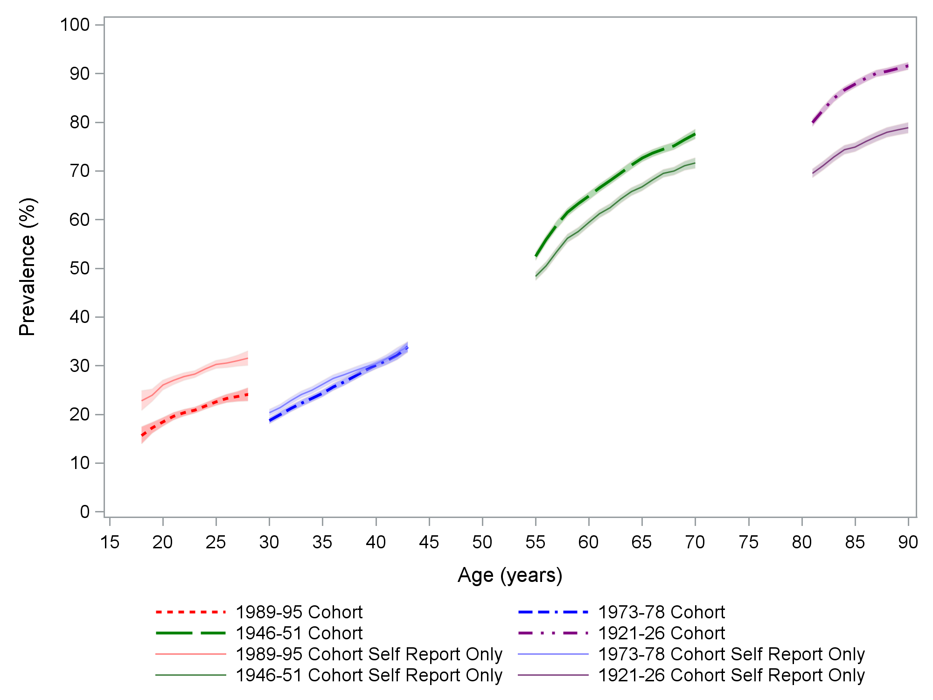

|  |  |  |  |
| --- | --- | --- | --- |
|  | 1989-95 cohort |  | 1946-51 cohort |
|  | 1989-95 cohort self-report only |  | 1946-51 cohort self-report only |
|  | 1973-78 cohort |  | 1921-26 cohort |
|  | 1973-78 cohort self-report only |  | 1921-26 cohort self-report only |

Figure 3‑1 Age specific prevalence of musculoskeletal conditions among four cohorts of women (born 1989-95, 1973-78, 1946-51 and 1921-26) from the Australian Longitudinal Study on Women’s Health.

Prevalence of musculoskeletal conditions increased with age, over time, and across surveys. Prevalence was highest for the oldest women, born in 1921-26, with about 90% having musculoskeletal condition(s) at age 90. For the older two cohorts (born in 1946-51 and 1921-26) the prevalence estimated from self-reports only is slightly lower than prevalence estimated by the algorithm, with the 1946-51 cohort showing a difference of about 5% at older ages, and a difference of about 10% at older ages in the 1921-26 cohort. Prevalence based on self-report from the 1973-78 cohort is closer to the prevalence estimated from the algorithm. In the 1989-95 cohort the self-reported prevalence is higher than the prevalence estimated from the algorithm by around 10%.

Across all cohorts, 28,416 women were identified with one or more musculoskeletal conditions at some time during the study, using a combination of self-report and administrative health data sources. Prevalence varied between the cohorts, but generally the older the cohort, the more women who were identified with a condition (Table 3‑2). Over 84% of the 1921-26 cohort were identified with a musculoskeletal condition, while only 23% of the 1989-95 cohort were similarly identified.

Table 3‑2 Prevalence of musculoskeletal conditions in the Australian Longitudinal Study on Women’s Health: Numbers and percent of participants identified at any time during the study using the algorithm described above.

|  | **1989-95 cohort** | | **1973-78 cohort** | | **1946-51 cohort** | | **1921-26 cohort** | |
| --- | --- | --- | --- | --- | --- | --- | --- | --- |
|  | **(n=16,987)** | | **(n=13,487)** | | **(n=12,653)** | | **(n=12,063)** | |
|  | n | % | n | % | n | % | n | % |
| **Musculoskeletal conditions** | 3,964a | 23.34 | 4,476b | 33.19 | 9,827c | 77.67 | 10,149d | 84.13 |

These prevalence estimates are broadly similar to those for women in the 2017 National Health Survey (shown in Table 3‑3).

Table 3‑3 Prevalence of musculoskeletal conditions from the 2017 National Health Survey for women in various age groups.

|  |  |  |  |  |  |
| --- | --- | --- | --- | --- | --- |
|  | **National Health Survey Prevalence (%)** | | | | |
| **Age** | **15-24** | **25-34** | **35-44** | **65-74** | **85+** |
| **Musculoskeletal condition** | 12.5 | 16.7 | 28 | 70.3 | 81.6 |

*Note*: Adapted from National Health Survey, Table 3.11 Long-term health conditions, Proportion of persons – Females. (12 December 2018; Australian Bureau of Statistics: 4364055001DO003_20172018 National Health Survey: First Results, 2017–18 — Australia )

## Mental health conditions

### Definition and case ascertainment of mental health conditions

The mental health conditions included in this report are mood (affective) disorders (e.g., depression and bipolar disorder), anxiety disorders (e.g., anxiety, post-traumatic stress disorder [PTSD], obsessive-compulsive disorder [OCD]) and eating disorders. Eligibility criteria used for ascertainment of cases are listed in detail in Appendix A and summary is provided in Table 3‑4.

Table 3‑4 Summary of criteria used to identify women with mental health conditions from multiple linked data sources. (More details are provided in Appendix A)

|  |  |
| --- | --- |
| **Data source** | **Eligibility criteria** |
| **ALSWH Surveys** | Self-reported mental health condition reported in at least two surveys  OR  Self-reported mental health condition in at least one survey and a relevant record in at least one of MBS, Hospital, PBS, Aged Care or COD |
| *Note 1:* A positive comment and a positive question response in a single survey is counted as the condition being reported in one survey only, whereas a positive comment and/or a positive question response in different surveys is counted as the condition being reported in two surveys.  *Note 2:* A positive response to the treatment of symptoms of anxiety or depression, without a positive response to the diagnosis/treatment question, must be corroborated by another data source. |
| **MBS** | One or more relevant MBS items and also reported in at least one of ALSWH, Hospital, Aged Care or cause of death |
| **PBS** | Two or more relevant prescriptions in a 12-month period and also reported in at least one of ALSWH, Hospital, Aged Care or cause of death |
| **Aged Care** | Reported once or more |
| **Cause of death** | Reported anywhere on the death certificate |
| **Hospital** | Reported once or more |

### Prevalence of mental health conditions

Figure 3‑2 shows the prevalence of mental health conditions by participant age. The estimates are based on data at particular times, and are displayed by the ages of the women at these times. Prevalence based only on ever having reported a mental health condition once on the self-reported survey data are shown in the solid lines and those from survey and linked data are shown in dotted lines.

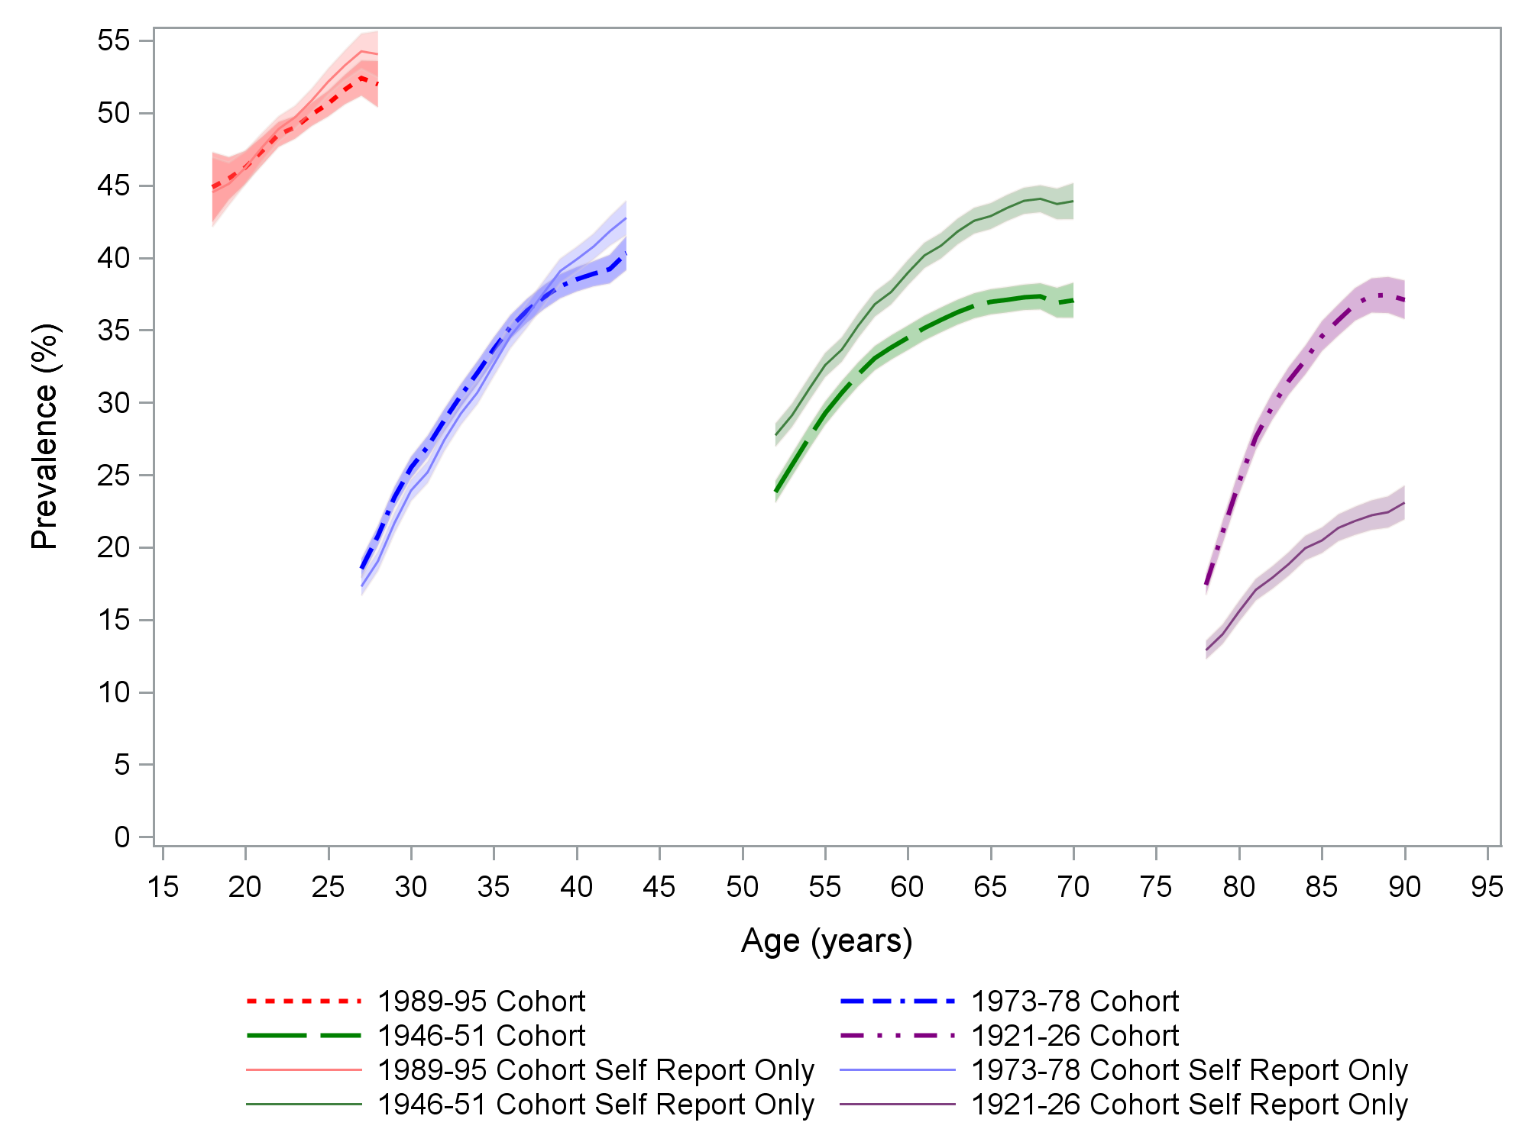

|  |  |  |  |
| --- | --- | --- | --- |
|  | 1989-95 cohort |  | 1946-51 cohort |
|  | 1989-95 cohort self-report only |  | 1946-51 cohort self-report only |
|  | 1973-78 cohort |  | 1921-26 cohort |
|  | 1973-78 cohort self-report only |  | 1921-26 cohort self-report only |

Figure 3‑2 Age specific prevalence of mental health conditions among four cohorts of women (born 1989-95, 1973-78, 1946-51 and 1921-26) from the Australian Longitudinal Study on Women’s Health.

Participants in the 1921-26, 1946-51, and 1973-78 cohorts were first asked mental health questions at their second survey, so only data from the corresponding ages for completion of Survey 2 for these cohorts is shown. Information for participants in the 1921-26 cohort has been truncated at age 90, owing to the small number of participants who are still alive after this age. Mental health questions were asked at all surveys for the 1989-95 cohort, so all ages are presented for this cohort.

There was a steady increase in the prevalence of ever having a mental health condition as participants aged, and this increase is most dramatic amongst women in the 1989-95 and 1973-78 cohorts. For these two cohorts it is also notable that the prevalence estimates are similar regardless of whether cases are identified through self-report, or from the algorithm using self-report and linked data. This suggests that the survey self-reports are a strong reflection of the participant’s mental health status, and the linked data do not identify many additional cases.

For women in the 1946-51 cohort, the prevalence of self-reported mental health conditions is greater than the prevalence of cases from all sources. This is due to a high proportion of women in this cohort self-reporting a mental health condition at a single survey only – they are included in the prevalence estimate shown in the solid line. In contrast, the prevalence estimate based on the algorithm required self-report of a mental health condition at two or more surveys and/or corroboration from the linked data.

The opposite trend is observed for the oldest women, born 1921-26, where the prevalence of self-reports is substantially lower than for cases identified from multiple sources. This reflects our reliance on linked data for these participants. Without the linked data, we would fail to detect a substantial number of participants with mental health conditions.

A total of 22,966 women were identified with one or more mental health condition, using a combination of self-report and administrative health data at any time during the study. Prevalence was highest in younger women and diminished with cohort age (Table 3‑5). More than half (51.2%) of the 1989-95 cohort and around a third (35.85%) of the 1921-26 cohort were identified with a mental health condition.

Table 3‑5 Prevalence of mental health conditions in the Australian Longitudinal Study on Women’s Health, numbers and percent of participants identified at any time during the study using the algorithm described above.

|  |  |  |  |  |  |  |  |  |
| --- | --- | --- | --- | --- | --- | --- | --- | --- |
|  | **1989-95 cohort**  **(n = 16,987a)** | | **1973-78 cohort**  **(n = 13,487)** | | **1946-51 cohort**  **(n = 12,653)** | | **1921-26 cohort**  **(n = 12,063)** | |
|  | n | % | n | % | n | % | n | % |
| **Mental**  **health condition** | 8,696 | 51.19 | 5,203 | 38.58 | 4,742 | 37.48 | 4,325 | 35.85 |

These prevalence estimates are higher than those reported in the National Health Survey (NHS) of 2017-18, but NHS measured the prevalence of current mental health conditions of at least six months duration, whereas estimates in this report measure cumulative lifetime incidence (Table 3‑6).

Table 3‑6 Prevalence of mental health conditions from the 2017 National Health Survey for women in various age groups.

|  |  |  |  |  |  |
| --- | --- | --- | --- | --- | --- |
|  | **National Health Survey Prevalence (%)** | | | | |
| **Age** | **15-24** | **25-34** | **35-44** | **65-74** | **85+** | |
| **Mental health condition** | 39.7 | 32.9 | 28.3 | 28.1 | 17.9 | |

*Note*: Adapted from National Health Survey, Table 3.11 Long-term health conditions, Proportion of persons – Females. (12 December 2018; Australian Bureau of Statistics: 4364055001DO003_20172018 National Health Survey: First Results, 2017–18 — Australia )

## Heart disease

### Definition and case ascertainment of heart disease

The heart diseases included in this report were ischaemic heart disease and heart failure. Cases were included based on the eligibility criteria listed in detail in Appendix A. Very few women in the 1989-95 cohort had records of heart disease in any data sources, so data from this cohort has not been included. Due to variations in the wording of ALSWH surveys and high percentages of women responding positively to some of the questions, the ascertainment criteria for heart disease required corroboration of survey responses by linked data from another source. Summary details of ascertainment are provided in Table 3‑7.

Table 3‑7 Summary of criteria used to identify women with heart disease from multiple linked data sources. (More details are provided in Appendix A).

|  |  |
| --- | --- |
| **Data Source** | **Eligibility criteria** |
| **ALSWH Surveys** | Self-reported heart disease reported in at least two surveys and also reported in at least one of MBS, PBS Hospital, Aged Care or cause of death. |
| **MBS** | Reported once or more |
| **PBS** | Reported once or more |
| **Aged Care** | Reported once or more |
| **Cause of death** | Reported anywhere on the death certificate |
| **Hospital** | Reported once or more |

### Prevalence of heart disease

Figure 3‑3 shows the prevalence of heart disease in three cohorts by participant age. Prevalence based on self-reported survey data only are shown in the dotted lines and the prevalence estimates from survey and linked data are shown in solid lines. Results for the 1921-26 cohort have also been truncated at age 90, owing to the small number of participants still alive after this age.

There was a steady increase in the prevalence of heart disease as women aged, with this increase most dramatic amongst the 1921-26 cohort and significantly more cases identified from all sources than from self-report alone. Without the linked data, we would fail to reliably detect a substantial number of participants with heart disease in this cohort. For the 1973-78 cohort, the prevalence of self-reports of heart disease over time is similar to the prevalence using multiple data sources. This suggests that the survey self-reports for the 1973-78 cohort are a strong reflection of the participant’s heart disease status, and the linked data does not identify many additional cases. However, for the 1946-51 cohort, the prevalence of self-reports is initially greater than the prevalence of multiple data sources but this changed over time as more cases were identified in the linked data.

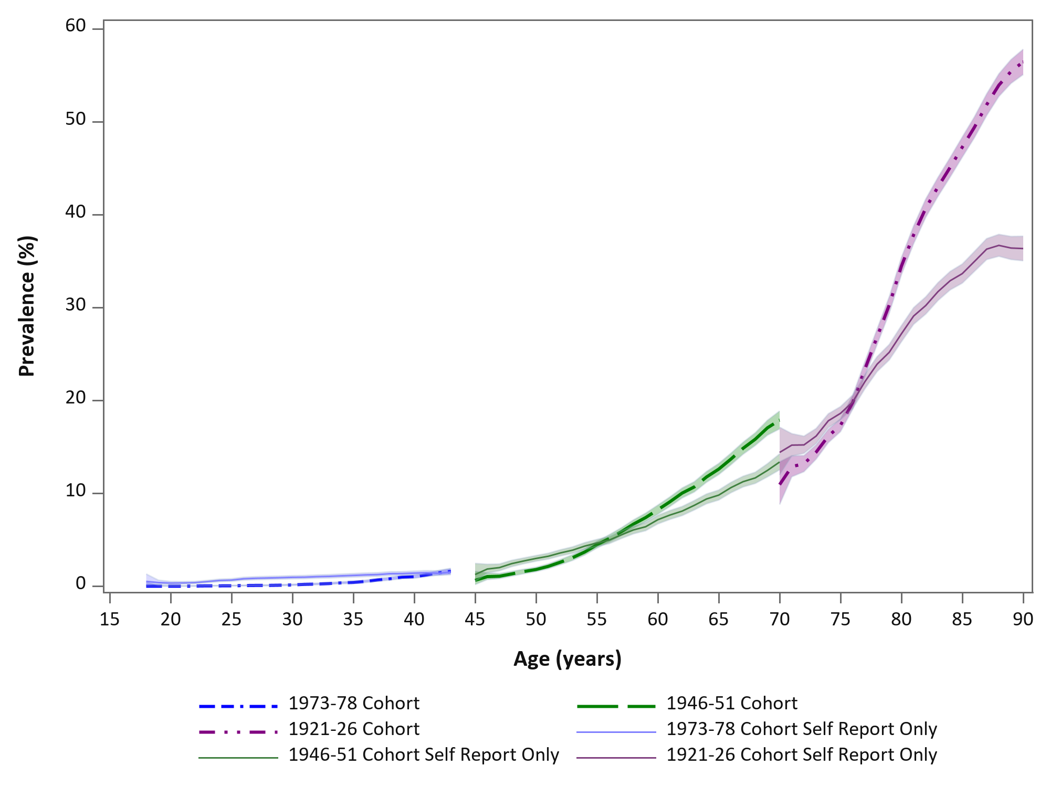

|  |  |  |  |
| --- | --- | --- | --- |
|  | 1973-78 cohort |  | 1946-51 cohort |
|  | 1973-78 cohort self-report only |  | 1946-51 cohort self-report only |
|  |  |  | 1921-26 cohort |
|  |  |  | 1921-26 cohort self-report only |

Figure 3‑3 Age specific prevalence of heart disease among three cohorts of women (born 1973-78, 1946-51 and 1921-26) from the Australian Longitudinal Study on Women’s Health.

Using combined self-report and administrative health data sources, 10,509 (27.5%) women from the 1973-78, 1946-51 and 1921-26 cohorts were ascertained as having heart disease at any time during the study period. Prevalence varied from 1.5% in the 1973-78 cohort to 66.0% in the 1921-26 cohort (Table 3‑8).

Table 3‑8 Prevalence of heart disease in the Australian Longitudinal Study on Women’s Health, numbers and percent of participants identified at any time during the study using the algorithm described above.

|  | **1973-78 cohort** | | **1946-51cohort** | | **1921-26 cohort** | |
| --- | --- | --- | --- | --- | --- | --- |
|  | **(n=13,487)** | | **(n=12,653)** | | **(n= 12,063)** | |
|  | n | % | n | % | n | % |
| **Heart disease** | 205 | 1.5 | 2,346 | 18.5 | 7,958 | 66.0 |

These prevalence estimates are higher than those reported in the National Health Survey (NHS) of 2017-18 (Table 3‑9), but NHS measured the prevalence of current heart disease of at least six months duration, whereas this report measures cumulative lifetime incidence and includes deaths.

Table 3‑9 Prevalence of heart disease from the 2017 National Health Survey for women in various age groups.

|  |  |  |  |  |  |
| --- | --- | --- | --- | --- | --- |
|  | **National Health Survey Prevalence (%)** | | | | |
| **Age** | **15-24** | **25-34** | **35-44** | **65-74** | **85+** |
| **Heart disease** | 0.0 | 0.2 | 0.2 | 8.0 | 15.1 |

*Note*: Adapted from National Health Survey, Table 3.11 Long-term health conditions, Proportion of persons – Females. (12 December 2018; Australian Bureau of Statistics: 4364055001DO003_20172018 National Health Survey: First Results, 2017–18 — Australia )

## Respiratory disease

### Definition and case ascertainment of respiratory disease

Respiratory diseases included are asthma and chronic obstructive pulmonary disease (COPD). The major conditions in this group differ between cohorts with asthma being the predominant condition among the younger women and COPD more common in the oldest women. Eligibility criteria are listed in detail in Appendix A. Due to the high percentages of women responding positively to some of the questions on respiratory conditions in the ALSWH surveys, possibly due to illness that was not chronic, the ascertainment criteria for respiratory disease required responses to more than one survey or corroboration of survey responses by linked data from another source. Summary details of the criteria are provided in Table 3‑10.

Table 3‑10 Summary of criteria used to identify women with respiratory disease from multiple linked data sources. (More details are provided in Appendix A).

|  |  |
| --- | --- |
| **Data source** | **Eligibility criteria** |
| **ALSWH Surveys** | Self-reported asthma in at least two surveys and breathing difficulties ‘often’ and also reported in at least one of MBS, Hospital, PBS (asthma only medication), or cause of death |
| **MBS** | One or more relevant MBS items |
| **PBS** | Two or more relevant prescriptions in a 12-month period for asthma only medication  OR  COPD only medication and record in MBS, hospital or cause of death data. |
| **Aged Care** | Reported once or more and if reported in MBS, hospital or cause of death data. |
| **Cause of death** | Reported anywhere on the death certificate |
| **Hospital** | Reported once or more |

### Prevalence of respiratory disease

Figure 3‑4 shows the prevalence of respiratory disease in the four cohorts by participant age (with results for the oldest women truncated at age 90, owing to the small numbers of participants who were still alive after this age). Prevalence based on self-reported survey data only are shown in the solid lines and those from survey and linked data are shown in dotted lines.

There was a steady increase in prevalence of respiratory disease with the age of participants. The prevalence of self-reported respiratory disease, which required a condition to be reported at only one survey, is much higher than the prevalence of cases for all data sources. This suggests that the survey self-reports may overestimate respiratory disease prevalence, and the linked data more correctly identify cases.

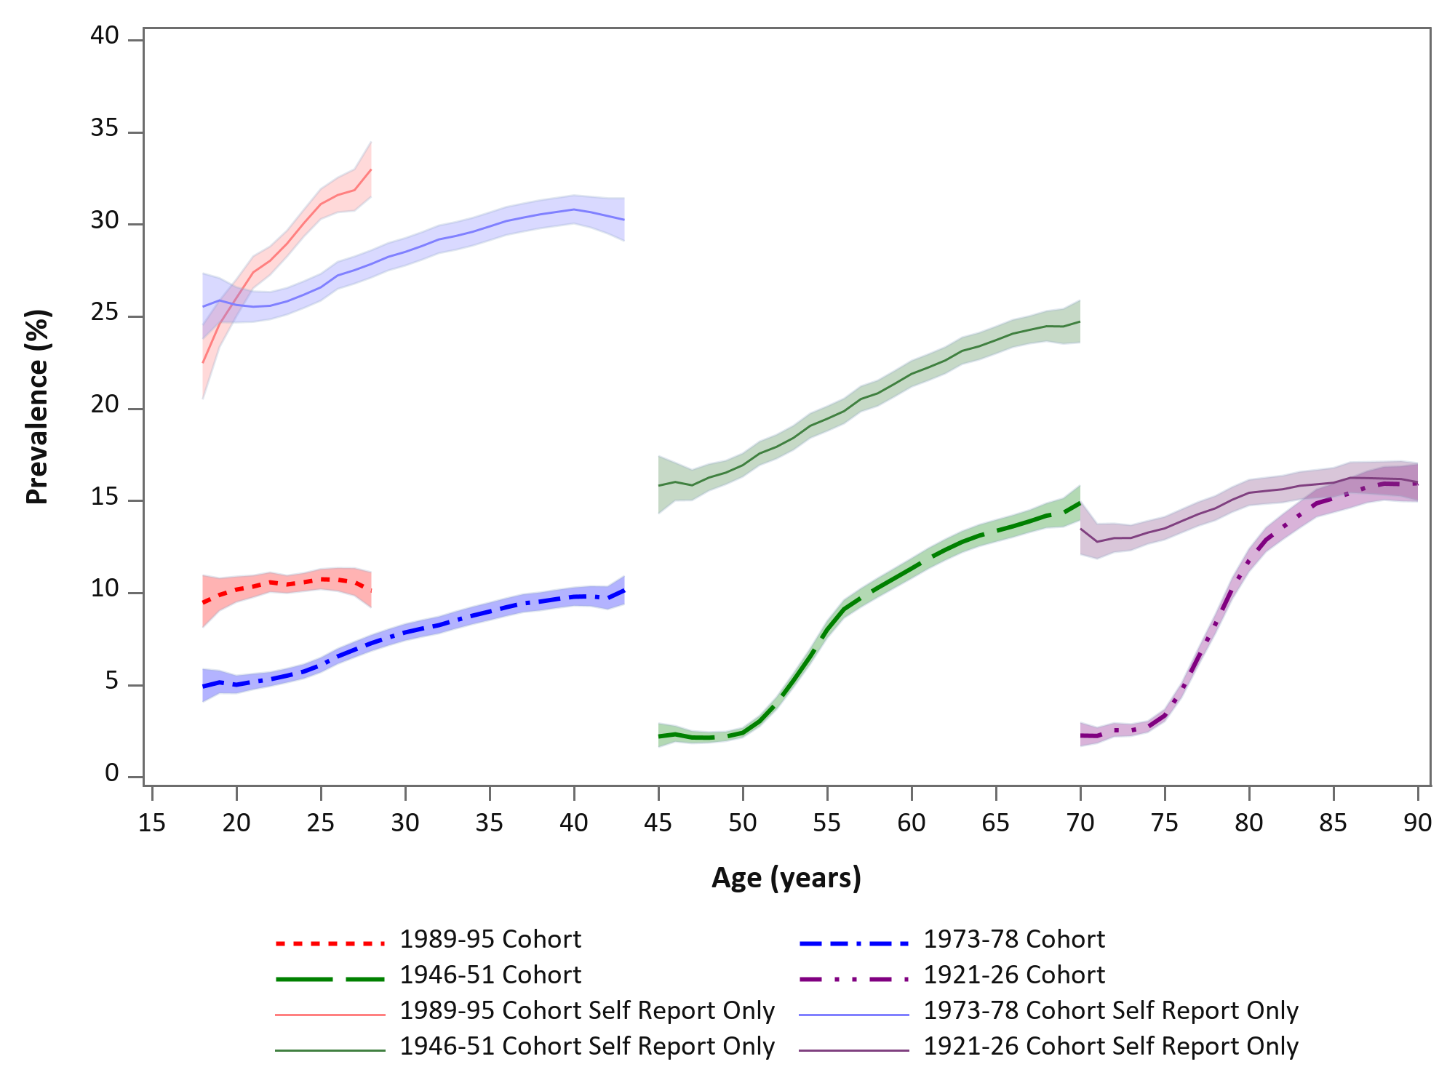

|  |  |  |  |
| --- | --- | --- | --- |
|  | 1989-95 cohort |  | 1946-51 cohort |
|  | 1989-95 cohort self-report only |  | 1946-51 cohort self-report only |
|  | 1973-78 cohort |  | 1921-26 cohort |
|  | 1973-78 cohort self-report only |  | 1921-26 cohort self-report only |

Figure 3‑4 Age specific prevalence of respiratory disease among four cohorts of women (born 1989-95, 1973-78, 1946-51 and 1921-26) from the Australian Longitudinal Study on Women’s Health.

A total of 7,042 (12.75%) of women were identified using the algorithm as having a chronic respiratory disease at some time during the study. Prevalence varied from 10.8% in the 1989-95 cohort to 15.4% in the 1946-51 cohort (Table 3‑11).

Table 3‑11 Prevalence of respiratory disease in the Australian Longitudinal Study on Women’s Health, numbers and percent of participants identified at any time during the study using the algorithm described above.

|  | **1989-95 cohort** | | **1973-78 cohort** | | **1946-51 cohort** | | **1921-26 cohort** | |
| --- | --- | --- | --- | --- | --- | --- | --- | --- |
|  | **(n=16,987)** | | **(n=13,487)** | | **(n=12,653)** | | **(n=12,063)** | |
|  | n | % | n | % | n | % | n | % |
| **Respiratory disease** | 1,832 | 10.8 | 1,423 | 10.6 | 1,944 | 15.4 | 1,825 | 15.1 |

These prevalence estimates are higher than those reported in the National Health Survey (NHS) of 2017-18 (Table 3‑12), but NHS measured the prevalence of current respiratory disease of at least six months duration, whereas this report measures cumulative incidence.

Table 3‑12 Prevalence of respiratory disease from the 2017 National Health Survey for women in various age groups.

|  |  |  |  |  |  |
| --- | --- | --- | --- | --- | --- |
|  | **National Health Survey Prevalence (%)** | | | | |
| **Age** | **15-24** | **25-34** | **35-44** | **65-74** | **85+** |
| **Respiratory disease** | 10.5 | 12.8 | 12.8 | 15.6 | 9.6 |

*Note*: Adapted from National Health Survey, Table 3.11 Long-term health conditions, Proportion of persons – Females. (12 December 2018; Australian Bureau of Statistics: 4364055001DO003_20172018 National Health Survey: First Results, 2017–18 — Australia )

## Cancer

### Definition and case ascertainment of cancer

All cancers, excluding non-melanoma skin cancers, have been included in this report. The only source of data used for cancer was the Australian Cancer Database maintained by the Australian Institute of Health and Welfare. This database is a data collection of all primary, malignant cancers diagnosed in Australia. It does not include in situ cancers which may be recorded in State-based cancer registries. At the time of preparing this report data were only available up to December 2015.

### Prevalence of cancer

Figure 3‑5 shows the prevalence of cancer in four cohorts by participant age (with results from the oldest women truncated at age 90, owing to the small number of women still alive after this age).

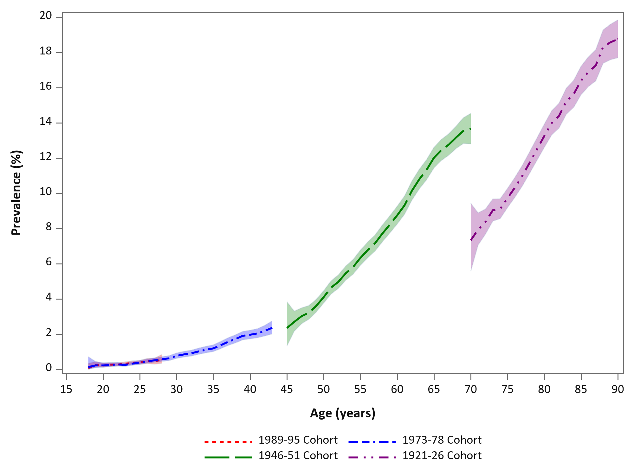

|  |  |  |  |
| --- | --- | --- | --- |
|  | 1989-95 cohort |  | 1946-51 cohort |
|  | 1989-95 cohort self-report only |  | 1946-51 cohort self-report only |
|  | 1973-78 cohort |  | 1921-26 cohort |
|  | 1973-78 cohort self-report only |  | 1921-26 cohort self-report only |

Figure 3‑5 Age specific prevalence of cancer among four cohorts of women (born 1989-95, 1973-78, 1946-51 and 1921-26) from the Australian Longitudinal Study on Women’s Health.

Prevalence for the 1989-95 and 1973-78 cohort were almost identical when women in these cohorts were that same age. There was a steady increase in the prevalence of cancer as participants aged, with the highest prevalence amongst the 1921-26 cohort.

Across all cohorts, 6,035 (10.93%) women were identified as having cancer. Prevalence varied from 0.4% in the 1989-95 cohort to 29.9% in the 1921-26 cohort (Table 3‑13).

Table 3‑13 Prevalence of cancer in the Australian Longitudinal Study on Women’s Health, numbers and percent of participants identified at any time during the study.

|  | **1989-95 cohort** | | **1973-78 cohort** | | **1946-51 cohort** | | **1921-26 cohort** | |
| --- | --- | --- | --- | --- | --- | --- | --- | --- |
|  | **(n=16,987)** | | **(n=13,487)** | | **(n=12,653)** | | **(n=12,063)** | |
|  | n | % | n | % | n | % | n | % |
| **Cancer** | 62 | 0.4 | 302 | 2.2 | 2,065 | 16.3 | 3,606 | 29.9 |

These prevalence estimates are higher than those reported in the National Health Survey (NHS) of 2017-18 (Table 3‑14), but NHS measured the prevalence of current cancer of at least six months duration, whereas this report measures cumulative lifetime incidence.

Table 3‑14 Prevalence of cancer from the 2017 National Health Survey for women in various age groups.

|  |  |  |  |  |  |
| --- | --- | --- | --- | --- | --- |
|  | **National Health Survey Prevalence (%)** | | | | |
| **Age** | **15-24** | **25-34** | **35-44** | **65-74** | **85+** |
| **Cancer** | 0.2 | 0.1 | 0.9 | 4.8 | 5.8 |

*Note*: Adapted from National Health Survey, Table 3.11 Long-term health conditions, Proportion of persons – Females. (12 December 2018; Australian Bureau of Statistics: 4364055001DO003_20172018 National Health Survey: First Results, 2017–18 — Australia )

## Diabetes

### Definition and case ascertainment of diabetes

This report includes Diabetes Mellitus (Type 1 and Type 2; Gestational diabetes was not included). Ascertainment of diabetes was established through self-report (reported on at least two ALSWH surveys) or linked health administrative data sources (namely MBS, PBS, hospital admissions, aged care, or through causes of death). Criteria for identification of diabetes case are presented in detail in Appendix A, and a summary is provided in Table 3‑15.

Table 3‑15 Summary of criteria used to identify women with diabetes from multiple linked data sources. (More details are provided in Appendix A).

|  |  |
| --- | --- |
| **Data source** | **Eligibility criteria** |
| **ALSWH Surveys** | Self-reported diabetes in at least two surveys |
| **MBS** | One or more relevant MBS items |
| **PBS** | Two or more relevant prescriptions in a 12-month period (excluding times of pregnancies) |
| **Aged Care** | Reported once or more and if reported in MBS, hospital or cause of death data. |
| **Cause of death** | Reported anywhere on the death certificate |
| **Hospital** | Reported once or more |

### Prevalence of diabetes

Figure 3‑6 displays the prevalence for diabetes in the four ALSWH cohorts according to participant age. For all four cohorts, self-reported diabetes (reported at 1 or more surveys) tracked reasonably well compared with the prevalence of diabetes identified using multiple data sources. It should be noted that women from the 1921-26 cohort were only asked to self-report the diagnosis or treatment of diabetes until 2011 and this is reflected in the levelling off of self-reported prevalence at older ages for these women.

The cohort with the highest prevalence was the 1921-26 cohort which peaked at around 22% at age 90 (note: the 1921-26 cohort is truncated at age 90 due to low numbers of participants alive after this age). Prevalence for the 1989-95 and 1973-78 cohort were almost identical when women in these cohorts were that same age.

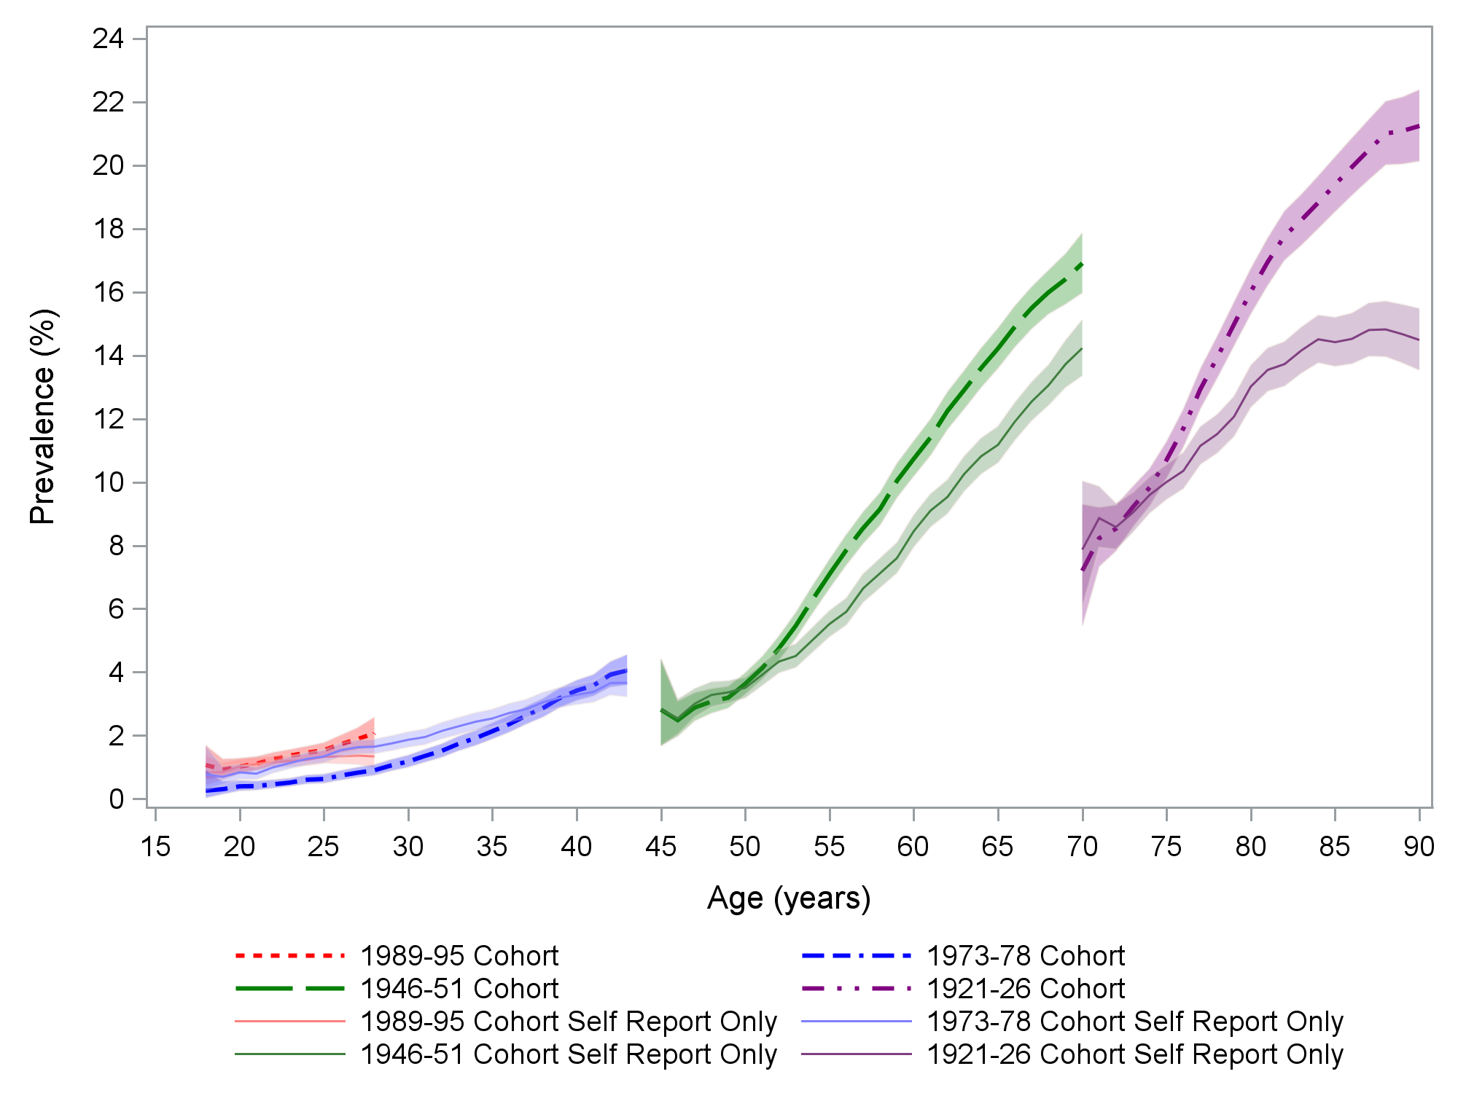

|  |  |  |  |
| --- | --- | --- | --- |
|  | 1989-95 cohort |  | 1946-51 cohort |
|  | 1989-95 cohort self-report only |  | 1946-51 cohort self-report only |
|  | 1973-78 cohort |  | 1921-26 cohort |
|  | 1973-78 cohort self-report only |  | 1921-26 cohort self-report only |

Figure 3‑6 Age-specific prevalence for diabetes among four cohorts of Australian women (born 1989-95, 1973-78, 1946-51 and 1921-26).

A total of 5,804 women (10.5%) were ascertained as having diabetes identified at some time during the study, using a combination of self-report and administrative health data sources. The lifetime prevalence of diabetes varied from 1.8% in the 1989-95 cohort to 23.3% in the 1921-26 cohort (Table 3‑16).

Table 3‑16 Prevalence of diabetes for four cohorts of Australian women, numbers and percent of participants identified at any time during the study using the algorithm described above.

|  | **1989-95 cohort** | | **1973-78 cohort** | | **1946-51 cohort** | | **1921-26 cohort** | |
| --- | --- | --- | --- | --- | --- | --- | --- | --- |
|  | **(n=16,987)** | | **(n=13,487)** | | **(n=12,653)** | | **(n=12,063)** | |
|  | n | % | n | % | n | % | n | % |
| **Diabetes** | 299 | 1.76 | 528 | 3.91 | 2,161 | 17.08 | 2,816 | 23.34 |

These prevalence estimates are higher than those reported in the National Health Survey (NHS) of 2017-18 (Table 3‑17), but NHS measured the prevalence of current diabetes of at least six months duration, whereas this report measures cumulative lifetime incidence.

Table 3‑17 Prevalence of diabetes from the 2017 National Health Survey for women in various age groups.

|  |  |  |  |  |  |
| --- | --- | --- | --- | --- | --- |
|  | **National Health Survey Prevalence (%)** | | | | |
| **Age** | **15-24** | **25-34** | **35-44** | **65-74** | **85+** |
| **Diabetes** | 0.4 | 0.3 | 2.6 | 12.4 | 15.7 |

*Note*: Adapted from National Health Survey, Table 3.11 Long-term health conditions, Proportion of persons – Females. (12 December 2018; Australian Bureau of Statistics: 4364055001DO003_20172018 National Health Survey: First Results, 2017–18 — Australia )

## Dementia

### Definition and case ascertainment of dementia

For this report, dementia includes Alzheimer’s disease and other forms of dementia. Criteria for identification of cases are listed in detail in Appendix A. Dementia data have only been included for the oldest women born 1921-26. A participant was required to meet one or more of the criteria shown in Table 3‑18 to be included as a case. There are no dementia specific items in MBS data.

Table 3‑18 Summary of criteria used to identify women with dementia from multiple linked data sources. (More details are provided in Appendix A).

|  |  |
| --- | --- |
| **Data source** | **Eligibility criteria** |
| **ALSWH Surveys** | Reported once or more by the participant or a proxy |
| **PBS** | Dementia specific drugs reported once or more |
| **Aged Care** | Reported once or more |
| **Cause of death** | Reported in any position on the death certificate |
| **Hospital** | Reported once or more |

### Prevalence of dementia

Figure 3‑7 shows the prevalence of dementia in the 1921-26 cohort. Women were first asked dementia questions at Survey 2, when they were aged 73 to 78, so data have only been included from these ages, and results have been truncated at age 90, owing to the small number of women who were still alive after this age. Prevalence based on self-reported survey data only are shown in the solid line and those from the survey and linked data are shown in dotted lines.

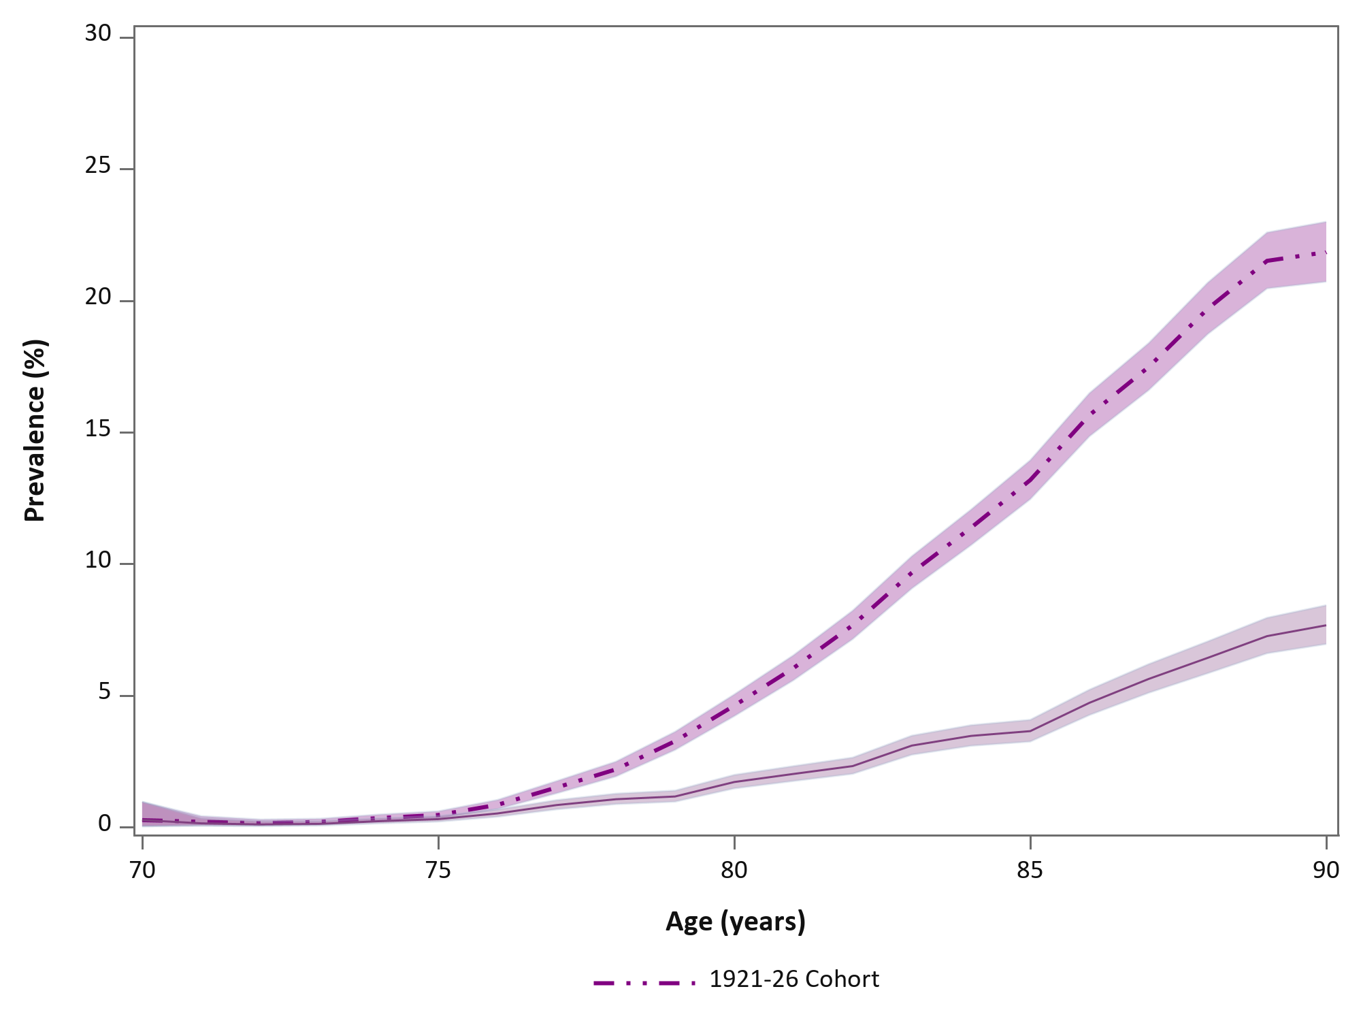

|  |  |  |  |
| --- | --- | --- | --- |
|  | 1921-26 cohort |  | 1921-26 cohort self-report only |

Figure 3‑7 Prevalence of dementia in the 1921-26 cohort from age 73 to age 90.

The figure shows a steady increase in dementia prevalence as women age. The prevalence of self-reports (or report by a proxy) or dementia is substantially lower than for all cases identified from multiple sources. Without the linked data, we would fail to detect a substantial number of participants with dementia. Using combined self-report and linked health data records, 4,111 (34.1%) women in the 1921-26 cohort were identified with dementia. (Table 3‑19). (Note: Dementia is not recorded in the National Health Survey, so comparison is not possible).

Table 3‑19 Prevalence of dementia in the Australian Longitudinal Study on Women’s Health, numbers and percent of participants identified at any time during the study using the algorithm described above.

|  | **1921-26 cohort** | |
| --- | --- | --- |
|  | **(n=12,063)** | |
|  | n | % |
| **Dementia** | 4,111 | 34.1 |

## Stroke

### Definition and case ascertainment of stroke

The stroke conditions included in this report were any report of stroke or cerebrovascular disease. Cases were included based on the eligibility criteria listed in detail in Appendix A. Few women in the younger cohorts had stroke or cerebrovascular disease, so only data from women in the two older cohorts, born 1946-51 and 1921-26, have been included. There are no stroke specific items in MBS or PBS so these data sources were not used. The ALSWH data included stroke reported by a proxy. Summary details of ascertainment criteria are shown in Table 3‑20.

Table 3‑20 Summary of criteria used to identify women with stroke from multiple linked data sources. (More details are provided in Appendix A).

|  |  |
| --- | --- |
| **Data source** | **Eligibility criteria** |
| **ALSWH Surveys** | Self-reported stroke in at least one survey and also reported in at least one of Hospital, Aged Care or cause of death.  Note: A positive comment and a positive question response in a single survey is counted as the condition being reported in one survey only, whereas a positive comment and a positive question response in different surveys is counted as the condition being reported in two surveys |
| **Aged Care** | Reported once or more |
| **Cause of death** | Reported in any position on the death certificate |
| **Hospital** | Reported once or more |

### Prevalence of stroke

Figure 3‑8 shows the prevalence of stroke in the two older cohorts by participant age, with results for the 1921-26 cohort truncated at age 90, as only a small number of women were still alive after this age. There is a steady increase in the prevalence of stroke as women age, with this increases most dramatic amongst older women in the 1921-26 cohort.

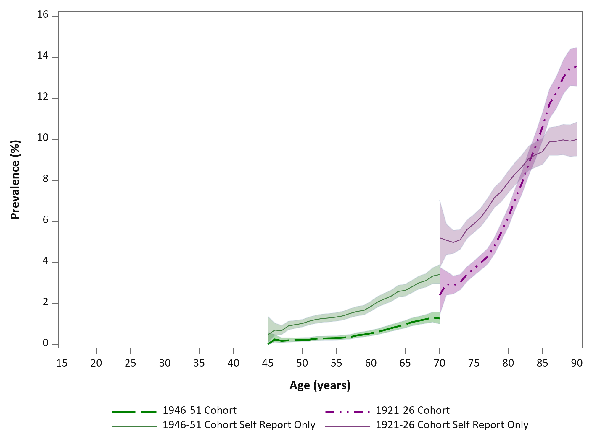

|  |  |  |  |
| --- | --- | --- | --- |
|  | 1946-51 cohort |  | 1921-26 cohort |
|  | 1946-51 cohort self-report only |  | 1921-26 cohort self-report only |

Figure 3‑8 Age specific prevalence of stroke among two cohorts of women (born 1946-51 and 1921-26) from the Australian Longitudinal Study on Women’s Health.

Amongst the 1946-51 cohort, the prevalence of self-reported stroke is greater than the prevalence based on data from all sources. This is due to a high proportion of participants in this cohort self-reporting a stroke at a single survey only, which is not sufficient to be included according to the algorithm used to identify cases from multiple sources. This is potentially due to reports of transient ischaemic attack (TIA) and stroke-like events as stroke (Jackson, 2015). The opposite trend is observed in the 1921-26 cohort, where the prevalence of self-reported stroke is substantially lower than estimates obtained using multiple data sources. This reflects our reliance on linked data for these participants. Without the linked data, we would fail to detect a substantial number of participants with stroke.

Across both cohorts, 3,225 women were identified with stroke at some time during the study (Table 3‑21) – however, most of these (2,975) were amongst the oldest women (born 1921-26). Just under a quarter (24.7%) of all the women in this cohort had evidence of stroke, while only 2% of the women in the 1946-51 cohort had evidence of stroke.

Table 3‑21 Prevalence of stroke in the Australian Longitudinal Study on Women’s Health, numbers and percent of participants identified at any time during the study using the algorithm described above.

|  | **1946-51 cohort** | | **1921-26 cohort** | |
| --- | --- | --- | --- | --- |
|  | **(n=12,653)** | | **(n=12,063)** | |
|  | n | % | n | % |
| **Stroke** | 250 | 2.0 | 2,975 | 24.7 |  |

These prevalence estimates are higher than those reported in the National Health Survey (NHS) of 2017-18 (Table 3‑22), but NHS measured the prevalence of stroke of at least six months duration, whereas this report measures cumulative lifetime incidence and includes strokes where women either completely recovered, as well as those that resulted in death.

Table 3‑22 Prevalence of stroke from the 2017 National Health Survey for women in aged 65-74 and 85+.

|  |  |  |
| --- | --- | --- |
|  | **National Health Survey Prevalence (%)** | |
| **Age** | 65-74 | 85+ |
| **Stroke** | 1.8 | 2.6 |

*Note*: Adapted from National Health Survey, Table 3.11 Long-term health conditions, Proportion of persons – Females. (12 December 2018; Australian Bureau of Statistics: 4364055001DO003_20172018 National Health Survey: First Results, 2017–18 — Australia )

# Multimorbidity

Chapter 3 provided detailed data on the most common groups of chronic conditions affecting women in each cohort and trends in these conditions over time. In this chapter the most common combinations of these groups of conditions are examined, first at a single fairly recent time (i.e., a snap shot), and then how these combinations have accumulated over time. The times chosen for the snap shots correspond to the most recent full survey for each cohort. These times are as follows:

* 1921-26 cohort – 1 July 2015, when the women were aged 89-94 years,
* 1946-51 cohort – 1 July 2017, aged 66-71,
* 1973-78 cohort – 1 July 2016, aged 38-43,
* 1989-95 cohort – 31 Dec 2018, aged 23-29.

Particularly for the 1921-26 cohort, the number of participants at the snap shot date is many fewer than the initial number in 1996, mainly due to deaths.

## Prevalence of chronic conditions

The snapshot data for each cohort are shown in Table 4‑1. The numbers in brackets are the prevalence estimates, i.e., percentages of women who experienced at least one condition in each group using the algorithms described in Chapter 3. For example, the prevalence of musculoskeletal conditions increased from 23% in the youngest cohort (aged 23-29) to 94% in the oldest cohort (aged 89-94). Similar increases with age are apparent for all the other groups of conditions except mental health conditions. The prevalence of mental health conditions decreased with increasing age.

Table 4‑1 Prevalence of each group of conditions in each cohort.

|  |  |  |  |  |
| --- | --- | --- | --- | --- |
|  | **1921-26 cohort** | **1946-51 cohort** | **1973-78 cohort** | **1989-95 cohort** |

|  |  |  |  |  |
| --- | --- | --- | --- | --- |
|  | **N = 4,418\*** | **N = 11,621** | **N = 12,923** | **N = 16,852** |
| **Snap shot date** | **1 Jul 2015** | **1 Jul 2017** | **1 Jul 2016** | **31 Dec 2018** |
| **Age** | **89-94 years** | **66-71 years** | **39-43 years** | **23-29 years** |
|  | n (%) | n (%) | n (%) | n (%) |
| Musculoskeletal | 4,147 (93.87) | 9,032 (77.72) | 4,129 (31.95) | 3,942 (23.39) |

|  |  |  |  |  |
| --- | --- | --- | --- | --- |
| Mental health conditions | 1,569 (35.51) | 4,349 (37.42) | 5,004 (38.72) | 8,653 (51.35) |
| Heart disease | 2,521 (57.06) | 1,869 (16.08) | 141 (1.09) | - |
| Respiratory disease | 725 (16.41) | 1,785 (15.36) | 1,360 (10.52) | 1,822 (10.81) |
| Diabetes | 943 (21.34) | 1,873 (16.12) | 445 (3.44) | 291 (1.73) |
| Cancer | 844 (19.10) | 1,501 (12.92) | 267 (2.07) | 61 (0.36) |
| Dementia | 971 (21.98) | - | - | - |
| Stroke | 572 (12.95) | 151 (1.30) | - | - |

*The number of women in the 1921-26 cohort by 1 July 2015 was much less than the initial number of participants in this cohort in 1996 (n=12,063). This is mainly due to deaths, but also to non-consent to linkage and other factors.

## Common combinations of conditions

Many groups of conditions co-occur. The most common combinations at the snap shot dates are shown in Tables 4-2 to 4-5. For example, Table 4‑2 shows that for the oldest cohort musculoskeletal conditions, heart disease and mental health conditions most commonly occurred together, even among women who also had dementia, diabetes or chronic respiratory disease. Note that, for example, a woman with the 2 conditions (Musculoskeletal + Heart disease) is also counted in groups with 3 conditions such as (Musculoskeletal + Mental health condition + Heart disease) or (Musculoskeletal + Heart disease + Diabetes).

**Table 4‑2 Most common combinations of conditions – 1921-26 cohort (n = 4,418, aged 89-94).**

|  |  |  |  |
| --- | --- | --- | --- |
| **No. Condition Groups** | **Conditions** | **Cases** | **%** |
| **Two** | Musculoskeletal conditions + Heart disease | 2,413 | 54.62 |
|  | Musculoskeletal conditions + Mental health condition | 1,515 | 34.29 |
|  | Mental health condition + Heart disease | 1,010 | 22.86 |
| **Three** | Musculoskeletal + Mental health condition + Heart disease | 983 | 22.25 |
|  | Musculoskeletal + Heart disease + Diabetes | 582 | 13.17 |
|  | Musculoskeletal + Mental health condition + Diabetes | 535 | 12.11 |
| **Four** | Musculoskeletal + Mental health condition + Heart disease + Dementia | 315 | 7.13 |
|  | Musculoskeletal + Mental health condition + Heart disease + Diabetes | 255 | 5.77 |
|  | Musculoskeletal conditions + Mental health condition + Heart disease + Respiratory disease | 222 | 5.02 |

The same pattern (co-occurrence of musculoskeletal conditions, mental health conditions and heart disease) was also apparent for women born in 1946-51 – see Table 4‑3.

**Table 4‑3 Most common combinations of conditions – 1946-51 cohort (n = 11,621, aged 66-71).**

| **No. Condition Groups** | **Conditions** | **Cases** | **%** |
| --- | --- | --- | --- |
| **Two** | Musculoskeletal + Mental health condition | 3,788 | 32.60 |
|  | Musculoskeletal + Heart disease | 1,643 | 14.14 |
|  | Musculoskeletal + Diabetes | 1,569 | 13.50 |
| **Three** | Musculoskeletal + Mental health condition + Heart disease | 907 | 7.80 |
|  | Musculoskeletal + Mental health condition + Respiratory disease | 850 | 7.33 |
|  | Musculoskeletal + Mental health condition + Diabetes | 780 | 6.71 |
| **Four** | Musculoskeletal + Mental health condition + Heart disease + Diabetes | 285 | 2.45 |
|  | Musculoskeletal + Mental health condition + Heart disease + Respiratory disease | 259 | 2.23 |
|  | Musculoskeletal + Mental health condition + Respiratory disease + Diabetes | 244 | 2.10 |

For the 1973-38 cohort (Table 4‑4) and 1989-95 cohort (Table 4‑5) musculoskeletal conditions, and mental health condition together with chronic respiratory disease were the most common combinations. For these two cohorts only two and three combinations are shown due to very small numbers of women with more than three chronic conditions.

**Table 4‑4 Most common combinations of conditions – 1973-78 cohort (n = 12,923, aged 38-43).**

|  |  |  |  |
| --- | --- | --- | --- |
| **No. Condition Groups** | **Conditions** | **Cases** | **%** |
| **Two** | Musculoskeletal + Mental health condition | 2,130 | 16.45 |
|  | Mental health condition + Respiratory disease | 656 | 5.08 |
|  | Musculoskeletal + Respiratory disease | 587 | 4.54 |
| **Three** | Musculoskeletal + Mental health condition + Respiratory disease | 343 | 2.65 |
|  | Musculoskeletal + Mental health condition + Diabetes | 135 | 1.04 |
|  | Musculoskeletal conditions + Mental health condition + Cancer | 67 | 0.52 |

**Table 4‑5 Most common combinations of conditions – 1989-95 cohort (n = 16,852, aged 23-28).**

|  |  |  |  |
| --- | --- | --- | --- |
| **No. Condition Groups** | **Conditions** | **Cases** | **%** |
| **Two** | Musculoskeletal + Mental health condition | 2,627 | 15.59 |
|  | Mental health condition + Respiratory disease | 1,136 | 6.74 |
|  | Musculoskeletal + Respiratory disease | 575 | 3.41 |
| **Three** | Musculoskeletal + Mental health condition + Respiratory disease | 423 | 2.51 |
|  | Musculoskeletal + Mental health condition + Diabetes | 86 | 0.51 |
|  | Mental health condition + Diabetes + Respiratory disease | 36 | 0.21 |

## Accumulation of multimorbidity over time

In this section, the accumulation of multiple conditions is shown. Due to the patchy availability of data before 2002 (from hospitals in some States, and the PBS) the figures show the growth of multimorbidity (the co-occurrence of two or more groups of conditions) from 2002 until the snap shot date for the relevant cohort (or from the establishment in 2013 until 2018 for the 1989-95 cohort). It is important to note that only the groups of chronic conditions included in this report are counted – some women may have had other chronic conditions.

Figure 4‑1 shows the accumulation of chronic conditions in the 1921-26 cohort. While the percentage of women with 6 or more conditions across groups (the darkest shading at the bottom of the figure) was low throughout the period, the percentages with 5 and 4 conditions across groups increased, the percentage with 3 conditions across groups was fairly constant and the percentages with 2, 1 or zero conditions across groups (palest shading at the top of the figure) decreased. Over the period shown the percentage of women with 3 or more conditions across groups increased from around 50% to over 80%.

Figure 4‑1 Accumulation of the groups of chronic conditions included in this report in the 1921-26 cohort from ages 76-81 (2002) to ages 89-94 (2015).

The patterns for the 1946-51 cohort (Figure 4‑2) and 1976-78 cohort (Figure 4‑3) were similar. While the numbers of conditions were smaller than for the 1921-26 cohort, the prevalence of multiple conditions increased. For example, for the 1946-51 cohort the prevalence of multimorbidity (conditions from 2 or more of the groups of conditions considered in this report) increased from 63% to 86% and for the 1973-78 cohort from below 30% to 57%.

**Figure 4‑2 Accumulation of the groups of chronic conditions included in this report in the 1946-51 cohort from ages 51-56 (2002) to ages 66-71 (2017).**

**Figure 4‑3 Accumulation of the groups of chronic conditions included in this report in the 1973-78 cohort from ages 24-29 (2002) to ages 38-43 (2016).**

For the 1989-95 cohort, who have been participating in the study over a much shorter period (2013-2018), the prevalence of multimorbidity remained fairly constant (Figure 4‑4).

**Figure 4‑4 Accumulation of the groups of chronic conditions included in this report in the 1989-95 cohort from ages 18-24 (2013) to ages 23-29 (2018).**

## Summary

This chapter has documented how multimorbidity increases over time within each cohort as the women age. The pattern of multimorbidity is broadly similar across cohorts with the exception of mental health conditions.

The next chapters demonstrate how the accumulation of multiple conditions impacts on women’s lives and their use of health and other services.

# Quality of life

At every survey of the three original cohorts, and at Survey 4 of the youngest cohort, participants completed the 36 item Short-Form Health Related Quality of Life questionnaire (SF-36). This is scored to produce summary measures of physical function, mental health and other dimensions of quality of life. These self-reported data are important because they summarise each woman’s own perceptions about her health, not just about the specific chronic conditions considered in this report. Her considerations might include limitations due to other conditions and take into account her life circumstances and her capacity and resilience.

The data shown here are for physical function scores and the mental health index. They range from zero for very poor health related quality of life to 100 for excellent health related quality of life. The data are from the latest survey completed by the women before the dates used to calculate the number of chronic conditions.

The figures show comparisons between women with different numbers of groups of chronic conditions at a single time point, i.e., they are snap shots. The data are shown as box plots. The horizontal lines in the boxes are the median scores, the small diamonds in the boxes are the means, the top and bottom edges of the boxes are the upper and lower quartile scores, the vertical lines show the span of most of the scores, and small circles above or below the ends of these lines are extreme values.

## Physical functioning

Physical functioning scores cover health related limitations to activities such as participation in sports and leisure time physical activity, doing housework, carrying groceries, climbing stairs, walking various distances, and bathing and dressing.

Figure 5‑1 shows the box plots for women born in 1921-26 for physical function scores in the last survey they completed before 1 July 2015, when they were in their 90s. The women are grouped by the number of chronic conditions at 1 July 2015.

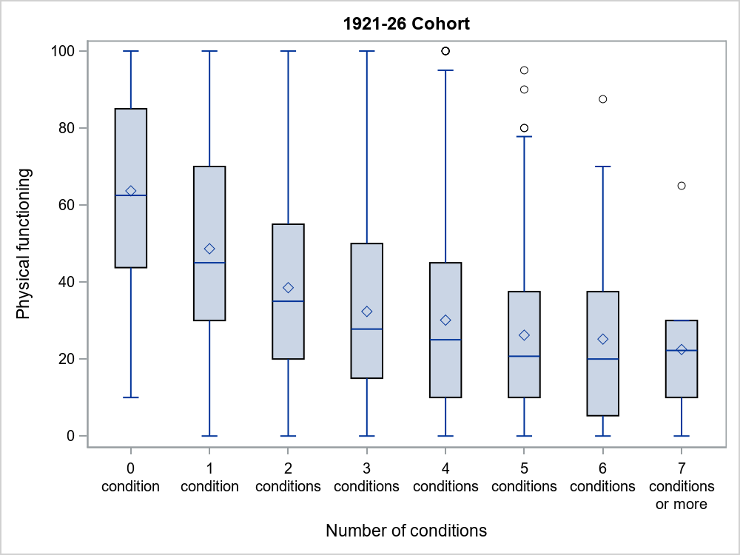

Figure 5‑1 Physical functioning scores and number of groups of conditions considered in the report for women in their 90s (1921-26 cohort in 2015).

*Note*: ◊ shows the mean, ── shows the median, the box is the interquartile range.

The figure shows how physical functioning scores decline sharply, for example for women with 0, 1, 2 or 3 groups of conditions compared women with more conditions. But there is less difference among women with 3 or more groups of conditions. The other notable feature is the range of scores among women with the same number of groups of conditions – some women with 3 conditions score the maximum value of 100, however there are also women with the minimum score of zero.

Figure 5‑2 for the 1946-51 cohort has the same vertical scale as Figure 5‑1 (0 – 100) but the number of groups of conditions ranges from 0 to 5 or more (compared with up to 7 or more). Overall the scores are much higher than for the 1921-26 cohort with many women having the maximum score and few women with 2 or fewer conditions having low scores.

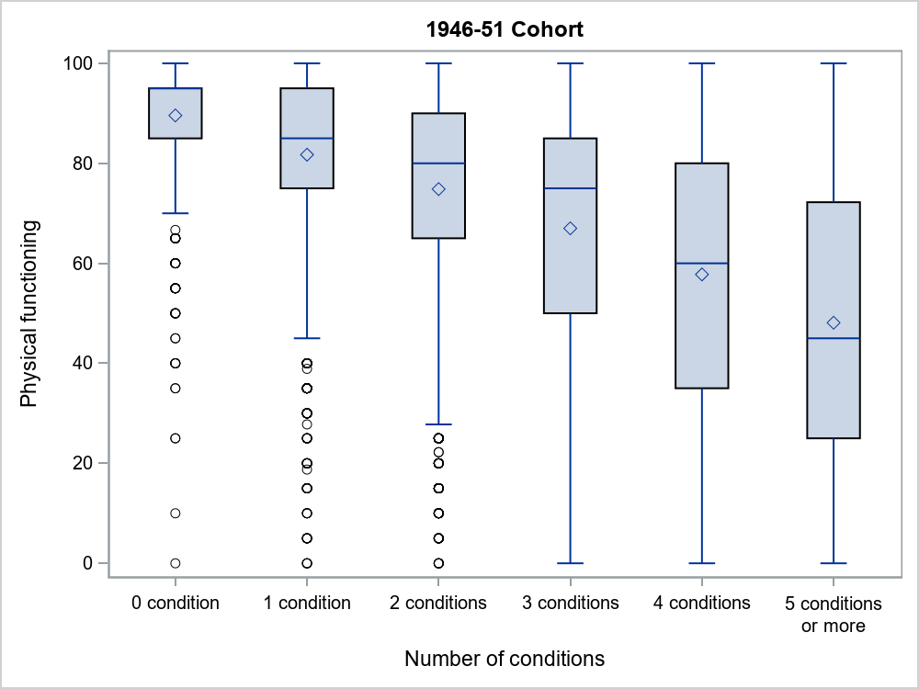

Figure 5‑2 Physical functioning scores and number of groups of conditions considered in the report for women aged 65-70 (1946-51 cohort, Survey 8)

*Note*: ◊ shows the mean, ── shows the median, the box is the interquartile range.

The physical functioning scores for the 1973-78 (Figure 5‑3) and 1989-95 (Figure 5‑4) cohorts show similar patterns to the 1946-51 cohort, but with higher scores overall. Most women had very high scores, i.e. few limitations due to health issues; few women had very low scores; and there was a gradual decline with increasing numbers of chronic conditions.

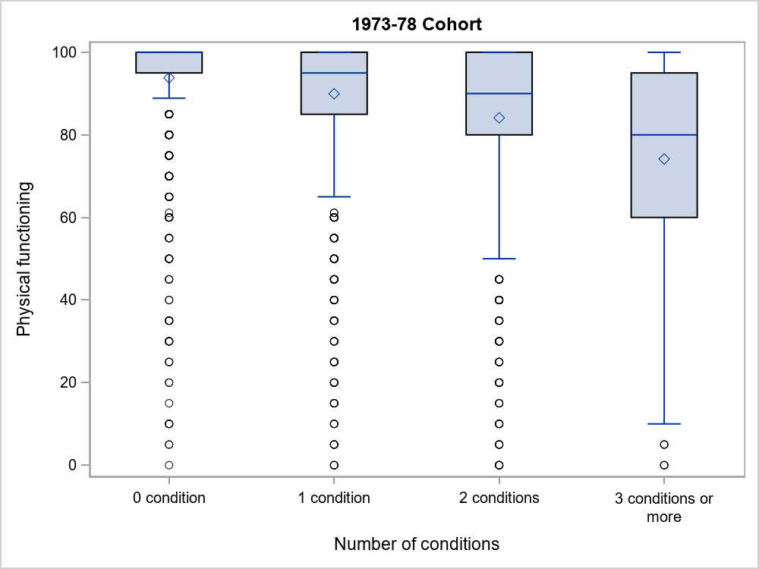

Figure 5‑3 Physical functioning scores and number of groups of conditions considered in the report for women aged 40-45 (1973-78 cohort, Survey 8).

*Note*: ◊ shows the mean, ── shows the median, the box is the interquartile range.

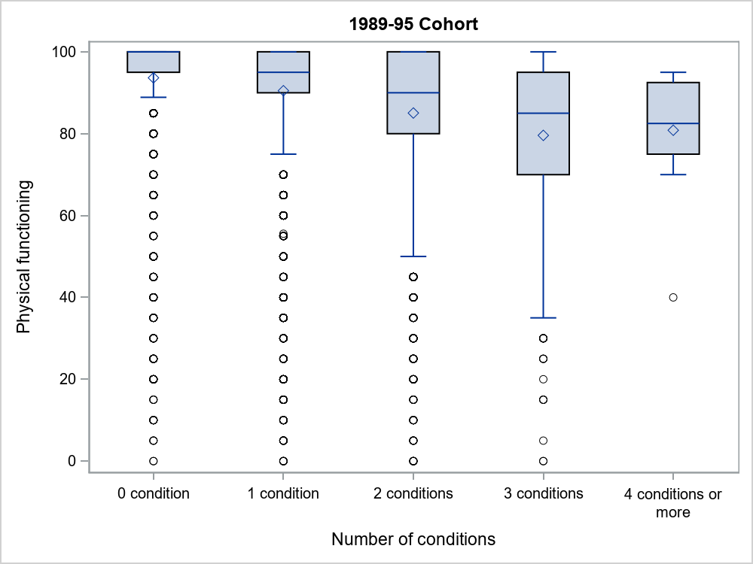

Figure 5‑4 Physical functioning scores at age 21-26 (2016) for the 1989-95 cohort by number of groups of conditions considered in the report.

*Note*: ◊ shows the mean, ── shows the median, the box is the interquartile range

## Mental health

Items for the mental health index cover mood and symptoms of anxiety and depression.

Results for the 1921-26 cohort are shown in Figure 5‑5. Median and mean scores decrease with increasing numbers of conditions (note that the data for the category with 7 or more conditions may be unreliable due to small numbers of women). At least 25% of women (top quartile) have scores above about 85, except for those with 5 or more conditions. However there was a greater range of low scores among women with more conditions.

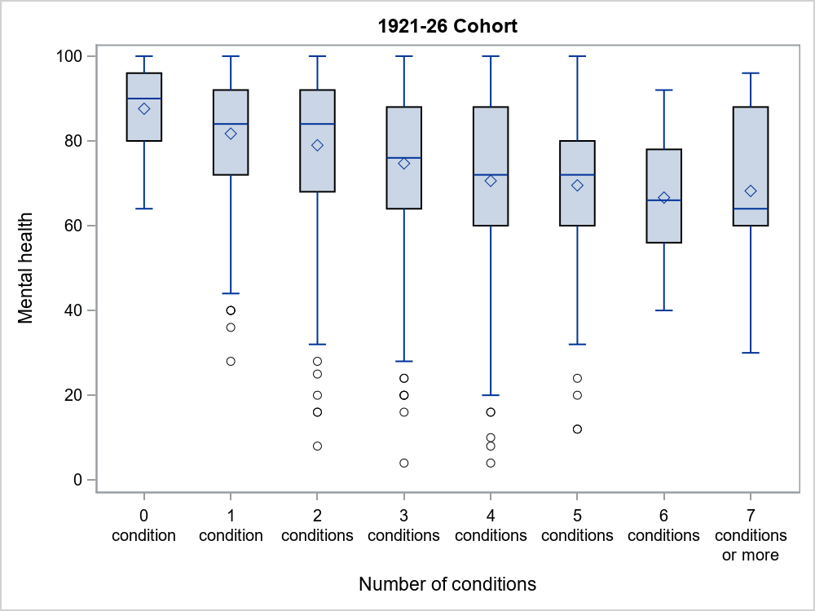

Figure 5‑5 Mental health and number of conditions – 1921-26 cohort.

*Note*: ◊ shows the mean, ── shows the median, the box is the interquartile range.

For the 1946-51 cohort (Figure 5‑6) and 1973-78 cohort (Figure 5‑7) the median and mean scores were similar to those for the 1921-26 cohort (Figure 5‑5) and there similar declines with increasing numbers of chronic conditions.

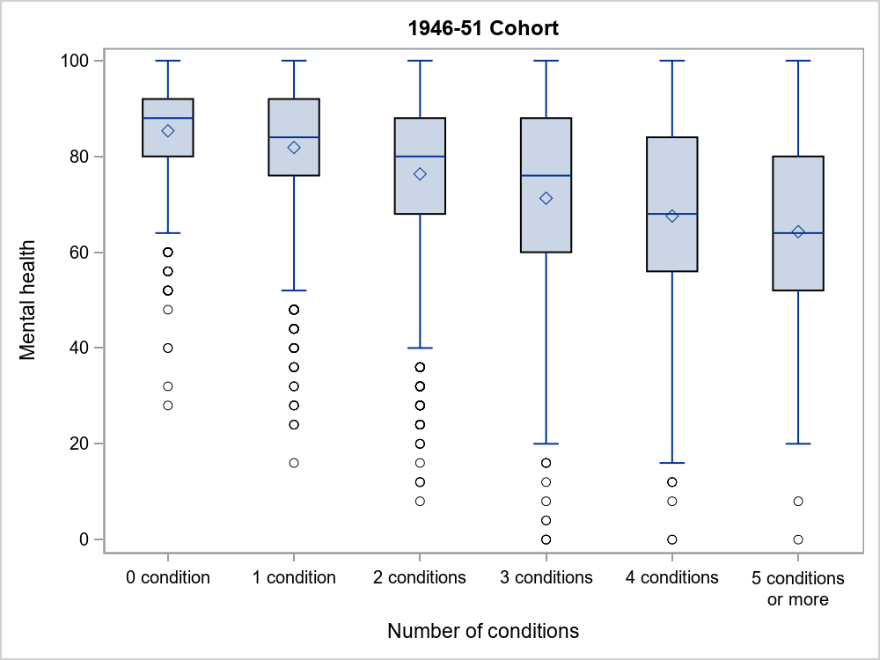

Figure 5‑6 Mental health and number of conditions – 1946-51 cohort.

*Note*: ◊ shows the mean, ── shows the median, the box is the interquartile range.

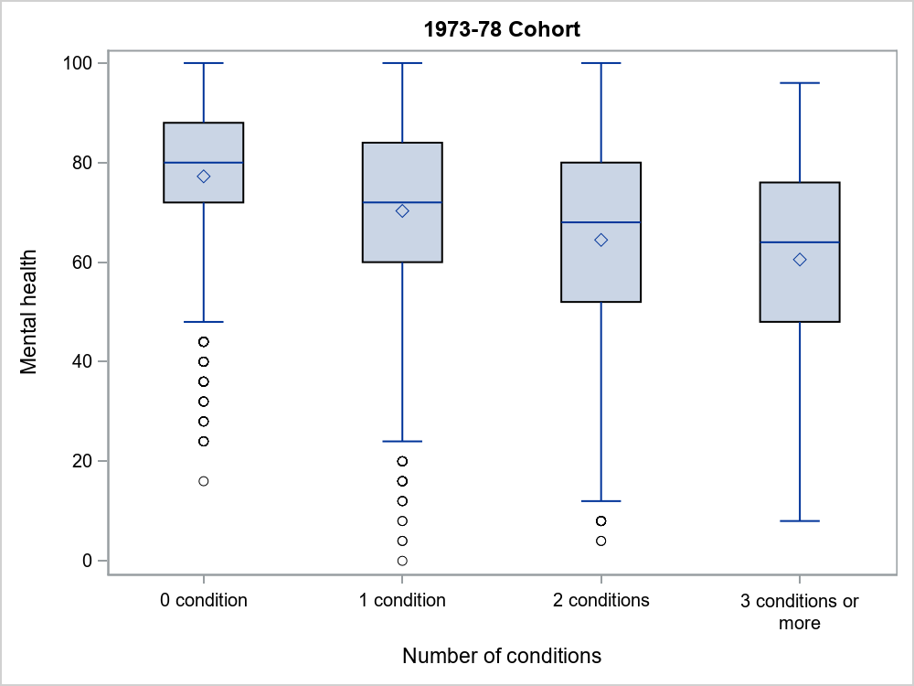

Figure 5‑7 Mental health and number of conditions – 1973-78 cohort.

*Note*: ◊ shows the mean, ── shows the median, the box is the interquartile range.

In contrast to the three older cohorts, women in the 1989-95 cohort, aged 21-26 when they completed the survey that included SF-36 had lower median and mean mental health scores overall. There was a steady decline in mental health scores with increasing number of chronic conditions (though the results for the category with 4 or more conditions may be unreliable due to small numbers of younger women with multiple conditions).

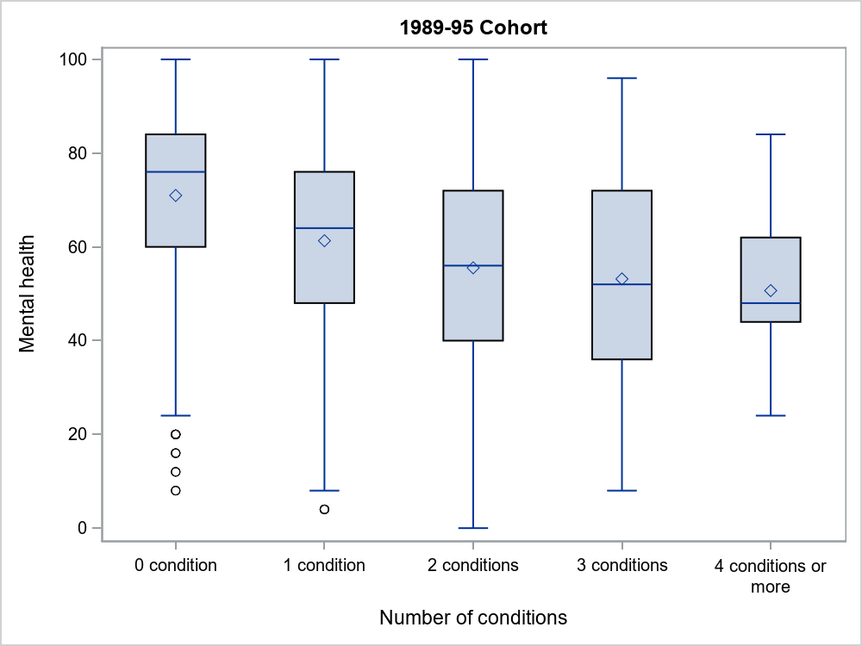

Figure 5‑8 Mental health at age 21-26 (2016) for the 1989-95 cohort by number of conditions.

*Note*: ◊ shows the mean, ── shows the median, the box is the interquartile range.

## Summary

The results in this chapter show the impact of multimorbidity on self-reported measures of physical function and mental health. Physical and mental health related quality of life scores decreased as the number of conditions increased, indicating poorer quality of life for women with complex multimorbidity.

The next chapter shows the association between increasing multimorbidity and use of health and other services.

# Use of health and other services

Associations between multimorbidity and the use of health and community services are examined in this chapter. As in Chapter 5 the focus is on recent use of services and not historical changes. The chapter comprises a series of snap shots comparing use of services at one period in time by groups of women with different levels of multimorbidity. The services included are hospitalisations, annual numbers of visits to general practitioners (GPs), and medical specialists, and numbers of pharmaceutical prescriptions filled. Also, for the 1921-26 cohort use of aged care and community based support services is included. To obtain reasonably stable estimates, especially for smaller groups, service use data were aggregated and averaged over the three year period immediately before the time used to define the number of conditions (or for up to 3 years of data for hospital use, depending on data availability). Due to smaller numbers of younger women with multiple conditions, the maximum number of groups of conditions shown in the figures differs between cohorts: up to 7 or more for the 1921-26 cohort, up to 5 or more for the 1946-51 cohort, up to 3 or more for the 1973-78 cohort, but up to 4 or more for the 1989-95 cohort.

## Hospitalisation

Hospital admissions data from States and Territories were obtained by record linkage for public hospitals and, for some jurisdictions for private hospitals. The figures below show the percentages of women admitted to hospital at least once over three years by numbers of groups of chronic conditions considered in this report. Multiple admissions are counted once only.

Figure 6‑1 for the 1921-26 cohort shows a steady increase in hospitalisation with increasing numbers of chronic conditions from 0 to 4 but a more stable level of around 80% after that.

**Figure 6‑1 Women in the 1921-26 cohort with at least one hospital admission over the three year period from 1 July 2012 to 30 June 2015 (i.e., from when the women were aged 86-91 to when they were aged 89-94), by the number of groups of chronic conditions considered in this report.**

For the 1946-51 cohort (Figure 6‑2), 1973-78 cohort (Figure 6‑3) and 1989-95 cohort (Figure 6‑4) the percentage of women admitted to hospital at least once increased approximately linearly with the number of chronic conditions (although for the younger women hospitalisation associated with childbirth is likely to have inflated the level of admissions).

**Figure 6‑2 Women in the 1946-51 cohort with at least one hospital admission over the three year period from 1 July 2013 to 30 June 2016 (i.e., from when they were aged 62-67 to when they were aged 65-70), by the number of groups of chronic conditions considered in this report.**

**Figure 6‑3 Women in the 1973-78 cohort with at least one hospital admission over the three year period from 1 July 2013 to 30 June 2016 (i.e., from when they were aged 35-40 to when they were aged 38-43), by the number of groups of chronic conditions considered in this report.**

**Figure 6‑4 Women in the 1989-95 cohort with at least one hospital admission over the three year period from 1 July 2013 to 30 June 2016 (i.e., from when they were aged 18-24 to when they were aged 21-27), by the number of groups of chronic conditions considered in this report.**

## General practitioner visits

The GP visits for each woman were identified by record linkage to the Medical Benefits Scheme data base. They cover the broad categories of service A (unreferred attendances – Vocationally Registered GP/GP), B (unreferred attendances – Other) and M (unreferred attendances – Enhanced Primary Care). The number of visits per year were averaged over three years. Figures 6-5 to 6-8 show the results for the four cohorts.

In all cohorts the numbers of GP visits increased with the number of chronic conditions, although the levels varied with the age of the women. For example, for the 1921-26 cohort (Figure 6‑5) the median number of visits increased from just over 6 per year for women with no chronic condition to 17 per year for those with 7 or more conditions.

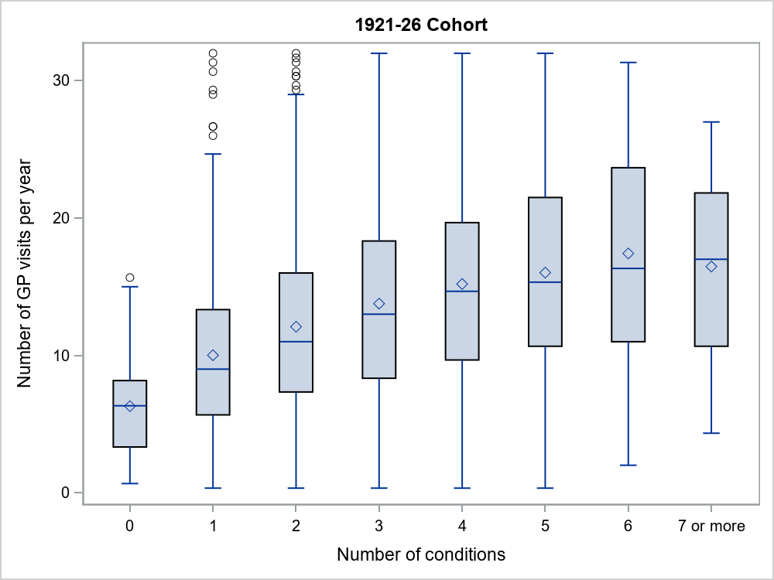

Figure 6‑5 GP visits per year for women in the 1921-26 cohort over the three year period 1st July 2012 to 30th June 2015 (i.e., from when they were aged 86-91 to when they were aged 89-94), by the number of groups of chronic conditions considered in this report.

*Note*: ◊ shows the mean, ── shows the median, the box is the interquartile range.

The corresponding numbers for the 1946-51 cohort (Figure 6‑6) were approximately 4 GP visits per year for women with no chronic conditions to 12 for those with 5 or more chronic conditions.

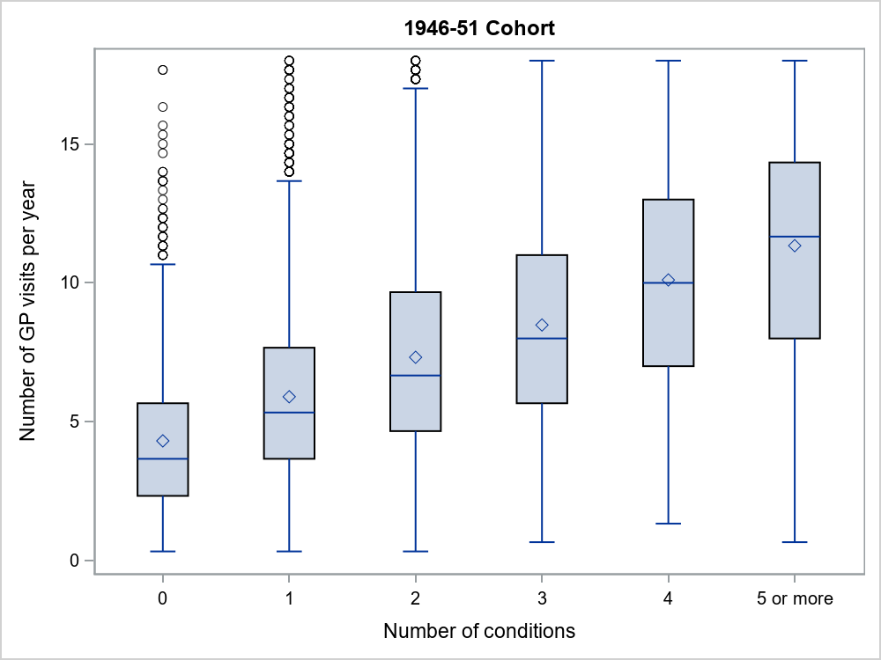

Figure 6‑6 GP visits per year for women in the 1946-51 cohort over the three year period from 1st July 2014 to 30th June 2017 (i.e., from when they were aged 62-67 to when they were aged 65-70), by the number of groups of chronic conditions considered in this report.

*Note*: ◊ shows the mean, ── shows the median, the box is the interquartile range

For the 1973-78 cohort (Figure 6‑7) the median number of GP visits increased from 3 per year for women with no chronic conditions to more than 6 per year for those with 3 or more chronic conditions.

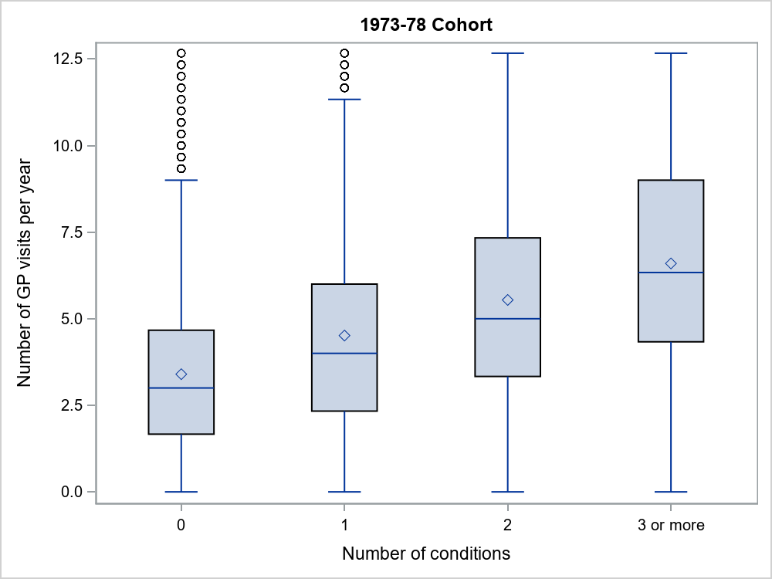

**Figure 6‑7 GP visits per year for women in the 1973-78 cohort over the three year period from 1st July 2013 to 30th June 2016 (i.e., from when they were aged 35-40 to when they were aged 38-43), by the number of chronic conditions.**

*Note*: ◊ shows the mean, ── shows the median, the box is the interquartile range.

For the 1989-95 cohort (Figure 6‑8) the corresponding medians were from 4 for women with no chronic conditions to 8 for those with 3 chronic conditions. For the younger cohorts these numbers may be inflated by visits related to reproductive issues including contraception, pregnancy and childbirth.

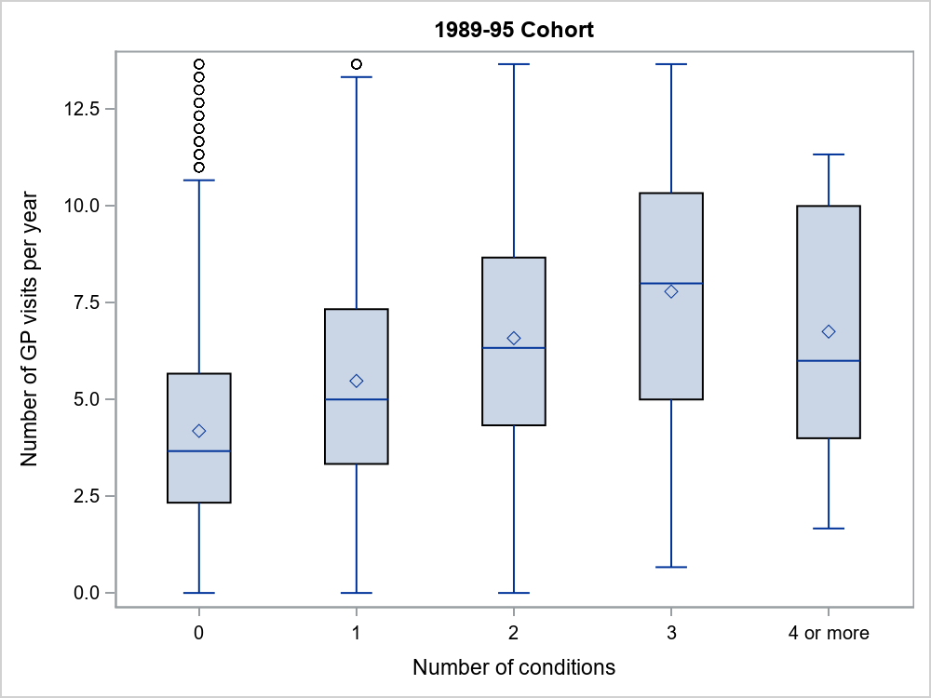

Figure 6‑8 GP visits per year for women in the 1989-95 cohort over the three year period from 1st July 2015 to 30th June 2018 (i.e., from when they were aged 18-24 to when they were aged 21-27), by the number of groups of chronic conditions considered in this report.

*Note*: ◊ shows the mean, ── shows the median, the box is the interquartile range.

## Visits to medical specialists

The numbers of specialist visits were obtained by record linkage with the Medical Benefit Scheme data base. The number of visits per year were averaged over three years for each woman. While many women in all cohorts did not have any specialist visits, some had large numbers of visits (especially among those in the 1921-26 cohort) so the distributions are highly skewed making medians better measures of ‘average’ numbers than means.

The patterns for specialist visits were similar to those for GP visits. In all cohorts the numbers increased with the number of chronic conditions, although the medians were generally low. For example, for the 1921-26 cohort (Figure 6‑9) and 1946-51 cohort (Figure 6‑10) the medians ranged from just over 1 visit per year for women with no chronic condition to between 3 or 4 visits per year for those with 5 or more conditions. The range in the numbers of visits is also of interest with a large spread across the upper quartile and higher maximum scores for multimorbidity across two or more groups of chronic conditions.

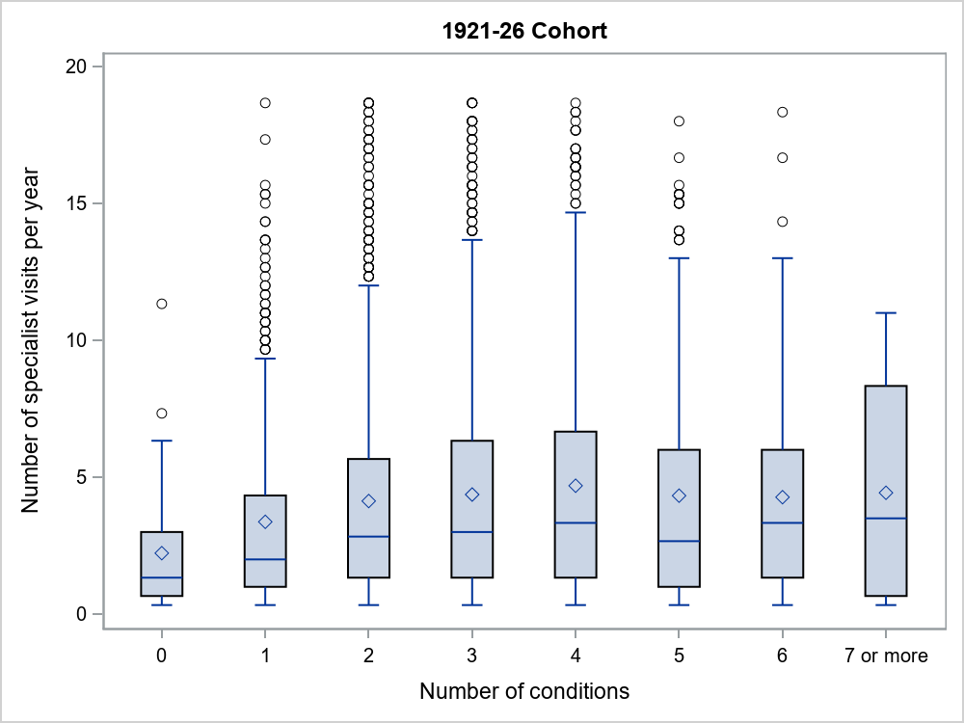

Figure 6‑9 Specialist visits per year for women in the 1921-26 cohort over the three year period 1st July 2012 to 30th June 2015 (i.e., from when they were aged 86-91 to when they were aged 89-94), by the number of groups of chronic conditions considered in this report.

*Note*: ◊ shows the mean, ── shows the median, the box is the interquartile range.

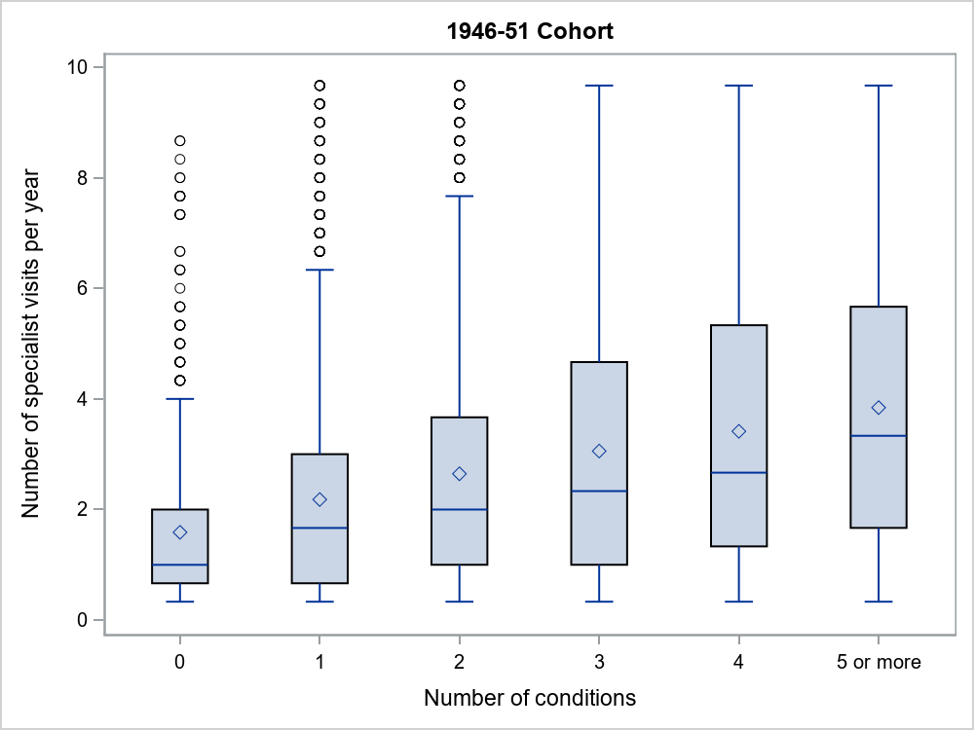

Figure 6‑10 Specialist visits per year for women in the 1946-51 cohort over the three year period from 1st July 2014 to 30th June 2017 (i.e., from when they were aged 62-67 to when they were aged 65-70), by the number of groups of chronic conditions considered in this report.

*Note*: ◊ shows the mean, ── shows the median, the box is the interquartile range.

For the 1973-78 cohort (Figure 6‑11) and 1989-95 cohort (Figure 6‑12) the median number of specialist visits was 0 per year for women with no chronic conditions and increasing for those with more chronic conditions.

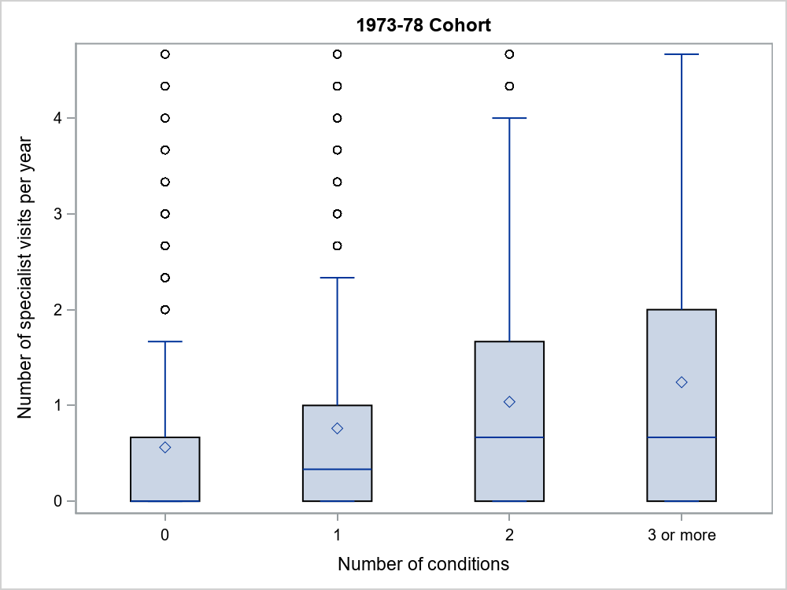

Figure 6‑11 Specialist visits per year for women in the 1973-78 cohort over the three year period from 1st July 2013 to 30th June 2016 (i.e., from when they were aged 35-40 to when they were aged 38-43), by the number of groups of chronic conditions considered in this report.

*Note*: ◊ shows the mean, ── shows the median, the box is the interquartile range.

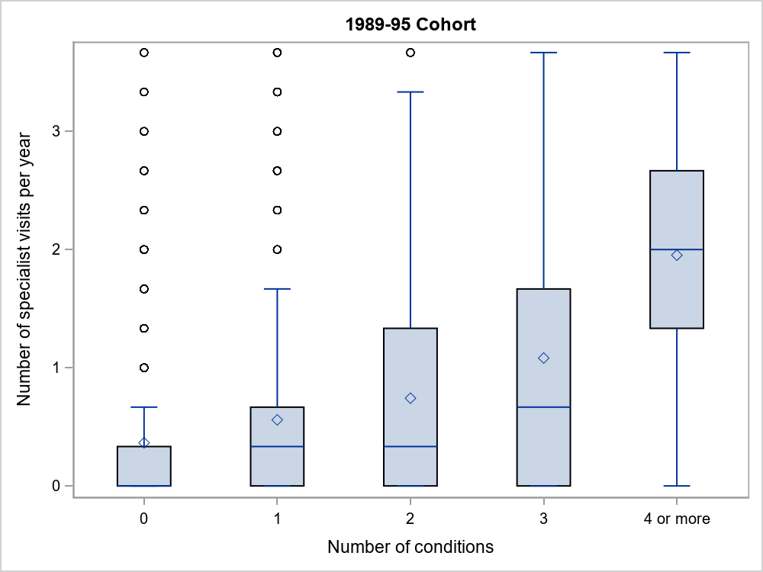

Figure 6‑12 Specialist visits per year for women in the 1989-95 cohort over the three year period from 1st July 2015 to 30th June 2018 (i.e., from when they were aged 18-24 to when they were aged 21-27), by the number of groups of chronic conditions considered in this report.

*Note*: ◊ shows the mean, ── shows the median, the box is the interquartile range.

## Pharmaceutical prescriptions filled

Data on the number of pharmaceutical prescriptions filled were obtained by record linkage to the Pharmaceutical Benefits System. The numbers of prescriptions filled include repeated prescriptions for the same medication. The average number per year for the four cohorts are shown in Figure 6-13 to Figure 6-16.

For all cohorts the medians and means increased approximately linearly with the number of chronic conditions, except possibly for the highest categories where the estimates may be unstable due to small numbers. For the 1921-26 cohort (Figure 6‑13) the median number of prescriptions increased from 22 filled per year for women with none of the chronic conditions considered in this report to 70 or more for women with 4 or more conditions.

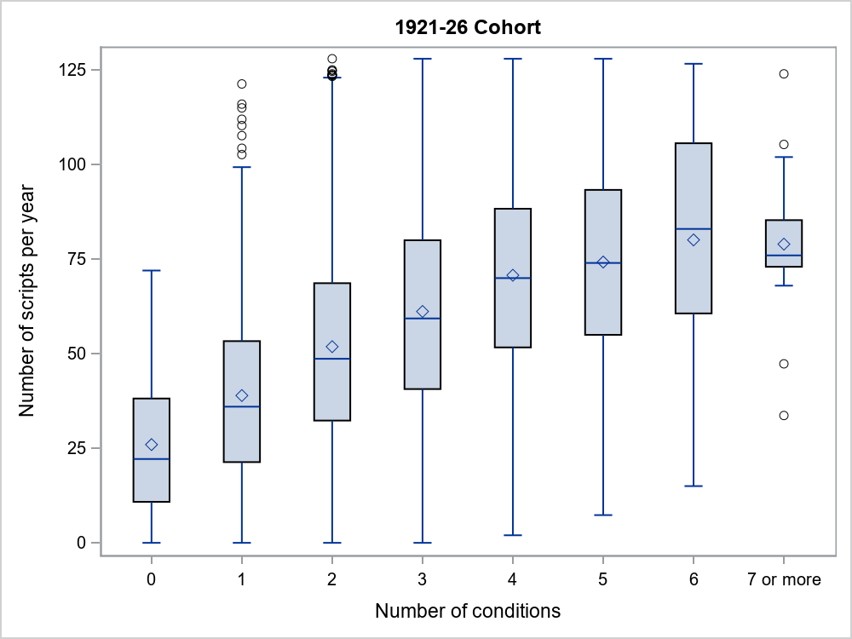

Figure 6‑13 Pharmaceutical prescriptions filled per year for women in the 1921-26 cohort over the three year period 1st July 2012 to 30th June 2015 (i.e., from when they were aged 86-91 to when they were aged 89-94), by the number of groups of chronic conditions considered in this report.

*Note*: ◊ shows the mean, ── shows the median, the box is the interquartile range.

The corresponding numbers for the 1946-51 cohort (Figure 6‑14) were from 6 to 50 scripts per year.

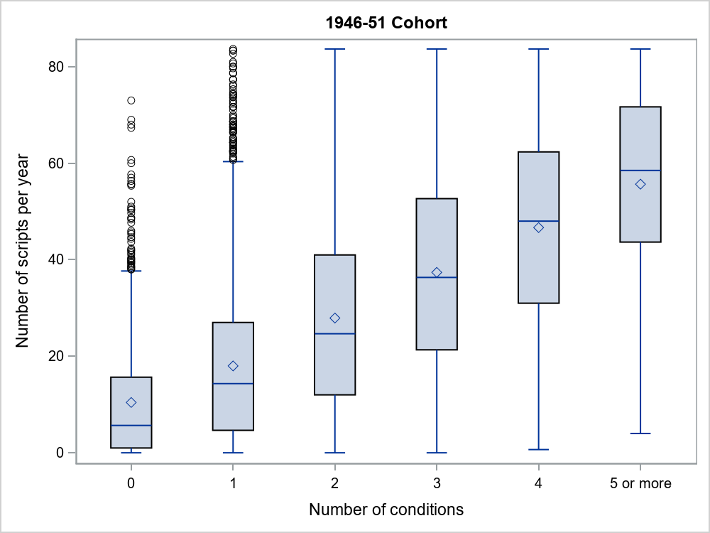

Figure 6‑14 Pharmaceutical prescriptions filled per year for women in the 1946-51 cohort over the three year period from 1st July 2014 to 30th June 2017 (i.e., from when they were aged 62-67 to when they were aged 65-70), by the number of groups of chronic conditions considered in this report.

*Note*: ◊ shows the mean, ── shows the median, the box is the interquartile range.

For the 1973-78 cohort (Figure 6‑15) the median numbers of prescriptions filled per year were much less, ranging from 2 for women with no chronic conditions to 11 for those with 3 or more conditions. The median annual numbers for the 1989-95 cohort (Figure 6‑16) were similar ranging from 2 for women with none of these conditions to 12 for those with conditions across 4 or more of the groups of chronic conditions.

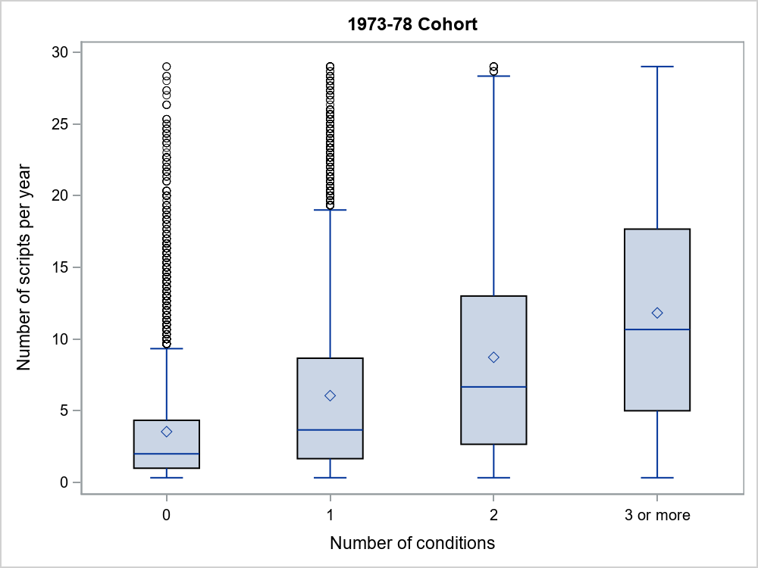

Figure 6‑15 Pharmaceutical prescriptions filled per year for women in the 1973-78 cohort over the three year period from 1st July 2013 to 30th June 2016 (i.e., from when they were aged 35-40 to when they were aged 38-43), by the number of groups of chronic conditions considered in this report.

*Note*: ◊ shows the mean, ── shows the median, the box is the interquartile range.

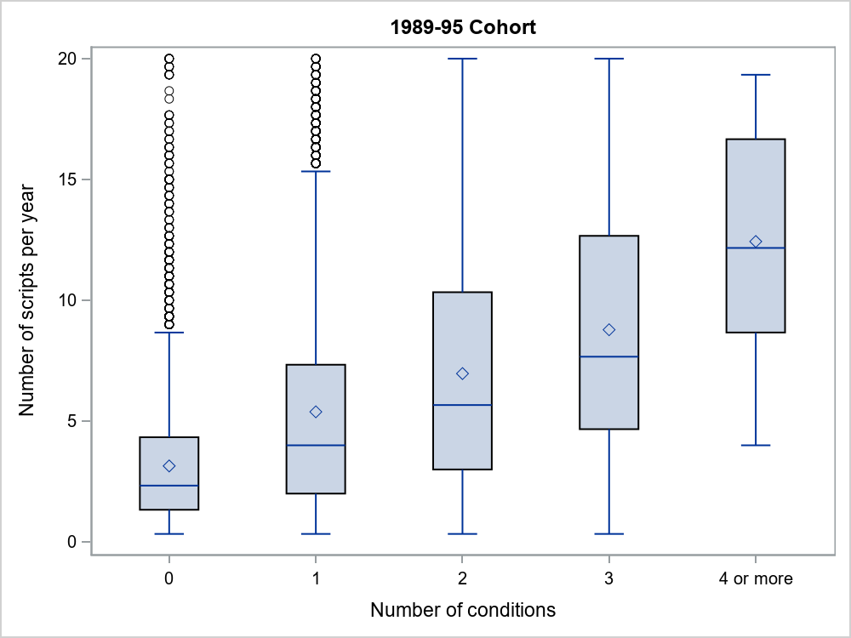

Figure 6‑16 Pharmaceutical prescriptions filled per year for women in the 1989-95 cohort over the three year period from 1st July 2015 to 30th June 2018 (i.e., from when they were aged 18-24 to when they were aged 21-27), by the number of groups of chronic conditions considered in this report.

*Note*: ◊ shows the mean, ── shows the median, the box is the interquartile range.

## Aged care and community support services

For older women, multimorbidity can lead to increased use of aged care and community support services. In this section data are presented for the most common services used by women in the 1921-26 cohort. These are admission to a permanent residential aged care facility and use of Health and Community Care (HACC) services for nursing and other allied health care, and ‘other’ services (including homemaking, maintenance, meals and transport). These data were obtained by record linkage. They refer to the three year period 1 July 2012 to 30 June 2015 as access to aged care data has not been available from the Australian Institute of Health and Welfare since then. Consequently, the data do not include the greater range of community-based services now offered.

Figure 6‑17 shows higher percentages of women using permanent residential aged care with increasing multimorbidity (except for the group with 7 or more which may have been affected by small numbers). In contrast, use of HACC nursing and allied health services (Figure 6‑18) and HACC ‘other’ services (Figure 6‑19) increased with the number of chronic conditions from 0 to 2 or 3 and then appeared to decline or stabilise. This may be a consequence of changes in services available as well as for women with multiple chronic conditions moving into permanent residential care so they no longer used community-based services.

Figure 6‑17 Women in the 1921-26 cohort using permanent residential age care over the three year period from 1 July 2012 to 30 June 2015 (i.e., from when they were aged 86-91 to when they were aged 89-94), by the number of groups of chronic conditions considered in this report.

Figure 6‑18 Women in the 1921-26 cohort using Home and Community Care nursing and allied health services over the three year period from 1 July 2012 to 30 June 2015 (i.e., from when they were aged 86-91 to when they were aged 89-94), by the number of groups of chronic conditions considered in this report.

Figure 6‑19 Women in the 1921-26 cohort using Home and Community Care ‘other’ services over the three year period from 1 July 2012 to 30 June 2015 (i.e., from when they were aged 86-91 to when they were aged 89-94), by the number of groups of chronic conditions considered in this report.

## Summary

This chapter documents the extent to which use of health and aged care services is related to multimorbidity. For almost all of the services considered, use increased with the prevalence of multiple chronic conditions and also increased across the cohorts with increasing age.

# *I am as well as I can be,* managing multiple conditions across the lifespan.

## Introduction

The quantitative data in this report shed light on the impact of multimorbidity on women’s overall quality of life and health service use. The qualitative analysis provided in this section brings the voices of Australian women to the fore. The information highlights the complex experiences of women living with multimorbidity, which need to be understood in order to design and deliver effective, efficient services.

## Aim

This section aims to demonstrate the importance of understanding the management of multimorbid conditions at the individual level for women interacting with the Australian health system. Specifically, the analysis will focus on exploring women’s experiences with multimorbidity in relation to disease management and health service use.

## Methods

At the end of every survey, ALSWH participants are provided with the opportunity to give feedback in their own words about their lives, particularly in relation to their health and wellbeing. Specifically, participants from all four cohorts are asked the question, “Have we missed anything? If you have anything you would like to tell us, please write on the lines (type in the box) below”. Qualitatively assessing the free-text comments to this question helps to highlight the lived experiences of women, offering more context around how their health actually impacts their lives. As the focus of this report is on multimorbidity, the analysis included those comments written by women living with multimorbidity.

### Sampling frame

Identification of relevant comments employed a similar method to that used for the 2018 ALSWH Major Report and associated publication (Coombe et al. 2019; Tooth et al. 2018). Based on the eight groups of conditions defined in previous sections of this report, only participants with multimorbidity, defined as two conditions or more from the groups of conditions, were included in the sampling frame for this qualitative analysis. Available data from the most recent full survey (i.e. index survey) of each of the four cohorts was used to identify participants who were living with multimorbidity and who provided a free-text comment at the end of the index survey. Within each cohort, the multimorbidity status for each participant was determined one year after the index survey was launched, using all available survey and linked administrative data sources. The latest survey was chosen as the index survey to provide the highest prevalence (i.e. cumulative incidence) of multimorbidity within the cohort. For the 1921-26 cohort the index survey was in 2011; after then an abbreviated version of the survey was adopted and conducted every 6 months. The index survey and the time point for determining multimorbidity status for each cohort is provided in Table 7‑1.

Table 7‑1 Index surveys used to identify pertinent free-text comments provided by women from all ALSWH cohorts living with multimorbidity.

|  |  |  |  |  |
| --- | --- | --- | --- | --- |
| **Cohort** | **Index survey** | **Index survey year** | **Age at survey (years)** | **Time point for determination of multimorbidity status** |
| 1989-95 | 5 | 2017 | 22-27 | 01 July 2018 |
| 1973-78 | 7 | 2015 | 37-42 | 01 July 2016 |
| 1946-51 | 8 | 2016 | 65-70 | 01 July 2017 |
| 1921-26 | 6 | 2011 | 85-90 | 01 July 2012 |

Of the women responding to the index survey, 4,368 provided free-text comments that were retrieved. There were 202 comments from 2,104 women from the 1989-95 cohort, 412 comments from 1,837 women from the 1973-78 cohort, 2,041 comments from the 4,586 women from the 1946-51 cohort, and 1,713 comments from the 3,131 women from the 1921-26 cohort. The free-text comments from the 4,368 women from all four cohorts who were living with multimorbidity and provided a comment at the index surveys were reviewed for relevance. Comments were considered relevant if they had mentioned managing a health condition or interacting with the health system.

A total of 1,105 participants had provided comments from the index surveys that were deemed relevant. The free-text comments from all additional surveys for each of these participants were gathered to create a longitudinal qualitative dataset. Data from an additional 47 participants were excluded upon re-checking the free-text comments for relevance, resulting in relevant free text data from 1,058 participants.

A total of 159 women provided a purely factual comment about an interaction with health services (e.g. “I had radiation and treatment for cancer”). These comments were not included in the thematic analysis, as they would not contribute to an in-depth understanding of women’s experiences with multimorbidity, disease management and interactions with health services. Therefore, the comments from 899 participants were eligible for the qualitative thematic analysis, including comments from: 12 women from the 1989-95 cohort, 48 women from the 1973-78 cohort, 435 women from the 1946-51 cohort and 404 women from the 1921-26 cohort. Figure 7‑1 contains a flowchart of the participant inclusion process.

Figure 7‑1 Flowchart of participant inclusion.

|  |  |  |  |  |
| --- | --- | --- | --- | --- |
|  | **1989-95 Cohort** | **1973-78 Cohort** | **1946-51 Cohort** | **1921-26 Cohort** |
| Longitudinal comments collated and additional screening for relevance | 2104 participants with multimorbidity responded at index survey  21 participants with relevant comments | 80 participants with relevant comments  88 participants with relevant comment | 517 participants with relevant comments  4586 participants with multimorbidity responded at index survey | Initial review to identify relevance to research question  Surface level health service use comments removed  17,010 cohort participants  3625 participants with multimorbidity by 01 July 2018  202 participants with a free-text comment  22 participants with relevant comment  12 participants with included comments  14,247 cohort participants  3116 participants with multimorbidity by 01 July 2016  1837 participants with multimorbidity responded at index survey  412 participants with a free-text comment  48 participants with included comments  13,714 cohort participants  7351 participants with multimorbidity by 01 July 2017  2041 participants with a free-text comment  545 participants with relevant comment  435 participants with included comments  12,432 cohort participants  10044 participants with multimorbidity by 01 July 2012  Two: XXXXX  Three: XXXXX  Four or more: XXXXX  1713 participants with a free-text comment  450 participants with relevant comment  404 participants with included comments  440 participants with relevant comments  3131 participants with multimorbidity responded at index survey |

### Analysis

Free-text comments from multiple random samples from the 899 eligible participants were thematically analysed until no new information, or themes, were identified. (Guest, Bunce & Johnson 2006). For this analysis, the free-text comments were thematically analysed according to the process described by Braun and Clarke (2006). The six-step process includes: familiarising oneself with the data, generating initial codes, searching for themes, reviewing the themes, defining and naming the themes, and writing up the report.

To initiate the coding process, two coders reviewed comments from a stratified random sample of 40 participants, with 10 participants from each of the four cohorts. After familiarising themselves with the data, the first coder created an initial codebook which was discussed and agreed upon through consensus with the second coder. Both coders then used QSR International's NVivo 12 qualitative data analysis software to individually analyse the comments from the first 40 participants. The two coders compared their codes. During this comparison, discrepancies were resolved, new codes were agreed upon and potential themes apparent in the data were discussed. The codebook was refined and updated with more detail defining each code.

With the refined codebook, the first coder went on to analyse the next stratified random sample of data from 40 participants (i.e. data from the remaining 2 participants from the 1989-95 cohort, 12 from the 1973-78 cohort, 13 from the 1945-51 cohort, and 13 from the 1921-26 cohorts). The second coder went on to code a further random sample of data from 30 participants (i.e. data from 10 participants from both each of the 1973-78, 1946-51 and 1921-26 cohorts). Two final random samples of data from 30 participants each were drawn to confirm the codebook. The low number of women with multimorbid conditions in the younger two cohorts coupled with a lower number of eligible free text comments meant all available data were analysed. It is possible that additional themes may have been identified if the 1973-78 and 1989-95 cohorts had a larger number of relevant comments available. Nevertheless, the data did reveal some useful insights that contributed to answering the research questions.

A 10% random sample of the final sample of data from 170 participants (12 from the 1989-95 cohort, 48 from the 1973-78 cohort, 55 from the 1946-51 cohort and 55 from the 1921-26 cohort) was analysed by a third coder, who reported no new information arising outside of those included in the existing codebook. All three coders then met to review, define and name the themes before writing up the report.

Descriptive statistics were calculated to report the demographics and health-related characteristics of the participants included in the final sample (n=170) of the thematic analysis.

## Results

Table 7‑2 contains the characteristics of the 170 women whose comments were included in the thematic analysis for this chapter.

Table 7‑2 Characteristics of the 170 ALSWH participants included in the thematic analysis.

|  |  |  |  |  |  |
| --- | --- | --- | --- | --- | --- |
| **Characteristics** | **1989-95 Cohort**  **(n=12)** | **1973-78 Cohort**  **(n=48)** | **1946-51 Cohort**  **(n=55)** | **1921-26 Cohort**  **(n=55)** | **Total**  **N=170** |
| Year of index survey | 2017 | 2015 | 2016 | 2011 |  |
| Age (years) at index survey | 22-27 | 37-42 | 65-70 | 85-90 |  |
|  | n (%) | n (%) | n (%) | n (%) | n (%) |
| Area of residence |  |  |  |  |  |
| Major city | 9 (82) | 22 (47) | 19 (36) | 32 (58) | 82 (49.4) |
| Regional | 1 (9) | 24 (51) | 34 (64) | 20 (36) | 79 (47.6) |
| Remote | 1 (9) | 1 (2) | 0 (0) | 3 (5) | 5 (3.0) |
| Number of comorbidities |  |  |  |  |  |
| Two | 9 (75) | 34 (71) | 29 (53) | 16 (29) | 88 (51.8) |
| Three | 3 (25) | 13 (27) | 19 (35) | 27 (49) | 62 (36.5) |
| Four or more | 0 (0) | 1 (2) | 7 (13) | 12 (22) | 20 (11.8) |
| Self-rated general health |  |  |  |  |  |
| Excellent | 0 (0) | 9 (19) | 6 (11) | 1 (2) | 16 (9.5) |
| Very good | 0 (0) | 8 (17) | 10 (18) | 7 (13) | 25 (14.8) |
| Good | 3 (25) | 14 (29) | 17 (31) | 25 (46) | 59 (34.9) |
| Fair | 4 (33) | 9 (19) | 19 (35) | 18 (33) | 50 (29.6) |
| Poor | 5 (42) | 8 (17) | 3 (5) | 3 (6) | 19 (11.2) |

When exploring the experiences of women with multimorbidity in relation to disease management and health service use, three main themes were identified in the data:

* Experiences of the health system
* Personal impacts of disease management
* Additional support, or lack thereof, in disease management.

It is important to note that although these themes are described as individual entities, they are intricately intertwined in varying ways to form each woman’s unique experience.

### Experiences of the health system

One of the most prominent themes that was drawn from the free-text comments was women’s experiences of the health system. This theme captured women’s interactions with the health system, their attitudes towards the system, and their adherence to recommendations made by health service providers for managing the diseases with which they live.

#### Interactions with health services

A multitude of comments focussed on women’s interactions with health services, highlighting both positive and negative experiences women had with general practitioners, medical specialists, hospitals, and allied or alternative health care providers. Starting with women’s positive experiences, women commented on what they valued from their health service interaction. An appreciation for good rapport with health care providers was often highlighted. For example, women mentioned:

“*I am now going to a third doctor who is fantastic and receiving excellent care from her and regular psychologist visits (also excellent!).”* (1973-78 cohort participant)

“*I have a good GP who helps me through the bad times*” (1946-51 cohort participant)

Additionally, the importance of health care providers’ continuity of care in managing the women’s conditions was stressed. Continuity of care was considered a benefit to managing chronic conditions, as it was focussed on a long-term, person-centred approach rather than a one-off, short-term solution. As women explained:

“*Life has dramatically changed for the better with the help of an exceptional team of physiotherapists who've helped me firstly in the post-op period and now through an extensive physio supervised Pilates program and home exercises. I have greatly reduced the pain and stiffness from osteo-arthritis of the spine and many joints and am now able to take part in activities I never thought possible again*” (1946-51 cohort participant)

“*I was diagnosed with bowel cancer and had a bowel resection, followed by six months of chemotherapy. Since that time I have had check-ups at regular intervals as advised by the surgeon…I have been grateful and amazed at the scrupulous care the surgeon gives to my health. At no time have I felt 'on the scrap heap' because of my age.*” (1921-26 cohort participant)

Interactions with health care providers that were perceived as having expert knowledge or extensive experience were also reflected upon as being advantageous. This was particularly true when those interactions led to resolving previously unanswered questions or to mitigating the negative impacts of the condition. Expertise came from medical, allied or alternative health care providers. For example:

“*Approx 3 years ago I changed to a different GP. As a result of her testing it has been revealed that I have a genetic blood condition which makes me at high risk of stroke and heart attack…* *This condition was probably a contributing factor to the angina TIA's I experienced previously.”* (1946-51 cohort participant)

Ease of access to health services was mentioned by a few participants. Accessibility of a service was seen in a good light if the service was located close by. This was reflected by women in the 1921-26 cohort:

“*We have a very good medical service here with two hospitals and several specialists in the area.”* (1921-26 cohort participant)

*“I live in a small shopping centre that has mostly what I need and doctor around the corner.”*  (1921-26 cohort participant)

Unfortunately, women reported many more negative experiences than positive ones in their interactions with health services. Several women wrote about the potentially avoidable, negative impacts of treatment, such as infection, clinical error, or temporary or permanent disability:

*“I am on a disability pension due to my illnesses. I have a live-in carer and have had since an incident in hospital sent me into anaphylaxis and had me unconscious and receiving constant opiates - I cannot take these in any form as they aggravate a previously stable condition which leads to pancreatitis. I have subsequently gone drastically downhill. My endometriosis spread from being a small cyst on one ovary (and having stayed that way for years) to being 3 5cm cysts and spread all through my abdomen right up to my diaphragm. This required removal and the PTSD from the hospital situation made this agonisingly traumatic in itself*.” (1989-95 cohort participant)

*“I received an operation to correct the prolapse. I had a lot of complications following the operation which cause me to return to hospital 3 times.” (1973-78 cohort participant)*”

“*Have recently found out that my family doctor has not been adequately monitoring my thyroid levels - I may be hyperthyroid (sic) from too much medication.*” (1946-51 cohort participant)

Not surprisingly, certain attributes of health care providers were perceived more negatively, such as poor communication, lack of rapport or insufficient knowledge. Some women described their experiences of not being respected as an autonomous, participating individual in managing their own health, for example:

“*Regarding doctors (GPs) I have given up. I have never [been] one to visit a doctor regularly but the last few times I have been horrified at the service. One doctor did not look at me but typed on his computer as I explained my symptoms, another prescribed antibiotics for symptoms I did not have. When I explained to another that I have been feeling suicidal she suggested I stop drinking coffee. I don't drink coffee.”* (1973-78 cohort participant)

“*I was diagnosed as being severely thyrotoxic. This was the result of hyperthyroidism being undiagnosed by my then GP, a number of specialists including a consultant physician in [first town] and a specialist in [second town]. These doctors, all of whom were male, clearly thought I was a neurotic woman, who apparently invented symptoms for the drama of visiting doctors.”* (1946-51 cohort participant)

Multiple women also expressed dissatisfaction where their health needs were not met. One of the unmet needs that some women described was a lack of answers regarding their diagnosis or prognosis despite multiple investigations by health care providers, such as:

“*Constant pain in neck and shoulder, had x-rays and physio, massage and acupuncture and anti-inflammatory tablets, it makes me feel fed up and limits my daily exercise. I wish I could find some help!”* (1946-51 cohort participant)”

Additional unmet needs of women included needing a treatment, such as surgery, but not being able to have it due to potential complications from age or other chronic conditions (e.g. heart disease). For example, one woman stated, “*I need 2 stents above and 1 below my heart, but too much radiation makes this impossible.”* (1921-26 cohort participant). A few women also were left unfulfilled by the limit on the number of follow-ups with particular health services or the types of services that were not available to them at low or no cost, such as:

“*Needing more government assist osteopath physiology. Is there any more than the five allotments for me?”* (1921-26 cohort participant)

“*I went onto a new treatment called Forteo*… is not on the pharmaceutical benefits, so if you cant (sic) pay, too bad.”* (1921-26 cohort participant, *2008 survey – one year prior to Forteo being added to the PBS)

Limited accessibility was also mentioned as a negative aspect of health system interactions. Getting an appointment, seeing their preferred doctor, or extent of travel needed to obtain the service were all reported as barriers:

*“It took close to 1 year to see a specialist as I was on a waiting list through the hospital then 3 months more until I received an operation to correct the prolapse.”* (1973-78 cohort participant)

*“My nearest health centre is 83km away. Alternatively the visits 6 weekly by the F.D.S. who occasionally supply a specialist.” (1921-26 cohort participant)*

#### Attitudes towards the health system

Women expressed particular attitudes they had towards the Australian health system, including health policies and entitlements. A few women highlighted the benefits of certain government health entitlements, particularly those from the Department of Veterans Affairs as mentioned by women in the 1921-26 cohort:

“*For anything medical receive help and housework am helped by D.V.A*.” (1921-26 cohort participant)

“*I am on a white card which means the Dept of Veterans Affairs look after my specific illness. I am therefore able to have someone come in once a fortnight for 1 1/2 hrs for a token payment by me of $10 a month*.” (1921-26 cohort participant)

“*I have seen many doctors and specialists for D.V.A. regarding a gold card.”* (1921-26 cohort participant)

Some women wrote about the benefits of having private health insurance, believing they were able to access better or more timely care than they would without private health insurance. There was also a shared frustration among some women regarding the divide and perceived inequities between the public and private health sectors, as well as the financial costs of private health insurance and the Medicare levy surcharge. Some women believed that certain health services were only available to those who could afford to pay for them.

“*My GP is also a naturopath…she is excellent and I can access her but I only see her when I have booked 3 months in advance. I also get great 'bedside manner' but pay $120 per visit plus supplements. I am entitled to norm rebate only via Medicare and can't claim on private health as naturopath as she is a GP.*” (1973-78 cohort)

“*I hate having health insurance as it’s a waste of money but the government has made it unavoidable, unfortunately.”* (1973-78 cohort participant)

“*I work bloody hard and choose to have health insurance but soon my rebate is lower as I earn more.*” (1973-78 cohort)

“*Both my husband and myself have been in private health insurance since the age of 16 (34 and 32 years respectively) up until six months ago when we could no longer afford to pay the $1800 a year required for fees. I feel the government needs to look at this and abolish the Medicare levy for those willing to pay for private health care or similarly the private health funds reduce their fees or have some incentive for people who have not made a claim for say three or four years.”* (1946-51 cohort participant)

“*I am a 70 year old widow, ever since private health insurance came into being my family belonged to [named] Health fund, but as now I am an old age person had to give it up as on pension I found it too expensive to keep up so now have to wait if needing operation. I think this very worrying and after having been in scheme for so long I find it a little hard.*” (1921-26 cohort participant)

#### Adherence to disease management

Women often mentioned how they managed their chronic conditions within the health system. There were many types of adherence that women described, such as adhering to medical appointments and treatments provided at a health service:

Women also wrote about managing disease by adhering to the prescribed treatment from broader allied and alternative health services:

*“I have seen a mental health professional in the past 12 months to assist me in working through psychological issues I have experienced and improve my resilience to cope with these situations.*” (1989-95 cohort participant)

*“I'm currently on treatment for endometriosis under a Naturopath, and it is very effective.”*” (1973-78 cohort participant)

“*I was referred to an exercise physiologist. I have been attending twice a week since beginning of year & can notice an improvement.”* (1921-26 cohort participant)

Medications and at home-treatments, such as oxygen or walking aids, were also covered:

“*Osteoporosis... After one year on Fosomax medication this has returned to normal bone density range. Continuing to take Fosomax weekly.”* *(1946-51 cohort participant)*

“*In the last 6 months I have definitely slowed down, the old legs need the compression stockings (yuk!) and I get very short of breath when walking. I use a puffer.”* (1921-26 cohort participant)

However, for some women, a reluctance to adhere to recommended disease management was reported. For example, with regard to prescribed medication or recommended treatments:

*“Do not want to use strong drugs which doctor prescribes.”* (1946-51 cohort participant)

*“Hyperparathyroidism for about 2 years. Do not want investigation or surgery.”* (1921-26 cohort participant)

Other women with multimorbidity limit or avoid health service use altogether. This behaviour appeared to be caused by fear, trust issues, past negative experiences, and cost among other reasons:

“*I don't have a car so it is difficult to get to doctors clinics because they are usually out of the way…I would like to see a lot more information available about where doctors are, names, gender etc, because I'd rather die of a disease than go to somebody I don't trust.”* (1973-78 cohort participant)

“*I'm not having any more mammograms. The last two tests hurt so much. I'm sure they do more harm than good.”* (1921-26 cohort participant)

### Personal impacts of disease management

Personal impacts of disease management encompassed subthemes that reflected how managing multimorbidity impacted many areas of women’s lives.

#### Lifestyle changes

Many women discussed the changes they had to make to their overall lifestyle in order to manage chronic conditions. For some women this was seen to be empowering, offering them some control in their disease management.

“*The other important thing is that I actively manage my health and actively control what I do and what I eat (this is important because I have several food related difficulties, including coeliac disease). My wellbeing doesn't just happen - if I left it to chance I would either be dead or very unwell. Instead, I am as well as I can be in my particular circumstances because I make choices [to] maintain and improve my wellbeing*.” (1973-78 cohort participant)

“*Sudden attacks of Angina are still a problem and so I have done a lifestyle change programme (6 week course) late last year. This course educated me enormously about heart conditions and what impacts on our heart by our lifestyle choices. I now exercise regularly, eat healthier, drink alcohol less, and removed myself from a stressful work environment. I am currently trying differing hobbies and interests to fill the void my mind is experiencing.”* (1946-51 cohort participant)

Common lifestyle changes that women made to manage multimorbidity included dietary alterations (including supplements and vitamins), weight maintenance, and limiting or increasing physical activity:

*“Due to a serious eating disorder which lasted 9 years, I began intense long distance running at the age of 14. At 15 I began going to the gym and at 15 I was the youngest [fitness] instructor in Australia. I gave up the gym when I was 24, after a realisation in my psychology session that I could finally give it up. For the past 3 years I have been gentle walking, doing yoga and Pilates only.”* (1989-95 cohort participant)

“*Had a gastric bypass have lost 44kgs. No longer type 2 diabetic, off cholesterol meds.”* (1946-51 cohort participant)

*“Green Ripped [sic] Mussel Extract seems to be helping arthritis which has recently started in knees.”* (1921-26 cohort participant)

Further, some women displayed independent help-seeking behaviours such as sourcing additional types of health information or strategies to assist them in managing their condition:

“*Last year [date] I had a procedure to kill the tissues in my fibroids (I had 3 similar to a 16 week pregnancy). Its a new technique that is only performed in [major city] in a couple of private medical clinics and the [named] Hospital. It uses ultra sound technology. I found out about it over the internet my gyno didn't give it to me as an option but suggested surgery.”* (1973-78 cohort participant*)*”

“*I have been diagnosed with postnatal depression…so to try and get myself back on track and enjoying motherhood again, I have made a few changes.* (1973-78 cohort participant)

*“I was not medically diagnosed - it was self-diagnosis and help”* (1946-51 cohort participant)

#### Challenges in managing the negative impacts

There were also negative impacts of multimorbidity which made disease management difficult. Many women’s lifestyles were impaired by chronic conditions. For some this meant not being able to undertake paid work, study, socialise or enjoy hobbies.

*“I am embarrassed about how little activity I do but my chronic illness really limits me. I hate not being able to work or study.”* (1989-95 cohort participant)

“*Now cannot travel on public transport. I had to move as my place of residence was unsuitable for my state of health and my landlord required me to leave. I have nothing and due to my health I have no one. No friends. No chances of romantic relationships or a sex life…Life is hopeless because I have to watch it pass me at the most crucial ages of my life and wave as it does so.”* (1989-95 cohort participant)

“*I was forced to retire as a registered nurse because of my limitation. I have had to accept early retirement plus have to pace my activities to be able to control my pain and mobility*.” (1946-51 cohort participant)

“*In the last 4 months my physical health has dropped. Where I now need a walker and can no longer do my own shopping.”* (1921-26 cohort participant)

“*After my last surgery the Dr said that I should give up driving my car - this I agreed to but find my independence has gone.”* (1921-26 cohort participant)

For others, multimorbidity meant certain usual activities became more challenging due to the disease management strategies they were using (e.g. needing a walking aid).

“*Because of spinal disability I am unable to walk in and out of house without aid of walking frame or crutches which makes it hard to exercise or socially mix.*” (1921-26 cohort participant)

There were many cases where women explained how their diet, nutrition, weight, and physical activity had been severely impacted by chronic disease, by the condition itself, by treatment, or an unmet need for treatment:

“*Now 1 year has passed since my operation and I’m now on a waiting list for surgery once again as I have a bladder /uterus prolapse. Because of this and not being as active as before I’ve put on 10 kg and my mental state isn’t the best emotionally.”* (1973-78 cohort participant*)*

*“Regular feelings of unhappiness at weight and shape due to inability to vigorously exercise (gym and swim x 5 wks) since back injury.”* (1973-78 cohort participant)

“*Diagnosed with fructose metabsorption [sic] causing I.B.S. in [Year]. This effects my diet esp in the fruits and vegetables I am able to eat.”* (1946-51 cohort participant)

“*Am diabetic as tablets and insulin so can't diet.”* (1946-51 cohort participant)

“*I have had cancer of the throat tongue & lymph gland but have made a great recovery after 7 weeks of radiation & chemo. I have difficulty swallowing meat or dry foods & very little taste, so gravy, sauces & fluid in my diet is important.”* (1921-26 cohort participant)”

A few women described how they were unable to take recommended medication to manage their disease due to unwanted side effects, contraindications from multiple conditions and medications, or allergies.

“*I have begun to take Nagestic osteo acute in an attempt to not having to take Panadeine for osteoarthritis pain daily as I had an anaphylactic reaction to Naproxen recently but I still find I have to take panadeine sometimes as I now can't take any anti-inflammatory tablets.”* (1946-51 cohort participant)

“*Major change has been severe chest pains. I have many allergies to chemicals and cannot take medication, if it is angina. Allergies can cause the problem. Also high blood pressure, unable to take prescription drugs, cure is worse than complaint.”* (1921-26 cohort participant)

Two of the most frequent unmanageable burdens identified during the analysis were the negative impacts on women’s physical and mental wellbeing. Regarding their physical wellbeing, women described the difficulty they had in managing their pain or physical discomfort, limited physical ability, and overall physical health.

“*I have constant night terrors and have ground my teeth to stubs. My jaw dislocates because of this and I have referred pain from my diaphragm and my pancreas that hurts and causes lack of sensation all over my shoulders and ribs. I am bloated and painfully uncomfortable. My muscles have wasted and I lost a huge amount of weight, which is negated/hidden by hormonal fits that cause severe bloating and fluid retention.”* (1989-95 cohort participant)

“*Diagnosed with Fibro Myalgia in [Year] - constant body aches and pains especially in mornings - body stiffness - no other reason found for symptoms.”* (1973-78 cohort participant)

“*I have been diagnosed with Bronchiectasis, which is very debilitating at times. I therefore have a lot of chest infections. I can never feel well enough to do all the things I would like, which can be frustrating and depressing.”* (1946-51 cohort participant)

Emotional distress was often a consequence that women struggled with and went hand in hand with other unmanageable negative impacts of their conditions. Although depression and anxiety were more commonly mentioned, some women also discussed other negative impacts multimorbidity had on their emotional wellbeing, such as shame, embarrassment and a sense of hopelessness.

“*I suffer from fibromyalgia and am currently going through a severe flare which has mostly left me bed bound. When I am not flaring, I still suffer greatly. I am finding it very difficult to treat and am not getting much benefit from any treatment I have had. The doctors treating me are no help and any help I have gotten I have had to push for or seek out myself. They are happy to let me suffer with severe pain that, at some moments, leaves me screaming or in tears. It has impacted my mental health a lot, which wasn't great previously.”* (1989-95 cohort participant)

“*I eventually was diagnosed last year with under active thyroid which causes me to experience exhaustion and then a real emotional 'not coping'.”* (1973-78 cohort participant)

“*The frustration of being disabled and not being able to do things that you once could do. Loss of independence and having to ask people for help - extremely difficult.”* (1946-51 cohort participant)

“*But the arthritic joints started to slow me down -- first knees, one of which has been totally replaced three times, the other once. Then 3 1/2 years ago the right hip was totally replaced, eight weeks ago the prosthesis was removed and totally replaced with a new one, hence my lack of activity during the last few weeks and my feelings of frustration and even depression.”* (1921-26 cohort participant)

#### Financial burden

A large personal implication of women managing their multimorbidity was the associated financial burden. The financial burdens were experienced in many forms, with some being specific to certain life stages. For example, many women who were still in the paid workforce underwent changes to their employment status or working conditions in order to manage chronic diseases.

“*I have no energy and am unable to be employed because my illnesses are severe and chronic.”* (1989-95 cohort participant)

“*I would normally work full-time but I have been on leave since June last year due to my weakness, tremor, poor eyesight, fatigue etc.”*” (1973-78 cohort participant)

“*Due to burn-out (stress and health problems) I have ceased working.”*” (1946-51 cohort participant)

“*I have been very concerned because I am finding my work aggravates the injury, but because it is casual home help I don't get any sick leave etc, so I have kept working out of financial need. I think I will need to get a loan from my parents so that I can have the arthroscopy as a private patient.”* (1946-51 cohort participant)

Women also wrote about the actual financial costs associated with managing multimorbidity. These ranged from costs of prescriptions, travel, specialist appointments, private health insurance premiums, and other treatment related expenses.

“*I have fibroids and had them treated with a scanning procedure (using heat to kill the cells) in [major city]…I had to have it done privately, it costed $7000. (Plus airfares & accommodation) It was [non-invasive]. I did not want to have surgery, as I still wanted to keep my options open in case I wanted to have a baby. I was only offered a surgical option, through the public health system. I was fairly disappointed with the outcome.”* (1973-78 cohort participant)

“*The specialist thinks well of this 18 month treatment and it seems to be working, but it is expensive (total cost over 18 months $15,000).”* (1921-26 cohort participant)

“*I have many food allergies and sensitive to many prescribed drugs, the medical doctors are not very well educated equipped to be helpful. This leaves me to report to alternative health carers. This can be costly.”* (1921-26 cohort participant)

There were also some women who could not afford the assistance they needed. Different life circumstances, such as being a student, retired or on a pension affected women’s ability to afford desired help. Women wrote about how their options were limited by financial concerns, for example, some women were unable to afford certain medications, and others noted an inability to afford private health cover or the cost of seeing a private health provider:

“*I am a student, taking a break from university because I have been diagnosed with several chronic conditions. I'm trying to get better and to get support but it is hard with no money.”* (1989-95 cohort participant)

“*However I still have issues associated with the caesarean and have a hernia and muscle separation I need fixed. It causes me pain and limits my mobility. However, I had a quote of $9,000 to fix it ($7,000 out of pocket) to go private or 10yr public wait list. Can't afford it so have just put it to the side for now*.” (1973-78 cohort participant)

“*I just needed someone to talk to and I still do. At the moment I would like to see a counsellor but I don't have that kind of money.”* (1973-78 cohort participant)

### Additional support, or lack thereof, in disease management

A third major theme that was identified was the presence, or absence, of additional support to help them manage multimorbidity. Women wrote about the interpersonal support they received, or did not receive, from other people, including both formal (e.g. support services) and informal support (e.g. help from family or friends). Interestingly, a handful of women also displayed internal self-supporting characteristics, suggesting attributes of resilience, optimism or acceptance may have benefited some women in managing health and wellbeing.

#### Interpersonal support

Several women wrote about formal supports that they were able to access. This came in many forms, including government support programs offered by Home and Community Care and the Department of Veterans Affairs, as well as from NGOs. For example, a participant from the 1989-95 cohort mentioned, *“I am on a disability pension due to my illnesses. I have a live-in carer.”* Although not all women required formal support to the degree of a live-in carer, they did access formal support to achieve other aspects of daily living that had become difficult for them to manage:

“*I made some lifestyle changes (increased exercise and employ a babysitter approx 25 hours/week) to try and reduce stress and exhaustion. With 3 small children and no family close by for additional support, I got to a point of sheer exhaustion.”* (1973-78 cohort participant)

“*I have needed help to stay in my own home and assistance with all the outside jobs I once did easily on my own, for the first 18 months I also had assisted showers*.” (1946-51 cohort participant)

“*While I can do personal things, I have paid help (not group) to do all the work that requires physical exertion e.g. vacuuming, sweeping, mopping, laundry etc*.” (1921-26 cohort participant)

*“I have been home now for about one month and am coping very well with Meals on Wheels supplying food. I am no longer (able) to drive my car so am dependent on taxi services and assistance with my shopping.”* (1921-26 cohort participant)

Women from all cohorts made mention of the informal support, most frequently provided by family members, with some women also describing how their friends supported them.

*“I have terminal metastatic breast cancer that went to the brain and has riddled all through my bones. My mum stays here 3 nights a week, sometimes 4 to help.”* (1973-78 cohort participant)

“*After brain surgery my health has deteriorated and radio-therapy did not help my overall health. I am now living with my daughter and her family.”* (1946-51 cohort participant)

*“My husband is doing all the shopping and helps with the housework too.”* (1921-26 cohort participant)

*“I have a great group of young friends who visit me and go for a walk four days a week for an hour have a coffee and home.”* (1921-26 cohort participant)

A few women also wrote about the benefit they received from participating in organised social groups, such as sporting clubs or veterans’ clubs. These clubs often kept women active physically and/or mentally and provided a regular means of socialising with others.

“[Survey 3] *Secretary to the local Legacy Widows Club since your last survey and bible classes twice a month, so with my volunteer job at the Church of Christ bookshop every week and my bridge club and card evening once a week.[Survey 4]] Being secretary and treasurer of our local Legacy Women's Widow's Club keeps me busy and alert*.*”* (1921-26 cohort participant)

“*Have joined two carers groups. Belong to Ex servicewomen and WAAAF groups. They all meet once a month so I get to see lots of people.”* (1921-26 cohort participant)

“*I go to a hot water pool each Wednesday and each Thursday I go to a Social Connections Group I have friends there*.” (1921-26 cohort participant)

#### Lack of interpersonal support

Several women had very little support from others which greatly impaired their ability to cope with chronic conditions. Social isolation in managing chronic disease came in many forms, with a few women having no one to call on, others being separated from loved ones by distance, and a few women writing that they were simply unable to turn to family and friends for support.

*“I have recently moved into a new area & started a new job more than 1000kms from close friends & family so this has had an effect on my health & also disrupted my fitness routine.”* (1973-78 cohort participant)

*“I wasn't coping I became sick I felt as though there was no one that I could talk to, that understood what I was going through. I just needed someone to talk to and I still do.” (1973-78 cohort participant)*

*“I have complex regional pain syndrome plus fibromyalgia. this causes a lot of my restriction with social activities and my partner has no understanding of the change in me following the second car accident that caused CRPS*.*”* (1946-51 cohort participant)

*“I need help to put the garbage bins out and bring them in. Unfortunately, my 2 neighbours (units) are never home or helpful.”* (1921-26 cohort participant)

#### Self-supporting characteristics

Several women portrayed self-supporting characteristics, such as resilience, optimism and acceptance which helped them in managing their conditions. Interestingly, these characteristics were often expressed by women who also wrote about the presence of other support. These self-supporting characteristics appeared to give women across the four cohorts a sense of control or strength in managing their health and wellbeing.

*“I underwent a craniectomy... I am experiencing neurologically and physical deficits during the recovery process from this operation. Prior to this my health was quite good and I was managing my chronic health conditions well with a healthy diet, exercise, physio etc and leading what I consider to be a good life. I'm currently attending day rehab to regain strength and function and I hope to return to that state within a couple of months.”* (1989-95 cohort participant)

*“As you'd expect, having cancer really made me take stock of, well everything really; friends, family, job. It changed my priorities... A couple of weeks ago my specialist suggested that I can pretty much expect to get cancer again. Even if this doesn't happen (fingers crossed), this confirms that I've been making the right choices. My job, my decision to stay at home (at my age it's slightly embarrassing), my relationships with family and friends, all have been influenced by health.”* (1973-78 cohort participant)

*“Yes, my health is deteriorating especially my osteo-arthritis but I am not giving up. I am still in the process of fighting back on my degeneration of arthritis.”* (1946-51 cohort participant)

*“This year so far is splendid. The osteo-arthritis (in my fingers and toes) is bad; but I wear a patch with a low dose of morphine which keeps me fairly pain-free. I was a violinist but can no longer play. I thought I would be devastated; but find there is still joy in the world.”* (1921-26 cohort participant)

*“It is important to be able to feel that there is hope of some quality of life, when many of your peer group are falling away all around you. The instinct to survive remains undimmed, no matter what the years are or the circumstances.”* (1921-26 cohort participant)

For some of the women, these characteristics were reflected in comments made across the different surveys over time. However, the heavy burden of managing multimorbidity was at times highlighted by a shift in the mindsets of these women who had previously been more optimistic. Such a shift can be seen in the following example from a woman in the 1921-26 cohort who maintained her resilience until she felt overwhelmed by medication in her final battle with pancreatic cancer:

Survey 2 (1999): “*Having had a previous L (left) hip replacement done in 1990 which was a success, I am hoping that with improved mobility I will be able to carry out my many commitments more comfortably than has been the case in the past.”*

Survey 3 (2002): “*There have not been many dramatic changes other than my back being more painful (arthritis and loss of cartilage between vertebrae). The only medication I take for that is panadol or panamax - anything stronger would perforate my stomach... My blood pressure is 130/70 which pleases the doctor, who also says I'm in very good shape for my age. I lead a very busy life - both in Church and Community…I visit New Zealand for a month each year. My bad back is an inconvenience but not life threatening... P.S. I attend a Tai Chi class weekly without puffing or panting*.”

Survey 4 (2005): “*On the whole, I would have to say I am healthy. I do suffer pain from arthritis and a spine lacking cartilage plus as arthritis thumb (left), which prevents me from knitting. But fortunately doesn't affect my typing, which is fortunate because I am secretary of 2 organisations... I don't burden other people whether friends or family with worries or problems, I found it more rewarding to listen to theirs because they seem to have more than I do…* *I spend 1 month in NZ every year and visit a daughter in Tasmania with whom I am trying to do one last thing with an overseas trip.”*

Survey 5 (2008): “*I am as healthy as anybody I know of similar age group… My doctor tells me I am doing exceptionally well for my age and I am truly thankful that I am – so many of my friends younger than I are in nursing homes either that or falling like leaves in autumn. I’m very blessed. If it weren’t for degenerating discs in my spine and the consequent pain from pinched nerves I would be 100%.”*

Survey 6 (2011): “*I learnt that I have inoperable Pancreatic Cancer, with a life expectancy of 12 months. Apart from loss of appetite and a slight gnawing sensation, with reduced energy, it appears I am to enjoy myself for six months and then the 'shit hits the fan' as they say. I am taking the verdict very well because it is preferable to Dementia, in fact one could say I am quite light-hearted. Have already booked tickets to New Zealand…, plus trips to Tasmania…and Queensland... Am compiling a 'Bucket List'... My family are very supportive… and am hoping to avoid Nursing Home - now, determined to avoid it. Was a bit concerned about pain control, (allergic to Morphine, Pethidine etc) but seeing I'll be gone by the time I need it, I'm planning to grow my own Marijuana if they won't prescribe it for me. So you can say this is my Swan Song Best of Good wishes to all those who tried to improve Women’s health. I'm not prepared to hang around - only regret I have is leaving my beloved family*.”

Survey 6MF1 (2011): “*Cancer is no fun. Would prefer to be at home. Too many drugs make for a pharmaceutical straight jacket.”*

*Date of death – December 2011*

## Discussion of qualitative comments

Managing multimorbidity involves more than just accessing health services. Women from the four cohorts of the ALSWH wrote about the overarching impact that chronic conditions had on all aspects of their lives. Women experienced physical, emotional, social, financial, and lifestyle consequences due to chronic conditions. Many women altered their lifestyles or called on their existing or available support systems around them to mitigate the impact of multimorbidity. Women sought help from medical, allied, and complementary health services to assist them in treating their conditions and maintaining their health. Although some women experienced positive interactions with the health system, a larger number of women reported negative experiences which in many cases impacted their ability to manage their condition and led to a poorer quality of life.

Given the findings reported above, a holistic, person-centred approach to health and wellbeing is needed in order to properly address the unique needs of women with multimorbidity. This starts first and foremost with providing quality of care within both private and public sectors of the health system, and extends to ensuring financial stability and access to a range of affordable support services to help minimise the devastating effects multimorbidity is having on their lives.

## Key points and recommendations

* Multimorbidity impacts multiple aspects of women’s lives. In order to address this complex issue, a multi-faceted lens needs to be applied to both policy and practice to improve health and wellbeing.
* Establish a person-centred approach and continuity of care within and across the private and public sectors of the health system, to allow for better individual treatment and management of multimorbidity.
* Reduce the personal, health system and societal burdens associated with managing multimorbidity related to cost, access, waiting times, expertise and availability of allied health services.
* Develop formal and informal support structures to improve women’s capacity to cope with multiple chronic conditions.

## References

Braun, V & Clarke, V 2006, ‘Using thematic analysis in psychology’, *Qualitative Research in Psychology*, vol. 3, no. 2, pp. 77-101.

Coombe, J, Loxton, D, Tooth, L & Byles, J, 2019, ‘I can be a mum or a professional, but not both: What women say about their experiences of juggling paid employment with motherhood.’ *Australian Journal of Social Issues*, vol. 54, pp.305-322.

Guest, G, Bunce, A & Johnson, L, 2006, ‘How many interviews are enough?: An experiment with data saturation and variability’, *Field Methods*, vol. 18, no. 1, pp. 59–82, https://doi.org/10.1177/1525822X05279903.

NVivo qualitative data analysis software; QSR International Pty Ltd. Version 12, 2018.

Tooth, L, Loxton, D, Chan, H, Coombe, J, Dobson, A, Hockey, R, Townsend, N, Byles, J & Mishra, G, *From child care to elder care: Findings from the Australian Longitudinal Study on Women’s Health,* Report prepared for the Australian Government Department of Health, May 2018.

# Relevant ALSWH publications

* Australian Longitudinal Study on Women’s Health. (2018). *Health service use at the end of life by older Australian women with chronic conditions*,Report to the Department of Health.
* Byles J, Hockey R, McLaughlin D, Dobson A, Brown W, Loxton D & Mishra G. (2015) *Chronic conditions, physical function and health care use: Findings from the Australian Longitudinal Study on Women’s Health.* Report prepared for the Australian Government Department of Health.
* Byles J, Rahman M, Princehorn E, Holliday E, Leigh L, Loxton D, Beard J, Kowal P & Jagger C. (2019). Successful ageing from old to very old: A longitudinal study of 12,423 women from Australia. *Age and Ageing*, 48:803-810 doi: 10.1093/ageing/afz116
* de Luca KE, Parkinson L, Haldeman S, Byles JE, Blyth F. (2017). The relationship between spinal pain and comorbidity: A cross-sectional analysis of 579 community-dwelling, older Australian Women. *J Manipulative Physiol Ther*, 40(7): 459-66.
* Forder P, Byles J, Vo K, Curryer & Loxton D. (2018). Cumulative incidence of admission to permanent residential aged care for Australian women – A competing risk analysis. *Australian and New Zealand Journal of Public Health*, 42(2): 166-171. Doi: 10.1111/1753-6405.12713
* Jackson CA, Dobson A, Tooth L, Mishra GD. (2015). Body Mass index and socioeconomic position are associated with 9-year trajectories of multimorbidity: A population–based study. *Preventive Medicine*, 81:92-98.
* Jackson CA, Jones M, Tooth L, Mishra GD, Byles J, Dobson A. (2015). Multimorbidity patterns are differentially associated with functional ability and decline in a longitudinal cohort of older women. *Age & Ageing,* 44(5); 810-816.
* Jackson CA, Dobson AJ, Tooth LR & Mishra GD. (2016). Lifestyle and socioeconomic determinants of multimorbidity patterns among mid-aged women: A longitudinal study. *PLoS One,* 11(6); e0156804.
* Kanesarajah J, Waller M, Whitty JA, Mishra GD. (2018). Multimorbidity and quality of life at mid-life: A systematic review of general population studies. *Maturitas*, 109: 53-62.
* Leigh L, Byles JE & Mishra GD. (2017). [Change in physical function among women as they age: Findings from the Australian Longitudinal Study on Women’s Health](https://link.springer.com/article/10.1007/s11136-016-1422-3)*. Quality of Life Research*, 26: 981-991. Doi: 10.1007/s11136-016-1422-3
* Mishra G, Chung H-F, Dobson A. (2018). *Evidence refresh for women’s health strategy.* Report to Jean Hailes for Women’s Health.
* Peeters GMEE, Tett SE, Hollingworth SA, Gnjidic D, Hilmer SN, Dobson AJ, Hubbard RE. (2017). Associations of guideline recommended medications for acute coronary syndromes with fall-related hospitalizations and cardiovascular events in older women with ischemic heart disease. *Journals of Gerontology Series A: Biological Sciences and Medical Sciences*, 72(2): 259-265.
* **Peeters GMEE, Waller M & Dobson AJ. (2018).** SF-36 normative values according to level of functioning in older women. *Quality of Life Research*, doi.org/10.1007/s11136-018-2077-z
* Xu X, Mishra GD, Jones M. (2018). [Trajectories of mental health symptoms for women in their 20s predict the onset of chronic physical conditions in their 30s: Two decades of follow-up of young Australian women.](https://www.ncbi.nlm.nih.gov/pubmed/30597301) *J Affect Disord*. 246: 394-400.
* Xu X, Mishra GD, Dobson AJ, Jones M. (2018a). [Short-term weight gain is associated with accumulation of multimorbidity in mid-aged women: a 20-year cohort study.](https://www.ncbi.nlm.nih.gov/pubmed/30459401) *Int J Obes (Lond)*. doi.org/10.1038/s41366-018-0250-7
* Xu X, Mishra GD, Dobson AJ, Jones M. (2018b). [Progression of diabetes, heart disease, and stroke multimorbidity in middle-aged women: A 20-year cohort study.](https://www.ncbi.nlm.nih.gov/pubmed/29534066) *PLoS Med*. 13;15(3):e1002516.

# Appendix A

* 1. **Musculoskeletal conditions – source specific criteria for case ascertainment**

Case ascertainment for musculoskeletal conditions was established from the following data sources:

1. ALSWH surveys
2. Pharmaceutical Benefits Schedule (PBS) items
3. Hospital (Admitted Patient) records
4. Aged Care
5. Cause of Death (COD)

A participant must meet one or more of the following criteria to be included as a case from a data source:

|  |  |
| --- | --- |
| **Data source** | **Eligibility criteria** |
| **ALSWH SURVEYS** | Self-reported musculoskeletal condition reported in at least two surveys  **OR**  Self-reported musculoskeletal condition in at least one survey and also indicated in at least one of PBS, hospital, aged care or COD |
| *Note:* A positive comment and a positive question response in a single survey is counted as the condition being reported in one survey only, whereas a positive comment and a positive question response in different surveys is counted as the condition being reported in two surveys. |
| **PBS** | Two or more relevant prescriptions in a 12-month  **OR**  A single relevant script and an indication from any one of hospital, aged care, COD, or any single indication from self-report (ALSWH surveys) |
| **Aged Care** | Indicated once or more |
| **COD** | Indicated once |
| **Hospital** | Indicated once or more |

* + 1. **ALSWH surveys**

Musculoskeletal conditions can be self-reported on ALSWH surveys via specific questions and/or by free-text comments. The survey questions used for musculoskeletal condition case ascertainment are shown below.

**1989-95 cohort**

| **QUESTION TEXT** | **SURVEYS** |
| --- | --- |
| **Back pain - symptoms** |  |
| In the past 12 months, have you had any of the following: Back pain | 1,2,3,5 |

**1973-78 cohort**

**QUESTION TEXT SURVEYS**

|  |  |
| --- | --- |
| **Back pain - symptoms** |  |
| In the past 12 months, have you had any of the following: Back pain | 1,3,4,5,6,7 |
| **Osteoarthritis** |  |
| Have you ever been diagnosed with or treated for: Osteoarthritis | 7 |
| **Rheumatoid arthritis** |  |
| Have you ever been diagnosed with or treated for: Rheumatoid arthritis | 7 |
| **Other arthritis** |  |
| Have you ever been diagnosed with or treated for: Other arthritis | 7 |

**1946-51 cohort**

|  |  |  |
| --- | --- | --- |
| **QUESTION TEXT** | **SURVEYS** | |
| **Back pain - symptoms** | |  |
| In the past 12 months, have you had any of the following: Back pain | 1,2,3,4,5,6,7,8 | |
| **Osteoarthritis** |  | |
| In the last 3 years have you been diagnosed with or treated for: Osteoarthritis | 5,6,7,8 | |
| **Rheumatoid arthritis** |  | |
| In the past 3 years have you been diagnosed with or treated for: Arthritis/rheumatism | 3,4 | |
| In the last 3 years have you been diagnosed with or treated for: Rheumatoid arthritis | 5,6,7,8 | |
| **Osteoporosis** |  | |
| Have you ever been told by a doctor you have: Osteoporosis | 1,2 | |
| In the past 3 years, have you been diagnosed or treated for: Osteoporosis | 3,4,5,6,7,8 | |
| **Other arthritis** |  | |
| During the past four weeks, have you taken any medications (recommended or prescribed by a doctor): For arthritis | 3,4 | |
| During the past four weeks, have you taken any medications (any other medications): For arthritis | 3,4 | |
| In the last 3 years, have you been diagnosed with or treated for: Other arthritis | 5,6,7,8 | |

**1921-26 cohort**

| **QUESTION TEXT** | **SURVEYS** | |
| --- | --- | --- |
| **Back pain - symptoms** | |  |
| In the past 12 months, have you had any of the following: Back pain | 1,3,4,5,6 | |
| **Osteoarthritis** |  | |
| In the last 3 years have you been diagnosed with or treated for: Osteoarthritis | 4,5,6 | |
| **Rheumatoid arthritis** |  | |
| In the last 3 years have you been diagnosed with or treated for: Rheumatoid arthritis | 4,6 | |
| **Osteoporosis** |  | |
| Have you ever been told by a doctor you have: Osteoporosis | 1 | |
| In the last 3 years, have you ever been told by a doctor you have: Osteoporosis | 2 | |
| In the past 3 years, have you been diagnosed or treated for: Osteoporosis | 3,4,5,6 | |
| **Other arthritis** |  | |
| In the last 3 years have you been told by a doctor that you have: Arthritis (including osteoarthritis, rheumatoid arthritis) | 2,3 | |
| During the past 4 weeks, have you taken any medications: Recommended or prescribed by a doctor: For arthritis | 3 | |
| In the last 3 years, have you been diagnosed with or treated for: Other arthritis | 4,6 | |

**Free text comments**

In addition to the survey questions, a section is included at the end of all ALSWH surveys for participants to write any additional information/comments. The instructions for this section are:

Have we missed anything? If you have ANYTHING else you would like to tell us, please write on the lines below (paper surveys)/type in the box below(online surveys).

These free text comments were searched for text relevant to musculoskeletal conditions.

At some survey questions, participants are also provided opportunity to write-in the details of any physical illnesses or disabilities that have not been included in the lists provided. These free text comments were also examined for reference to musculoskeletal conditions – the surveys and questions included were:

|  |  |  |
| --- | --- | --- |
|  | **Question** | **Surveys** |
| **1989-95 COHORT** | Have you ever been diagnosed or treated for: Other major physical illness (please specify) | 1,2,3 |
| **1973-78 COHORT** | In the past three years, have you been diagnosed or treated for: Other major physical illness | 7,8 |
| **1946-51 COHORT** | In the PAST THREE YEARS, have you been diagnosed or treated for: Other major illness or disability | 7,8 |

Participants are also asked to write details of any request for withdrawal from the study, and these were also included in the analysis of free text.

All free text analysis followed these steps:

1. Text was searched for word strings: For musculoskeletal conditions, the words searched were: Arthr, Athritis Arthtritis Arthrtis Arthtitis Arthir Arthitis rheum rhamatoid rhematiod rhumatoid OSTEOA OSTEO ARTH OSTEOP scoliosis scolyosis scholiosis scholosis Spondylitis spondylolisthesis spondilolisthesis spondilolithisis spondyolisthesis spond Kyphosis lordosis disc spinal fusion sciatica spine spinal Ankylosing back injury back issues back pain back problem injured back
2. A manual check was conducted to remove any comments not referring to the participant themselves having the health condition
3. The number of valid comments across surveys (for each participant) were counted
4. The date and survey number when the first comments was made regarding the health condition were selected.
   * 1. **Pharmaceutical Benefits Scheme (PBS)**

|  |  |
| --- | --- |
| **ATC code** | **Use 2nd level (i.e., first 3 characters of code, apart from exceptions)** |
| M01 (except all M01AE’s and M01CA’s and M01AG01) | Anti-inflammatory and anti rheumatic products (except Propionic acid derivatives, Quinolines and mefenamic acid) |
| M04 | Anti-gout preparations |
| M05 | Drugs for treatment of bone disease |

* + 1. **Hospital Admissions**

| **ICD code** | **Version** | **Description** | **Notes/ Source\*** |
| --- | --- | --- | --- |
| M15-M19 | ICD10-AM | osteoarthritis | Includes all sub-levels below |
| M05, M06, M08 | ICD10-AM | rheumatoid arthritis | Includes all sub-levels below |
| M40, M41, M45–M51, M53, M54, M99 | ICD10-AM | back pain (Kyphosis and lordosis, scoliosis, Ankylosing spondylitis, Other inflammatory spondylopathies, spondylosis, Other spondylopathies, spondylopathies in disease elsewhere classified, cervical disc disorders, other intervertebral disc disorders) | Includes all sub-levels below |
| M80-81 | ICD10-AM | Osteoporosis | Includes all sub-levels below |
| M13 | ICD10-AM | Other arthritis | Includes all sub-levels below |
| M82 | ICD10-AM | Osteoporosis in diseases classified elsewhere | Includes all sub-levels below |
| M85 | ICD10-AM | Other disorders of bone density and structure | Includes all sub-levels below |
| 715 | ICD9 | Osteoarthritis | Includes all sub-levels below |
| 714 | ICD9 | Rheumatoid Arthritis | Includes all sub-levels below |
| 720, 721, 722, 723, 724 | ICD9 | Back Pain | Includes all sub-levels below |
| 733.0 – 733.09 | ICD9 | Osteoporosis | Includes all sub-levels below |
| 716.20 – 716.39, 716.5 – 716.59 | ICD9 | Other Arthritis | Includes all sub-levels below |

### Aged Care- Aged Care Assessment Program (ACAP) and Aged Care Funding Instrument (ACFI) datasets

**ACAP dataset: B_COHORT_ACAP_DATA**

|  |  |
| --- | --- |
| **Health conditions  (HEALTH CODES HC1-HC10)** | **Description** |
| 1301 | Rheumatoid arthritis |
| 1302 | Other arthritis and related disorders (includes gout, arthrosis, osteoarthritis) |
| 1304 | Back problems – dorsopathies (includes scoliosis) |
| 1306 | Osteoporosis |
| 1399 | Other disorders of the musculoskeletal system and connective tissue n.o.s or n.e.c (includes osteomyelitis) |

**ACFI dataset: D_COHORT_ACFI_DATA**

|  |  |  |
| --- | --- | --- |
| **Variable** | **Description** | **Code values** |
| ACFI_Q14C1_CODE | The health code for the Medical Diagnosis based on the Health codes used for the Aged Care Assistance Program (ACAP). | 1301, 1302, 1304, 1306, 1399 |
| ACFI_Q14C2_CODE | The health code for the Medical Diagnosis based on the Health codes used for the Aged Care Assistance Program (ACAP). | 1301, 1302, 1304, 1306, 1399 |
| ACFI_Q14C3_CODE | The health code for the Medical Diagnosis based on the Health codes used for the Aged Care Assistance Program (ACAP). | 1301, 1302, 1304, 1306, 1399 |

**VETERANS HOME CARE dataset: W_ALSWH_VH_AI_QSTN_ANSWER**

1**.** The text field "AI_COMMENT_TEXT" was searched for**:**

Arthr Athritis Arthtritis Arthrtis Arthtitis Arthir Arthitis

rheum rhamatoid rhematiod rhumatoid

OSTEOA OSTEO ARTH

OSTEOP

scoliosis scolyosis scholiosis scholosis Spondylitis spondylolisthesis spondilolisthesis spondilolithisis spondyolisthesis spond Kyphosis lordosis disc spinal fusion sciatica spine spinal Ankylosing back injury back issues back pain back problem injured back

2. Manual check of comments: Comments that referred to other people having the musculoskeletal condition, or that didn’t actually refer to a health condition, were removed/deleted/ignored**.**

* + 1. **Cause of Death**

ALSWH obtains cause of death details from the National Death Index annually. The following causes of death were included in musculoskeletal condition ascertainment.

|  |  |  |  |
| --- | --- | --- | --- |
| **ICD code** | **Version** | **Description** | **Notes/ Source\*** |
| M15-M19 | ICD10-AM | osteoarthritis | Includes all sub-levels below |
| M05, M06, M08 | ICD10-AM | rheumatoid arthritis | Includes all sub-levels below |
| M40, M41, M45–M51, M53, M54, M99 | ICD10-AM | back pain (Kyphosis and lordosis, scoliosis, Ankylosing spondylitis, Other inflammatory spondylopathies, spondylosis, Other spondylopathies, spondylopathies in disease elsewhere classified, cervical disc disorders, other intervertebral disc disorders) | Includes all sub-levels below |
| M80-81 | ICD10-AM | Osteoporosis | Includes all sub-levels below |
| M13 | ICD10-AM | Other arthritis | Includes all sub-levels below |
| M82 | ICD10-AM | Osteoporosis in diseases classified elsewhere | Includes all sub-levels below |
| M85 | ICD10-AM | Other disorders of bone density and structure | Includes all sub-levels below |
| 715 | ICD9 | Osteoarthritis | Includes all sub-levels below |
| 714 | ICD9 | Rheumatoid Arthritis | Includes all sub-levels below |
| 720, 721, 722, 723, 724 | ICD9 | Back Pain | Includes all sub-levels below |
| 733.0 – 733.09 | ICD9 | Osteoporosis | Includes all sub-levels below |
| 716.20 – 716.39, 716.5 – 716.59 | ICD9 | Other Arthritis | Includes all sub-levels below |

*Note*: listed anywhere on the death certificate

* + 1. **Case ascertainment**

Table 9‑1 shows the numbers of women with musculoskeletal conditions in each cohort, identified across all sources. The main sources of information about musculoskeletal conditions were the ALSWH surveys and pharmaceutical prescriptions filled. There were also records of these conditions in hospital admissions data and these conditions were mentioned in some aged care and death records. Note there are no items specific to musculoskeletal conditions. For most women identified as having morbidity in this group, records of musculoskeletal conditions were observed in more than one data source.

Table 9‑1 Summary of case ascertainment for musculoskeletal conditionsa.

|  | **1989-95 cohort** | | **1973-78 cohort** | | | **1946-51 cohort** | | | **1921-26 cohort** | | | |
| --- | --- | --- | --- | --- | --- | --- | --- | --- | --- | --- | --- | --- |
| Number identified across all sources | **(n=3,964)** | | **(n=4,476)** | | | **(n=9,827)** | | | **(n=10,149)** | | | |
|  | n | % | | n | % | | n | % | | n | % | |
| **Source** |  |  | |  |  | |  |  | |  |  | |
| **Survey** | 3,297 | 83.17 | | 3,080 | 68.81 | | 8,228 | 83.73 | | 8,228 | 81.07 | |
| **MBS** | 0 | 0 | | 0 | 0 | | 0 | 0 | | 0 | 0 | |
| **PBS** | 2,407 | 60.72 | | 3,170 | 70.82 | | 8,030 | 81.71 | | 8,490 | 83.65 | |
| **Hospital** | 462 | 11.65 | | 1,150 | 25.69 | | 3,639 | 37.03 | | 4,974 | 49.01 | |
| **Aged Care** | 0 | 0 | | 0 | 0 | | 107 | 1.09 | | 5,292 | 52.14 | |
| **Cause of death** | 0 | 0 | | 1 | 0.02 | | 18 | 0.18 | | 524 | 5.16 | |
| **Number of sources** | | | | | | | | | | | | |
| **1** | 1,906 | 48.08 | | 1,893 | 42.29 | | 2,137 | 21.75 | | 1,235 | 12.17 | |
| **2** | 1,914 | 48.28 | | 2,241 | 50.07 | | 5,243 | 53.35 | | 3,015 | 29.71 | |
| **3** | 144 | 3.63 | | 342 | 7.64 | | 2,391 | 24.33 | | 3,534 | 34.82 | |
| **4** | 0 | 0 | | 0 | 0 | | 54 | 0.55 | | 2,184 | 21.52 | |
| **5** | 0 | 0 | | 0 | 0 | | 2 | 0.02 | | 181 | 1.78 | |
| **Five most frequent data source combinationsb** | | | | | | | | | | | |
| **1** | SP | 43.57 | | SP | 39.34 | | SP | 43.86 | | SPHA | 19.71 | |
| **2** | S | 33.68 | | S | 17.85 | | SPH | 23.82 | | SPA | 17.45 | |
| **3** | P | 11.1 | | P | 17.11 | | S | 10.07 | | SP | 16.05 | |
| **4** | SPH | 3.63 | | SPH | 7.64 | | P | 8.45 | | SPH | 12.37 | |
| **5** | H | 3.3 | | H | 7.33 | | SH | 4.88 | | P | 4.19 | |

a n = number of women identified from each data source, and % = percentage of all women identified at any time as having a musculoskeletal condition.

b S=Surveys/self-report; M=MBS; P=PBS; H=Hospital; A=Aged Care; D=Cause of Death.

## Mental health conditions – source specific criteria for case ascertainment

Case ascertainment for mental health was established from the following data sources:

1. ALSWH surveys
2. Medicare Benefits Schedule (MBS) items
3. Pharmaceutical Benefits Schedule (PBS) items
4. Hospital (Admitted Patient) records
5. Aged Care
6. Cause of Death (COD)

A participant must meet the following criteria to be included as a case from a data source:

|  |  |
| --- | --- |
| **Data source** | **Eligibility criteria** |
| **ALSWH SURVEYS** | Self-reported MH condition reported in at least two surveys  **OR**  Self-reported MH condition in at least one survey and also reported in at least one of MBS, Hospital, PBS*, Aged Care or COD |
| *Note 1:* A positive comment and a positive question response in a single survey is counted as the condition being reported in one survey only, whereas a positive comment and a positive question response in different surveys is counted as the condition being reported in two surveys.  *Note 2:* A positive response to the treatment of symptoms of anxiety or depression, without a positive response to the diagnosis/treatment question, must be corroborated by a secondary data source. |
| **MBS** | One or more relevant MBS items and also reported in at least one of ALSWH, Hospital, Aged Care or COD |
| **PBS\*** | Two or more relevant prescriptions in a 12-month period and also reported in at least one of ALSWH, Hospital, Aged Care or COD |
| **Aged Care** | Reported once or more |
| **COD** | Reported once |
| **Hospital** | Reported once or more |

### ALSWH surveys

Mental health can be self-reported on ALSWH surveys via specific questions and/or by free-text comments. The survey questions used for mental health condition case ascertainment are shown below.

1989-95 cohort

| **QUESTION TEXT** | | **SURVEYS** | |
| --- | --- | --- | --- |
| **Depression** | | |  |
| Have you ever been diagnosed or treated for: Depression | | | 1,2,3,5 |
| Have you ever been diagnosed with, or treated for the following in the last 12 months? Depression | | | 5 |
| In what year was this first diagnosed or treated? Depression | | | 5 |
| Were you diagnosed with or treated for: Antenatal Depression (If you had a stillbirth, at least 20 weeks gestation or at least 400 grams birth weight, please include) | | | 5 |
| Were you diagnosed with or treated for: Postnatal Depression (If you had a stillbirth, at least 20 weeks gestation or at least 400 grams birth weight, please include) | | | 5 |
| **Anxiety** | | |  |
| Have you ever been diagnosed or treated for: Anxiety disorder | | | 1,2,3,5 |
| Have you ever been diagnosed with or treated for the following in the last 12 months? Anxiety disorder | | | 5 |
| In what year was this first diagnosed or treated? Anxiety disorder | | | 5 |
| Were you diagnosed with or treated for: Antenatal Anxiety (If you had a stillbirth, at least 20 weeks gestation or at least 400 grams birth weight, please include) | | | 5 |
| Were you diagnosed with or treated for: Postnatal Anxiety (If you had a stillbirth, at least 20 weeks gestation or at least 400 grams birth weight, please include) | | | 5 |
| **Post Traumatic Stress Disorder** | | |  |
| Have you ever been diagnosed with or treated for: Post-traumatic stress disorder | | |  |
| Have you been diagnosed with treated for in the last 12 months? Post-traumatic stress disorder | | |  |
| In what year was this first diagnosed or treated? Post-traumatic stress disorder (PTSD) | | |  |
| **Bipolar Disorder** | | |  |
| Have you ever been diagnosed or treated for: Bipolar disorder | | |  |
| **Anorexia** | | |  |
| Have you ever been diagnosed or treated for: Anorexia | | | 2,3,5 |
| Have you been diagnosed with treated for in the last 12 months? Anorexia | | | 5 |
| In what year was this first diagnosed or treated? Anorexia | | | 5 |
| **Bulimia** | | |  |
| Have you ever been diagnosed or treated for: Bulimia | | | 2,3,5 |
| Have you been diagnosed with treated for in the last 12 months? Bulimia | | | 5 |
| In what year was this first diagnosed or treated? Bulimia | | | 5 |
| **Other Eating Disorders** | | |  |
| Have you ever been diagnosed or treated for: Other eating disorder | 2,3,5 | | |
| Have you been diagnosed with treated for in the last 12 months? Other eating disorder | 5 | | |
| In what year was this first diagnosed or treated? Other eating disorder | 5 | | |

1973-78 cohort

| **QUESTION TEXT** | **SURVEYS** |
| --- | --- |
| **Depression** |  |
| Have you ever been told by a doctor that you have: Depression (not postnatal)   * Yes, in the last 4 years * Yes, more than 4 years ago | 2 |
| In the past three years, have you been diagnosed or treated for: Depression (not postnatal) | 3,4 |
| In the past three years, have you been diagnosed or treated for: Depression | 5,6,7,8 |
| For the problems you had, did you seek help? Depression | 2,3,4,5,6,7 |
| If yes, did you seek help for this problem? Depression | 8 |
| Were you diagnosed or treated for? Antenatal depression?   * Total number of deliveries (+ order of child deliveries, Survey 7) | 5,6,7 |
| For your children born in the last 10 years, were you diagnosed with or treated for: Antenatal Depression | 8 |
| Child dataset | 3,4,5,6,7 |
| Were you diagnosed or treated for? Antenatal depression?   * Total number of deliveries (+ order of child deliveries, Survey 7) | 5,6,7 |
| Child dataset | 3,4,5,6,7 |
| Have you ever been told by a doctor that you have: Postnatal depression   * Yes, in the past 4 years * More than 4 years ago | 2 |
| In the LAST 3 YEARS, have you been diagnosed or treated for: Postnatal depression | 3,4 |
| Were you diagnosed or treated for: Postnatal depression   * Total number of deliveries * Child order of deliveries | 5,6,7 |
| **Anxiety** |  |
| Have you ever been told by a doctor that you have: Anxiety   * Yes, in the last 4 years * Yes, more than 4 years ago | 2 |
| In the past three years, have you been diagnosed or treated for: Anxiety/Anxiety disorder | 3,4,5,6,7,8 |
| For the problems you had, did you seek help? Episodes of intense anxiety (e.g., panic attacks) | 2,3,4,5,6,7 |
| If yes, did you seek help for this problem? Episodes of intense anxiety (e.g., panic attacks) | 8 |
| Were you diagnosed or treated for? Antenatal anxiety?   * Total number of deliveries (+ order of child deliveries, Survey 7) | 5,6,7 |
| Child dataset | 3,4,5,6,7 |
| Were you diagnosed or treated for? Postnatal anxiety?   * Total number of deliveries (+ order of child deliveries, Survey 7) | 5,6,7 |
| **Post Traumatic Stress Disorder** |  |
| In the last three years, have you been diagnosed with or treated for: Post traumatic stress disorder (PTSD) | 7 |
| **Bipolar Disorder** |  |
| In the last 3 years, have you been diagnosed or treated for: Bipolar disorder |  |
| In the last 3 years, have you been diagnosed or treated for: Bipolar disorder |  |

1946-51 cohort

| **QUESTION TEXT** | **SURVEYS** |
| --- | --- |
| **Depression** |  |
| Have you EVER been told by a doctor that you have? Depression | 2 |
| In the past three years, have you been diagnosed or treated for: Depression | 3, 4, 5, 6, 7, 8 |
| For the problems you had, which of the following apply? Depression | 2 |
| For the problems you had, did you seek help? Depression | 3, 4, 5, 6 |
| **Anxiety** |  |
| Have you EVER been told by a doctor that you have? Anxiety | 2 |
| In the past three years, have you been diagnosed or treated for: Anxiety/nervous disorder | 3,4 5, 6, 7, 8 |
| For the problems you had, which of the following apply? Anxiety | 2 |
| For the problems you had, did you seek help? Episodes of intense anxiety (e.g., panic attacks) | 3, 4, 5, 6 |

1921-26 cohort

|  |  |  |
| --- | --- | --- |
| **QUESTION TEXT** | **SURVEYS** | |
| **Depression** | |  |
| In the last 3 years have you been told by a doctor that you have: Depression | | 2 |
| In the past three years, have you been diagnosed or treated for: Depression | | 3, 4,5,6 |
| **Anxiety** | |  |
| In the last 3 years have you been told by a doctor that you have: Anxiety/Nervous disorder | | 2 |
| In the past three years, have you been diagnosed or treated for: Anxiety/nervous disorder | | 3,4,5,6 |
| For the problems you had, did you seek help? Anxiety/panic attacks | | 2,3 |

**Free-text comments**

A section is also included at the end of all ALSWH surveys for participants to write any additional information/comments. The instructions for this section are:

Have we missed anything? If you have ANYTHING else you would like to tell us, please write on the lines below (paper surveys)/type in the box below(online surveys).

These free-text comments were searched for any references to mental health conditions using the following steps:

1. Text was searched for these words:

depression, low mood, affective disorder, mood disorder, dysthymia, anxiety, nervous disorder, stress disorder, ptsd, ocd, obsessive compulsive disorder, phobi*, panic, bipolar, mania, manic, manic depress*, cyclothymia, anorexia, bulimia, binge eating, overeating, disordered eating, osfed, other specified feeding and eating disorder, eating disorder, pica, ednos, orthorexia.

1. The number of valid comments across surveys (for each participant) were counted.
2. The date and survey number when the first comment was made regarding mental health condition were selected.

### Cause of Death

ALSWH obtains cause of death details from the National Death Index annually. The following causes of death were included in mental health condition ascertainment.

| **ICD10 code** | **Description** |
| --- | --- |
| F40-F43 | Anxiety |
| F32, F33, F34.1, F34.8–F39 | Depression |
| F30, F31, F34.0 | Bipolar |
| F50 | Eating disorders |
| F53 | Mental and behavioural disorders associated with the puerperium, not elsewhere classified (e.g. Postnatal Depression/Anxiety) |

| **ICD9 codes** | **Description** |
| --- | --- |
| 300.0 | Anxiety (Anxiety states) |
| 300.2 | Anxiety (Phobic states) |
| 300.3 | Anxiety (Obessive-compulsive disorders) |
| 300.4 | Depression (neurotic depression) |
| 301.1 | Depression or Bipolar (affective personality disorder) |
| 308 (308.0, 308.1, 308.2, 308.3, 308.4, 308.9) | Anxiety (acute reaction to stress) |
| 309 (309.0, 309.1, 309.2, 309.3, 309.4, 309.8, 309.9) | Anxiety (adjustment reaction) |
| 311 | Depression (depressive disorder, not elsewhere classified) |
| 296 (296.0, 296.1, 296.2, 296.3, 29.6.4, 296.5, 296.8, 296.9) | Bipolar (affective psychoses) |
| 298.0 | Depression (depressive type - nonorganic psychoses) |
| 298.1 | Bipolar (excitative type - nonorganci psychoses) |
| 307.1 | Eating disorder (anorexia nervosa) |
| 307.5 | Eating disorder (other and unspecified disorders of eating) |

Note: ICD9 codes used in Western Australia only before 1999

### Hospital/Admitted Patient data

Data was available for public hospitals in all Australian States and Territories.

| **ICD10 AM code** | **Description** |
| --- | --- |
| F40-F43 | Anxiety |
| F32, F33, F34.1, F34.8, F34.9, F39 | Depression |
| F30, F31, F34.0 | Bipolar |
| F50 | Eating disorders |
| F53 | Mental and behavioural disorders associated with the puerperium, not elsewhere classified (e.g. Postnatal Depression/Anxiety) |

### Medicare Benefits Schedule (MBS)

| **MBS code** | **Description** |
| --- | --- |
| 272, 276, 277, 279, 281, 282, 283, 285, 286, 287, 371, 372 | Non-Specialist Practitioner mental health care (Better Access Scheme) |
| 2700, 2701, 2712, 2713, 2715, 2717, 2721, 2723, 2725, 2727, 2729, 2731 | GP Mental Health Treatment Plan (Better Access Scheme) |
| 2121, 2150, 2196 | Mental Health and Wellbeing Video Conferencing Consultation |
| 10956 | Allied Health Services - Mental Health Service |
| 10968 | Allied Health Services - Psychology |
| 80000, 80001, 80005, 80010, 80011, 80015, 80020, 80021, | Psychological Therapy Services |
| 80100, 80101, 80105, 80110, 80111, 8115, 80120, 80121, 80125, 80126, 80130, 80135, 80136, 80140, 80145, 80146, 80150, 80151, 80155, 80160, 80161, 80165, 80170, 80171 | Focussed Psychological Strategies (Allied Mental Health) |

### Aged Care - Aged Care Assessment Program (ACAP) and Aged Care Funding Instrument (ACFI) datasets

| **ACAP code** | **Description** |
| --- | --- |
| 0552 | Depression/Mood affective disorders |
| 0561 | Phobic & anxiety disorders (includes agoraphobia, panic disorder) |
| 0562 | Nervous tension/stress |
| 0563 | Obsessive-compulsive disorder |

| **ACFI code** | **Description** |
| --- | --- |
| 550A | Depression, mood and affective disorders, Bi-Polar |
| 560 | Neurotic, stress related, anxiety, somatoform disorders e.g. post traumatic stress disorder, phobic and anxiety disorders, nervous tension/stress, obsessive-compulsive disorder |

### Pharmaceutical Benefits Schedule (PBS)

| **ATC code** | **PBS CHAR5** | **PBS CHAR4** |
| --- | --- | --- |
| N03AE01 | Clonazepam | Benzodiazepine derivatives (N03AE) |
| N03AF01 | Carbamazepine | Carboxamide derivatives (N03AF) |
| N03AG01 | Valproic Acid | Fatty acid derivatives (N03AG) |
| N03AG06 | Tiagabine | Fatty acid derivatives (N03AG) |
| N03AX09 | Lamotrigine | Other antiepileptics |
| N05AA01 | Chlorpromazine | Phenothiazines with aliphatic side-chain (N05AA) |
| N05AA02 | Levomepromazine | Phenothiazines with aliphatic side-chain (N05AA) |
| N05AA06 | Cyamemazine | Phenothiazines with aliphatic side-chain (N05AA) |
| N05AB06 | Trifluoperazine | Phenothiazines with piperazine structure (N05AB) |
| N05AB08 | Thioproperazine | Phenothiazines with piperazine structure (N05AB) |
| N05AB10 | Perazine | Phenothiazines with piperazine structure (N05AB) |
| N05AC02 | Thioridazine | Phenothiazines with piperidine structure (N05AC) |
| N05AD01 | Haloperidol | Butyrophenone derivatives (N05AD) |
| N05AD03 | Melperone | Butyrophenone derivatives (N05AD) |
| N05AD06 | Bromperidol | Butyrophenone derivatives (N05AD) |
| N05AD07 | Benperidol | Butyrophenone derivatives (N05AD) |
| N05AE04 | Ziprasidone | Indole derivatives (N05AE) |
| N05AE05 | Lurasidone | Indole derivatives (N05AE) |
| N05AF01 | Fluxpentixol | Thioxanthene derivatives (N05AF) |
| N05AF03 | Chlorprothixene | Thioxanthene derivatives (N05AF) |
| N05AF05 | Zuclopenthixol | Thioxanthene derivatives (N05AF) |
| N05AH03 | Olanzapine | Diazepines, oxazepines, thiazepines and oxepines (N05AH) |
| N05AH04 | Quetiapine | Diazepines, oxazepines, thiazepines and oxepines (N05AH) |
| N05AH05 | Asenapine | Diazepines, oxazepines, thiazepines and oxepines (N05AH) |
| N05AL01 | Sulpiride | Benzamides (N05AL) |
| N05AL05 | Amisulpride | Benzamides (N05AL) |
|  |  |  |
| N05AX07 | Prothipendyl | Other antipsychotics (N0AX) |
| N05AX08 | Risperidone | Other antipsychotics (N0AX) |
| N05AX12 | Aripiprazole | Other antipsychotics (N0AX) |
| N05AX15 | Cariprazine | Other antipsychotics (N0AX) |
| N05BA01 | Diazepam | Benzodiazepine derivatives (N05BA) |
| N05BA02 | Chlordiazepoxide | Benzodiazepine derivatives (N05BA) |
| N05BA04 | Oxazepam | Benzodiazepine derivatives (N05BA) |
| N05BA06 | Lorazepam | Benzodiazepine derivatives (N05BA) |
| N05BA07 | Adinazolam | Benzodiazepine derivatives (N05BA) |
| N05BA08 | Bromazepam | Benzodiazepine derivatives (N05BA) |
| N05BA10 | Ketazolam | Benzodiazepine derivatives (N05BA) |
| N05BA11 | Prazepam | Benzodiazepine derivatives (N05BA) |
| N05BA12 | Alprazolam | Benzodiazepine derivatives (N05BA) |
| N05BA13 | Halazepan | Benzodiazepine derivatives (N05BA) |
| N05BA15 | Camazepam | Benzodiazepine derivatives (N05BA) |
| N05BA16 | Nordazepam | Benzodiazepine derivatives (N05BA) |
| N05BA17 | Fludiazepam | Benzodiazepine derivatives (N05BA) |
| N05BA19 | Etizolam | Benzodiazepine derivatives (N05BA) |
| N05BA21 | Clotiazepam | Benzodiazepine derivatives (N05BA) |
| N05BA22 | Cloxazolam | Benzodiazepine derivatives (N05BA) |
| N05BA22 | Tofisopam | Benzodiazepine derivatives (N05BA) |
| N05BA23 | Lorazepam, combinations | Benzodiazepine derivatives (N05BA) |
| N05BB |  | Diphenylmethane derivatives (N05BB) |
| N05BC01 | Meprobamate | Carbamates (N05BC) |
| N05BC51 | Meprobamate, combinations | Carbamates (N05BC) |
| N05BD01 | Benzoctamine | Dibenzo-bicyclo-octoadiene derivatives (N05BD) |
| N05BE01 | Buspirone | Azaspirodecanedione derivatives (N05BE) |
| N05BX03 | Etifoxine | Other anxiolytics (N05BX) |
| N06A |  |  |
| N06AX | Lithium | Other antidepressant (N06AX) |
| N06CA |  | Antidepressants in combination with psycholeptics (N06CA) |

### Case ascertainment

Using the six data sources, the combinations below (indicated in green) were used to confirm an indication for a mental health condition.

|  |  |  |  |  |  |  |  |
| --- | --- | --- | --- | --- | --- | --- | --- |
|  | **SURVEYS 1 only** | **SURVEYS  2 or morea** | **MBS** | **PBSb** | **Hospital** | **Aged Care** | **Cause of Death** |
| **SURVEYS: 1 only** |  |  |  |  |  |  |  |
| **SURVEYS: 2 or morea** |  |  |  |  |  |  |  |
| **MBS** |  |  |  |  |  |  |  |
| **PBSb** |  |  |  |  |  |  |  |
| **Hospital** |  |  |  |  |  |  |  |
| **Aged Care** |  |  |  |  |  |  |  |
| **Cause of Death** |  |  |  |  |  |  |  |

a if participant has indicated via (i) affirmative response to specific mental health questions at two or more surveys, or (ii) free text comments indicating mental health condition at two or more surveys; or (iii) one affirmative response to specific mental health questions at one survey and free text comment indicating mental health condition at a different survey.

b participant has had at least two mental health medications prescribed within a 12 month period.

A summary of records found from each data source is provided in Table 9‑2.

Table 9‑2 Summary of case ascertainment for mental health conditionsa

|  | **1989-95** | | **1973-78** | | | **1946-51** | | **1921-26** | |
| --- | --- | --- | --- | --- | --- | --- | --- | --- | --- |
|  | **(n=8,696)** | | **(n=5,203)** | | | **(n=4,742)** | | **(n=4,325)** | |
|  | n | % | n | % | | n | % | n | % |
| **Data source** |  |  |  |  | |  |  |  |  |
| **Survey** | 8,624 | 99.17 | 4,846 | 93.14 | | 4,506 | 95.02 | 2,279 | 52.69 |
| **MBS** | 8,025 | 92.28 | 4,156 | 79.88 | | 2,924 | 61.66 | 941 | 21.76 |
| **PBS** | 5,850 | 67.27 | 3,506 | 67.38 | | 3,807 | 80.28 | 3,795 | 87.75 |
| **Hospital** | 1,264 | 14.54 | 1,011 | 19.43 | | 750 | 15.82 | 1,482 | 34.27 |
| **Aged Care** | 0 | 0 | 0 | 0 | | 87 | 1.83 | 2,485 | 57.46 |
| **Cause of death** | 4 | 0.05 | 6 | 0.12 | | 21 | 0.44 | 173 | 4.00 |
| **Number of data sources** | | | |  | |  |  |  |  |
| **1** | 396 | 4.55 | 482 | 9.26 | | 299 | 6.31 | 388 | 8.97 |
| **2** | 2,628 | 30.22 | 1,660 | 31.90 | | 1,993 | 42.03 | 1,938 | 44.81 |
| **3** | 4,575 | 52.61 | 2,524 | 48.51 | | 2,022 | 42.64 | 1,273 | 29.43 |
| **4** | 1,095 | 12.59 | 534 | 10.26 | | 396 | 8.35 | 570 | 13.18 |
| **5 +** | 2 | 0.02 | 3 | 0.06 | | 32 | 0.67 | 156 | 3.60 |
| **Five most frequent data source combinationsb** | | | | |  | | | | |
| **1** | SMP | 51.28 | SMP | 42.42 | | SMP | 38.13 |  | 18.03 |
| **2** | SM | 26.92 | SM | 20.93 | | SP | 27.69 | SP | 16.76 |
| **3** | SMPH | 12.57 | SMPH | 10.24 | | SM | 12.04 | SPA | 10.52 |
| **4** | S | 4.44 | SP | 9.17 | | SMPH | 7.59 | PH | 6.77 |
| **5** | SP | 2.81 | S | 8.03 | | S | 5.23 | PHA | 5.02 |

a n = number of women identified from each data source and % = percentage of all women identified at any time as having a mental health condition.

b S=Surveys/self-report; M=MBS; P=PBS; H=Hospital; A=Aged Care; D=Cause of Death

## Heart Disease – source specific criteria for case ascertainment

Case ascertainment for heart disease was established with the following data sources:

1. ALSWH surveys
2. MBS
3. PBS
4. Hospital
5. Aged Care
6. Cause of Death (COD)

A participant must meet one or more of the following criteria to be included as a case:

|  |  |
| --- | --- |
| **Data source** | **Eligibility criteria** |
| **ALSWH SURVEYS** | Self-reported heart disease reported in at least two surveys and also reported in at least one of MBS, PBS*, Hospital, Aged Care or COD. |
| **MBS** | Reported once or more |
| **PBS\*** | Reported once or more |
| **Aged Care** | Reported once or more |
| **COD** | Reported once |
| **Hospital** | Reported once or more |

### ALSWH Surveys

**Survey questions**

**1973-78 cohort**

| **QUESTION TEXT** | **SURVEY** |
| --- | --- |
| **HEART DISEASE** |  |
| Have you ever been told by a doctor that you have: Heart disease | 1 |
| Have you ever been told by a doctor that you have: Heart disease   * Yes, in the last 4 years   Yes, more than 4 years ago | 2 |
| In the past three years, have you been diagnosed or treated for: Heart disease (including heart attack, angina) | 3, 4,5,6,7,8 |

**1946-51 cohort**

|  |  |
| --- | --- |
| **QUESTION TEXT** | **SURVEY** |
| **Heart disease** |  |
| Have you EVER been told by a doctor that you have? Heart disease | 1,2 |
| In the past three years, have you been diagnosed or treated for: Heart disease (including heart attack, angina) | 3,4,5,6,7,8 |

**1921-26 Cohort**

|  |  |
| --- | --- |
| **QUESTION TEXT** | **SURVEY** |
| **Heart disease** |  |
| Have you EVER been told by a doctor that you have? Heart disease | 1 |
| In the last 3 years have you been told by a doctor that you have: Heart disease (including angina, heart attack) | 2 |
| In the last 3 years have you been diagnosed with or treated for: Angina,  heart attack, other heart problems | 3,4,5,6 |

**Free-text comments**

1. Free text comments were searched for:

Heart, Angina, Glyceryl trinitrate, Anginine, Lycinate, GTN, Minitran, Nitro, Digoxin, Lanoxin, Sigmaxin, Isosorbide mononitrate, Duride, Imdur, Imtrate, Isomonit, Monodur.

1. Results were checked and recoded to ensure mention of heart disease referred to the participant having heart disease - as opposed to the spouse (husband), relative, friend or place.
2. The number of valid comments across surveys (for each participant) were counted and the date and survey when the first comment was made regarding a heart disease condition was selected.

### Cause of Death

| **ICD10 code** | **Description** |
| --- | --- |
| I20-I25 | Ischaemic heart disease |
| I50 | Heart failure |
| ICD9 code | Description |
| 410-414 | Ischaemic heart disease |
| 428 | Heart failure |

### Hospital Admissions

| **ICD10 AM code** | **Description** |
| --- | --- |
| I20-I25 | Ischaemic heart disease |
| I50 Heart failure | Heart failure |

| **ICD9 AM codes** | **Description** |
| --- | --- |
| 410-414 | Ischaemic heart disease |
| 428 | Heart failure |

*Note:* ICD9 AM codes used in Western Australia and Victoria only before 1999

### Medicare Benefits Schedule (MBS)

| **MBS code** | **Description** |
| --- | --- |
| 35304, 35305, 35310, 35335, 35338, 35341, 35344, 38300, 38303, 38306 38309, 38312, 38315, 38318 | Angioplasty (PTCA) |
| 38497 – 38504 | Coronary artery bypass graft (CABG) |
| 38215 – 38246 | Angiography |

### Aged Care - Aged Care Assessment Program (ACAP) and Aged Care Funding Instrument (ACFI) datasets

|  |  |
| --- | --- |
| **ACAP code** | **Description** |
| 0903 | Angina |
| 0904 | Myocardial infarction (heart attack) |
| 0905 | Acute and chronic ischaemic heart disease |
| 0906 | Congestive heart failure (congestive heart disease) |
| **ACFI code** | **Description** |
| 0903 | Angina |
| 0904 | Myocardial infarction (heart attack) |
| 0905 | Acute and chronic ischaemic heart disease |
| 0906 | Congestive heart failure (congestive heart disease) |

### Pharmaceutical Benefits Schedule (PBS)

| **ATC code** | **Drug name** |
| --- | --- |
| C01AA05 | digoxin |
| C01DA14 | isosorbide mononitrate |
| C01DA02 | glyceryl trinitrate |

### Case ascertainment

The main sources of information about heart disease were pharmaceutical scripts filled and hospital admissions (Table 9‑3). MBS records were the next best data sources for women in the 1973-78 and 1946-51 cohorts, while for the oldest women, surveys and cause of death records were next best.

Table 9‑3 Summary of case ascertainment for heart diseasea

|  | **1973-78 cohort** | | | | **1946-51 cohort** | | | | | **1921-26 cohort** | |
| --- | --- | --- | --- | --- | --- | --- | --- | --- | --- | --- | --- |
|  | **(n=205)** | | | | **(n=2,346)** | | | | | **(n=7,958)** | |
|  | n | | % | | n | | | % | | n | % |
| **Data Source** |  |  | |  | |  |  | |  | | |
| Survey | 19 | | 9.3 | | 900 | | | 38.4 | | 3,977 | 50.0 |
| MBS | 44 | | 21.5 | | 1098 | | | 46.8 | | 1,532 | 19.2 |
| PBS | 123 | | 60.0 | | 1347 | | | 57.4 | | 5,250 | 66.0 |
| Hospital | 76 | | 37.1 | | 1172 | | | 50.0 | | 5,101 | 64.1 |
| Aged Care | 0 | | 0.0 | | 0 | | | 0.0 | | 2,236 | 28.1 |
| Cause of death | 2 | | 1.0 | | 100 | | | 4.3 | | 3,577 | 45.0 |
| **Number of sources** | | | | | | |  | |  | | |
| 1 | 160 | | 78.0 | | 933 | | | 39.8 | | 1,876 | 23.6 |
| 2 | 35 | | 17.1 | | 755 | | | 32.2 | | 1,997 | 25.1 |
| 3 | 6 | | 2.9 | | 463 | | | 19.7 | | 1,727 | 21.7 |
| 4 | 4 | | 2.0 | | 190 | | | 8.1 | | 1,353 | 17.0 |
| 5 + | 0 | | 0.0 | | 5 | | | 0.2 | | 1,005 | 12.6 |
| **Five most frequent data source combinationsb** | | | | | | | | |  | | |
| 1 | P | | 46.8 | | P | | | 17.4 | | P | 7.9 |
| 2 | H | | 20.5 | | M | | | 11.3 | | C | 7.2 |
| 3 | M | | 10.2 | | H | | | 9.8 | | H | 6.8 |
| 4 | PH | | 4.4 | | SMPH | | | 7.0 | | SPH | 5.5 |
| 5 | MH | | 4.4 | | SPH | | | 6.9 | | PH | 5.1 |

a n = number of women identified from each data source and % = percentage of all women identified at any time during the study as having heart disease.

b S=Surveys/self-report; M=MBS; P=PBS; H=Hospital; A=Aged Care; D=Cause of Death

Using the six data sources, the combinations below (indicated in green) were used to confirm an indication for heart disease.

|  |  |  |  |  |  |  |  |
| --- | --- | --- | --- | --- | --- | --- | --- |
|  | **SURVEYS 1 only** | **SURVEYS  2 or morea** | **MBS** | **PBSb** | **Hospital** | **Aged Care** | **Cause of Death** |
| **SURVEYS: 1 only** |  |  |  |  |  |  |  |
| **SURVEYS: 2 or morea** |  |  |  |  |  |  |  |
| **MBS** |  |  |  |  |  |  |  |
| **PBSb** |  |  |  |  |  |  |  |
| **Hospital** |  |  |  |  |  |  |  |
| **Aged Care** |  |  |  |  |  |  |  |
| **Cause of Death** |  |  |  |  |  |  |  |

a if participant has indicated via (i) affirmative response to specific heart disease questions at two or more surveys, or (ii) free text comments indicating heart disease condition at two or more surveys; or (iii) one affirmative response to specific heart disease questions at one survey and free text comment indicating heart disease condition at a different survey.

b participant has had at least two heart disease medications prescribed within a 12 month period.

## Respiratory disease – source specific criteria for case ascertainment

Case ascertainment for respiratory disease was established with the following data sources:

1. ALSWH surveys
2. MBS
3. PBS
4. Hospital
5. Aged Care
6. Cause of Death (COD)

A participant must meet one or more of the following criteria to be included as a case:

|  |  |
| --- | --- |
| **Data source** | **Eligibility criteria** |
| **ALSWH SURVEYS** | Self-reported asthma in at least two surveys and breathing difficulties ‘often’  **AND**  also reported in at least one of MBS, Hospital, PBS (asthma only medication)*, or COD |
| **MBS** | One or more relevant MBS items |
| **PBS\*** | Two or more relevant prescriptions in a 12-month period for asthma only medication  **OR**  not COPD only medication and reported in MBS, hospital or cause of death data. |
| **Aged Care** | Reported once or more and if reported in MBS, hospital or cause of death data. |
| **COD** | Reported once |
| **Hospital** | Reported once or more |

### ALSWH Surveys

**Survey questions**

**1989-95 cohort**

|  |  |
| --- | --- |
| **QUESTION TEXT** | **SURVEYS** |
| Have you ever been diagnosed or treated for: Asthma | **1,2,3,5** |
| In the last 12 months, have you ever been diagnosed with or treated for : Asthma | **5** |
| In what year was this first diagnosed or treated: Asthma |  |
| In the last 12 months, have you had any of the following: Breathing difficulty | **1,2,3,4,5** |

**1973-78 cohort**

|  |  |
| --- | --- |
| **QUESTION TEXT** | **SURVEYS** |
| Have you ever been told by a doctor that you have: Asthma | **1** |
| Have you ever been told by a doctor that you have: Asthma   * Yes , in the last 4 years * Yes, more than 4 years ago | **2** |
| In the past 3 years, have you been diagnosed with or treated for : Asthma | **3,4,5,6,7,8** |
| In the last 12 months, have you had any of the following: Breathing difficulty | **5,6,7,8** |

**1946-51 cohort**

|  |  |
| --- | --- |
| **QUESTION TEXT** | **SURVEYS** |
| Have you ever been told by a doctor that you have: Asthma | **1** |
| Have you ever been told by a doctor that you have: Asthma   * Never * Yes , in the last 2 years * Yes, more than 2 years ago * Both | **2** |
| In the past 3 years, have you been diagnosed with or treated for : Asthma | **3,4,5,6,7,8** |
| In the last 12 months, have you had any of the following: Breathing difficulty | **1,2,3,4,5,6,7,8** |

**1921-26 cohort**

|  |  |
| --- | --- |
| **QUESTION TEXT** | **SURVEYS** |
| Have you ever been told by a doctor that you have: Asthma | **1** |
| In the last 3 years, have you been told by a doctor you have: Asthma | **2** |
| In the past 3 years, have you been diagnosed with or treated for : Asthma | **3,4,5,6** |
| In the last 12 months, have you had any of the following: Breathing difficulty | **1,3,4,5,6** |

**Free-text comments**

1. Free text comments from the six-monthly follow up surveys and the Veteran’s Home Care dataset were searched for the following words: Asthma,
2. Results were checked and recoded to ensure mention of asthma referred to the participant having asthma - as opposed to the spouse (husband), relative, friend or place.
3. The number of valid comments across surveys (for each participant) were counted and the date and survey when the first comment was made regarding asthma was selected.

### Cause of Death

| **ICD10 code** | **Description** |
| --- | --- |
| J45 | Asthma |
| J46 | Status asthmaticus |
| **ICD9 code** | **Description** |
| 493 | Asthma |

### Hospital Admissions

| **ICD10 AM code** | **Description** |
| --- | --- |
| J45 | Asthma |
| J46 | Status asthmaticus |

| **ICD9 AM codes** | **Description** |
| --- | --- |
| 493 | Asthma |

*Note*: ICD9 AM codes used in Western Australia and Victoria only before 1999

### Medicare Benefits Schedule (MBS)

|  |  |
| --- | --- |
| **MBS code** | **Description** |
| 02546-02559, 02664-02677 | Asthma Annual Cycle of Care |

### Aged Care - Aged Care Assessment Program (ACAP) and Aged Care Funding Instrument (ACFI) datasets

| **ACAP code** | **Description** |
| --- | --- |
| 1005 | Chronic lower respiratory diseases (includes emphysema,  chronic obstructive airways disease (COAD), asthma) |

| **ACFI code** | **Description** |
| --- | --- |
| 1005 | Chronic lower respiratory diseases (includes emphysema,  chronic obstructive airways disease (COAD), asthma) |

### Pharmaceutical Benefits Schedule (PBS)

| **ATC code** | **Drug name** |
| --- | --- |
| R03 | Drugs for obstructive airway diseases |
| 08625Y 08431R 08518H 08430Q 08796Y 08409N 08517G 10015D 11129R 08141L 11043F 08628D 10008R 02066R 10007Q 11273H 08408M 08239P 08136F 02065Q 11629C 08627C 02827T | Asthma only (PBS items) |
| 08626B 10509D 05134F 10156M 10557P 10059K 10188F 10187E 10124W 05137J 11379X | COPD only (PBS items) |

### Case ascertainment

The main source of information about respiratory disease was pharmaceutical scripts filled – for each cohort, over 90% of women identified with respiratory disease had PBS record(s) for related medications. For the youngest women, hospital admissions and GP/Specialist visits (i.e., MBS records) were the other main sources. Surveys and hospital admissions were the next best main sources for women in the 1973-78 and 1946-51 cohorts. For the oldest women, after PBS records, Aged Care data, Hospital admissions records, and ALSWH surveys were all good sources (Table 9‑4).

Table 9‑4 Summary of respiratory disease case ascertainmenta

|  | **1989-95 cohort** | | | | **1973-78 cohort** | | | | | | | | **1946-51 cohort** | | **1921-26 cohort** | | | |
| --- | --- | --- | --- | --- | --- | --- | --- | --- | --- | --- | --- | --- | --- | --- | --- | --- | --- | --- |
|  | **(n=1,832)** | | | | **(n=1,423)** | | | | | | | | **(n=1,944)** | | **(n=1,825)** | | | |
|  | n | | | % | | n | | | % | | | n | | % | n | % | | |
| **Source** |  | | |  | |  | | |  | | |  | |  |  |  | | |
| **Survey** | 110 | | | 6.0 | | 820 | | | 57.6 | | | 770 | | 39.6 | 680 | 37.3 | | |
| **MBS** | 390 | | | 21.3 | | 232 | | | 16.3 | | | 339 | | 17.4 | 177 | 9.7 | | |
| **PBS** | 1,697 | | | 92.6 | | 1,291 | | | 90.7 | | | 1,876 | | 96.5 | 1,685 | 92.3 | | |
| **Hospital** | 446 | | | 24.3 | | 449 | | | 31.6 | | | 421 | | 21.7 | 693 | 38.0 | | |
| **Aged Care** | - | | | - | | - | | | - | | | 24 | | 1.2 | 735 | 40.3 | | |
| **Cause of death** | 2 | | | 0.1 | | 2 | | | 0.1 | | | 15 | | 0.8 | 127 | 7.0 | | |
| **Number of sources** | | | | | | | | | | | | | | | | | | |
| **1** | 1,132 | | 61.8 | | | 437 | | | | 30.7 | | 872 | | 44.9 | 563 | 30.8 | | |
| **2** | 596 | | 32.5 | | | 638 | | | | 44.8 | | 692 | | 35.6 | 566 | 31.0 | | |
| **3** | 95 | | 5.2 | | | 311 | | | | 21.9 | | 331 | | 17.0 | 427 | 23.4 | | |
| **4** | 9 | 0.5 | | | | 37 | | | 2.6 | | | 49 | | 2.5 | 226 | 12.4 | |
| **5 +** | 0 | 0.0 | | | | 0 | | | 0.0 | | | 0 | | 0.00 | 43 | 2.4 | |
| **Five most frequent data source combinationsa** | | | | | | | | | | | | | | | | | |
| **1** | P | 54.4 | | | | | SP | | | | 30.6 | P | | 41.7 | P | | 25.6 | |
| **2** | MP | 15.4 | | | | | P | | | | 24.8 | SP | | 20.8 | PA | | 10.2 | |
| **3** | PH | 13.8 | | | | | SPH | | | | 14.4 | SPH | | 8.8 | SPA | | 8.4 | |
| **4** | H | 5.8 | | | | | SMP | | | | 7.1 | PH | | 7.2 | PH | | 8.1 | |
| **5** | SP | | | 3.3 | | PH | | 6.3 | | | | MP | | 6.8 | SPHA | 7.8 | | |

a n = number of women identified from each data source and % = percentage of all women identified at any time during the study as having a respiratory condition.

b S=Surveys/self-report; M=MBS; P=PBS; H=Hospital; A=Aged Care; D=Cause of Death.

Using the six data sources, the combinations below (indicated in green) were used to confirm an indication for respiratory disease.

|  |  |  |  |  |  |  |  |
| --- | --- | --- | --- | --- | --- | --- | --- |
|  | **SURVEYS 1 only** | **SURVEYS  2 or morea** | **MBS** | **PBSb** | **Hospital** | **Aged Care** | **Cause of Death** |
| **SURVEYS: 1 only** |  |  |  |  |  |  |  |
| **SURVEYS: 2 or morea** |  |  |  |  |  |  |  |
| **MBS** |  |  |  |  |  |  |  |
| **PBSb** |  |  |  |  |  |  |  |
| **Hospital** |  |  |  |  |  |  |  |
| **Aged Care** |  |  |  |  |  |  |  |
| **Cause of Death** |  |  |  |  |  |  |  |

a if participant has indicated via (i) affirmative response to specific asthma questions at two or more surveys, or (ii) free text comments indicating asthma condition at two or more surveys; or (iii) one affirmative response to specific asthma questions at one survey and free text comment indicating asthma condition at a different survey.

b participant has had at least two asthma medications prescribed within a 12 month period.

## Diabetes – source specific criteria for ascertainment of cases

Case ascertainment for diabetes was established with the following data sources:

1. ALSWH surveys
2. Medicare Benefits Schedule (MBS)
3. Pharmaceutical Benefits Schedule (PBS)
4. Hospital Admissions
5. Aged Care
6. Cause of Death (COD)

### ALSWH Surveys

**Survey questions**

**1989-95 cohort**

| **QUESTION TEXT** | **SURVEY** |
| --- | --- |
| **Type 1 diabetes** |  |
| Have you ever been diagnosed or treated for: Insulin dependent (Type 1) diabetes | 1,2,5 |
| Have you been diagnosed, treated for in the last 12 months? Type I Diabetes | 5 |
| What year first diagnosed, treated for: Type I Diabetes | 5 |
| **Type 2 diabetes** |  |
| Have you ever been diagnosed or treated for: Non-insulin dependent (Type 2) diabetes | 1,2 |
| Have you ever been diagnosed, treated for: Type II Diabetes | 5 |
| Have you been diagnosed, treated for in the last 12 months? Type II Diabetes | 5 |
| What year first diagnosed, treated for: Type II Diabetes | 5 |

**1973-78 cohort**

|  |  |
| --- | --- |
| **QUESTION TEXT** | **SURVEY** |
| **Type 1 diabetes** |  |
| Have you ever been told by a doctor that you have: Insulin dependent (Type I) diabetes ;  Yes, in the last 4 years | 2 |
| Yes, more than 4 years ago |  |
| In the past three years, have you been diagnosed or treated for: Insulin dependent (type 1) diabetes | 3,4,5,6,7,8a |
| **Type 2 diabetes** |  |
| Have you ever been told by a doctor that you have: Non-insulin dependent (Type II) diabetes ;   * Yes, in the last 4 years * Yes, more than 4 years ago | 2 |
| In the past three years, have you been diagnosed or treated for: Non-insulin dependent (type 2) diabetes | 3,4,5,6,7,8a |
| **Diabetes (unspecificied)** |  |
| Have you ever been told by a doctor that you have: Diabetes (high blood sugar) | 1 |

**1946-51 cohort**

|  |  |
| --- | --- |
| **QUESTION TEXT** | **SURVEY** |
| **Type 1 diabetes** |  |
| Have you ever been told by a doctor that you have? Insulin dependent (type 1) diabetes | 2 |
| In the past three years, have you been diagnosed or treated for: Insulin dependent (type 1) diabetes | 3 |
| **Type 2 diabetes** |  |
| Have you ever been told by a doctor that you have? Non-insulin dependent (type 2) diabetes | 2 |
| In the past three years, have you been diagnosed or treated for: Non-insulin dependent (type 2) diabetes | 3 |
| **Diabetes (unspecified)** |  |
| Have you ever been told by a doctor that you have: Diabetes (high blood sugar) | 1 |
| In the last 3 years have you been diagnosed with or treated for: Diabetes (high blood sugar) | 4,5,6,7,8a |

**1921-26 cohort**

|  |  |
| --- | --- |
| **QUESTION TEXT** | **SURVEY** |
| **Diabetes (unspecified)** |  |
| Have you ever been told by a doctor that you have: Diabetes (high blood sugar) | 1 |
| In the last 3 years have you been told by a doctor that you have: Diabetes (high blood sugar) | 2,3,4,5,6 |

a using interim data from Survey 8 as at 4 September 2019 as data collection was still ongoing

**Free-text comments**

1. Free text comments were searched for these words: DIABET DAIBET INSULIN

1. A manual check was done to remove/ignore/delete any comments referring to:

* Other people with diabetes (e.g., husband, child, parent, sibling)
* Gestational diabetes with no mention of ongoing/chronic diabetes
* Pre-diabetes or borderline diabetes or being tested/screened for diabetes
* Hyperinsulinaemia (this condition is not diabetes)

1. For each participant, the number of valid comments across surveys was counted, and the date and survey selected for when the first comment was made regarding diabetes.

### Medicare Benefits Schedule (MBS)

| **Item number** | **Description** |
| --- | --- |
| **DACC** |  |
| 2517 | Diabetes Annual Cycle of Care (DACC) completion - by GP, in own consulting rooms, <20 mins |
| 2518 | Diabetes Annual Cycle of Care (DACC) completion - by GP, elsewhere, <20 mins |
| 2521 | Diabetes Annual Cycle of Care (DACC) completion - by GP, in own consulting rooms, 20-40 mins |
| 2522 | Diabetes Annual Cycle of Care (DACC) completion - by GP, elsewhere, 20-40 mins |
| 2525 | Diabetes Annual Cycle of Care (DACC) completion - by GP, in own consulting rooms, >40 mins |
| 2526 | Diabetes Annual Cycle of Care (DACC) completion - by GP, elsewhere, >40 mins |
| 2620 | Diabetes Annual Cycle of Care (DACC) completion - by medical practitioner (other than GP), in own consulting rooms, 5-25 mins |
| 2622 | Diabetes Annual Cycle of Care (DACC) completion - by medical practitioner (other than GP), in own consulting rooms, 26-45 mins |
| 2624 | Diabetes Annual Cycle of Care (DACC) completion - by medical practitioner (other than GP), in own consulting rooms, >45 mins |
| 2631 | Diabetes Annual Cycle of Care (DACC) completion - by medical practitioner (other than GP), elsewhere, 5-25 mins |
| 2633 | Diabetes Annual Cycle of Care (DACC) completion - by medical practitioner (other than GP), elsewhere, 26-45 mins |
| 2635 | Diabetes Annual Cycle of Care (DACC) completion - by medical practitioner (other than GP), elsewhere, >45 mins |
| 259 | Diabetes Annual Cycle of Care (DACC) completion - by medical practitioner, in own consulting rooms, in eligible area, 5-25 mins |
| 260 | Diabetes Annual Cycle of Care (DACC) completion - by medical practitioner, elsewhere, in eligible area, 5-25 mins |
| 261 | Diabetes Annual Cycle of Care (DACC) completion - by medical practitioner, in own consulting rooms, in eligible area, 26-45 mins |
| 262 | Diabetes Annual Cycle of Care (DACC) completion - by medical practitioner, elsewhere, in eligible area, 26-45 mins |
| 263 | Diabetes Annual Cycle of Care (DACC) completion - by medical practitioner, in own consulting rooms, in eligible area, >45 mins |
| 264 | Diabetes Annual Cycle of Care (DACC) completion - by medical practitioner, elsewhere, in eligible area, >45 mins |
|  |  |
| **PATHOLOGY TESTS** | |
| 66551 | Quantitation of glycated haemoglobin performed in the management of established diabetes |
| 73840 | Quantitation of glycosylated haemoglobin performed in the management of established diabetes – each test to a maximum of 4 tests in a 12 month period |
|  |  |
| **OTHER EXAMS** | |
| 10915 | Professional attendance of more than 15 minutes duration, being the first in a course of attention involving the examination of the eyes, with the instillation of a mydriatic, of a patient with diabetes mellitus requiring comprehensive reassessment |
| 12325 | Assessment of visual acuity and bilateral retinal photography with a non mydriatic retinal camera, including analysis and reporting of the images for initial or repeat assessment for presence or absence of diabetic retinopathy, in a patient with medically diagnosed diabetes (if ATSI) |
| 12326 | Assessment of visual acuity and bilateral retinal photography with a non-mydriatic retinal camera, including analysis and reporting of the images for initial or repeat assessment for presence or absence of diabetic retinopathy, in a patient with medically diagnosed diabetes |
|  |  |
| **ALLIED HEALTH GROUP SERVICES** | |
| 81100 | Diabetes education health service provided to a person by an eligible diabetes educator for the purposes of ASSESSING a person's suitability for group services for the management of type 2 diabetes |
| 81105 | Diabetes education health service provided to a person by an eligible diabetes educator, as a GROUP SERVICE for the management of type 2 diabetes |
| 81110 | Exercise physiology health service provided to a person by an eligible exercise physiologist for the purposes of ASSESSING a person's suitability for group services for the management of type 2 diabetes |
| 81115 | Exercise physiology health service provided to a person by an eligible exercise physiologist, as a GROUP SERVICE for the management of type 2 diabetes |
| 81120 | Dietetics health service provided to a person by an eligible dietitian for the purposes of ASSESSING a person's suitability for group services for the management of type 2 diabetes |
| 81125 | Dietetics health service provided to a person by an eligible dietitian, as a GROUP SERVICE for the management of type 2 diabetes |

### Pharmaceutical Benefits Schedule (PBS)

|  |  |
| --- | --- |
| **ATC code** | **Use 2nd level (ie. first 3 characters of code)** |
| A10 | Anti-diabetic Therapies |
| which includes: | |
| A10A | Insulins and analogues |
| A10BA | Biguanides (including Metformin, A10BA02) |
| A10BB | Sulfonylureas |
| A10BC | Sulfonamides (Heterocyclic) |
| A10BD | Combinations of oral blood glucode lowering drugs |
| A10BF | Alpha glucsidase inhibitors |
| A10BG | Thiazolidinediones |
| A10BH | Dipeptidyl peptidase 4 (DPP-4) inhibitors |
| A10BJ | Glucagon-like peptide-1 (GLP-1) analogues |
| A10BK | Sodium-glucose co-transporter 2 (SGLT2) inhibitors |
| A10BX | Other blood lowering drugs, excluding insulins |

### Hospital Admissions

|  |  |  |  |
| --- | --- | --- | --- |
| **ICD code** | **Version** | **Description** | **Notes/ Source\*** |
| E10 | 10-AM | Type 1 diabetes mellitus | include all sub-levels below |
| E11 | 10-AM | Type 2 diabetes mellitus | include all sub-levels below |
| E13 | 10-AM | Other specified diabetes mellitus | include all sub-levels below |
| E14 | 10-AM | Unspecified diabetes mellitus | include all sub-levels below |
| 250 | 9 | Diabetes mellitus | include all sub-levels below |
| 249 | 9 | Secondary diabetes melllitus | include all sub-levels below |

* Gestational diabetes excluded

### Aged care - Aged Care Assessment Program (ACAP) and Aged Care Funding Instrument (ACFI) datasets

|  |  |
| --- | --- |
| **ACAP dataset:** | **B_COHORT_ACAP_DATA** |
| **Health conditions  (HEALTH CODES HC1-HC10)** | **Description** |
| 402 | Diabetes mellitus - Type 1 (IDDM) |
| 403 | Diabetes mellitus - Type 2 (NIDDM) |
| 404 | Diabetes mellitus - other/unspecified/unable to be specified |

|  |  |  |
| --- | --- | --- |
| **ACFI dataset** | **D_COHORT_ACFI_DATA** |  |
| **Variable** | **Description** | **Code values** |
| Chkls_Response_Q12_2 | Whether blood glucose measurement for the monitoring of a diagnosed medical condition e.g. diabetes, is a usual care need AND frequency at least daily | Y = Blood glucose measurement for the monitoring of a diagnosed medical condition e.g. diabetes, is a usual care need AND frequency at least daily N = Statement does not apply null = Statement does not apply |
| ACFI_Q14C1_CODE | The health code for the Medical Diagnosis based on the Health codes used for the Aged Care Assistance Program (ACAP). | See ACAP HEALTH CODES as above |
| ACFI_Q14C2_CODE | The health code for the Medical Diagnosis based on the Health codes used for the Aged Care Assistance Program (ACAP). | See ACAP HEALTH CODES as above |
| ACFI_Q14C3_CODE | The health code for the Medical Diagnosis based on the Health codes used for the Aged Care Assistance Program (ACAP). | See ACAP HEALTH CODES as above |

**Free text comments**

1. Free text comments from Veteran’s Home Care dataset (**W** **_ALSWH_VH_AI_QSTN_ANSWER)** were searched for these words: DIABET DAIBET INSULIN
2. A manual check was done to remove/ignore/delete any comments referring to:

* Other people with diabetes (e.g., husband, child, parent, sibling)
* Gestational diabetes with no mention of ongoing/chronic diabetes
* Pre-diabetes or borderline diabetes or being tested/screened for diabetes
* Hyperinsulinaemia (this condition is not diabetes)

1. For each participant, the number of valid comments across surveys was counted, and the date and survey selected for when the first comment was made regarding diabetes.

### Cause of Death

|  |  |  |  |
| --- | --- | --- | --- |
| **ICD code** | **Version** | **Description** | **Notes/ Source\*** |
| E10 | 10-AM | Type 1 diabetes mellitus | include sub-levels below |
| E11 | 10-AM | Type 2 diabetes mellitus | include sub-levels below |
| E13 | 10-AM | Other specified diabetes mellitus | include sub-levels below |
| E14 | 10-AM | Unspecified diabetes mellitus | include sub-levels below |
| 250 | 9 | Diabetes mellitus | include sub-levels below |
| 249 | 9 | Secondary diabetes melllitus | include sub-levels below |

* Gestational diabetes excluded

### Case ascertainment

Diabetes was ascertained through multiple data sources which differed among the cohorts. (Table 9‑5). For the three youngest cohorts, the most common combination for diabetes case ascertainment was through survey self-report, MBS, PBS, and hospital admission, while diabetes identification in the oldest cohort also often relied on aged care and cause of death data.

Table 9‑5 Summary of diabetes case ascertainmenta.

|  | **1989-95 cohort** | | **1973-78 cohort** | | **1946-51 cohort** | | **1921-26 cohort** | |
| --- | --- | --- | --- | --- | --- | --- | --- | --- |
|  | **(n=299)** | | **(n=528)** | | **(n=2,161)** | | **(n=2,816)** | |
|  | n | % | n | % | n | % | n | % |
| **Source** |  |  |  |  |  |  |  |  |
| **Survey** | 156 | 52.17 | 218 | 41.29 | 1,357 | 62.80 | 1,796 | 63.78 |
| **MBS** | 159 | 53.18 | 313 | 59.28 | 1,770 | 81.91 | 2,134 | 75.78 |
| **PBS** | 254 | 84.95 | 390 | 73.86 | 1,600 | 74.04 | 1,517 | 53.87 |
| **Hospital** | 156 | 52.17 | 240 | 45.45 | 1,374 | 63.58 | 2,041 | 72.48 |
| **Aged Care** | 0 | 0.00 | 0 | 0.00 | 44 | 2.04 | 1,280 | 45.45 |
| **Cause of death** | 0 | 0.00 | 1 | 0.19 | 58 | 2.68 | 907 | 32.21 |
| **Number of sources** | |  |  |  |  |  |  |  |
| **1** | 96 | 32.11 | 200 | 37.88 | 414 | 19.16 | 536 | 19.03 |
| **2** | 75 | 25.08 | 116 | 21.97 | 357 | 16.52 | 392 | 13.92 |
| **3** | 33 | 11.04 | 119 | 22.54 | 548 | 25.36 | 422 | 14.99 |
| **4** | 95 | 31.77 | 92 | 17.42 | 784 | 36.28 | 555 | 19.71 |
| **5** | 0 | 0.00 | 1 | 0.19 | 53 | 2.45 | 597 | 21.20 |
| **6** | 0 | 0.00 | 0 | 0.00 | 5 | 0.23 | 314 | 11.15 |
| **Five most frequent data source combinationsa** | | | | | | | | |
| **1** | SMPH | 31.77 | SMPH | 17.42 | SMPH | 35.35 | SMPHA | 12.22 |
| **2** | P | 18.06 | P | 16.10 | SMP | 10.55 | SMPHAD | 11.15 |
| **3** | PH | 11.71 | M | 13.64 | MPH | 9.44 | SMPH | 6.82 |
| **4** | M | 8.70 | MPH | 10.80 | M | 7.17 | H | 6.75 |
| **5** | SP | 8.03 | SMP | 7.20 | MP | 6.02 | M | 6.71 |

a n = number of women identified from each data source and % = percentage of all women identified at any time during the study as having diabetes.

b S=Surveys/self-report; M=MBS; P=PBS; H=Hospital; A=Aged Care; D=Cause of Death.

Using the six data sources, the combinations below (indicated in green) were used to confirm an indication for diabetes.

|  |  |  |  |  |  |  |  |
| --- | --- | --- | --- | --- | --- | --- | --- |
|  | **SURVEYS 1 only** | **SURVEYS  2 or morea** | **MBSb** | **PBSc** | **Hospital** | **Aged Care** | **Cause of Death** |
| **SURVEYS: 1 only** |  |  |  |  |  |  |  |
| **SURVEYS: 2 or morea** |  |  |  |  |  |  |  |
| **MBSb** |  |  |  |  |  |  |  |
| **PBSc** |  |  |  |  |  |  |  |
| **Hospital** |  |  |  |  |  |  |  |
| **Aged Care** |  |  |  |  |  |  |  |
| **Cause of Death** |  |  |  |  |  |  |  |

a if participant has indicated via (i) affirmative response to specific diabetes questions at two or more surveys, or (ii) free text comments indicating diabetes at two or more surveys; or (iii) one affirmative response to specific diabetes questions at one survey and free text comment indicating diabetes at a different survey.

b participant has at least 1 Diabetes Annual Cycle of Care (DACC) claim or, in the absence of a DACC claim, at least 3 or more claims of either a HbA1C test (66551, 73840), an eye exam for established diabetes (10915, 12325, 12326) or an allied health group service for the management of diabetes (81100, 81105, 81110, 81115, 81120, 81125)

c participant has had at least 2 diabetes medications prescribed within a 12 month period (excluding times of pregnancy)

*Exclusions:* For women from the 1989-95 or the 1973-78 cohorts, women were excluded as having diabetes if they were prescribed metformin exclusively and were identified through the PBS data only (i.e. no other data source indicating diabetes). It was determined that these women may have been receiving treatment for polycystic ovary syndrome (PCOS) rather than diabetes.

## Dementia – source specific criteria for case ascertainment

Case ascertainment for dementia was established with the following data sources:

1. ALSWH surveys
2. Pharmaceutical Benefits Schedule (PBS)
3. Hospital
4. Aged Care
5. Cause of Death (COD)

A participant must meet one or more of the following criteria to be included as a case:

|  |  |
| --- | --- |
| **Data source** | **Eligibility criteria** |
| **ALSWH SURVEYS** | Reported once or more |
| **PBS** | Reported once or more |
| **Aged Care** | Reported once or more |
| **COD** | Reported once |
| **Hospital** | Reported once or more |

### ALSWH Surveys

**Survey questions**

**1921-26 cohort**

| **QUESTION TEXT** | **SURVEY** |
| --- | --- |
| In the last 3 years have you been told by a doctor that you have: Alzheimer's Disease or Dementia | 2 |
| In the last 3 years have you been diagnosed with or treated for: Alzheimer's Disease or Dementia | 3,4,5,6 |

**Free-text comments**

1. Search text for: dementia, alzh and diment.
2. Results checked and recoded to ensure mention of dementia referred to the participant having dementia
3. Select date and survey number when the first comment was made regarding dementia condition

### Cause of Death

| **ICD10 code** | **Description** |
| --- | --- |
| F00 | Dementia in Alzheimer's disease |
| F01 | Vascular dementia |
| F03 | Unspecified dementia |
| G30 | Alzheimer’s disease |
| **ICD 9 code** |  |
| 290 | Senile and presenile organic psychotic conditions |
| 2941 | Dementia in conditions classified elsewhere |
| 3310 | Alzheimer’s disease |

### Hospital separations

| **ICD10 AM code** | **Description** |
| --- | --- |
| F00 | Dementia in Alzheimer's disease |
| F01 | Vascular dementia |
| F03 | Unspecified dementia |
| G30 | Alzheimer's disease |

| **ICD9 AM codes** | **Description** |
| --- | --- |
| 2900 | Senile dementia w/o complication |
| 2901 | Presenile dementia |
| 29010 | Presenile dementia w/o comp |
| 29011 | Presenile dementia w/delirium |
| 29013 | Presenile dementia w/depression |
| 2902 | Senile dementia with delusional or depressive features |
| 29020 | Senile dementia w/delusion |
| 29021 | Senile dementia w/depression |
| 2904 | Arteriosclerotic dementia |
| 29040 | Vascular dementia uncomplicated |
| 29041 | Vascular dementia w/delirium |
| 29042 | Vascular dementia w/delusions |
| 29043 | Vascular dementia w/depression |
| 2908 | Other senile psychological condition |
| 2909 | Unspecified senile psychotic condition |
| 2942 |  |
| 29420 | Dementia, unspec, w/o behavioural disturbance |
| 29421 | Dementia, unspec, w/ behavioural disturbance |
| 3310 | Alzheimer’s disease |

*Note:* ICD9 AM codes used in Western Australia and Victoria only before 1999

### Aged Care - Aged Care Assessment Program (ACAP) and Aged Care Funding Instrument (ACFI) datasets

| **ACAP code** | **Description** |
| --- | --- |
| **0500** | **Dementia in Alzheimer’s disease** |
| 0501 | Dementia in Alzheimer’s disease with early onset (<65 years) |
| 0502 | Dementia in Alzheimer’s disease with late onset (>65 years) |
| 0503 | Dementia in Alzheimer’s disease, atypical or mixed type |
| 0504 | Dementia in Alzheimer’s disease, unspecified |
| **0510** | **Vascular dementia** |
| 0511 | Vascular dementia of acute onset |
| 0512 | Multi-infarct dementia |
| 0513 | Subcortical vascular dementia |
| 0514 | Mixed cortical and subcortical vascular dementia |
| 0515 | Other vascular dementia |
| 0516 | Vascular dementia - unspecified |
|  |  |
| 0530 | Other dementia |
| 0532 | Unspecified dementia (includes presenile & senile dementia) |

| **ACFI code** | **Description** |
| --- | --- |
| 500 | Dementia, Alzheimer’s disease including early onset, late onset, atypical or mixed type or unspecified |
| 510 | Vascular dementia e.g. multi-infarct, subcortical, mixed |
| 530 | Other dementias, e.g. Lewy Body, alcoholic dementia, unspecified |

**Department of Veteran’s Affairs Home care**

|  |  |
| --- | --- |
| **Question** | **Criteria** |
| Has there been a medical diagnosis of dementia?  **(file: W_alswh_vh_ai_qstn_answer)** | Yes |

### Pharmaceutical Benefits Schedule (PBS)

| **ATC code** | **Drug name** |
| --- | --- |
| N06DA01 | Tacrine |
| N06DA02 | Donepezil |
| N06DA04 | Galantamine |
| N06DA05 | Ipidacrine |
| N06DA52 | Donepezil and Memantine |
| N06DA53 | Donepezil, Memantine and Ginkgo folium |
| N06DX01 | Memantine |

### Case ascertainment

The main sources of information about dementia were Aged Care data and hospital admissions (Table 9‑6). Dementia information was also retrieved from death records, ALSWH surveys, and pharmaceutical scripts filled. There were no MBS items specific to dementia.

Table 9‑6 Summary of dementia case ascertainmenta.

|  | | **1921-26 cohort (n=4,111)** | |
| --- | --- | --- | --- |
|  | | n | % |
| **Source** | |  |  |
| **Survey** | | 1,296 | 31.5 |
| **PBS** | | 1,045 | 25.4 |
| **Hospital** | | 2,517 | 61.2 |
| **Aged Care** | | 2,620 | 63.7 |
| **Cause of death** | | 1,900 | 46.2 |
| **Number of sources** |  | | |
| **1** | | 1,422 | 34.6 |
| **2** | | 1,084 | 26.4 |
| **3** | | 853 | 20.8 |
| **4** | | 531 | 12.9 |
| **5** | | 221 | 5.4 |
| **Five most frequent data source combinationsb** | | | |
| **1** | | H | 12.9 |
| **2** | | A | 10.5 |
| **3** | | HA | 8.6 |
| **4** | | HAD | 7.5 |
| **5** | | SPHAD | 5.4 |

a n = number of women identified from each data source and % = percentage of all women identified at any time during the study as having dementia.

b S=Surveys/self-report; M=MBS; P=PBS; H=Hospital; A=Aged Care; D=Cause of Death.

Using the five data sources, the combinations below (indicated in green) were used to confirm an indication for dementia.

|  |  |  |  |  |  |
| --- | --- | --- | --- | --- | --- |
|  | **SURVEYS** | **PBS** | **Hospital** | **Aged Care** | **Cause of Death** |
| **SURVEYS** |  |  |  |  |  |
| **PBS** |  |  |  |  |  |
| **Hospital** |  |  |  |  |  |
| **Aged Care** |  |  |  |  |  |
| **Cause of Death** |  |  |  |  |  |

## Stroke – source specific criteria for case ascertainment

Case ascertainment for stroke was established with the following data sources:

1. ALSWH surveys
2. Hospital
3. Aged Care
4. Cause of Death (COD)

A participant must meet one or more of the following criteria to be included as a case:

|  |  |
| --- | --- |
| **Data source** | **Eligibility criteria** |
| **ALSWH SURVEYS** | Self-reported stroke in at least one survey and also reported in at least one of Hospital, Aged Care or COD.  Note: A positive comment and a positive question response in a single survey is counted as the condition being reported in one survey only, whereas a positive comment and a positive question response in different surveys is counted as the condition being reported in two surveys |
| **Aged Care** | Reported once or more |
| **COD** | Reported once |
| **Hospital** | Reported once or more |

### ALSWH Surveys

**Survey questions**

**1946-51 cohort**

|  |  |
| --- | --- |
| **QUESTION TEXT** | **SURVEY** |
| Have you EVER been told by a doctor that you have? Stroke | 1,2 |
| In the past three years, have you been diagnosed or treated for: Stroke | 3,4,5,6,7,8 |

**1921-26 COHORT**

|  |  |
| --- | --- |
| **QUESTION TEXT** | **SURVEY** |
| Have you EVER been told by a doctor that you have? Stroke | 1 |
| In the last 3 years, have you been told by a doctor that you have: Stroke | 2 |
| In the past 3 years, have you been diagnosed or treated for: Stroke | 3,4,5,6 |

**Free-text comments**

1. Free text comments were searched for:Stroke, CVA
2. Results were checked and recoded to ensure mention of stroke referred to the participant having a stroke - as opposed to the spouse (husband), relative, friend or other person. (In many cases these comments were recorded by proxies assisting the participant with the survey.)
3. The number of valid comments across surveys were counted for or each participant, and the date and survey when the first comment was made regarding stroke were selected.

### Cause of Death

| **ICD 9 code** | **Description** |
| --- | --- |
| 430-438 | Cerebrovascular diseases |
| **ICD 10 code** |  |
| I60-I69 | Cerebrovascular diseases |

### Hospital Admissions

| **ICD10 AM code** | **Description** |
| --- | --- |
| I60-I69 | Cerebrovascular diseases |

| **ICD9 AM codes** | **Description** |
| --- | --- |
| 430-438 | Cerebrovascular diseases |

*Note:* ICD9 codes used in Western Australia and Victoria only before 1999

### Aged Care - Aged Care Assessment Program (ACAP) and Aged Care Funding Instrument (ACFI) datasets

| **ACAP code** | **Description** |
| --- | --- |
| 0910-0916 | Cerebrovascular diseases |

| **ACFI code** | **Description** |
| --- | --- |
| 0910-0916 | Cerebrovascular diseases |

### Case ascertainment

For the oldest women (born 1921-26) death records (57.2%), hospital admissions (47.6%) and Aged Care data (46.3%) were the main source of information about stroke (Table 9‑7). For the women born 1946-51, hospital admission (83.6%) was the most common source, followed by self-report (34.8%) and death records (26.8%).

Table 9‑7 Summary of stroke case ascertainmenta.

|  | **1946-51 cohort**  **(n=250)** | | | | | **1921-26 cohort**  **(n=2975)** | | |
| --- | --- | --- | --- | --- | --- | --- | --- | --- |
|  |
|  | n | | % | | | n | | % |
| **Source** |  | |  | | |  | |  |
| **Survey** | 87 | | 34.8 | | | 949 | | 31.9 |
| **Hospital** | 209 | | 83.6 | | | 1417 | | 47.6 |
| **Aged Care** | 33 | | 13.2 | | | 1378 | | 46.3 |
| **Cause of death** | 67 | | 26.8 | | | 1702 | | 57.2 |
| **Number of sources** | |  | |  | | |  | |
| **1** | 127 | | 50.8 | | | 1248 | | 42.0 |
| **2** | 102 | | 40.8 | | | 1099 | | 36.9 |
| **3** | 19 | | 7.6 | | | 512 | | 17.2 |
| **4** | 2 | | 0.8 | | | 116 | | 3.9 |
| **Five most frequent data source combinationsa** | | | | |
| **1** | H | | 38.4 | | | D | | 20.3 |
| **2** | SH | | 24.8 | | | A | | 12.1 |
| **3** | D | | 10.8 | | | HD | | 11.6 |
| **4** | HD | | 10.0 | | | H | | 9.6 |
| **5** | SHA | | 3.6 | | | SA | | 7.4 |

a n = number of women identified from each data source and % = percentage of all women identified at any time during the study as having had a stroke.

b S=Surveys/self-report; M=MBS; P=PBS; H=Hospital; A=Aged Care; D=Cause of Death.

Using the four data sources, the combinations below (indicated in green) were used to confirm an indication for a stroke.

|  |  |  |  |  |
| --- | --- | --- | --- | --- |
|  | **SURVEYS 1 or more** | **Hospital** | **Aged Care** | **Cause of Death** |
| **SURVEYS: 1 or more** |  |  |  |  |
| **Hospital** |  |  |  |  |
| **Aged Care** |  |  |  |  |
| **Cause of Death** |  |  |  |  |