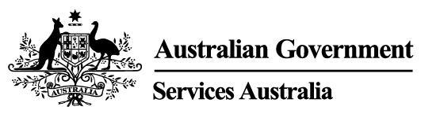
Services Australia Parent/Guardian Withdrawal of Consent Form
Mothers and their Children’s Healthcare Experience Study (MatCHES)

Version 1; Dated 3/11/2021

I wish to WITHDRAW consent to release my child’s [ full name of child ] Services Australia information to the study effective from the date below. I request that the study handles the information they have collected about my child in the following way (choose one option):

DESTROY all information collected about my child to date so it can no longer be used for research
RETAIN all information collected about my child to date so it can continue to be used for research

I understand that:
- no further information about my child will be collected for the study from the withdrawal date
- information about my child that has already been analysed and/or included in a publication by the study, may not be able to be destroyed; and
- choosing to withdraw my child from the study will not affect my child’s access to Health Services or Government benefits.

Print your first and second/family name, signature & date
First name
Second/Family name
Signature
DD/MM/YYYY

This form should be forwarded by email to: alswh@newcastle.edu.au. Alternatively, forms can be posted to: Women’s Health Australia, Reply Paid 70, Hunter Region MC NSW 2310.

