COVID-19 and its impact on health care use: Findings from the Australian Longitudinal Study on Women’s Health

Authors:
Mishra G, Dobson A, Tooth L, Chan H-W, Forder P, Townsend N, Egan N, Cavenagh D, Hockey R, Barnes I, Byrnes E & Loxton D.

  - Final report prepared for the Australian Government Department of Health and Aged Care, May 2023

ISBN: TBD

Acknowledgements
The research on which this report is based was conducted as part of the Australian Longitudinal Study on Women’s Health (ALSWH) by researchers from the University of Queensland and the University of Newcastle. We are grateful to the Australian Government Department of Health and Ageing for funding and to the women who provided the data. The authors also acknowledge the Australian Government Department of Health and Aged Care and Medicare Australia for the Medicare Benefits Schedule linked health records used in this report. We would like to thank the University of Newcastle and the Hunter Medical Research Institute for providing funding for the COVID-19 surveys.

Suggested citation

COVID-19 and its impact on health care use: Findings from the Australian Longitudinal Study on Women’s Health. Mishra G, Dobson A, Tooth L, Chan H-W, Forder P, Townsend N, Egan N, Cavenagh D, Hockey R, Barnes I, Byrnes E & Loxton D. Report prepared for the Australian Government Department of Health and Aged Care, May 2023.

Table of Contents
1. Executive summary 10
2. Introduction 15
2.1 Aims of this report 16
2.2 Special COVID-19 surveys 16
2.3 Defining the comparative time periods 17
2.4 Comparing health service use by area of residence 18
2.5 Comparing health service use by the ability to manage on income 19
2.6 Comparing health service use by women with a history of domestic violence 20
2.7 Comparing health service use by women with common conditions 20
3. Health and experiences accessing services during the COVID-19 pandemic in 2020 23
3.1 Key points 23
3.1.1 Women’s health during the COVID-19 pandemic in 2020: COVID-19 mini-survey results 23
3.1.2 Accessing health services during the COVID-19 pandemic in 2020: COVID-19 mini-survey results 24
3.2 Women’s health during the COVID-19 pandemic in 2020 25
3.2.1 General health 25
3.2.2 Mental health 26
3.3 Accessing health services during the COVID-19 pandemic in 2020 30
3.3.1 Delaying accessing health services 30
3.3.2 Accessing mental health services during the pandemic 32
3.3.3 Telehealth services 34
3.4 Conclusion 37
4. Patterns of health care use 38
4.1 Key points 38
4.1.1 General practitioner service use 38
4.1.2 Specialist services 39
4.1.3 Mental health services 39
4.1.4 Cervical cancer screening 40
4.2 Use of general practitioner services 40
4.2.1 Area of residence 42
4.2.2 Ability to manage on income 46
4.2.3 History of domestic violence 49
4.3 Specialist services 52
4.3.1 Area of residence 53
4.3.2 Ability to manage on income 56
4.3.3 History of domestic violence 59
4.4 Mental health services 62
4.4.1 Area of residence 63
4.4.2 Ability to manage on income 66
4.4.3 History of domestic violence 68
4.5 Participation in national cervical cancer screening program 70
5. Common conditions 71
5.1 Key points 71
5.2 Conditions associated with changes in general practitioner service use during the pandemic 72
5.3 Conditions associated with changes in specialist service use during the pandemic 74
5.4 Conditions associated with changes in obstetric service use during the pandemic 76
5.5 Conditions associated with changes in telehealth service use during the pandemic 77
5.6 Multimorbidity 79
6. Women’s experiences accessing health care during the COVID-19 pandemic in 2020-21 82
6.1 Key points 82
6.2 Introduction 83
6.3 Results 83
6.3.1 Unmet needs and reduced quality of care 83
6.3.2 Reluctance to seek care and concern for an overburdened health system 94
6.3.3 Confusion and frustration surrounding health information 97
6.3.4 Convenience and improved choices for care 100
6.4 Conclusion 103
7. References 105
8. Appendix A – ALSWH retention rate 110
9. Appendix B – ALSWH survey questions 112
9.1.1 Area of residence 112
9.1.2 Ability to manage on income 112
9.1.3 Experience of domestic violence 113
10. Appendix C – COVID-19 mini surveys 114
10.1 Participant response rate 114
10.2 Survey questions 116
10.2.1 General health 116
10.2.2 Stress 116
10.2.3 Psychological distress 116
10.2.4 Living arrangements 116
10.2.5 Social support 117
10.2.6 Delaying access to health services 117
10.2.7 Mental health services 117
10.2.8 Telehealth services 118
10.3 Qualitative methodology 118
10.3.1 Sampling frame 118
10.3.2 Analysis 118
10.3.3 List of terms for qualitative keyword search 119
11. Appendix D – Linked data sources 120
11.1 Data coverage 120
11.2 Medicare items for general practitioner services 120
11.3 Medicare items for specialist services 121
11.4 Better Access initiative 122
11.5 National cervical cancer screening 123
11.6 Common Conditions from Multiple Sources 123
11.7 Endometriosis 124
11.8 Multimorbidity 125

Table of Figures
Figure 2-1 Schematic of the comparison time periods used in this report 17
Figure 3-1 Percentage of women who reported fair or poor general health during the COVID-19 pandemic (April – October 2020). 25
Figure 3-2 Percentage of women who reported fair or poor health at least once during the COVID-19 pandemic in 2020, according to health reported prior to 2020. 26
Figure 3-3 Percentage of women who reported being very or extremely stressed during the COVID-19 pandemic (April – October 2020). 27
Figure 3-4 Percentage of women who reported being very or extremely stressed at least once during the COVID-19 pandemic in 2020, according to stress prior to 2020. 28
Figure 3-5 Percentage of women who reported high or very high psychological distress during the COVID-19 pandemic in 2020, according to living arrangements. 29
Figure 3-6 Percentage of women who reported high or very high psychological distress during 2020, according to social support. 30
Figure 3-7 Percentage of women who reported delaying accessing health services during the COVID-19 pandemic in 2020. 31
Figure 3-8 Percentage of women who reported delaying accessing health screening during the COVID-19 pandemic in 2020. 32
Figure 3-9 Percentage of women who accessed a mental health service during the COVID-19 pandemic in 2020. 33
Figure 3-10 Percentage of women who reported changes to their access to mental health services during the COVID-19 pandemic in 2020. 34
Figure 3-11 Percentage of women who reported at least one telehealth consultation for specified health services in 2020. 35
Figure 3-12 Percentage of women who rated their Telehealth consultation as positive, neutral or negative during the COVID-19 pandemic in 2020. 36
Figure 4-1 Mean annual number of GP services used by women in the 1989-95, 1973-78, and 1946-51 cohorts before and during the COVID-19 pandemic, categorised by type of attendance. 41
Figure 4-2 Mean annual Medicare benefit paid and out-of-pocket costs for GP services used by women in the 1989-95, 1973-78, and 1946-51 cohorts before and during the COVID-19 pandemic. 42
Figure 4-3 Mean annual number of GP services used by women in the 1989-95, 1973-78, and 1946-51 cohorts before and during the COVID-19 pandemic, categorised by type of attendance and area of residence. 44
Figure 4-4 Mean annual Medicare benefit paid and out-of-pocket costs for GP services used by women in the 1989-95, 1973-78, and 1946-51 cohort before and during the COVID-19 pandemic, categorised by type of attendance and area of residence. 45
Figure 4-5 Mean annual number of GP services used by women in the 1989-95, 1973-78, and 1946-51 cohort before and during the COVID-19 pandemic, categorised by type of service and ability to manage on income. 47
Figure 4-6 Mean annual Medicare benefit paid and out-of-pocket costs for GP services used by women in the 1989-95, 1973-78, and 1945-51 cohort before and during the COVID-19 pandemic, categorised by type of service and ability to manage on income. 48
Figure 4-7 Mean annual number of GP services used by women in the 1989-95, 1973-78 and 1946-51 cohorts before and during the COVID-19 pandemic, categorised by type of attendance and history of domestic violence. 50
Figure 4-8 Mean annual Medicare benefit paid and out-of-pocket costs for GP services used by women in the 1989-95, 1973-78, and 1946-51 cohorts before and during the COVID-19 pandemic, categorised by type of attendance and history of domestic violence. 51
Figure 4-9 Mean annual number of Specialist services used by women in the 1989-95, 1973-78, and 1946-51 cohorts before and during the COVID-19 pandemic, categorised by type of service. 52
Figure 4-10 Mean annual Medicare benefit paid and out-of-pocket costs for Specialist services used by women in the 1989-95, 1973-78, and 1946-51 cohorts before and during the COVID-19 pandemic. 53
Figure 4-11 Mean annual number of Specialist services used by women in the 1989-95, 1973-78, and 1946-51 cohort before and during the COVID-19 pandemic, categorised by type of service and area of residence. 54
Figure 4-12 Mean annual Medicare benefit paid and out-of-pocket costs for GP services used by women in the 1989-95, 1973-78, and 1946-51 cohorts before and during the COVID-19 pandemic, categorised by area of residence. 55
Figure 4-13 Mean annual number of specialist services used by women in the 1989-95, 1973-78, and 1946-51 cohort before and during the COVID-19 pandemic, categorised by type of service and ability to manage on income. 57
Figure 4-14 Mean annual Medicare benefit paid and out-of-pocket costs for specialist services used by women in the 1989-95 cohort before and during the COVID-19 pandemic, categorised by ability to manage on income. 58
Figure 4-15 Mean annual number of specialist services used by women in the 1989-95, 1973-78, and 1946-51 cohorts before and during the COVID-19 pandemic, categorised by type of service and history of domestic violence. 60
Figure 4-16 Mean annual Medicare benefit paid and out-of-pocket costs for specialist services used by women in the 1946-51 cohort before and during the COVID-19 pandemic, categorised by history of domestic violence. 61
Figure 4-17 Mean annual number of mental health services used by women in the 1989-95, 1973-78, and 1946-51 cohorts before and during the COVID-19 pandemic, categorised by type of service. 63
Figure 4-18 Mean annual number of mental health services used by women in the 1989-95, 1973-78, and 1946-51 cohort before and during the COVID-19 pandemic, categorised by type of service and area of residence. 65
Figure 4-19 Mean annual number of mental health services used by women in the 1989-95, 1973-78, and 1946-51 cohorts before and during the COVID-19 pandemic, categorised by type of service and ability to manage on income. 67
Figure 4-20 Mean annual number of mental health services used by women in the 1989-95, 1973-78, and 1946-51 cohort before and during the COVID-19 pandemic, categorised by type of service and history of domestic violence. 69
Figure 4-21 Mean annual HPV tests per 1,000 women before and during the COVID-19 pandemic by women in the 1989-95, 1973-78, and 1946-51 cohorts. 70
Figure 5-1 Mean annual number of GP services used by women in the 1989-95 cohort before and during the COVID-19 pandemic, categorised by type of attendance and diabetes status (top) and cancer (bottom). 73
Figure 5-2 Mean annual number of GP services used by women in the 1946-51 cohort before and during the COVID-19 pandemic, categorised by type of attendance and stroke status. 74
Figure 5-3 Mean annual number of specialist services used by women in the 1989-95 and 1973-78 cohorts before and during the COVID-19 pandemic, categorised by type of attendance and cancer status. 75
Figure 5-4 Mean annual number of specialist services used by women in the 1946-51 cohort before and during the COVID-19 pandemic, categorised by type of service and chronic obstructive pulmonary disorder (COPD) status. 76
Figure 5-5 Mean annual number of specialist services used by women in the 1989-95 cohort before and during the COVID-19 pandemic, categorised by type of service and diabetes status. 77
Figure 5-6 Mean annual number of GP services used by women in the 1989-95, 1973-78, and 1946-51 cohorts before and during the COVID-19 pandemic, categorised by type of attendance and number of conditions. 80
Figure 5-7 Mean annual number of specialist services used by women in the 1989-95, 1973-78, and 1946-51 cohorts before and during the COVID-19 pandemic, categorised by type of service and number of conditions. 81

List of Tables
Table 2-1 Age of women in the 1989-95, 1973-78, and 1946-51 ALSWH cohorts in the designated before and during COVID-19 periods for this report. 18
Table 2-2 Percentage of participants by area of residence before the COVID-19 pandemic in the 1989-95, 1973-78, and 1946-51 ALSWH cohorts. 19
Table 2-3 Percentage of participants by ability to manage on income before the COVID-19 pandemic in the 1989-95, 1973-78, and 1945-51 ALSWH cohorts. 20
Table 2-4 Prevalence of common conditions amongst women in the 1989-95, 1973-78, and 1946-51 ALSWH cohorts. 21
Table 5-1 Comparison of the proportion of total GP services delivered by telehealth during the COVID-19 pandemic for women with or without a history of specific conditions. 78
Table 5-2 Comparison of the proportion of total specialist services delivered by telehealth during the COVID-19 pandemic for women with or without a history of specific conditions. 78
Table 8-1 Participation and retention across surveys between 1996 and 2019 for women from the 1989-95, 1973-78, and 1946-51 cohorts. 110
Table 9-1 Categories and descriptions for area of residence used in this report. 112
Table 9-2 Response options for ability to manage on income. 113
Table 10-1 Number of participants in the ALSWH COVID-19 surveys 114
Table 11-1 Conditions used to define multimorbidity for the 1989-95, 1973-78, and 1946-51 cohorts. 125

Executive summary

The Australian Longitudinal Study on Women’s Health (ALSWH) examines the health and wellbeing of over 57,000 Australian women in four age cohorts. Surveys have been completed by women in three cohorts (born in 1921-26, 1946-51, and 1973-78) since 1996 and a fourth cohort (born in 1989-95) since 2012-13. In addition to the health information collected in the surveys, women’s data can also be linked to the Medicare Benefits Schedule (MBS) and other administrative datasets to provide a detailed view of their health service use across the life course. The longitudinal nature of the ALSWH survey and linked data enables comparisons of women’s health and health service use over time or between specific time points.
This report compares women’s use of health services during the first two years of the coronavirus disease (COVID-19) pandemic with that of previous years to assess the impact of the pandemic. We also consider the differential impact of the pandemic on health service use for women in different subpopulations, with particular focus on women’s health status (presence of chronic condition/s), area of residence, financial status, and domestic violence history. Furthermore, data from the ALSWH COVID-19 mini-surveys deployed in 2020 have been analysed to examine health service use at the onset of the pandemic, including analysis of qualitative data to give voice to the lived experience of women during this period.
This report focuses on women in three different age groups and life stages:
- women in their late 20s who are entering their peak reproductive years (1989-95 cohort),
- women in their mid 40s who have established their families and careers (1973-78 cohort), and
- women in their early 70s who are increasingly facing health challenges (1946-51 cohort).
The findings aim to highlight the impact on women’s health service use of both the COVID-19 pandemic and of the strategies that were implemented to prevent the spread of disease. Findings may also help inform government responses to future pandemics to minimise disruptions to women’s access to health services.

Women’s health and access to health services during the COVID-19 pandemic in 2020: Results of the mini-surveys
Fourteen mini-surveys were conducted during 2020 - from April to October - to capture information about women’s experiences of the pandemic and the actions taken to control COVID-19 transmission.
Results showed that young women (in their late 20s) were more likely to report poor health, high stress, and psychological distress than older women, and more likely to delay seeing a general practitioner (GP), mental health professional, or allied health professional than older women (in their early 70s). Young women were also more likely to access a mental health professional or helpline/chat services, and more likely to use telehealth for GP and mental health services than older women.
Women who lived alone were more likely to report high psychological distress than those who lived with others, and those who reported little or no pre-pandemic social support were more likely to report high psychological distress.
For screening tests (of the skin, breast, or cervix), up to one in ten women reported delaying the screening.
Three-quarters of women who used telehealth services during the pandemic had a positive experience with different types of health professionals.

Comparing women’s health service use before and during the COVID-19 pandemic
Analysis of women’s health service use was enabled by the linkage of ALSWH survey data to MBS data. Health service use – visits to GPs and specialists, obstetrician consultations, mental health treatment, and cervical screening – before the COVID-19 pandemic (March 2018 - August 2019) and during it (March 2020 – August 2021) were compared for women in their late 20s, mid 40s and early 70s.
Average yearly GP visits increased during the COVID-19 pandemic for women in their early 70s, but did not change for women in their late 20s and mid 40s. For all cohorts, out-of-pocket costs for GP visits did not change – the lack of increase for women in their early 70s is likely due to bulk billing of GP services for this cohort, and their eligibility for a Seniors Health Card. Medicare benefits paid for GP visits during the pandemic were greater among women in their 70s who had difficulty managing on income, and among women in their late 20s and mid 40s with a history of domestic violence.
The average number of yearly specialist visits increased during the COVID-19 pandemic for women in their late 20s, but not for the older women. The increase was due to use of obstetric services and was more apparent among women living in metropolitan areas, who were entering peak childbearing years, than for women living in rural and remote areas, who were more likely to have had children at a younger age. Not surprisingly, during the pandemic the use of specialist services was higher for women in their late 20s due to increased access to obstetric services and for those who found it easy to manage on income. Increased specialist service use during the pandemic was associated with both higher Medicare benefits paid and out-of-pocket costs.
Mental health service use increased during the pandemic from pre-pandemic levels for women aged in their late 20s (but not for women in their mid 40s or early 70s) and this difference decreased with remoteness and difficulty managing income.
Cervical screening fell by 32-59% during the COVID-19 pandemic with the biggest reduction observed for women in their mid 40s.

Changes in GP and specialist service use before and during the COVID-19 pandemic for women with common conditions and multimorbidity
Health service use - visits to GPs and specialists, and obstetrician consultations - before the COVID-19 pandemic (March 2018 - August 2019) and during the pandemic (March 2020 – August 2021) by women with and without a history of specific common conditions were compared.
Conditions associated with a greater increase in GP service use during the COVID-19 pandemic compared to before the pandemic differed by age group: diabetes and cancer were associated with greater increases for women in their late 20s, asthma for those in their mid 40s, and stroke for women in their early 70s.
Two specific conditions were associated with a greater increase in specialist service use during the COVID-19 pandemic compared to before the pandemic: cancer for the women in their late 20s and mid 40s, and chronic obstructive pulmonary disorder for the women in their early 70s.
The rate of obstetric service use was higher during the COVID-19 pandemic than before the pandemic because the women in their late 20s had entered the peak childbearing years; however, there was no increase in obstetric service use for women who had a history of diabetes or cancer.
During the pandemic period, for all cohorts, GP telehealth service use increased with the number of common conditions experienced by women.

Telehealth service use during the COVID-19 pandemic
Telehealth services (medical consultations via telephone or video conferencing) were introduced at the start of the COVID-19 pandemic to minimise virus transmission in the community and to protect patients and health care providers. MBS claims for telehealth services were examined for women in different age groups and subpopulations, and with various health conditions.
Telehealth services were predominantly delivered by phone, rather than video conferencing, for GP, specialist, and mental health consultations/therapies. Women in their late 20s and mid 40s were more likely to use telehealth services to consult GPs and specialists and obtain mental health treatment and less likely to use GPs for COVID-19 vaccinations than women in their early 70s.
GP telehealth services had the greatest uptake among women living in metropolitan areas and the least among women living in remote areas. Telehealth service use for both GP and specialist services was higher for women with common conditions than for those with no conditions across all cohorts. Women in their late 20s with a history of cancer and women in their 40s with a history of stroke or chronic obstructive pulmonary disorder (COPD) were more likely to use GP telehealth services than women without these conditions.
Specialist telehealth services varied by specific common conditions: mental health problems and musculoskeletal conditions were associated with greater uptake of telehealth services, as well as cancer, diabetes, and COPD, however the trends were not consistent across the three cohorts. Telehealth delivery of mental health services was least likely to be used by women in the 1973-78 cohort who lived in rural and remote areas, lived with children, or had a history of domestic violence.

Women’s experiences accessing health care during the COVID-19 pandemic in 2020-21 in their own words
A thematic analysis of the qualitative free-text responses from the COVID-19 mini-surveys identified four major themes in relation to health service use during the pandemic:
- Unmet needs and reduced quality of care encompassed disruptions to routine care, difficulty accessing health services, and telehealth services being an inadequate alternative for certain conditions and health concerns.
- Reluctance to seek care described delays in treatment, screening, and attending medical appointments due to a fear of COVID-19, consideration of others with health needs, and concern for an overburdened health system.
- Confusion and frustration surrounding health information is a theme largely focussed on women’s confusion about health messages in relation to the COVID-19 vaccine, particularly with regard to persistent encouragement of COVID-19 vaccine uptake during the early periods of low supply, perceived inconsistencies in information about who was eligible for vaccination and with information about where to get vaccinated. The theme also encompassed women’s frustration when public discourse highlighted concerning side-effects of COVID-19 vaccines.
- Convenience and improved choices for care describes women’s appreciation for the introduction of telehealth services across the wider community, compared with the more limited availability of the services prior to the pandemic.

Implications and recommendations
The COVID-19 pandemic highlighted a number of key areas of consideration when implementing strategies to minimise disease transmission in the community:
Younger women were more likely to be negatively impacted by the pandemic and policies designed to limit the transmission of COVID-19 than older women: they experienced more stress and sought more mental health services. Psychological distress during the pandemic was associated with low social support for all women, and with living alone for women in their 20s and 40s.
- Recommendation: Research is needed to determine who is most at risk of minimal social support, and to develop programs for promoting social connectivity. Furthermore, strategies implemented by local governments to promote social support, particularly for people who lived alone during the pandemic, need to be evaluated and, if required, improved to minimise the mental health impact of isolation.
- Recommendation: The pandemic can be viewed as a global stressor. The particular vulnerability of younger women to mental health issues warrants further examination and development of service and policy interventions.
Telehealth services were well-utilised by younger women, women who lived in areas that experienced more restrictions and stay-at home orders (metropolitan), and women who had common conditions. Phone consultations were the predominant mode of telehealth delivery. Additionally, most women who used telehealth services found it be a positive experience. Under some circumstances, uptake of telehealth was lower in non-urban compared to urban locations.
- Recommendation: Further research is needed to determine the barriers to using telehealth services and strategies to promote or facilitate the effective use of telehealth services, particularly for older women and women with certain conditions.
- Recommendation: A better understanding of the lower uptake of telehealth in non-urban areas would determine whether this was due to unmet need or other factors (such as service availability or telehealth connectivity).
Women delayed access to health care services and cancer screening programs during the COVID-19 pandemic.
- Recommendation: Research is needed to determine the short- and long-term impact of delays to health care and cancer screening on women’s health. This is needed to help inform future responses to global pandemics.
- Recommendation: Development of a public health campaign to remind the community to ‘get back on track’ with preventive screening activities could be helpful. Consideration should be given to some women’s reluctance to attend such appointments due to a fear of COVID-19 as a part of any such campaign.

Introduction
The ALSWH is a longitudinal, national cohort study that examines how women’s health and wellbeing changes throughout the life course. ALSWH collects data on women’s physical and mental health, as well as demographics, health behaviours, lifestyle factors, social circumstances, and use of health services. Information provided by the participants is also linked to data from the Medicare Benefits Schedule (MBS), Pharmaceutical Benefits Scheme (PBS), cancer registry, perinatal, aged care, hospital inpatient, and emergency hospital datasets. Further information on the study can be found at www.alswh.org.au. The ALSWH collects data from more than 57,000 women across four age cohorts. Women born in 1921-26, 1946-51, and 1973-78 were first surveyed in 1996 and re-surveyed on an approximately three-yearly basis. A new cohort of women born in 1989-95 was recruited in 2013 and surveys were conducted annually until 2017, then in 2019, with the next survey being deployed in 2023. For information on the retention of the three ALSWH cohorts whose data were analysed in this report (1989-95, 1973-78, and 1946-51), see Appendix A – Table 8-1. The longitudinal nature of the ALSWH presents a unique opportunity to investigate how women’s health and health service use changes over time or in response to major events such as the recent coronavirus pandemic.
A novel form of the severe acute respiratory syndrome coronavirus 2 (SARS-CoV-2) virus, which causes the coronavirus (COVID-19) disease, was discovered in Wuhan (a city in China) in December 2019. Its rapid global spread prompted the World Health Organization to declare the virus outbreak a pandemic on 11 March 2020, at which time there were more than 118,000 infected individuals across 114 countries and more than 4,000 deaths [1]. In Australia, the first four cases were identified in Victoria and New South Wales on 25 January 2020 [2, 3]. By the end of 2020, there were approximately 28,500 cases in Australia [4]. The Australian Government responded with measures to limit the spread of infection and to reduce its impact on the economy, including international travel restrictions, support packages for the health care sector, businesses and individuals, and infection control resources. The state and territory governments responded to local fluctuations in COVID-19 cases with stay-at-home orders and restrictions on both social gatherings and business operations.
The COVID-19 pandemic and associated responses are likely to have had a significant effect on women’s lives, health and health care use. On the demand side, women may have been reluctant to attend health facilities due to concerns about exposure to the virus; and, on the supply side, many services (e.g., non-urgent elective surgery, screening mammograms) were restricted [5, 6].

Aims of this report
This report will examine the use of health care services during the first two years of the COVID-19 pandemic, compared with previous years, to assess the impact of the pandemic on women’s health care use.
Specifically, the aims of this report are to compare patterns of health care use by women before and during the COVID pandemic, typically during 2018-19 and since 2020; with analyses presented for:
- All women, in each cohort,
- Women with common conditions (diabetes, heart disease, stroke, asthma, chronic obstructive pulmonary disorder, musculoskeletal conditions, mental health problems, eating disorders, cancer, endometriosis) and multimorbidity,
- Women with particular circumstances (area of residence, ability to manage on income, and history of domestic violence).
The specific heath care services, including telehealth, that will be analysed are:
- general practitioner (GP) services (unreferred attendances)
- specialist services
- mental health services
- participation in the national cervical screening program

Special COVID-19 surveys
Between April 2020 and September 2020, 14 fortnightly mini-surveys concerning COVID-19 were administered via email to women in the 1989-95, 1973-78 and 1946-51 cohorts. The last mini-survey (Survey 15) was deployed in August 2021. The purpose of these surveys was to ascertain women’s experiences with COVID-19 testing, their overall wellbeing, and the changes occurring for them during the pandemic. In all mini-surveys, women were asked to answer a number of short questions taking 1-2 minutes to complete, with each survey focussing on a different topic. The women were also provided an opportunity in each survey to comment on the impacts of COVID-19, providing a rich tapestry of free-text data for qualitative analysis.
A detailed description of the mini-surveys is provided in the 2021 ALSWH Technical Report [7], while summary reports for each mini-survey are provided on the ALSWH website (www.alswh.org.au). For information regarding the number of respondents for each of the COVID-19 mini-surveys, see Appendix A – Table 10-1.

Defining the comparative time periods
In this report, the linkage of the ALSWH survey data to MBS data enabled comparisons of GP and specialist service use and costs, mental health service use, and cervical cancer screening before and during the COVID-19 pandemic for different population subgroups and by common conditions. More details regarding the specific MBS items used in this report can be found in Appendix D – Chapter 11.
To define the time periods for ‘before’ and ‘during’ the COVID-19 pandemic, we considered the available linked data. The ALSWH MBS coverage spans February 1984 to August 2021. Therefore, we deemed ‘during COVID-19’ as the period from the start of the pandemic in Australia (March 2020) to the end of the available MBS period (August 2021). To eliminate any seasonal variations to health care use, the ‘before COVID-19’ period was defined as March 2018 – August 2019 (Figure 2-1).
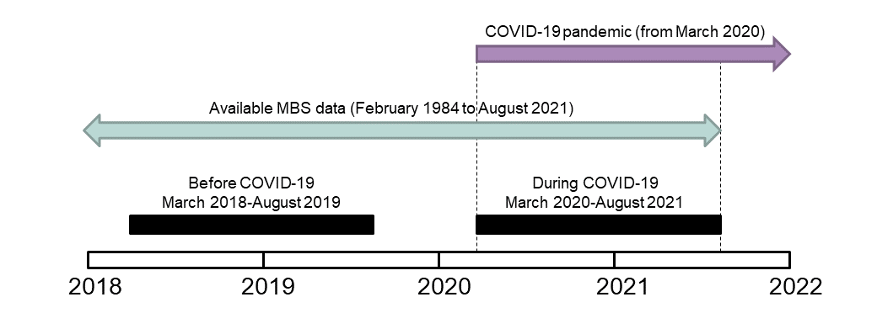
Figure 2-1 Schematic of the comparison time periods used in this report

In this report, we compared the impact of the COVID-19 pandemic on the health service use of women in three different stages of their lives. The age ranges of the 1989-95, 1973-78, and 1946-51 cohorts in the two comparative periods are shown in Table 2-1.
.

Table 2-1 Age of women in the 1989-95, 1973-78, and 1946-51 ALSWH cohorts in the designated before and during COVID-19 periods for this report.
 | Before COVID-19  March 2018 – August 2019 | During COVID-19  March 2020 – August 2021
1989-95 cohort | 23-29 years | 25-31 years
1973-78 cohort | 40-46 years | 42-48 years
1946-51 cohort | 67-73 years | 69-75 years

Comparing health service use by area of residence
Although COVID-19 initially spread through major cities connected by international air travel at a rapid rate, it was inevitable that cases began appearing in regional and remote areas. The key concerns for the spread of COVID-19 into Australia’s rural and remote communities were the already limited access to and availability of health services prior to the pandemic, reduced health services due to national and/or state restrictions, the impact on the smaller rural health work force, and the vulnerable subpopulations living in these areas [8]. Therefore, we sought to determine the differences in how women used health services before and during the pandemic according to their area of residence classification before the pandemic.
In this report, participants were classified by area of residence using the Monash Modified Model (MMM; see Appendix B – Section 9.1.1 for more details), derived from information provided in the last survey before the COVID-19 pandemic. The number and percentage of participants in each category for the 1989-95, 1973-78, and 1946-51 ALSWH cohorts are shown in Table 2-2. Women in the 1989-95 cohort were more likely to live in metropolitan areas (~75%), whereas women in the 1946-51 cohort were distributed across the metropolitan cities to small towns. 68% of women in the 1973-78 cohort lived in metropolitan areas and ~30% lived in regional centres or rural towns.

Table 2-2 Percentage of participants by area of residence before the COVID-19 pandemic in the 1989-95, 1973-78, and 1946-51 ALSWH cohorts.
 | 1989-95 cohort  Wave 6 – 2019  22-27 years  N=8,346  N (%) | 1973-78 cohort  Wave 8 – 2018  40-45 years  N=7,121  N (%) | 1946-51 cohort  Wave 9 – 2019  68-73 years  N=7,956  N (%)
Metropolitan areas (MM1) | 5,801 (74.3) | 4,771 (67.7) | 4758 (60.5)
Regional centres (MM2) | 834 (10.7) | 799 (11.3) | 905 (11.5)
Large rural towns (MM3) | 356 (4.6) | 504 (7.2) | 595 (7.6)
Medium & small rural towns (MM4-5) | 685 (5.8) | 847 (12.0) | 1,485 (18.9)
Remote & very remote communities (MM6-7) | 135 (1.8) | 125 (1.8) | 115 (1.5)

Comparing health service use by the ability to manage on income
Measures to control COVID-19 transmission in the community included closure of non-essential businesses, resulting in increased unemployment and underemployment. In April and May 2020, the combined unemployment and underemployment rate peaked at 20% before declining to pre-pandemic levels one year later [9]. In terms of income changes, 21% of Australians aged 18 years and older reported worse household finances in the 12-month period to February 2021 [10]. We previously reported that women with difficulty managing on income used more GP services than women who found it easier to manage on income [11]. Therefore, we compared health service use before and during the pandemic of women who did or did not have difficulty managing on income before the COVID-19 pandemic.
Survey questions in the ALSWH were used to determine ability to manage on income (see Appendix B – Section 9.1.2). In the last survey before the pandemic, approximately 60% of women in the 1989-95 and 1973-78 cohorts and 76% of women in the 1946-51 cohort reported no difficulty managing on income (Table 2-3). More than 13% of women in the younger cohorts had difficulty managing on income before the pandemic compared to 7% for the 1946-51 cohort.

Table 2-3 Percentage of participants by ability to manage on income before the COVID-19 pandemic in the 1989-95, 1973-78, and 1945-51 ALSWH cohorts.
 | 1989-95 cohort  Wave 6 – 2019  24-29 years  N=8,346  N (%) | 1973-78 cohort  Wave 8 – 2018  40-45 years  N=7,121  N (%) | 1946-51 cohort  Wave 9 – 2019  68-73 years  N= 7,956  N (%)
Impossible/always difficult | 1,066 (13.4) | 938 (13.6) | 545 (7.0)
Sometimes difficult | 2,165 (27.3) | 1,708 (24.8) | 1,361 (17.3)
Not too bad/easy | 4,710 (59.3) | 4,254 (61.6) | 5,943 (75.7)

Comparing health service use by women with a history of domestic violence
One of the key concerns regarding infection control measures for the COVID-19 pandemic was their impact on victim-survivors of domestic violence. Stay-at-home orders forced victim-survivors to spend more time with perpetrators (sometimes in confined quarters) and reduced their opportunity to access support services due to the lack of privacy at home [12]. In a survey of over 10,000 Australian women from February to April 2021, 9.6% reported experiencing physical violence in the 12 months prior to the survey and of these women, 44.9% were first-time victims [13]. Additionally, 43% of women who had a history of domestic violence from their most recent partner reported increased frequency or severity of physical and sexual violence, respectively, during the first 12 months of the pandemic. We previously showed that women who have ever experienced domestic violence have poorer mental and physical health throughout their life course [14]. Therefore, we compared health service use before and during the pandemic of women who have or have not ever experienced domestic violence prior to the COVID-19 pandemic.
Details on the survey questions used in this analysis can be found in Appendix B – Section 9.1.3. For all cohorts, approximately one in six women reported ever being in a violent relationship with a partner/spouse in their last survey before the COVID-19 pandemic.

Comparing health service use by women with common conditions
Specific common conditions are associated with COVID-19 disease severity. In Australia, the most common chronic conditions associated with COVID-19-related deaths up to April 2022 were cardiac conditions and dementia, each accounting for approximately one-third of deaths [9]. Other conditions associated with COVID-19-related deaths include diabetes, chronic respiratory conditions, cancer, and musculoskeletal disorders.
ALSWH developed the methodology for the Common Conditions from Multiple Sources (CCMS) dataset for the Study’s 2020 Major Report on The Impact of Multiple Chronic Conditions [15, 16]. The CCMS dataset includes many of the common conditions that have been associated with COVID-19 disease severity. Although not part of the CCMS dataset, a similar methodology was used to identify women with endometriosis. The prevalence of these conditions is shown in Table 2-4. These valuable resources were linked with MBS data to examine how women with these common conditions used health services before and during the COVID-19 pandemic. The impact of multimorbidity on health service use before and during the pandemic was also be investigated. Details on the data used for these analyses can be found in Appendix D – Section 11.6-11.8).
Table 2-4 Prevalence of common conditions amongst women in the 1989-95, 1973-78, and 1946-51 ALSWH cohorts.
 | 1989-95 cohort  N (%) | 1973-78 cohort  N (%) | 1946-51 cohort  N (%)
Diabetes | 371 (2.2) | 630 (4.7) | 2,334 (18.0)
Ischaemic heart disease | - | - | 2,389 (18.4)
Stroke | - | - | 594 (4.6)
Asthma | 1,950 (11.5) | 1,396 (10.3) | 1,999 (15.4)
Chronic Obstructive Pulmonary Disease | - | - | 847 (6.5)
Musculoskeletal condition | 4,934 (29.0) | 5,409 (40.1) | 10,800 (83.4)
Mental health problem | 7,785 (45.8) | 6,620 (49.0) | 5,810 (44.8)
Eating disorder | 1,001 (5.9) | - | -
Cancer | 3,05 (1.8) | 7,61 (5.6) | 3,226 (24.9)
Endometriosis | 1,502 (8.8) | 1,909 (14.1) | -
Multimorbidity
No condition | 6,247 (36.8) | 3,794 (28.1) | 991 (7.7)
1 condition | 6,093 (35.9) | 4,662 (34.5) | 3,349 (25.9)
2 conditions | 3,353 (19.8) | 3,296 (24.4) | 4,092 (31.6)
3 or more conditions | 1,279 (7.5) | 1,749 (13.0) | 4,522 (34.9)

Outline of this report

Chapter 3 presents a snapshot of women’s health and access to health services during 2020 using data collected by the COVID-19 mini surveys.

Chapter 4 describes patterns of health care use by women in each cohort before and during the COVID-19 pandemic. The Chapter presents findings for use of general practitioners, specialists, mental health services, and cervical screening.

Chapter 5 presents patterns of health care use by women with common conditions, including diabetes, heart disease, stroke, asthma and chronic obstructive pulmonary disease, musculoskeletal conditions, mental health problems, eating disorders, cancer, endometriosis, and multimorbidity. Differences in health care use are highlighted in this Chapter.

Chapter 6 presents the analysis of the free text data and provides the findings for women’s lived experiences of accessing health services while living through the COVID-19 pandemic.

The report concludes with references and Appendices with detailed documentation of ALSWH data and other resources used for the analyses.

Health and experiences accessing services during the COVID-19 pandemic in 2020

Key points

Women’s health during the COVID-19 pandemic in 2020: COVID-19 mini-survey results
- During the pandemic in 2020, poor health, high stress, and psychological distress were most prevalent among women aged 25-31, followed by women aged 42-47, and women aged 69-74.
- Across all age groups, women who had poor health or high stress before the COVID-19 pandemic were more likely to report poor health or high stress during the pandemic. However, many women aged 25-31 and 42-47 who did not report poor health or high stress prior to 2020 still reported poor health or high stress during the pandemic.
- Among women aged 25-31 and 42-47, those living alone were more likely to report high psychological distress, compared to those living with others. Among women aged 69-74, there were similar rates of high psychological distress for women who lived alone and those who lived with others.
- Women who indicated that they had little or no social support prior to 2020 were more likely to report high psychological distress during the pandemic in 2020 when compared to women with social support prior to 2020.

Accessing health services during the COVID-19 pandemic in 2020: COVID-19 mini-survey results
- Women delayed accessing health services during the pandemic in 2020:
  - 27% of women aged 25-31, 19% of women aged 42-47, and 10% of women aged 69-74 delayed seeing a GP or family doctor.
  - 9-10% of women aged 25-31, 42-47, and 69-74 delayed accessing a specialist.
  - 10% of women aged 25-31, 4% of women aged 42-47, and 1% of women aged 69-74 delayed seeing a mental health professional.
  - 17% of women aged 25-31, 13% of women aged 42-47, and 10% of women aged 69-74 delayed accessing an allied health professional.
- Women also delayed regular screening during the pandemic in 2020:
  - 6-9% of women aged 25-31, 42-47, and 69-74 delayed a skin check.
  - 4-5% of women aged 42-47 and 69-74 delayed a mammogram.
  - 10% of women aged 25-31, 5% of women aged 42-47, and 1% of women aged 69-74 delayed cervical cancer screening.
- Many women accessed mental health services during the pandemic in 2020:
  - 39% of women aged 25-31, 18% of women aged 42-47, and 4% of women aged 69-74 accessed a mental health professional.
  - 5% of women aged 25-31 and 2% of women aged 42-47 accessed mental health helpline services or online chat services (e.g., Lifeline).
- Many women experienced changes in their access to mental health services. The most common change in mental health service access was telehealth instead of face-to-face appointments (25% of women aged 25-31, 13% of women aged 42-47 and 4% of women aged 69-74).
- Telehealth consultations were used by many women during the pandemic in 2020:
  - 55% of women aged 25-31, 43% of women aged 42-49, and 49% of women aged 69-74 used telehealth with a GP or family doctor.
  - 25% of women aged 25-31, 11% of women aged 42-47 and 2% of women aged 69-74 used telehealth with a mental health professional.
  - 12% of women aged 25-31, 13% of women aged 42-47, and 17% of women aged 69-74 used telehealth with a specialist doctor.
  - 5-6% of women aged 25-31, 42-47, and 69-74 used telehealth with an allied health professional.
  - 4% of women aged 25-31 used telehealth with a midwife.
- Women rated their experiences of telehealth appointments with different health professionals:
  - 75% of women aged 25-31, 42-47, and 69-74 reported positive telehealth experiences with a range of health professionals.
  - 12% of women aged 69-74 rated their telehealth experiences with mental health professionals as negative, and 7% of women aged 25-31 rated their telehealth experiences with midwives and allied health professionals as negative.

Women’s health during the COVID-19 pandemic in 2020

General health
The percentage of women who reported fair or poor general health was consistently higher among women aged 25-31 than older women, peaking at 17% in early July 2020 (Figure 3-1). The percentage of women who reported fair or poor general health varied over time among women aged 42-47 (peaking at 12% between April and October 2020) and remained relatively constant at less than 8% among women aged 69-74.

Figure 3-1 Percentage of women who reported fair or poor general health during the COVID-19 pandemic (April – October 2020).

Women who had previously reported fair or poor health prior to 2020 were more likely to report fair or poor health during the COVID-19 pandemic in 2020. This was consistent across all three cohorts of women (63% of women aged 25-31, 55% of women aged 42-47, and 58% of women aged 69-74, Figure 3-2). However, many women aged 25-31 and 42-47 who did not report fair or poor health prior to 2020 still reported fair or poor health during the COVID-19 pandemic in 2020 (27% and 23%, respectively).

Figure 3-2 Percentage of women who reported fair or poor health at least once during the COVID-19 pandemic in 2020, according to health reported prior to 2020.

Mental health

Stress
Young women were consistently more likely to report being very or extremely stressed during the COVID-19 pandemic in 2020 than older women (Figure 3-3), with 23-27% of women aged 25-31 reporting being very or extremely stressed, compared to 11-19% of women aged 42-47 and 2-3% of women aged 69-74.

Figure 3-3 Percentage of women who reported being very or extremely stressed during the COVID-19 pandemic (April – October 2020).

Young women were the most likely to report that they were very or extremely stressed at least once during the COVID-19 pandemic in 2020, with 50% of women aged 25-31 reporting that they were very or extremely stressed at least once during the COVID-19 pandemic in 2020, compared to 35% of women aged 42-47, and 10% of women aged 69-74.
Across all cohorts, women who had previously reported high stress prior to 2020 were more likely to report high stress during the COVID-19 pandemic in 2020 (68% of women aged 25-31, 53% of women aged 42-47, and 22% of women aged 69-74; Figure 3-4). However, many women aged 25-31 and 42-47 who did not report high stress prior to 2020 still reported that they were very or extremely stressed during the COVID-19 pandemic in 2020 (42% and 29%, respectively).

Figure 3-4 Percentage of women who reported being very or extremely stressed at least once during the COVID-19 pandemic in 2020, according to stress prior to 2020.

Psychological distress
Women aged 25-31 were the most likely to report high or very high levels of psychological distress, with 37% of women aged 25-31 reporting high or very high levels of psychological distress during the COVID-19 pandemic in 2020, compared to 18% of women aged 42-47, and 6% of women aged 69-74.

Psychological distress and living arrangements
Women aged 25-31 and 42-47 who lived alone were more likely to report high or very high psychological distress in 2020 than those who lived with others. Among women aged 25-31, 46% of women who lived alone reported high or very high psychological distress in 2020, compared to 34% of those who lived with others (Figure 3-5). Among women aged 42-47, 23% of women living alone reported high or very high psychological distress compared to 18% of women who were living with others. Among women aged 69-74, there were similar rates of high or very high psychological distress reported for those who lived alone and those who lived with others (6% and 5%, respectively).

Figure 3-5 Percentage of women who reported high or very high psychological distress during the COVID-19 pandemic in 2020, according to living arrangements.

Psychological distress and social support
Women who indicated that they had little or no social support prior to 2020 were more likely to report high or very high psychological distress during the COVID-19 pandemic in 2020 when compared to women who indicated they had social support prior to 2020. Among women aged 25-31, 66% of women who indicated that they had little or no social support prior to 2020 reported high or very high psychological distress in 2020, compared to 33% of those who indicated they had social support prior to 2020. Among women aged 42-47, 41% of women who indicated that they had little or no social support prior to 2020 reported high or very high psychological distress in 2020, compared to 17% of those who indicated they had social support prior to 2020. Among women aged 69-74, 15% of women who indicated that they had little or no social support prior to 2020 reported high or very high psychological distress in 2020, compared to 5% of those who indicated they had social support prior to 2020 (Figure 3-6).

Figure 3-6 Percentage of women who reported high or very high psychological distress during 2020, according to social support.

Accessing health services during the COVID-19 pandemic in 2020

Delaying accessing health services
More than a quarter (27%) of women aged 25-31 indicated that they had delayed seeing a GP or family doctor during the pandemic in 2020, compared to 19% of women aged 42-47 and 10% of women aged 69-74. Around 9-10% of women reported delaying accessing a specialist doctor since the start of the COVID-19 pandemic. Women aged 25-31 were more likely to report that they had delayed accessing a mental health professional (e.g., psychologist, counsellor or social worker; 10%) than women aged 42-47 (4%) and women aged 69-74 (1%). Women aged 25-31 were also more likely to report that they had delayed appointments with allied health professionals (e.g., physiotherapist, podiatrist; 17%), compared to women aged 42-47 (13%) and women aged 69-74 (10%). Delaying access to hospital emergency departments or hospital stays was reported infrequently (around 1% in all cohorts).

Figure 3-7 Percentage of women who reported delaying accessing health services during the COVID-19 pandemic in 2020.

Women aged 25-31 were the most likely to report that they had delayed cervical screening, with 10% of women aged 25-31 reporting delaying accessing cervical screening, compared to 5% of women aged 42-47, and 1% of women aged 69-74. Among women aged 42-47 and 69-74, 4-5% reported that they had delayed having a mammogram during the COVID-19 pandemic in 2020. Approximately 6-9% of women reported that they had delayed a skin check during the COVID-19 pandemic in 2020 (Figure 3-8).

Figure 3-8 Percentage of women who reported delaying accessing health screening during the COVID-19 pandemic in 2020.

Accessing mental health services during the pandemic
During the COVID-19 pandemic in 2020, 39% of women aged 25-31 accessed a mental health professional (e.g., psychologist, counsellor), compared to 18% of women aged 42-47 and 4% of women aged 69-74 (Figure 3-9). Mental health helpline services or online chat services (such as Lifeline or Beyond Blue) were accessed by 5% of women aged 25-31 and 2% of women aged 42-47.

Figure 3-9 Percentage of women who accessed a mental health service during the COVID-19 pandemic in 2020.

The percentage of women who reported a mental health appointment being changed to telehealth was highest among women aged 25-31 (25%, Figure 3-10), followed by women aged 42-47 (13%) and women aged 69-74 (4%). Around one in eight (12%) women aged 25-31 reported that they experienced mental health appointment delays during 2020. Across cohorts, few women reported appointment cancellations or being unable to access needed medication or mental health services. Some women reported no impact of the pandemic on their access to mental health services (14% of women aged 25-31, 11% of women aged 42-47 and 4% of women aged 69-74).

Figure 3-10 Percentage of women who reported changes to their access to mental health services during the COVID-19 pandemic in 2020.

Telehealth services
During the COVID-19 pandemic in 2020, approximately half of women reported using telehealth consultations with a GP or family doctor (55% of women aged 25-31, 43% of women aged 42-49, and 49% of women aged 69-74; Figure 3-11). Around 21% of women aged 25-31 reported using telehealth consultations with a mental health professional (e.g., psychologist or counsellor), compared to 11% of women aged 42-47 and 2% of women aged 69-74. Women aged 69-74 (17%) were more likely to report using telehealth consultations with specialist doctors compared to women aged 42-47 (13%) or women aged 25-31 (12%). Around 5-6% of women reported using telehealth consultations with allied health professionals. Very few women aged 25-31 reported telehealth consultations with midwives (4%).

Figure 3-11 Percentage of women who reported at least one telehealth consultation for specified health services in 2020.

Of the women who reported using at least one telehealth consultation for a health service, the majority rated the experience as positive, with almost 75% of women aged 25-31, 42-27 and 69-74 reporting their telehealth experience as positive or very positive (Figure 3-12). However, some women reported negative experiences with telehealth, with 12% of women aged 69-74 indicating dissatisfaction with telehealth mental health professionals and around 7% of women aged 25-31 indicating negative experiences with telehealth consultations for midwifery and allied health professionals.

Figure 3-12 Percentage of women who rated their Telehealth consultation as positive, neutral or negative during the COVID-19 pandemic in 2020.

Conclusion
Women commonly reported experiencing poor physical and mental health during the pandemic in 2020. In addition, many women delayed accessing a variety of health services and health screening during the pandemic in 2020. Delaying treatment and screening can have serious consequences for long-term physical and mental health (e.g., delay in cervical screening may lead to late-stage cancer diagnosis and limited treatment options). The long-term health implications for these delays are not yet known and require a thorough investigation. Furthermore, a national health promotion strategy which encourages women to access health services when needed and also take part in overdue screening is warranted.
Once telehealth services were introduced, women used telehealth for a range of different types of health consultations. Women rated their experiences of telehealth as largely positive. However, some women rated their experiences of telehealth for particular services (mental health professionals, midwives, and allied health professionals) as negative. Telehealth has obvious benefits during a national crisis such as the COVID-19 pandemic, and also improves access and provides more options for ongoing health service provision. However, telehealth is not suitable for all people and all services, and its use needs to be tailored to the individual and their health needs.
A large number of women reported poor mental health and high psychological distress during the pandemic. Some women rated telehealth with mental health professionals as negative, and many women reported that they delayed accessing mental health services, and that consultations with mental health professionals were often changed to telehealth. In a crisis such as the COVID-19 pandemic, there is potential for high-risk mental health issues to go unaddressed and, therefore, have long-term health implications. In addition to traditional psychologist appointments, other mental health treatment options which can be made widely available when large scale access is needed should be considered. For example, some women reported accessing mental health helpline services and online chat services. Furthermore, women who reported living with someone had better mental health than those living alone, which highlights the importance of some strategies that were implemented during lockdown (e.g., the NSW bubble buddy system). However, those who had poor social support prior to the pandemic were more likely to report poor mental health than those who had a robust social support prior to the pandemic. For those who were already socially isolated prior to the pandemic, this isolation got worse with the implementation of restrictions. Providing a system which enables women to access and establish a social support network in these circumstances would assist with alleviating the mental health burden evident during a national crisis.

Patterns of health care use
This chapter describes the patterns and costs of health care use by women in each cohort before and during the COVID-19 pandemic, comparing use of:
- GP services,
- specialist services,
- mental health services, and
- the National Cervical Screening Program.
Details on the Medicare items, including telehealth, used in these analyses can be found in the Appendices: GP services (Section 11.2), specialist services (Section 11.3), mental health services (Better Access Initiative; Section 11.4), and cervical cancer screening (National Cervical Screening Program; Section 11.5). Before the pandemic, very few women used telehealth for any type of health care service [11], so these claims were grouped with the standard consultations. Discussion of telehealth in this report only refer to MBS items introduced due to the COVID-19 pandemic.

Key points

General practitioner service use
- Women in the 1946-51 cohort used, on average, two more GP services per year during COVID-19 than before the COVID-19 pandemic; little change was observed for younger women.
- There was greater uptake of telehealth services by women in the 1973-78 and 1973-78 cohorts than the 1946-51 cohort.
- For all age groups, women living in metropolitan areas had the greatest use of GP telehealth services whilst those living in remote areas had the least.
- Over 95% of GP telehealth services were delivered via phone rather than video conferencing for women in all three cohorts.
- COVID-19 vaccinations administered in GP clinics were more likely to be taken up by women aged in their 70s than younger women and did not vary by area of residence, ability to manage on income, or history of domestic violence.
- GP out-of-pocket costs were no higher during the pandemic compared to before the pandemic for women in all three age groups, even though women in the 1946-51 cohort had more GP consultations.
- For the 1946-51 cohort, the higher GP service use observed during the pandemic decreased with remoteness.
- A greater increase in Medicare benefits paid during the pandemic was associated with income management difficulty among women born 1946-51; and domestic violence among women born 1989-95 and 1973-78.

Specialist services
- Specialist service use did not differ before and during the COVID-19 pandemic for the 1973-78 and 1946-51 cohorts, however there was increased use of obstetric services for women born in 1989-95 who lived in metropolitan areas.
- There were minimal differences in specialist service use during the pandemic and it did not vary by area of residence or history of domestic violence for the 1973-78 and 1946-51 cohorts.
- For the 1989-95 cohort, specialist service use was higher (due to obstetric service use) during the pandemic for women who found it easy to manage on income.
- Like GP consultations, younger women were more likely to use telehealth services than older women; there was little difference by area of residence, ability to manage on income, or history of domestic violence.
- Phone was the predominant mode of delivery for specialist telehealth services.
- Increased specialist service use during the pandemic was associated with both higher Medicare benefits paid and out-of-pocket costs and did not vary by area of residence, ability to manage on income, or history of domestic violence.

Mental health services
- Mental health service use increased during the COVID-19 pandemic for young women but not older women.
- For the 1989-95 cohort, mental health service use increased during the pandemic from pre-pandemic levels, however the difference decreased with remoteness.
- Women born in 1989-95 who had difficulty managing on income before the pandemic had similar use of mental health services before and during the pandemic, however those who found it easy before the pandemic increased mental health service use during the pandemic.
- Approximately two-thirds of mental health services were provided by allied health professionals for all cohorts and this did not differ by area of residence or difficulty managing on income.
- Women in their late 20s and mid 40s were more likely to use telehealth delivery of mental health services (approximately one-third of the total service) than women in their 70s (one-fifth of the total service).
- Although overall telehealth service use for mental health treatment was similar by area of residence for the 1989-95 cohort, it decreased with remoteness for the 1973-78 cohort.
- Women in the 1973-78 cohort who did not have a history of domestic violence were less likely to use telehealth-delivery of mental health services.

Cervical cancer screening
- Cervical cancer screening fell by 32-59% during the COVID-19 pandemic with the biggest reduction observed for women born 1973-78.
- The changes in HPV testing from pre-pandemic to during pandemic levels varied by areas of residence, ability to manage on income, and history of domestic violence with no clear pattern observed.

Use of general practitioner services
The mean annual number of GP services used overall were almost two visits higher during the COVID-19 pandemic than before the pandemic for the 1945-51 cohort, whereas there was only a slight increase for the other cohorts (Figure 4-1). This is likely due to the combination of increased risk of severe COVID-19 disease [4, 17] and higher prevalence of health conditions amongst older women [18]. Furthermore, the COVID-19 mini-surveys demonstrated that younger women were more likely to delay seeing a GP during the pandemic than older women (see Section 3.3.1).
There was greater uptake of GP telehealth services, approximately two per year for all cohorts, during the pandemic. Telehealth GP services accounted for approximately one-third of the total GP service use for women in the 1989-95 and 1973-78 cohort and one-fifth for the 1946-51 cohort (Figure 4-1). Furthermore, over 95% of all telehealth services used by the three cohorts during the COVID-19 pandemic was by telephone. These are similar to findings in the web report by Snoswell and colleagues, documenting the quarterly national fluctuations in telehealth services used by females and males for GP consultations, as well as other clinical services, since the start of the pandemic [19]. Telehealth services were also found to be primarily conducted via telephone (88%) rather than video conferencing (12%) [4, 19].
COVID-19 vaccinations at a GP clinic were more likely to be undertaken by women in the 1946-51 cohort than the 1989-95 and 1973-78 cohorts.

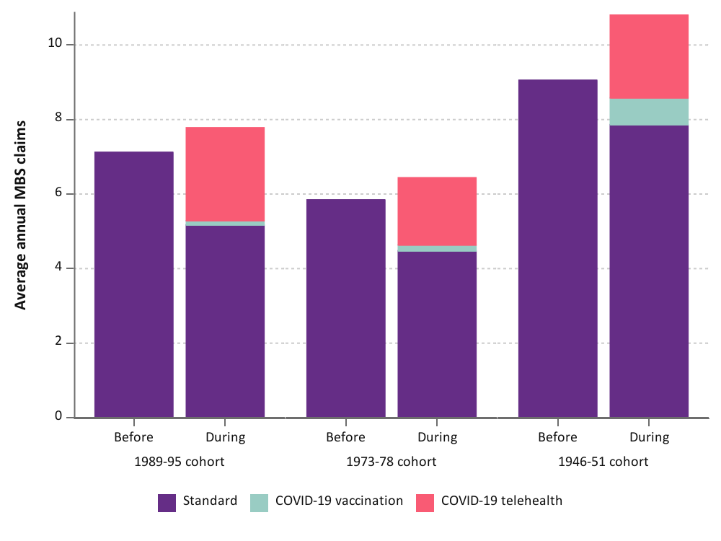
Figure 4-1 Mean annual number of GP services used by women in the 1989-95, 1973-78, and 1946-51 cohorts before and during the COVID-19 pandemic, categorised by type of attendance.

The mean annual Medicare benefit paid (i.e., the cost to the Australian Government) was higher during than before the pandemic, however there was little variation in out-of-pocket costs (Figure 4-2). This demonstrates the increased subsidisation of telehealth services by the Australian Government [20]. For the 1946-51 cohort, the mean annual Medicare benefit paid was $532 before the pandemic and increased by approximately $110 during the pandemic. For the 1989-95 and 1973-78 cohorts the mean annual Medicare benefit paid was lower before the pandemic ($372 and $308, respectively) and increased by $40-50 during the pandemic.
Although the 1946-51 cohort used more GP services than the younger cohorts, their mean annual out-of-pockets costs were up to a third less than the other two cohorts both before and during the pandemic. This is likely due to bulk billing of GP services for this cohort and their eligibility for a Seniors health care card. Although the 1989-95 cohort used, on average, one extra GP service in a year than the 1973-78 cohort, their mean annual out-of-pocket costs were similar.

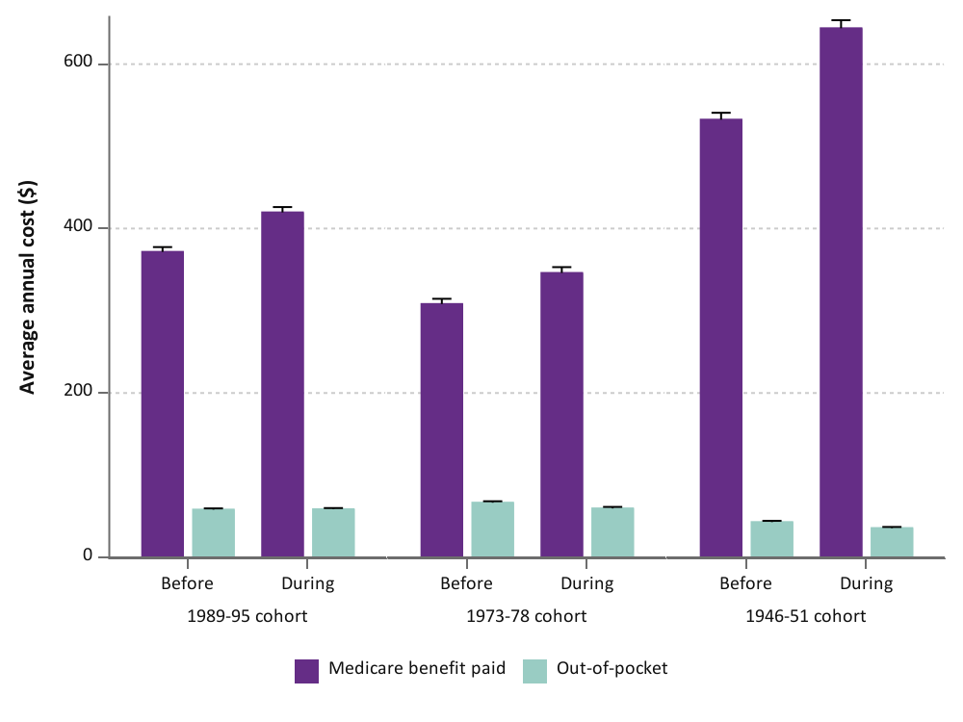
Figure 4-2 Mean annual Medicare benefit paid and out-of-pocket costs for GP services used by women in the 1989-95, 1973-78, and 1946-51 cohorts before and during the COVID-19 pandemic.

Area of residence
For the 1989-95 and 1973-78 cohorts, the increase in GP service use during the COVID-19 pandemic did not vary by areas of residence (Figure 4-3). However, women in the 1946-51 cohort who lived in metropolitan areas had the greatest increase in GP service use during the pandemic (2.4 GP services more on average per year compared to before the pandemic) and this difference decreased with remoteness (1.7 GP services more on average per year for remote women).
COVID-19 telehealth services had greatest uptake amongst women in the 1989-95 and 1973-78 cohorts living in metropolitan areas and decreased with remoteness, ranging from 30-34% of the total annual GP services in metropolitan areas to 21% in remote areas for both cohorts (Figure 4-3). In contrast, for women in the 1946-51 cohort, GP telehealth services accounted for 14% (remote) to 22% (metropolitan) of the annual GP consultations. Diverging from the general trend, GP service use for women in the 1989-95 cohort living in remote areas did not increase during the pandemic (Figure 4-3; top left panel). This is generally consistent with the NPS MedicineWise General practice insights report July 2019-June 2020 that showed less telehealth service use with remoteness in Australia overall, except for inner regional areas where the rate of billed MBS telehealth items exceeded that of major cities [21].
The proportion of GP visits for COVID-19 administration did not differ by area of residence for the 1946-51 cohort.
As expected, the total cost of GP services used was higher during than before the pandemic for all cohorts. The difference in annual out-of-pocket GP costs and Medicare benefits paid between before and during the pandemic did not greatly differ by area of residence for all cohorts (Figure 4-4). While the Medicare benefits paid varied with the number of GP consultations, the difference in average annual out-of-pocket costs before and during the pandemic varied between $2 more to $13 less and varied by area of residence.

1989-95 cohort
1973-78 cohort
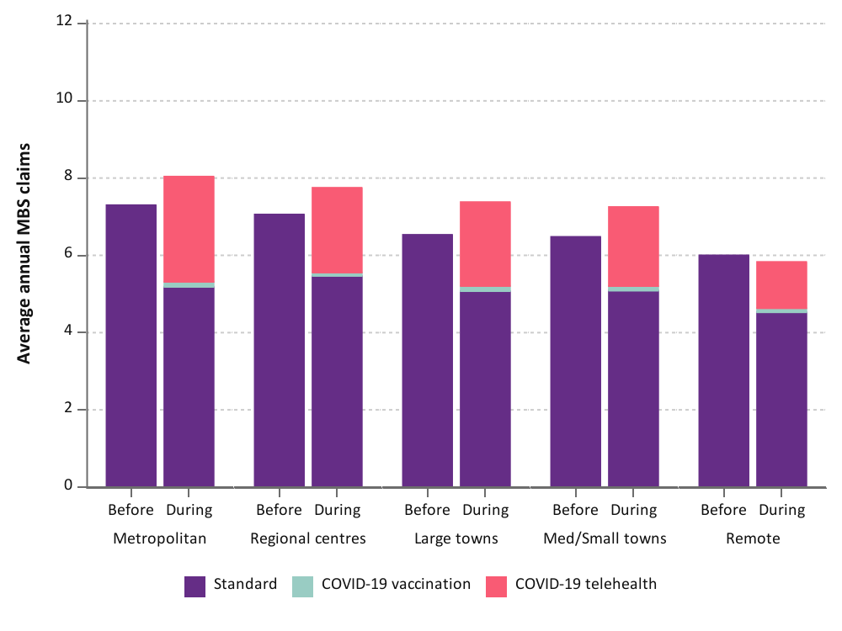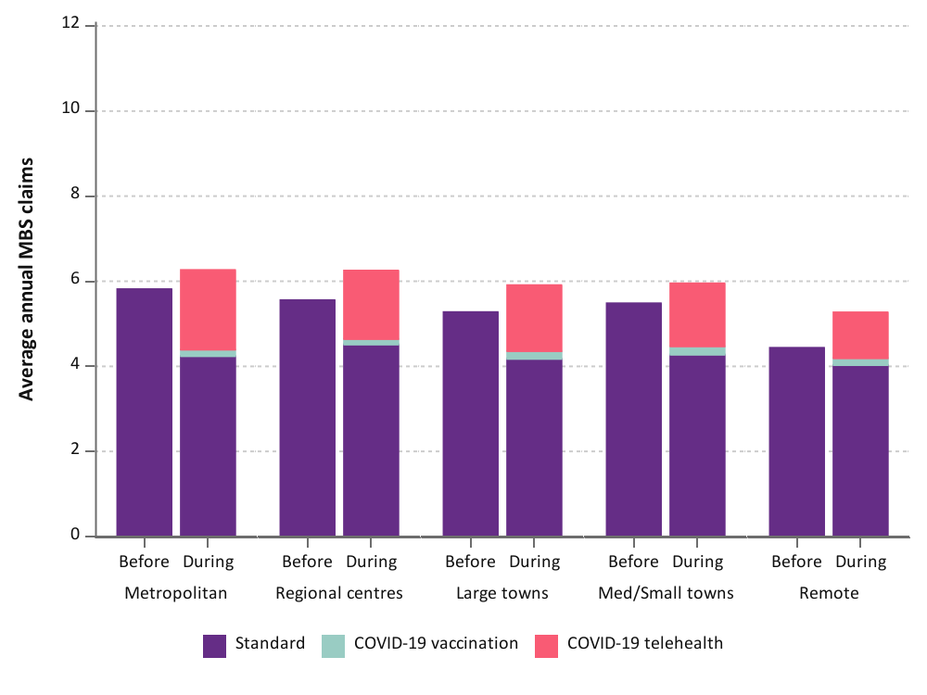
1946-51 cohort
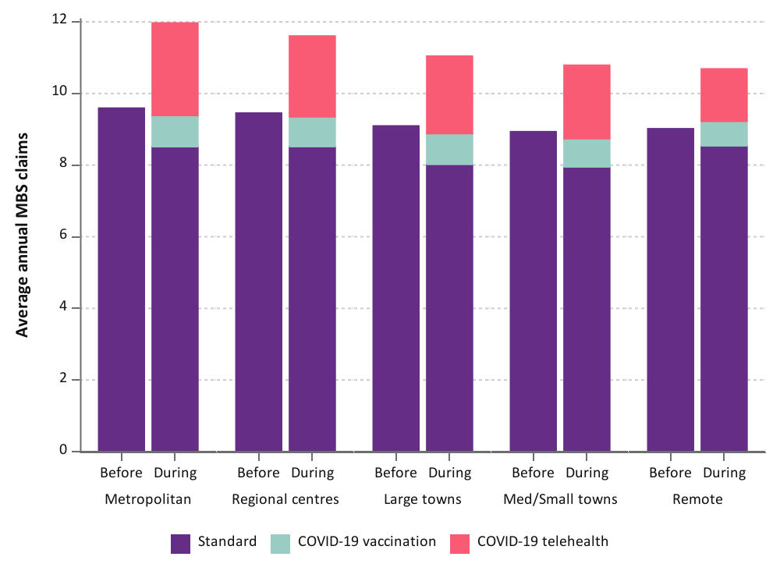
Figure 4-3 Mean annual number of GP services used by women in the 1989-95, 1973-78, and 1946-51 cohorts before and during the COVID-19 pandemic, categorised by type of attendance and area of residence.
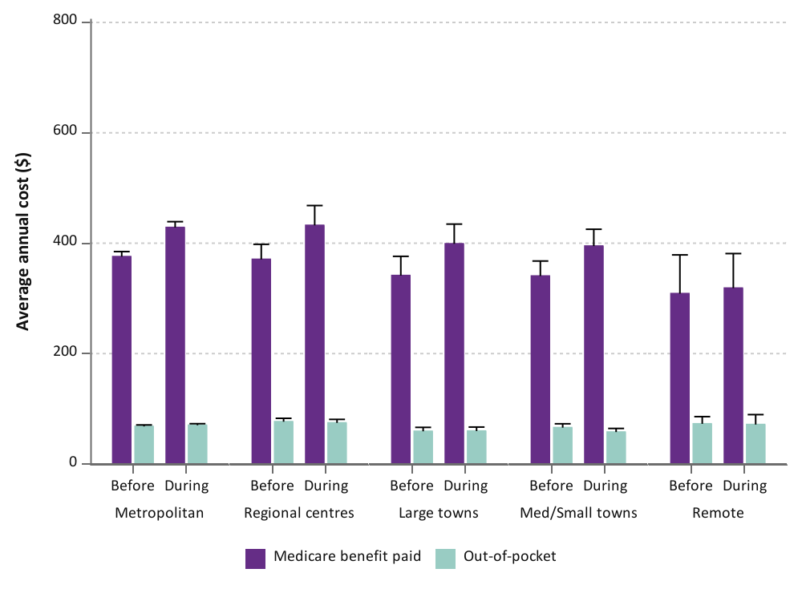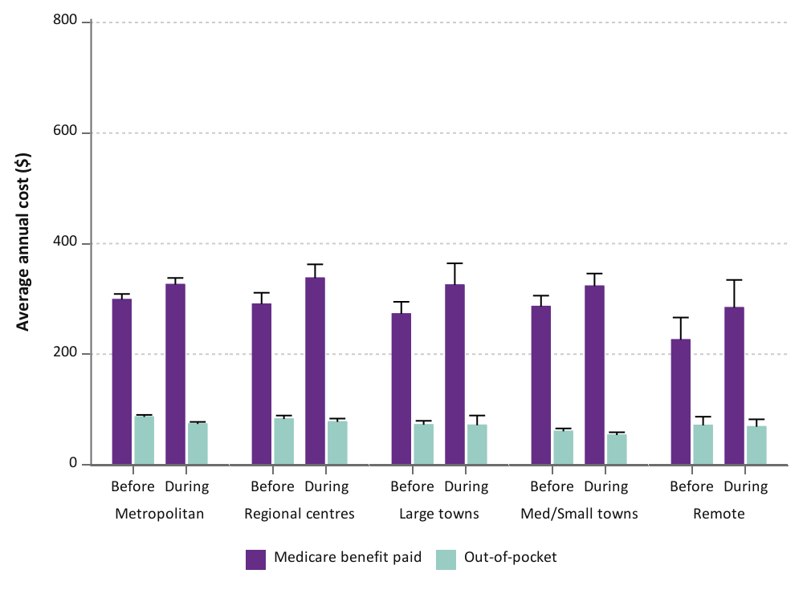
1973-78 cohort
1989-95 cohort
1946-51 cohort
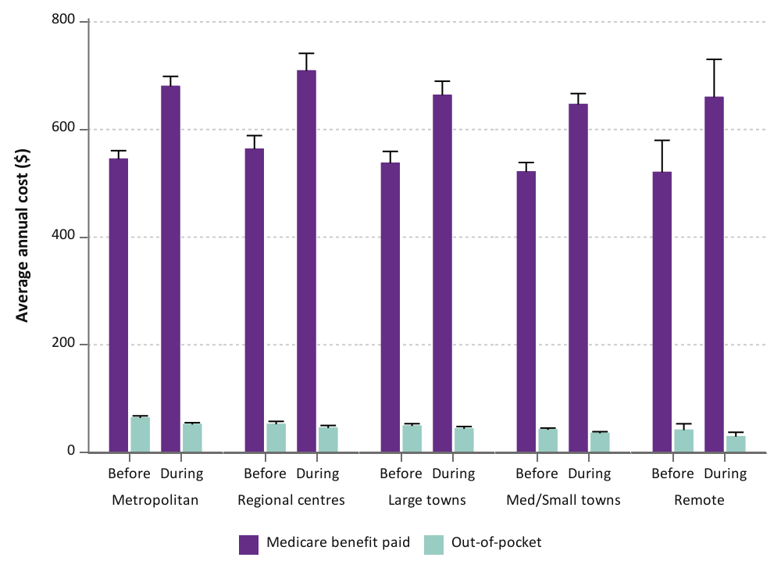
Figure 4-4 Mean annual Medicare benefit paid and out-of-pocket costs for GP services used by women in the 1989-95, 1973-78, and 1946-51 cohort before and during the COVID-19 pandemic, categorised by type of attendance and area of residence.

Ability to manage on income
The slightly higher GP service use during than before the pandemic did not greatly differ by the level of difficulty with income management for all cohorts (Figure 4-5). As expected, women who found it impossible or always difficult to manage on income had up to 3-4 more GP visits per year than women who found it easy to manage on income both before and during the pandemic. A study of SARS-CoV-2 infections in Victoria in 2020 reported that incidence of infections increased with household stress – specifically, mortgage repayments or rent exceeding household income [22]. The mortality rate from COVID-19 for people living in the lowest socioeconomic areas was almost three-fold higher than for those living in the highest socioeconomic areas [4].
The proportion of GP services accessed via telehealth or for the purpose of COVID-19 vaccinations during the COVID-19 pandemic did not differ by ability to manage on income for all cohorts.
For all cohorts, the mean annual out-of-pocket costs for GP services were similar before and during the pandemic, regardless of ability to manage on income (Figure 4-6). Whilst the annual Medicare benefit paid was higher during the COVID-19 pandemic than before (in line with increased GP service use), the mean annual difference did not vary by ability to manage on income for the 1989-95 and 1973-78 cohort. In contrast, the difference in Medicare benefits paid during the pandemic was higher for women in the 1946-51 cohort who found it impossible or always difficult to manage on income (mean annual difference of $160) than for women who found it easy to manage on income (mean annual difference of $124). In this cohort, this may be accounted for by the marginally greater increase in GP service use by women who found it impossible or always difficult to manage on income compared to women who found it easy (2.4 vs 2.1 GP services per year higher on average, respectively).
1989-95 cohort
1973-78 cohort
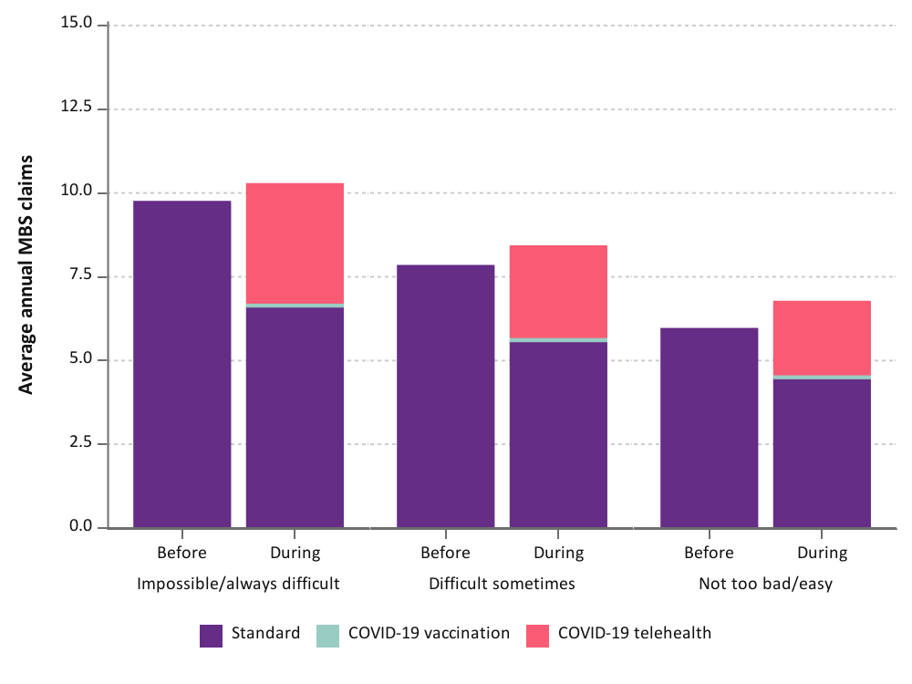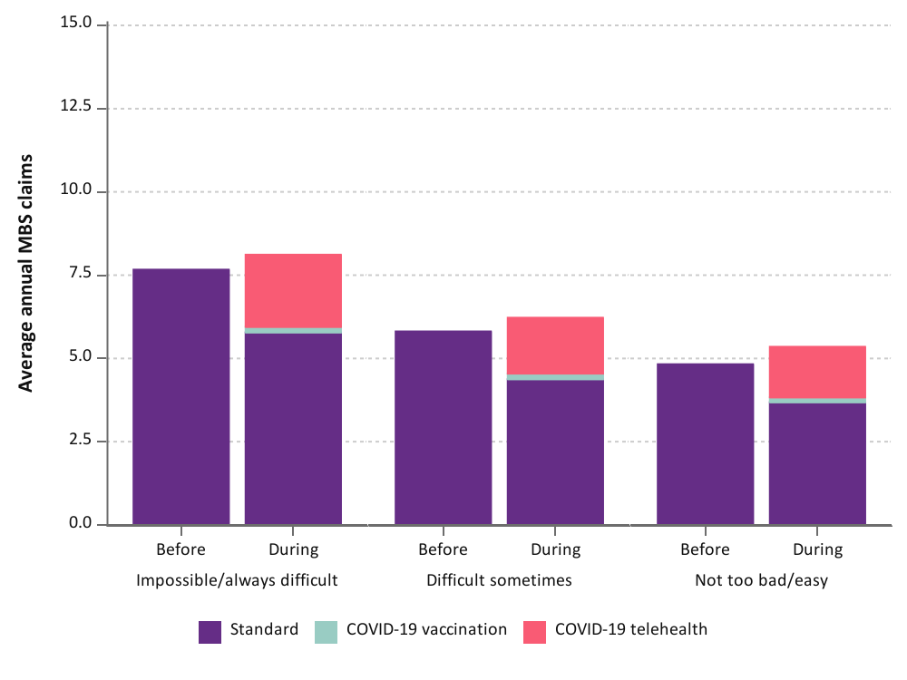
1946-51 cohort
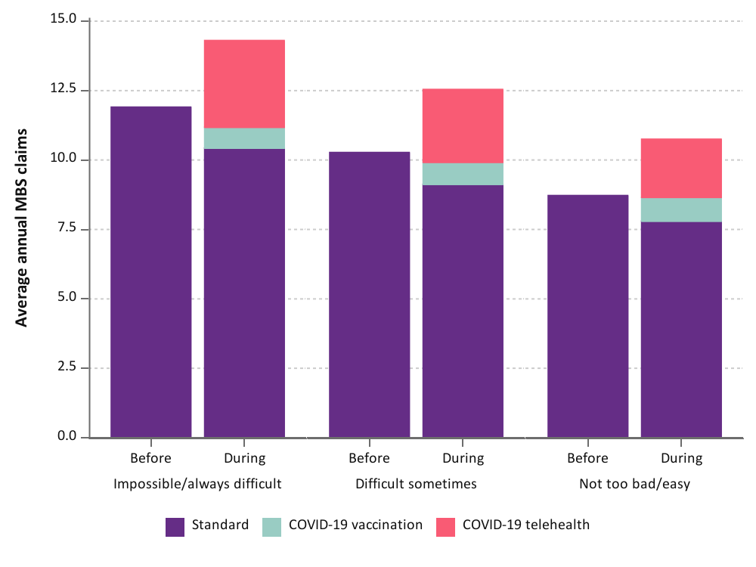
Figure 4-5 Mean annual number of GP services used by women in the 1989-95, 1973-78, and 1946-51 cohort before and during the COVID-19 pandemic, categorised by type of service and ability to manage on income.

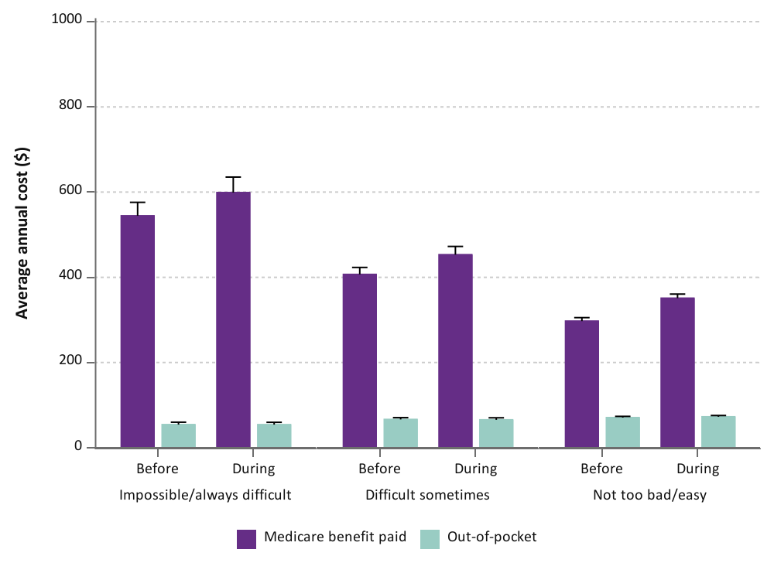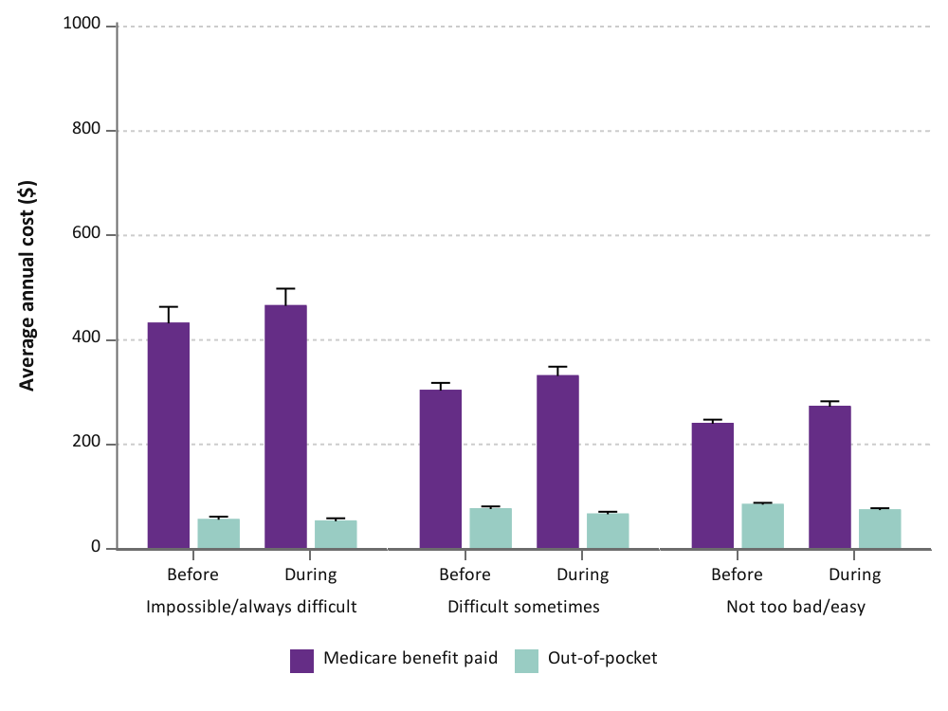
1973-78 cohort
1989-95 cohort
1946-51 cohort
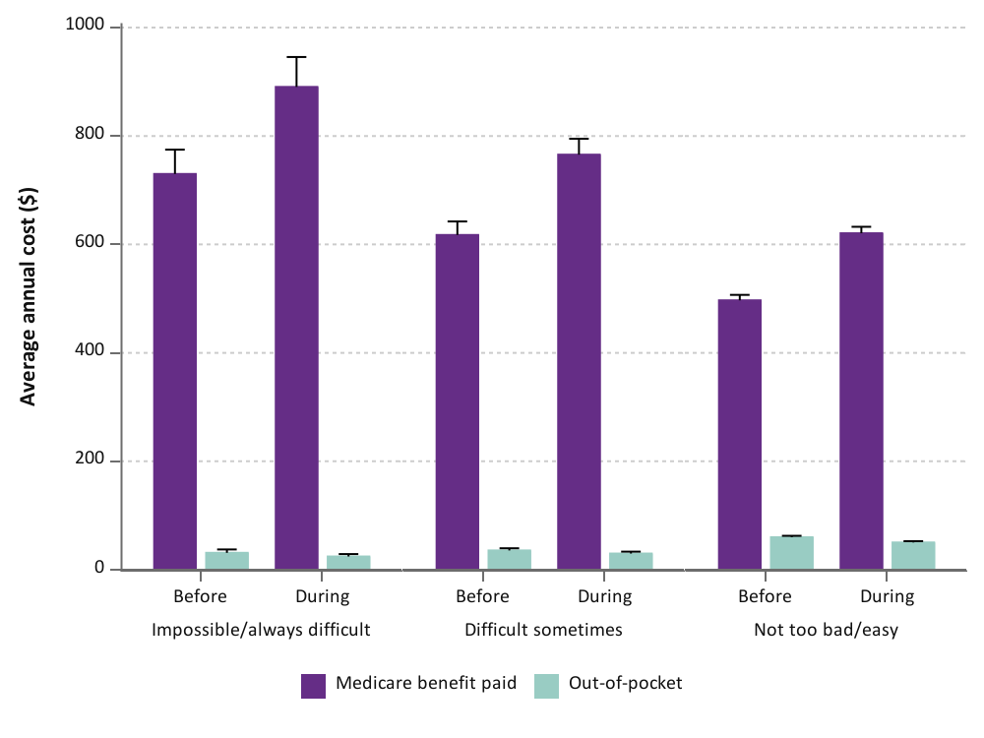

Figure 4-6 Mean annual Medicare benefit paid and out-of-pocket costs for GP services used by women in the 1989-95, 1973-78, and 1945-51 cohort before and during the COVID-19 pandemic, categorised by type of service and ability to manage on income.

History of domestic violence
The increase in GP service use during the COVID-19 pandemic was similar between women who did or did not report ever having experienced domestic violence for the 1973-78 and 1946-51 cohorts (Figure 4-7). For the 1989-95 cohort, women with a history of domestic violence had, on average, one extra GP visit per year during than before the pandemic compared to 0.6 more GP visits per year for women who have never experienced domestic violence.
The proportion of GP consultations delivered via telehealth or for the purpose of obtaining the COVID-19 vaccine was similar between women with or without a history of domestic violence for all cohorts.
Despite the higher health service use for women who are victim-survivors of domestic violence, this was not reflected in the out-of-pocket costs. There was minimal difference in the mean annual out-of-pocket GP costs before and during the pandemic (difference in mean annual cost ranging $0-3) for women in the 1989-95 cohort who had or had not experienced domestic violence (Figure 4-8). For the 1973-78 and 1946-51 cohorts, women who had a history of domestic violence had marginally lower annual out-of-pocket costs (approximately $7-11 less, on average, per year) than women who did not have a history of domestic violence.
In the 1989-95 and 1946-51 cohorts, the difference in the mean annual Medicare benefits paid before and during the COVID-19 pandemic was higher for women with a history of domestic violence than for women who do not have a history of domestic violence ($22 and $34 higher for the 1989-95 and 1946-51 cohorts, respectively; Figure 4-8), due to the somewhat increased GP service use. For women in the 1973-78 cohort, the difference in mean annual Medicare benefits paid before and during the COVID-19 pandemic did not greatly differ by history of domestic violence.

1989-95 cohort
1973-78 cohort
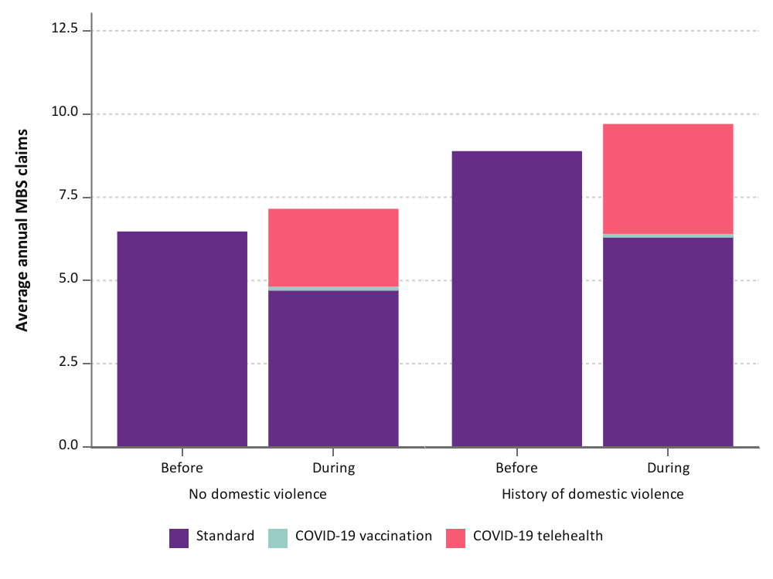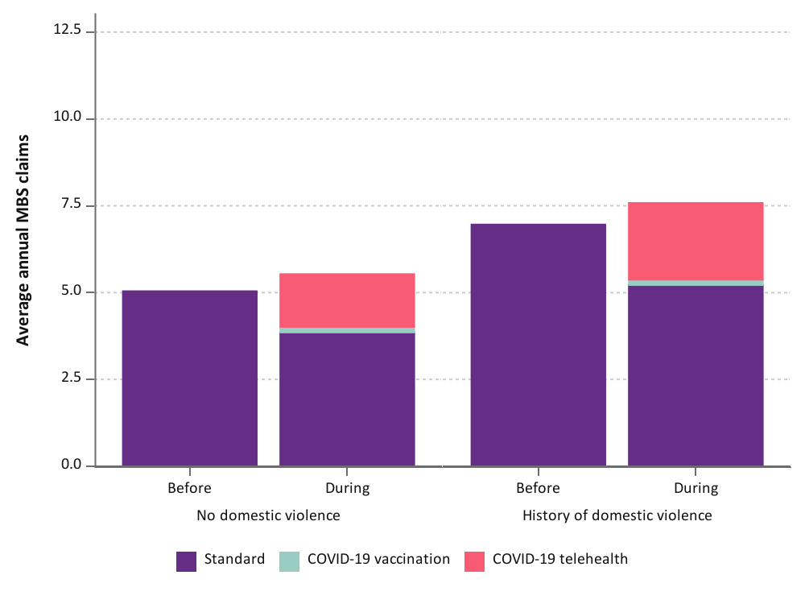
1946-51 cohort
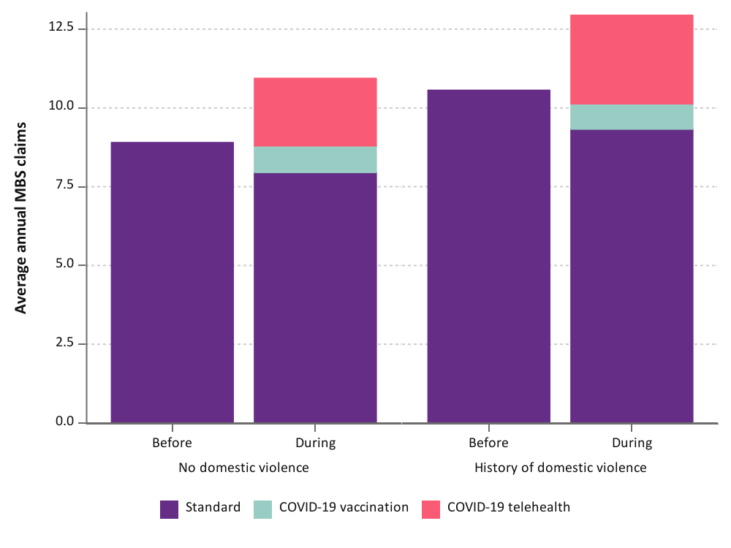
Figure 4-7 Mean annual number of GP services used by women in the 1989-95, 1973-78 and 1946-51 cohorts before and during the COVID-19 pandemic, categorised by type of attendance and history of domestic violence.

1989-95 cohort
1973-78 cohort
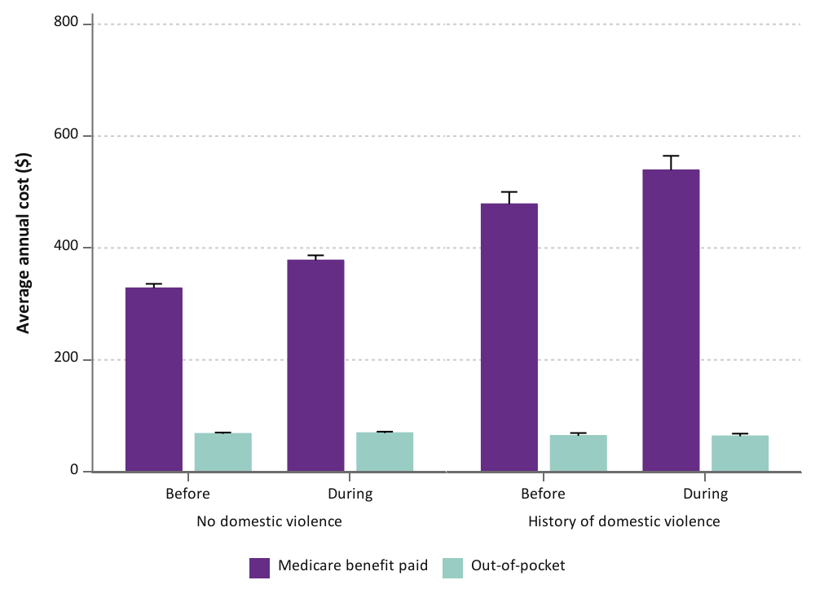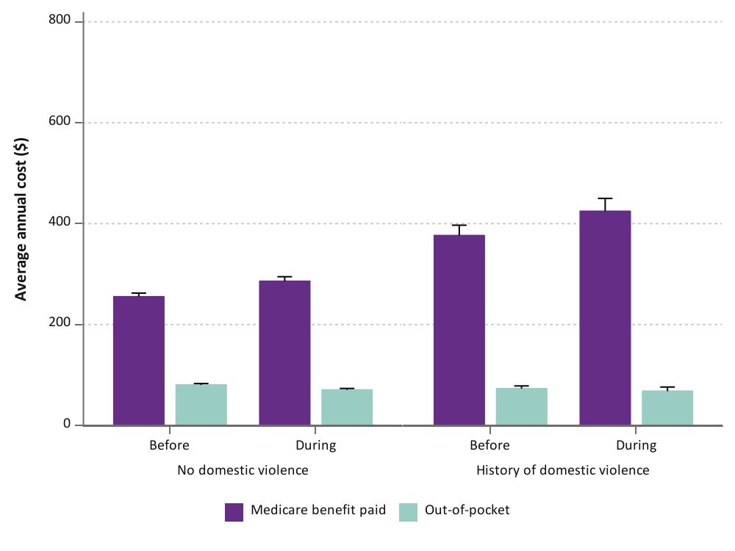
1946-51 cohort
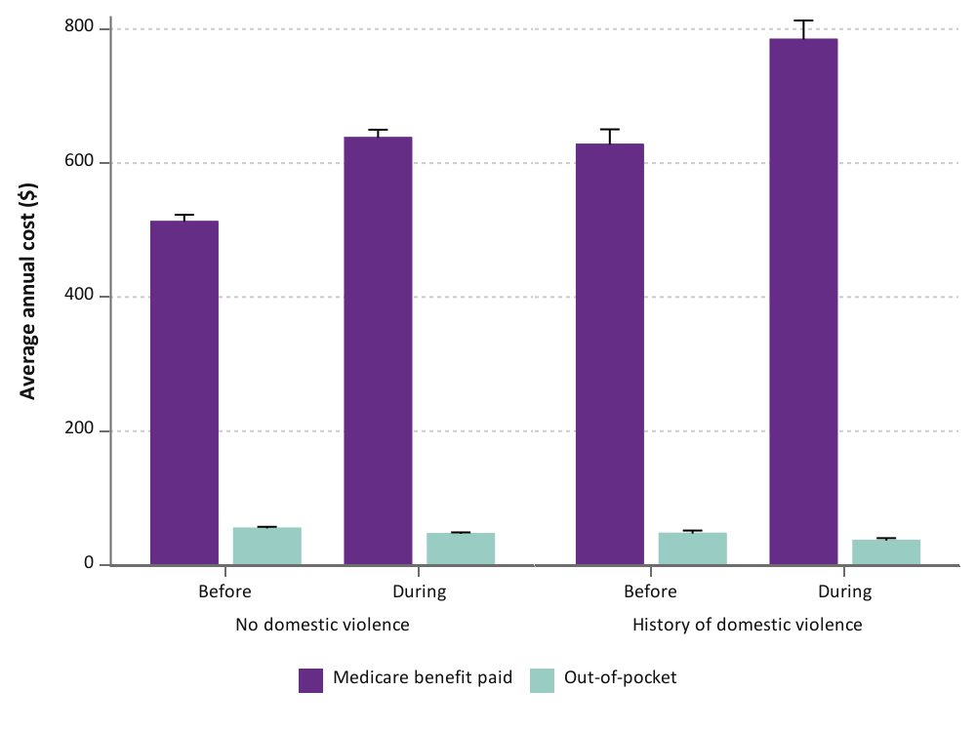
Figure 4-8 Mean annual Medicare benefit paid and out-of-pocket costs for GP services used by women in the 1989-95, 1973-78, and 1946-51 cohorts before and during the COVID-19 pandemic, categorised by type of attendance and history of domestic violence.

Specialist services
Total specialist service use was slightly higher during the COVID-19 pandemic for women in the 1989-95 cohort as more women entered the peak reproductive years and accessed obstetric services (Figure 4-9). There was little difference in the mean annual specialist service use before and during pandemic for the 1973-78 and 1946-51 cohorts.
Although telehealth services introduced at the start of the pandemic accounted for one-third to one-fifth of GP services during the pandemic, only 13-16% of specialist visits (including obstetrics) were undertaken via telehealth for all cohorts (Figure 4-9). A similar study of specialist consultations before and during the pandemic also reported that telehealth represented an average of 19% of consultations [23]. Across the pandemic period, telehealth services accounted for 13-30% of specialist consultations, fluctuating with the COVID-19 waves [19]. Like GP services, we and others found that telehealth services for specialist appointments were primarily conducted via telephone rather than video conferencing [4, 19]. There was greater uptake of video conferencing by younger women for specialist consultations (excluding obstetric services) than older women (38% for the 1989-95 cohort vs 9% for the 1946-51 cohort; data not shown). However, for obstetric services, less than 10% of consultations were undertaken via telehealth and over 89% was by phone (data not shown).

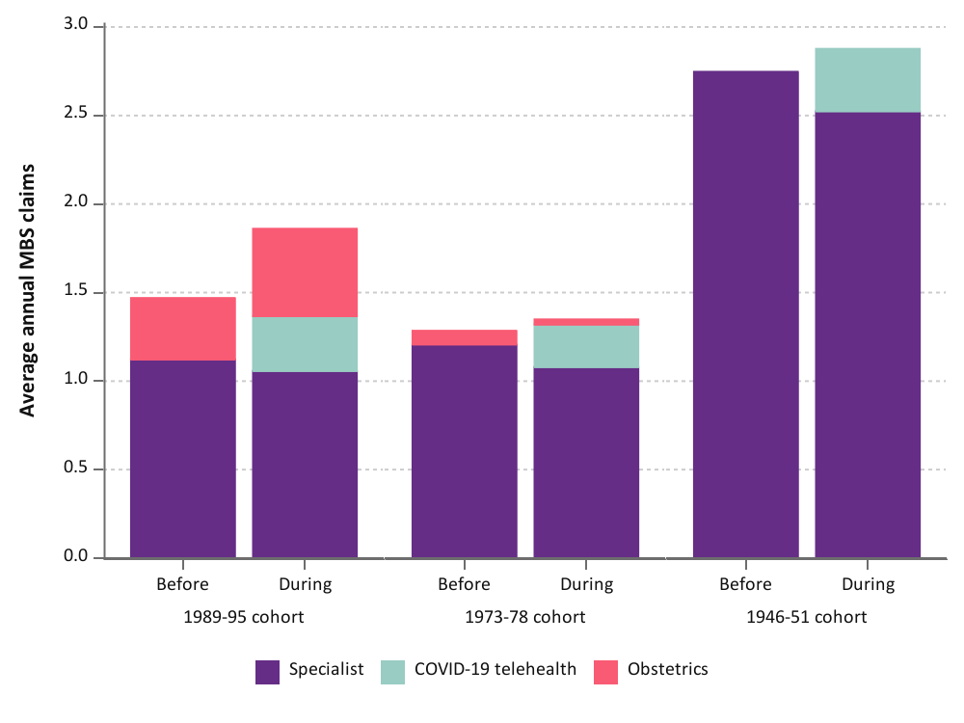
Figure 4-9 Mean annual number of Specialist services used by women in the 1989-95, 1973-78, and 1946-51 cohorts before and during the COVID-19 pandemic, categorised by type of service.

For the 1989-95 cohort, the Medicare benefits paid and out-of-pocket costs were approximately $40 higher during the pandemic due to the higher specialist service use (Figure 4-10). There was little difference in specialist costs for the 1973-78 and 1946-51 cohorts before and during the pandemic.
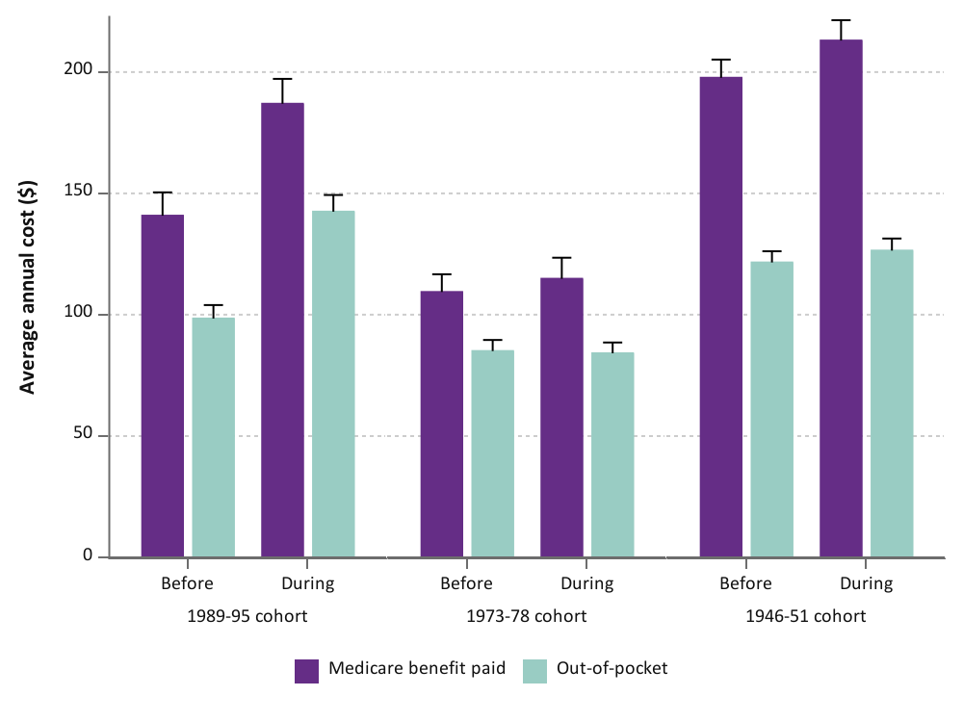
Figure 4-10 Mean annual Medicare benefit paid and out-of-pocket costs for Specialist services used by women in the 1989-95, 1973-78, and 1946-51 cohorts before and during the COVID-19 pandemic.

Area of residence
For all cohorts, the increase in the mean annual number of specialist services used (including obstetrics for the younger women) during the COVID-19 pandemic did not differ by area of residence (Figure 4-11). For the 1989-95 cohort, obstetric service use increased during the pandemic for women living in metropolitan areas, but did not change or decreased for women in rural and remote areas. Because women in rural and remote areas tend to have children at a younger age (around the age of 20) [9] and women in this cohort were aged 25-31 years during the pandemic (Table 2-1), this may explain why obstetric services increased for women in metropolitan areas.
Telehealth service use fluctuated by area of residence for all cohorts, ranging from 9-21%.
For all cohorts, both the out-of-pocket costs and Medicare benefits paid reflected the differences in specialist service use by area of residence (Figure 4-12).

1989-95 cohort
1973-78 cohort
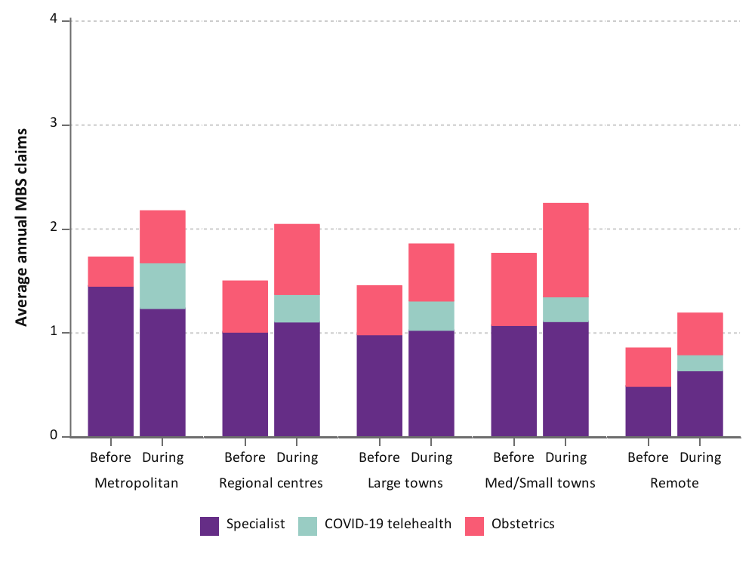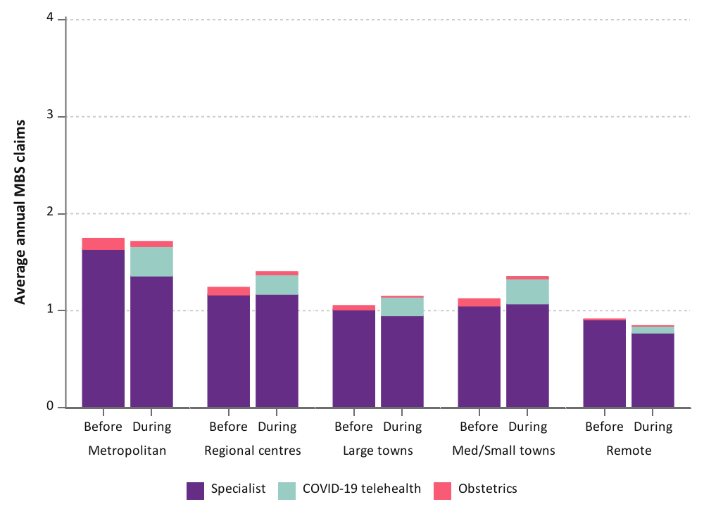
1946-51 cohort
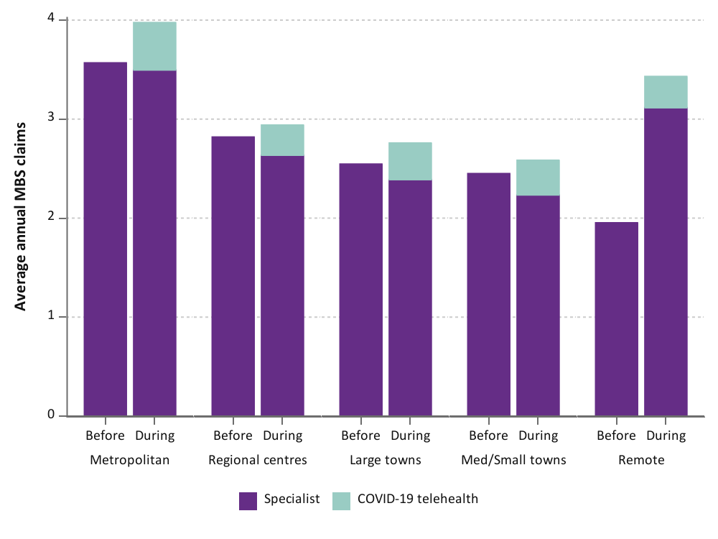
Figure 4-11 Mean annual number of Specialist services used by women in the 1989-95, 1973-78, and 1946-51 cohort before and during the COVID-19 pandemic, categorised by type of service and area of residence.
1973-78 cohort
1946-51 cohort
1989-95 cohort
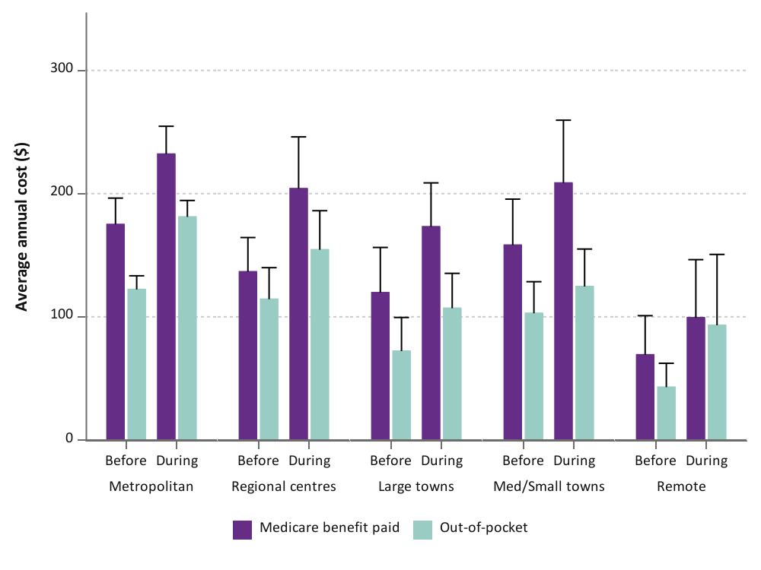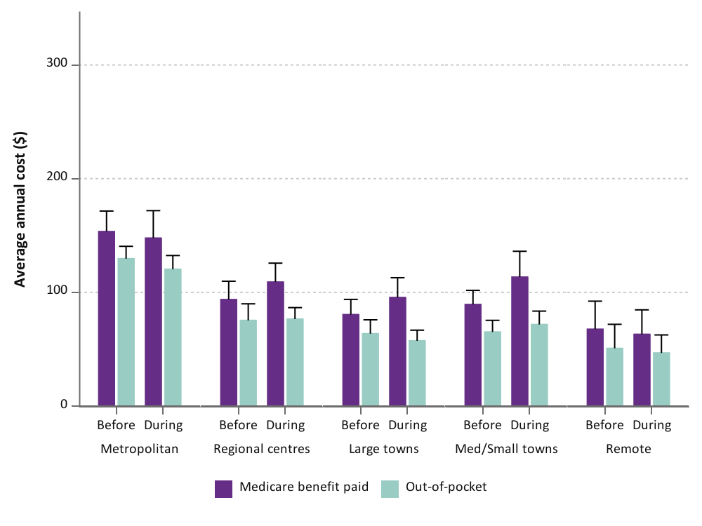

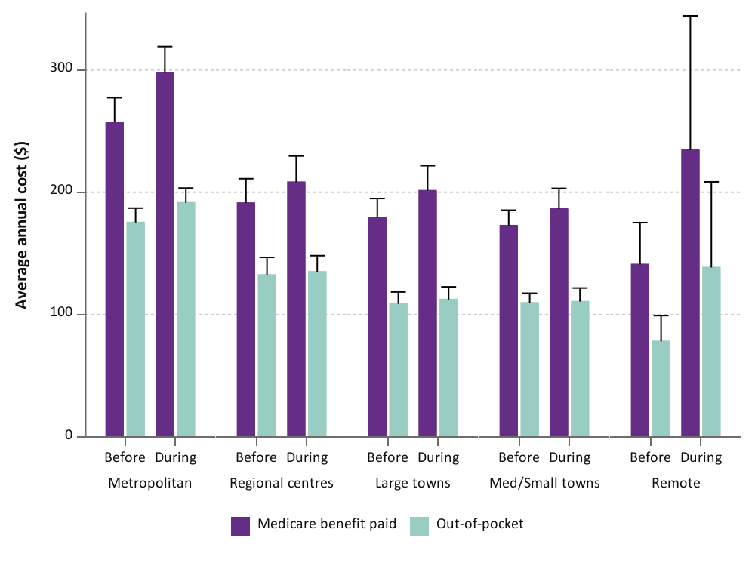
Figure 4-12 Mean annual Medicare benefit paid and out-of-pocket costs for GP services used by women in the 1989-95, 1973-78, and 1946-51 cohorts before and during the COVID-19 pandemic, categorised by area of residence.

Ability to manage on income
For the 1973-78 and 1946-51 cohorts, the level of specialist service use did not change during the pandemic for women who reported that it was impossible or always difficult to manage on income (Figure 4-13). For women in the 1989-95 cohort who sometimes found it difficult or who found it easy to manage on increase had a slight increase (annually 0.4-0.6 visits more, on average) in specialist service use during the pandemic. For women who found it easy to manage on income, this was due to the increased use of obstetric services (8.5%). There was little difference in obstetric service use during the pandemic for women who found it more difficult to manage on income.
There was little variation in telehealth service use by ability to manage on income for all cohorts.
For all cohorts, the Medicare benefits paid and out-of-pocket costs reflected the differences in specialist service use by ability to manage on income (Figure 4-14).

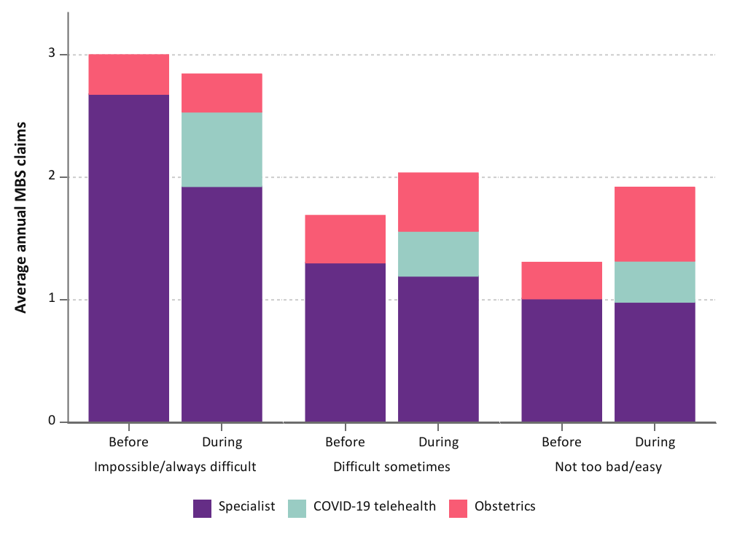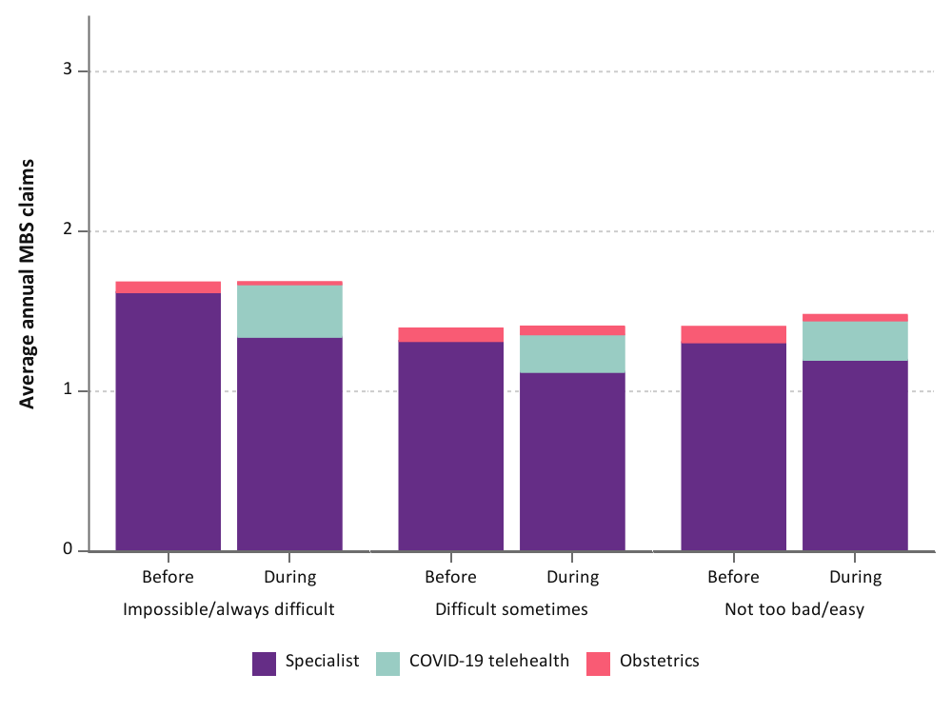
1973-78 cohort
1989-95 cohort
1946-51 cohort

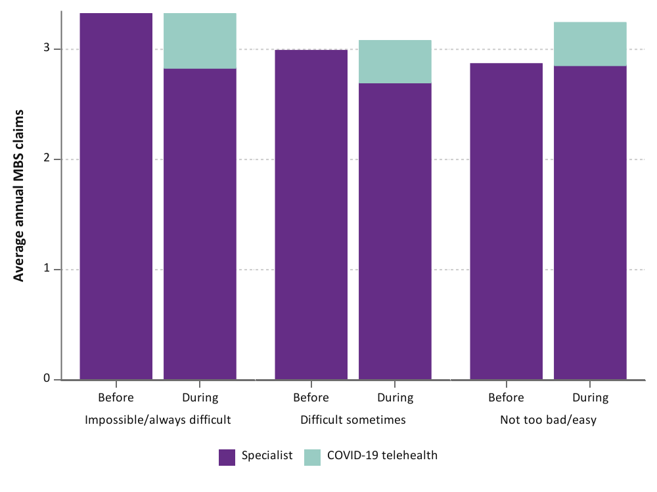
Figure 4-13 Mean annual number of specialist services used by women in the 1989-95, 1973-78, and 1946-51 cohort before and during the COVID-19 pandemic, categorised by type of service and ability to manage on income.
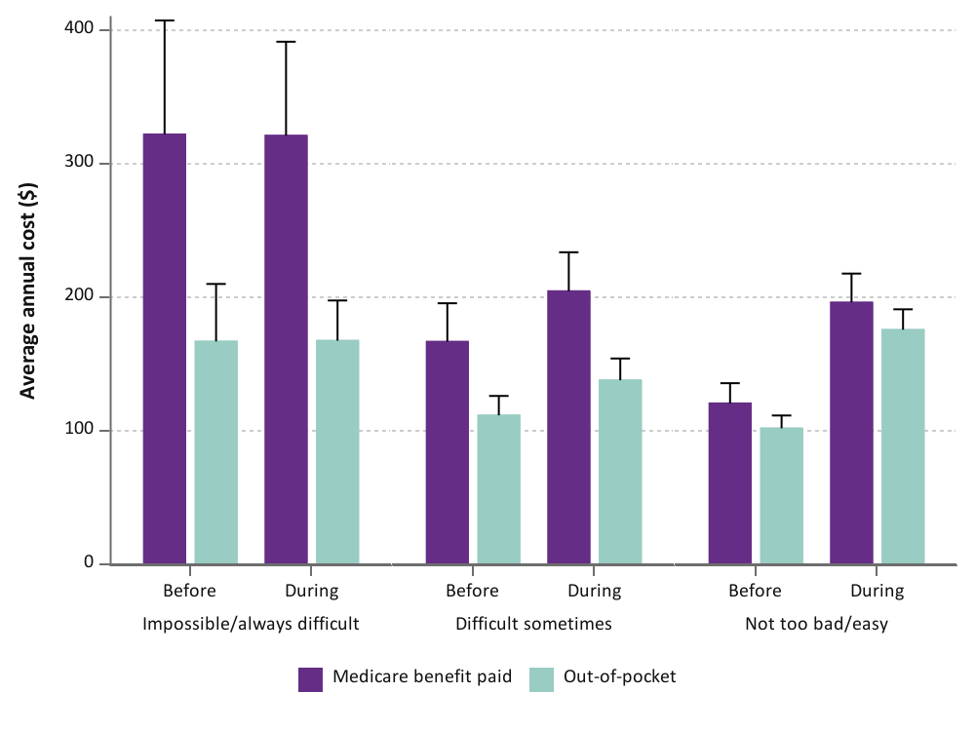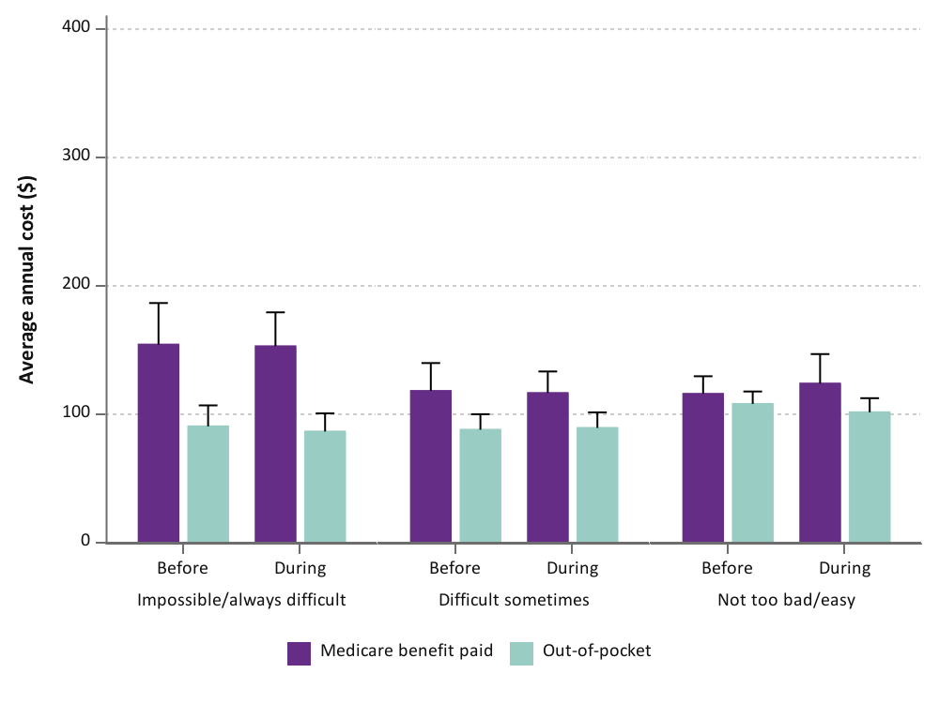
1973-78 cohort
1989-95 cohort
1946-51 cohort

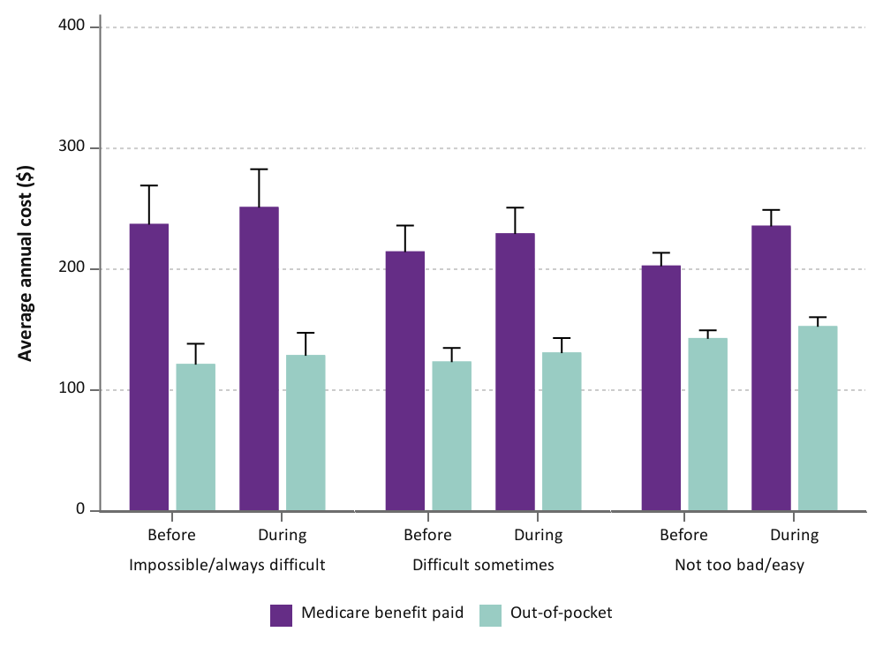
Figure 4-14 Mean annual Medicare benefit paid and out-of-pocket costs for specialist services used by women in the 1989-95 cohort before and during the COVID-19 pandemic, categorised by ability to manage on income.

History of domestic violence
For all cohorts, the difference in mean annual specialist or obstetric services used during the pandemic compared to before the pandemic did not differ between women who did or did not have a history of domestic violence (Figure 4-15). Furthermore, use of telehealth services during the pandemic was similar between women with or without a history of domestic violence for all cohorts (Figure 4-16).

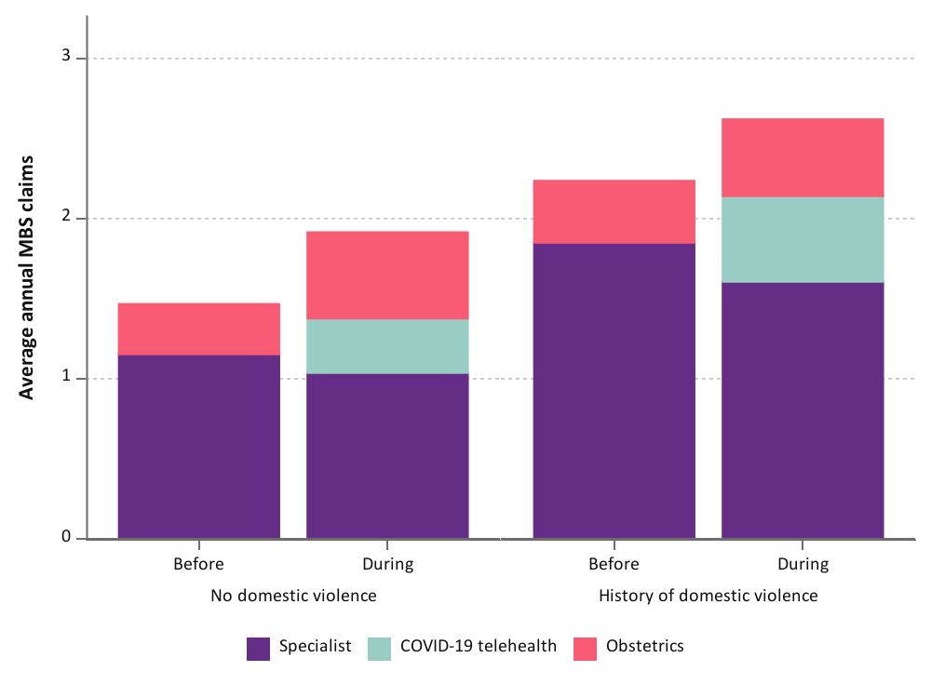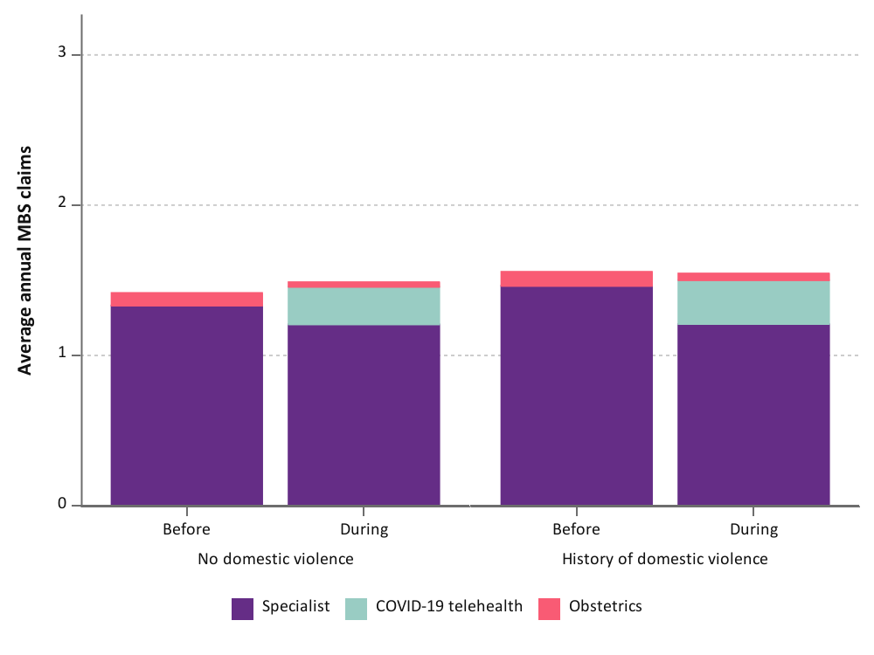
1973-78 cohort
1989-95 cohort
1946-51 cohort
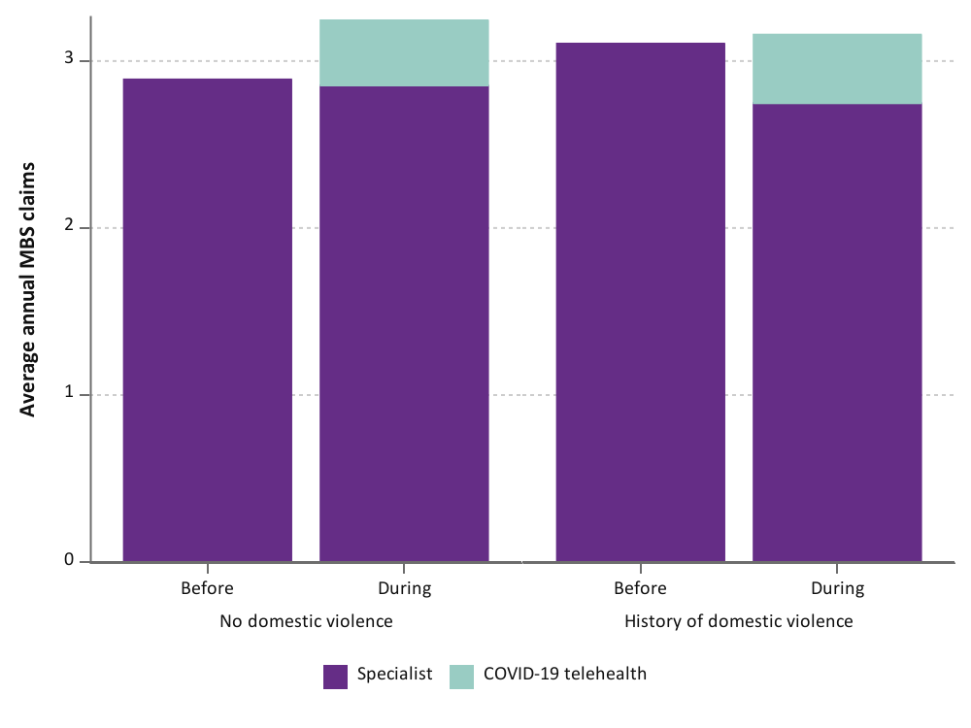
Figure 4-15 Mean annual number of specialist services used by women in the 1989-95, 1973-78, and 1946-51 cohorts before and during the COVID-19 pandemic, categorised by type of service and history of domestic violence.

1973-78 cohort
1989-95 cohort
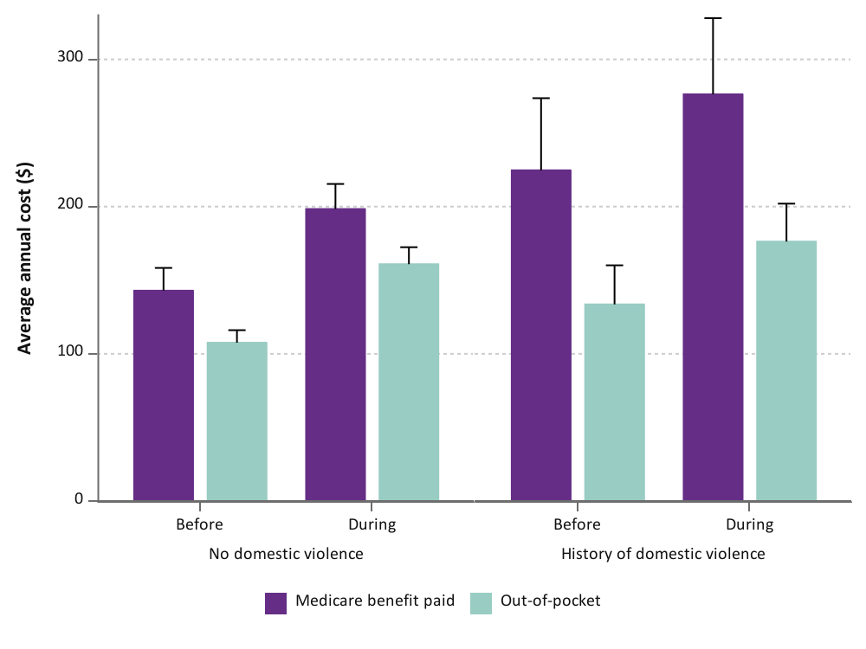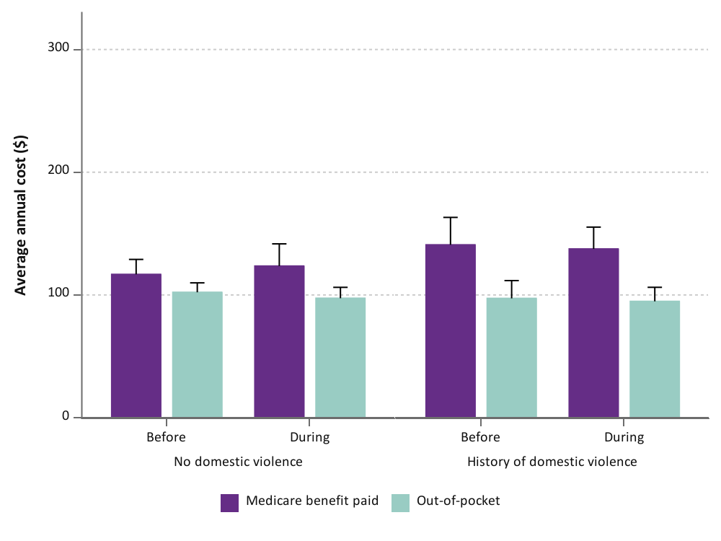
1946-51 cohort
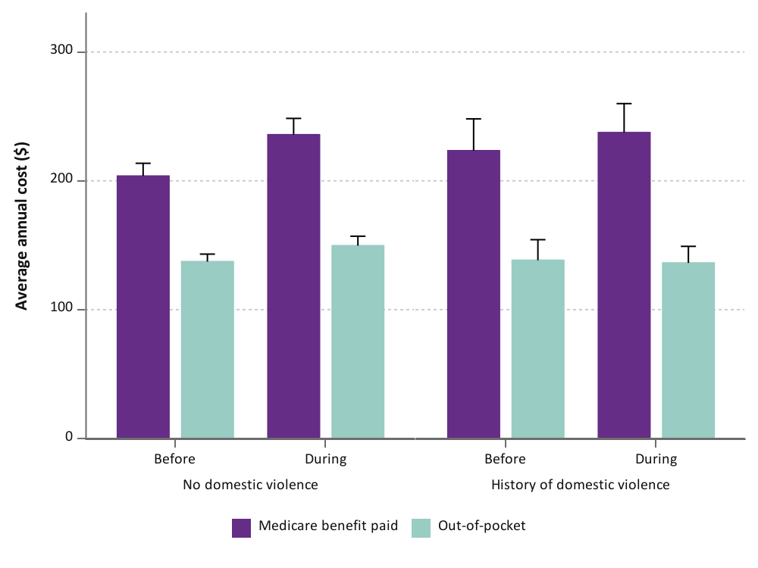
Figure 4-16 Mean annual Medicare benefit paid and out-of-pocket costs for specialist services used by women in the 1946-51 cohort before and during the COVID-19 pandemic, categorised by history of domestic violence.

Mental health services
The Better Access initiative (also known as the Better Access to Psychiatrists, Psychologists and General Practitioners through the Medicare Benefits Schedule) aims to help people who have a diagnosed mental health disorder gain access to mental health services [24]. A GP, psychiatrist, or paediatrician can refer patients for psychological assessment and treatment by clinical psychologists and targeted therapies by qualified GPs, psychologists, social workers, and occupational therapists. This initiative provides Medicare rebates for up to ten individual and ten group-based mental health services per calendar year. It also provides funding for health professionals to gain specialised skills in administering effective mental health treatment.
Due to the COVID-19 pandemic, mental health services delivered via telehealth (previously available to people living in rural and remote areas (MM4-7)) were offered to all people [24]. At the height of the first wave, 50.5% of MBS mental health services were delivered via telehealth [25].
Mental health service attendance increased during the COVID-19 pandemic for women in the 1989-95 cohort, but not for the other two cohorts (Figure 4-17). The ALSWH COVID-19 mini-surveys consistently showed that younger women were more likely to report feeling very or extremely stressed as well as experiencing high or very high levels of psychological distress during the pandemic than older women at different times during the pandemic (see Section 3.2.2). Furthermore, a greater proportion of women in the 1989-95 cohort accessed at least one mental health service during the pandemic than women in the 1973-78 and 1946-51 cohorts (see Section 3.3.2).
Both before and during the pandemic, there were on average twice as many mental health services provided by allied health professionals than by GPs for all cohorts.
As with other health services, younger women took advantage of telehealth for mental health services during the pandemic with approximately one-third of all consultations for the 1989-95 and 1973-78 cohorts conducted via telehealth (Figure 4-17). For the 1946-51 cohort, one-fifth of mental health services were delivered via telehealth.

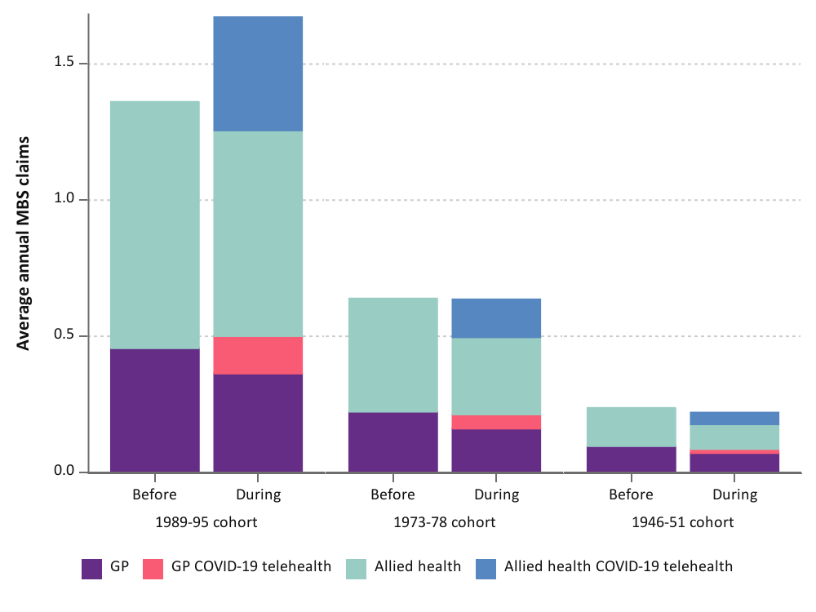
Figure 4-17 Mean annual number of mental health services used by women in the 1989-95, 1973-78, and 1946-51 cohorts before and during the COVID-19 pandemic, categorised by type of service.

Area of residence
For the 1989-95 cohort, mental health service use increased during the pandemic from pre-pandemic levels, however the difference decreased with remoteness (Figure 4-18).
Although mental health services provided by a GP were similar by area of residence, allied health service use decreased with remoteness both before and during the pandemic. The proportion of mental health services delivered by telehealth was similar but varied by area of residence for this cohort, ranging from 29% (remote) to 36% (metropolitan). Whilst 30-37% of allied health treatments were delivered via telehealth for all categories of area of residence, GP telehealth mental health services had greater uptake in metropolitan areas (31% of all GP mental health services) compared to non-metropolitan areas (16-21%).
For the 1973-78 cohort, mental health service use was similar before and during the COVID-19 pandemic by area of residence (Figure 4-18). GP-based mental health service use did not differ with remoteness, except for women living in the most remote areas where the mean annual GP mental health services use was approximately half that of women living in all other areas. Similar to women in the 1989-95 cohort, mental health services administered by an allied health professional were predominantly used by women in the 1973-78 cohort both before and during the pandemic. The proportion of mental health services delivered by telehealth for both GP and allied health treatments decreased with remoteness.
There was very little use of mental health services both before and during the COVID-19 pandemic amongst women in the 1946-51 cohort, however there was greater use in more populated than remote areas.

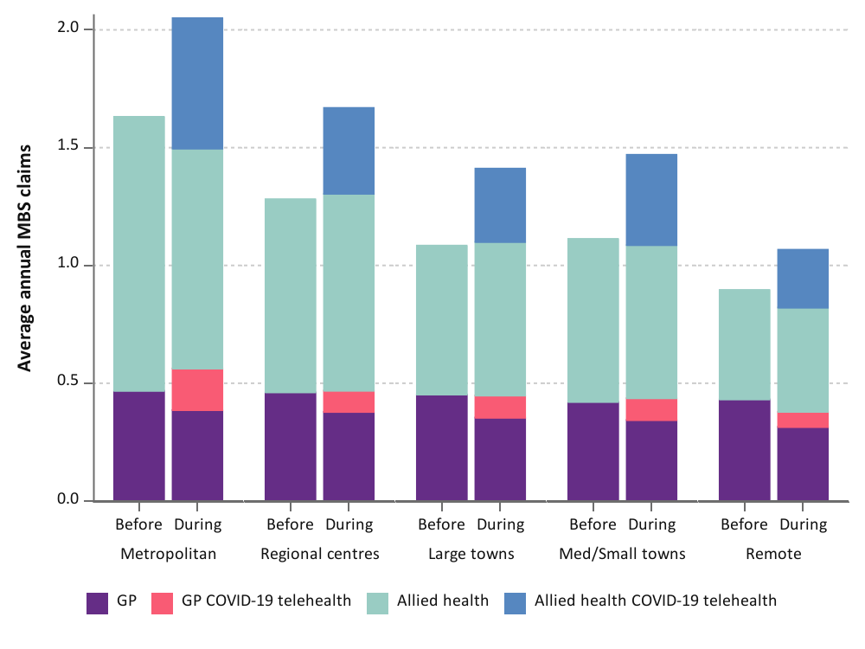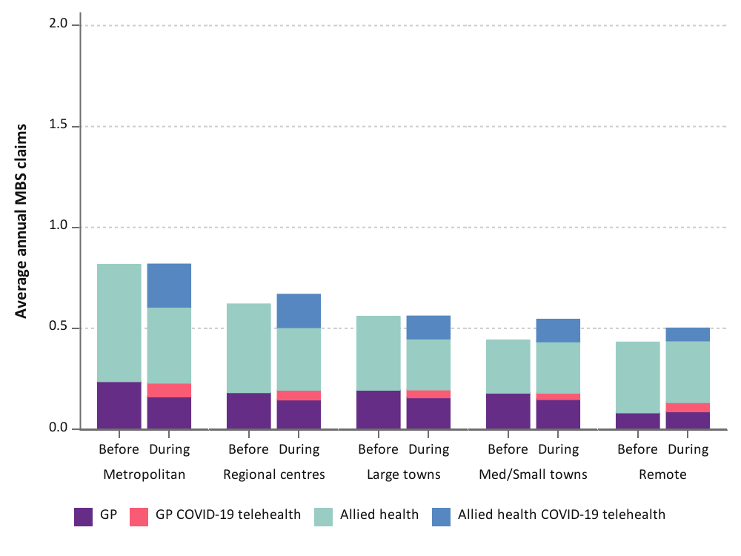
1973-78 cohort
1989-95 cohort
1946-51 cohort
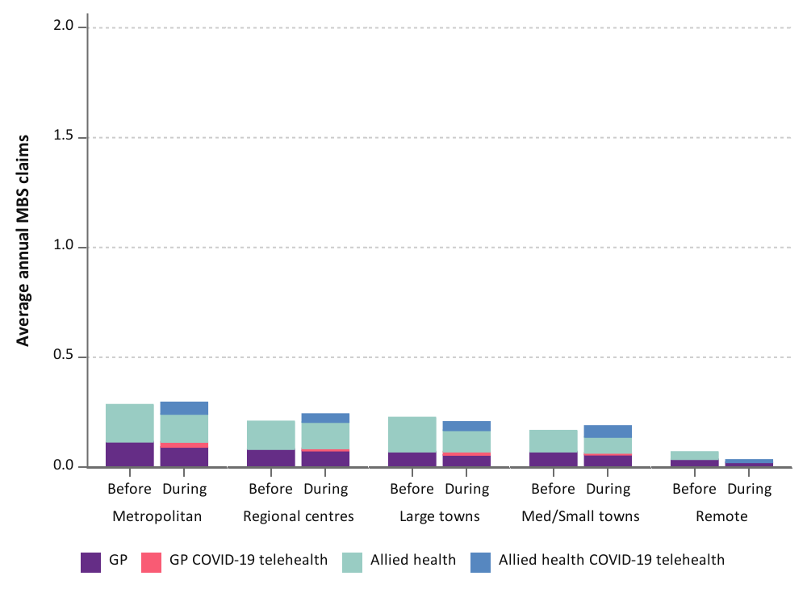

Figure 4-18 Mean annual number of mental health services used by women in the 1989-95, 1973-78, and 1946-51 cohort before and during the COVID-19 pandemic, categorised by type of service and area of residence.

Ability to manage on income
For the 1989-95 cohort, although mental health service use increased with difficulty managing on income, the elevated mental health service use during the COVID-19 pandemic was greater amongst women who found it easy to manage on income compared to women who had more difficulty (Figure 4-19). For women in the 1973-78 and 1946-51 cohorts, mental health service use did not vary before and during the pandemic.
There was little difference in the proportion of telehealth service use for mental health services according to ability to manage on income and regardless of whether the treatment was delivered by a GP or allied health professional.

1989-95 cohort
1973-78 cohort
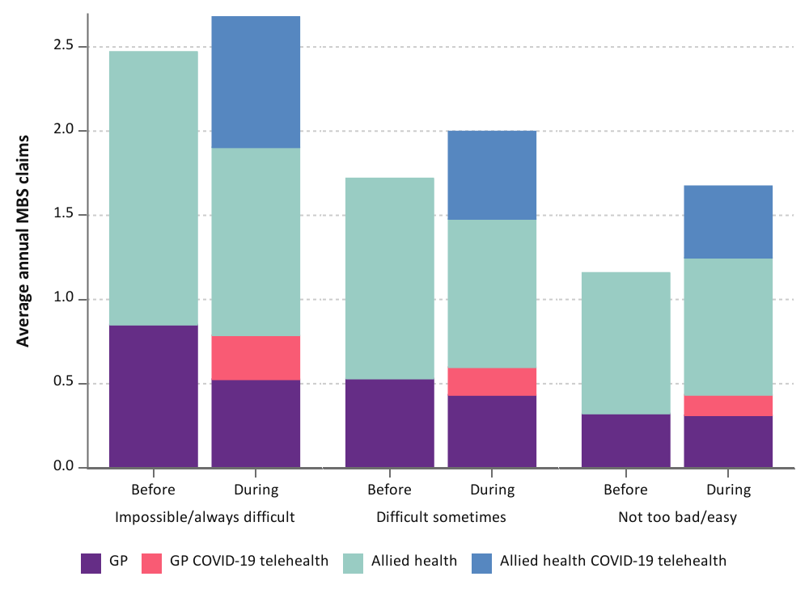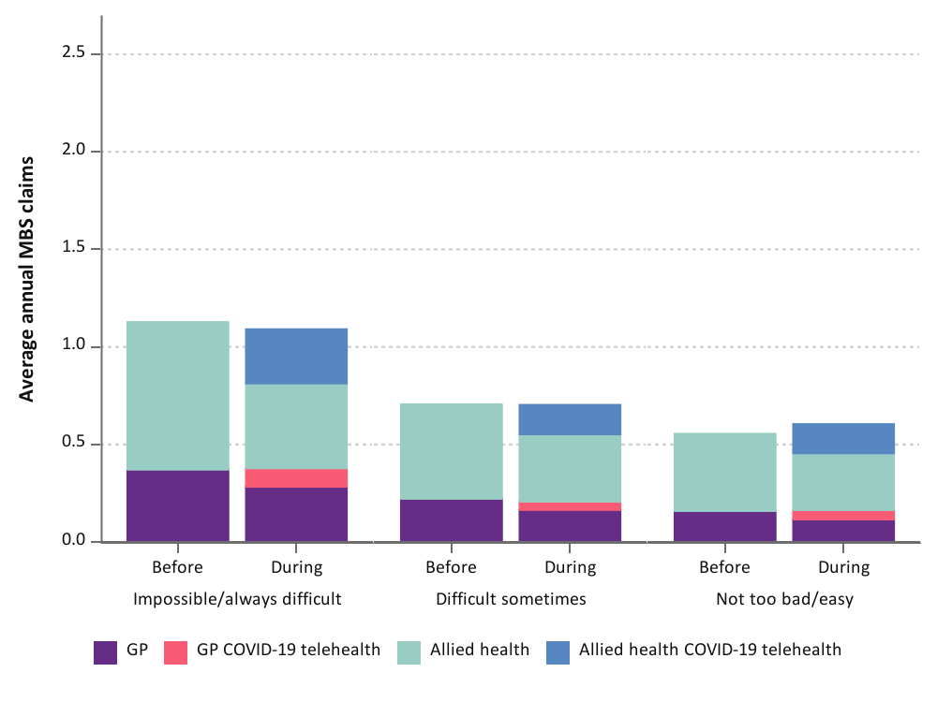
1946-51 cohort
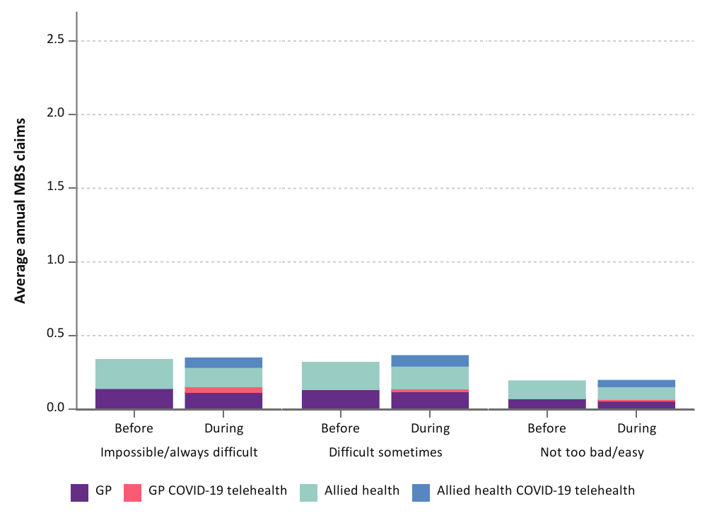
Figure 4-19 Mean annual number of mental health services used by women in the 1989-95, 1973-78, and 1946-51 cohorts before and during the COVID-19 pandemic, categorised by type of service and ability to manage on income.

History of domestic violence
Mental health service use was only higher during the pandemic for women in the 1989-95 cohort and the magnitude of increase did not differ between women who did or did not have a history of domestic violence (Figure 4-20). For women in the 1973-78 and 1946-51 cohorts, there was no difference in mental health service use before and during the pandemic regardless of whether they had a history of domestic violence.
Approximately one-third of mental health services were delivered via telehealth for the 1989-95 cohort and there were no differences between women who had or had not experienced domestic violence. For the 1973-78 cohort, women who had experienced domestic violence used more telehealth mental health services (one in three claims) than women who had not experienced domestic violence (one in five claims).

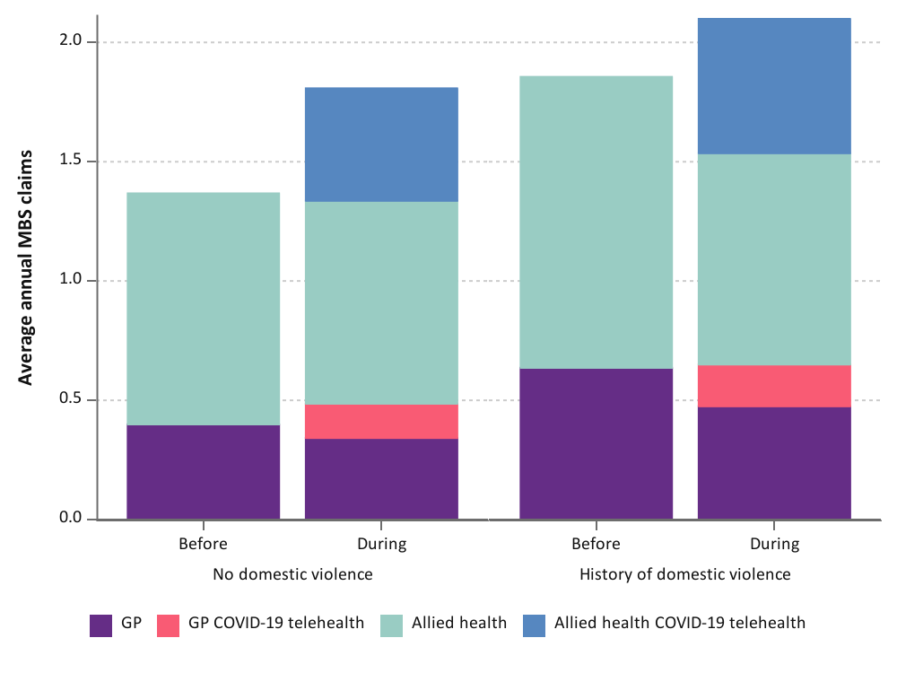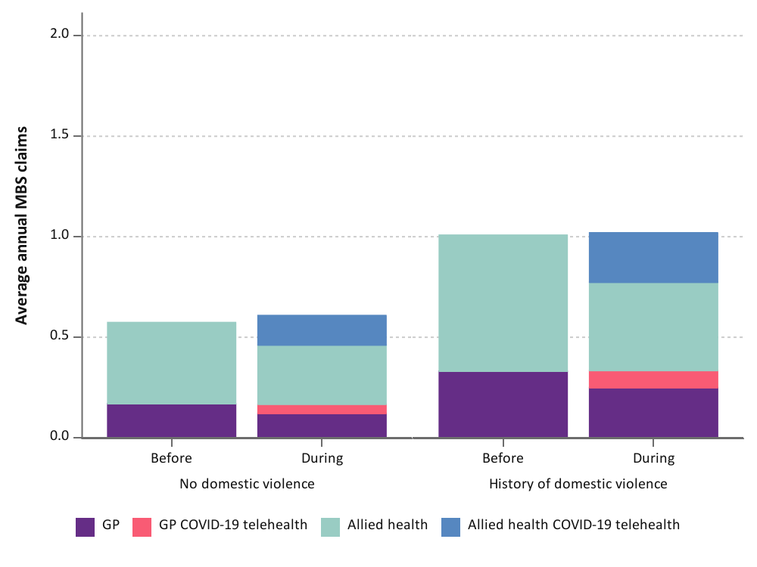
1973-78 cohort
1989-95 cohort
1946-51 cohort

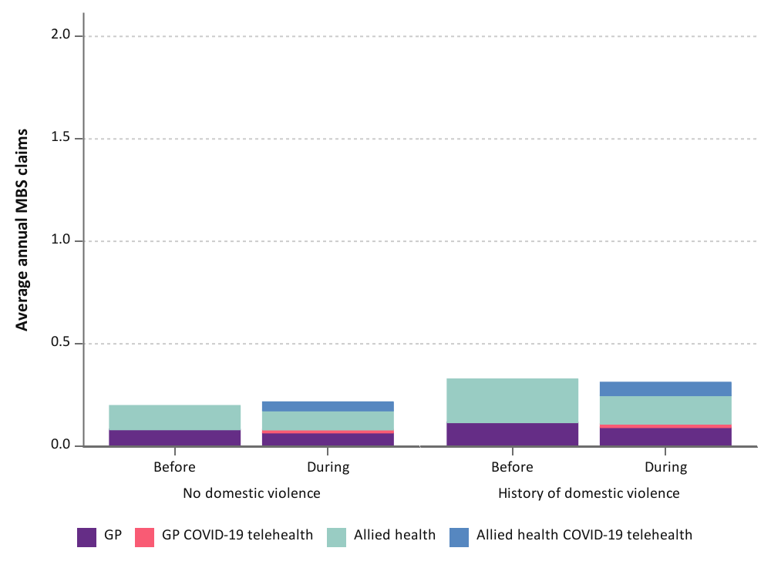
Figure 4-20 Mean annual number of mental health services used by women in the 1989-95, 1973-78, and 1946-51 cohort before and during the COVID-19 pandemic, categorised by type of service and history of domestic violence.

Participation in national cervical cancer screening program
The National Cervical Screening Program is a five-yearly test targeted for 25-74 year old individuals to detect the human papillomavirus (HPV) in cervical tissue [26]. The mean number of HPV tests was lower during than before the COVID-19 pandemic for women in all cohorts (Figure 4-21). This is consistent with a report from the AIHW that compared HPV tests between 2019 and 2020 [5]. Because the screening program changed from 2-yearly Pap tests to 5-yearly Cervical Screening Tests in December 2017, it was expected that cervical screening would be lower in 2020-2022 [27]. For women in the 1989-95 cohort, cervical screening decreased the least (by approximately 32%) during the pandemic. This is despite more women in the 1989-95 cohort (10%) reporting delays in cervical screening than those in the other two cohorts (1-5%; [28]). The 1973-78 cohort had the highest participation rate before the pandemic; however, the rate fell by 59% during the pandemic. For the 1946-51 cohort, the mean annual rate of HPV tests during the pandemic was approximately half the rate observed before the pandemic. This may be partly due to some women in this cohort (about one in ten were born in 1946) exceeding the upper age limit for the screening program during the pandemic.
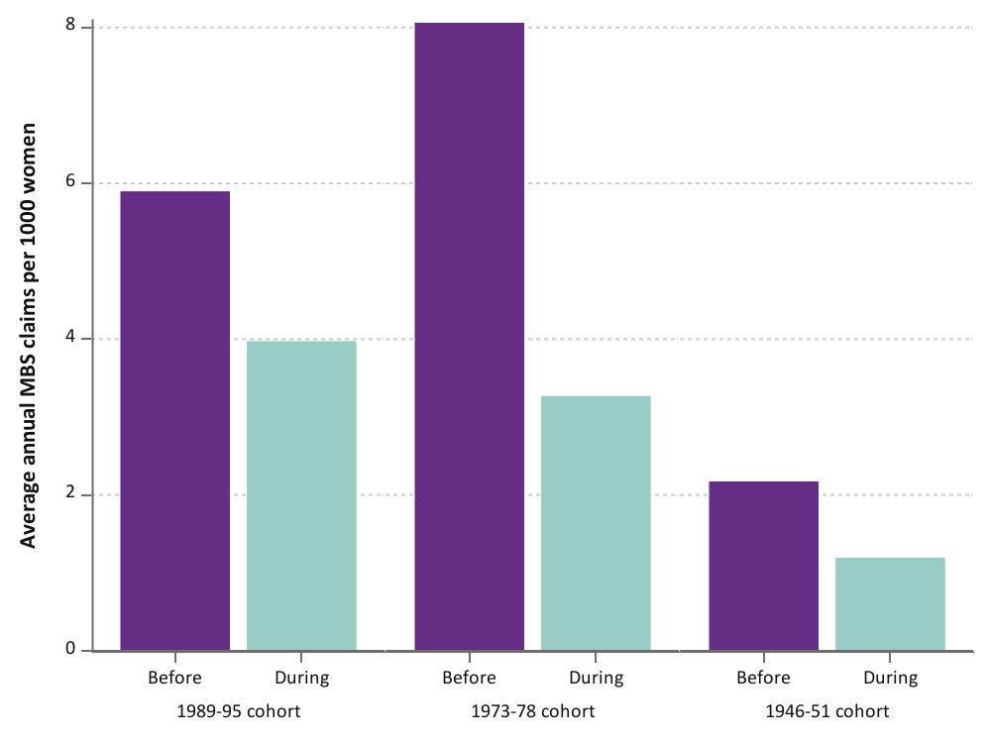
Figure 4-21 Mean annual HPV tests per 1,000 women before and during the COVID-19 pandemic by women in the 1989-95, 1973-78, and 1946-51 cohorts.

When cervical screening before and during the COVID-19 pandemic was compared by area of residence, ability to manage on income, and history of domestic violence, the HPV testing rate varied across the groups for all cohorts (data not shown).

Common conditions
In this chapter, we compared GP and specialist service use between women who did or did not have a range of common conditions, including diabetes, ischaemic heart disease, stroke, asthma, chronic obstructive pulmonary disease (COPD), musculoskeletal conditions, mental health problems, eating disorders, cancer, and endometriosis (for prevalence in the ALSWH cohorts, see Section 2.7). We highlight common conditions that were associated with differential health service use amongst women before and during the COVID-19 pandemic. Following this, the impact of multimorbidity on health service use by women was examined.

Key points
- Conditions associated with a greater increase in GP service use during the COVID-19 pandemic compared to before the pandemic were diabetes and cancer for women in the 1989-95 cohort, asthma for the 1973-78 cohort, and stroke for the 1946-51 cohort.
- Conditions associated with a greater increase in specialist service during the COVID-19 pandemic compared to before the pandemic were cancer for the 1989-95 and 1973-78 cohort and COPD for the 1946-51 cohort.
- Although the rate of obstetric service use was higher during the COVID-19 pandemic before the pandemic as the 1989-95 cohort entered the peak childbearing years, there was no increase in obstetric service use for women who had a history of diabetes or cancer.
- Women born in 1989-95 who have a history of cancer and women born in 1946-51 with a history of stroke or COPD were more likely to use GP telehealth services than women without these conditions.
- For specialist services, mental health problems and musculoskeletal conditions were associated with greater uptake of telehealth services, as well as cancer, diabetes, and COPD, however the trends varied across the three cohorts.
- The increase in GP service use during the pandemic was greater amongst women in the 1973-78 cohort who had two or more common conditions compared to women with less than 2 conditions; the magnitude of change in GP service use did not differ by the number of common conditions for women in the 1989-95 and 1946-51 cohorts.
- Telehealth service use for both GP and specialist services was higher for women with conditions than for those with no conditions across all cohorts.
- The proportion of specialist services used for obstetric consultations increased during the COVID-19 pandemic amongst women in the 1989-95 cohort who had no conditions or one condition, however there was no change for women who had two or more conditions.

Conditions associated with changes in general practitioner service use during the pandemic
Changes in GP service use during the pandemic were associated with different conditions across the three cohorts. For the 1989-95 cohort, the increase in GP service use during the COVID-19 pandemic was greater amongst women who had diabetes or cancer than women without these conditions. Women who had diabetes had approximately 1.6 more GP claims on average per year during than before the pandemic compared with 0.7 more GP claims for women without diabetes (Figure 5-1). For cancer, similar changes were observed; 1.5 vs 0.7 more GP visits per year during than before the pandemic for women with or without cancer, respectively (data not shown). For both conditions, the proportion of GP services delivered via telehealth did not differ by the absence or presence of these conditions.
Diabetes
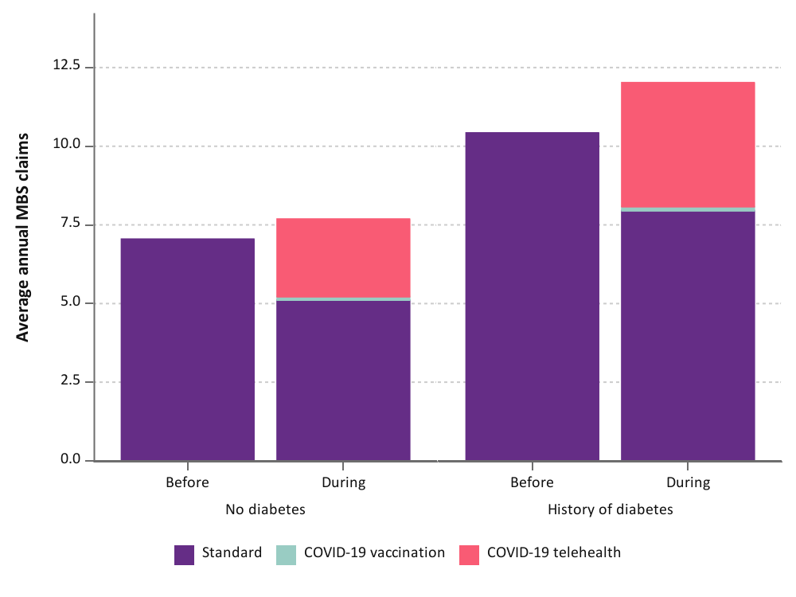
Cancer
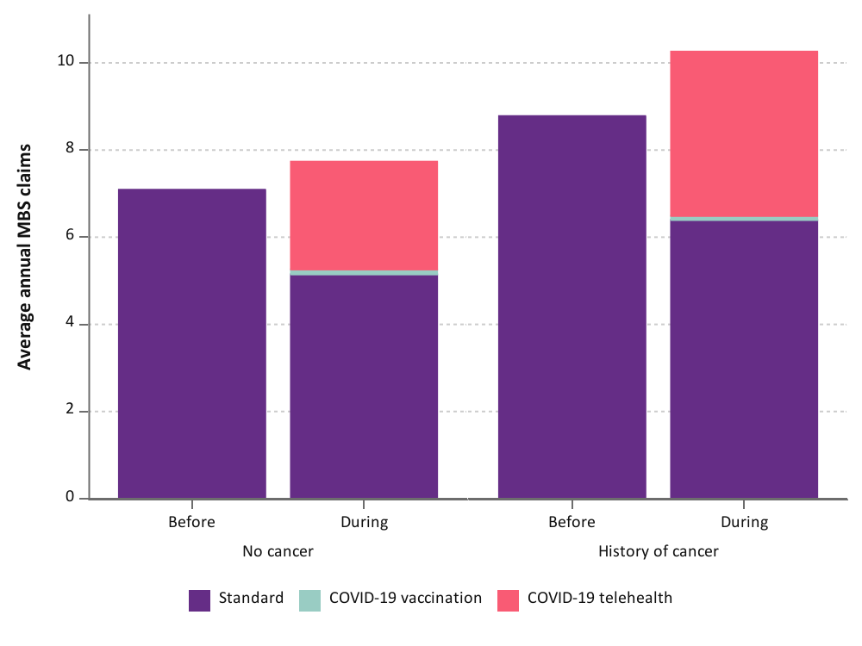
Figure 5-1 Mean annual number of GP services used by women in the 1989-95 cohort before and during the COVID-19 pandemic, categorised by type of attendance and diabetes status (top) and cancer (bottom).

For the 1973-78 cohort, the increased use of GP services during the COVID-19 pandemic was two-fold higher for women with asthma than for women without asthma (1.3 vs 0.6 GP services more, respectively; data not shown). Because diabetes, chronic respiratory conditions and cancer are associated with COVID-related deaths, women with these conditions may be more likely to experience severe COVID-19 symptoms requiring medical attention. However, it is not known why the difference in health care use during the pandemic only affected younger women with these conditions.
For the 1946-51 cohort, the increase in GP service use during the pandemic was slightly higher for women who had never had a stroke than for women who had experienced a stroke (1.7 vs 0.9 claims more per year, respectively; data not shown). As cerebrovascular conditions are considered one of the underlying health conditions that increase the risk of COVID-19 severity and mortality [29, 30], it is possible that women who had ever had a stroke avoided activities that increased their risk of infection, such as attending medical appointments.
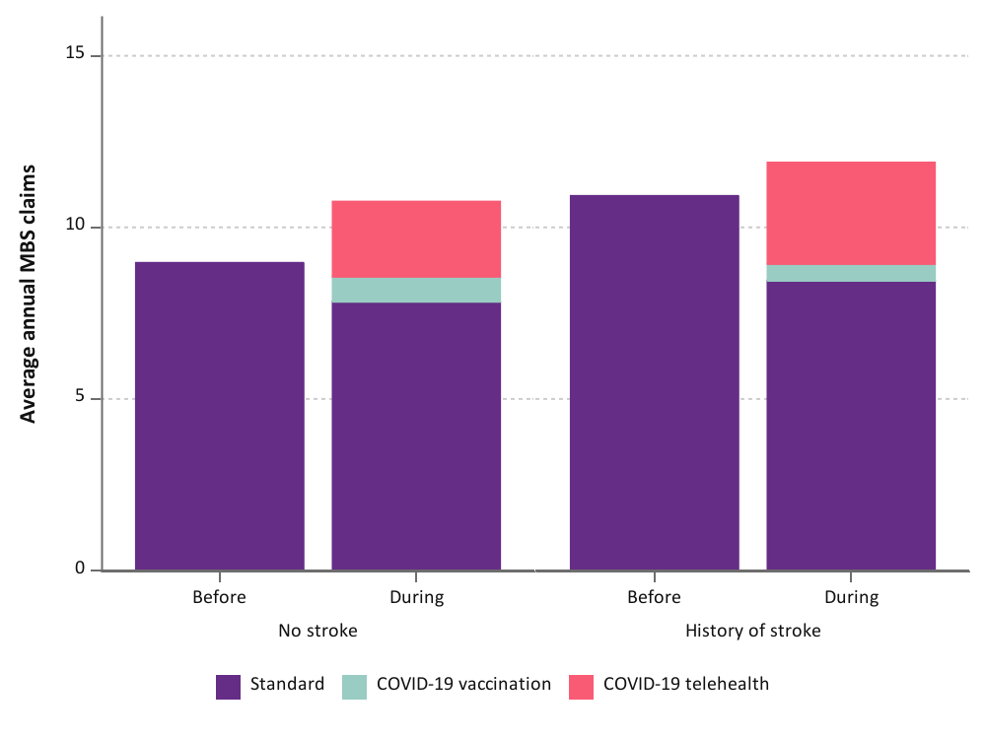
Figure 5-2 Mean annual number of GP services used by women in the 1946-51 cohort before and during the COVID-19 pandemic, categorised by type of attendance and stroke status.

Conditions associated with changes in specialist service use during the pandemic
Changes in specialist service use during the COVID-19 pandemic were greater for women who had ever had cancer than women who had not in the 1989-95 and 1973-78 (but not the 1946-51) cohorts. In the 1989-95 cohort, women who had ever had cancer used, on average, one additional specialist service per year during the pandemic than those who had not had cancer (0.4 specialist services more on average per year; Figure 5-3, top panel). For the 1973-78 cohort, there was no difference in specialist service use before and during the pandemic for women without a history of cancer. Conversely, women who had a history of cancer used an additional 0.4 annual specialist visits during the pandemic (Figure 5-3, bottom panel).
1989-95 cohort
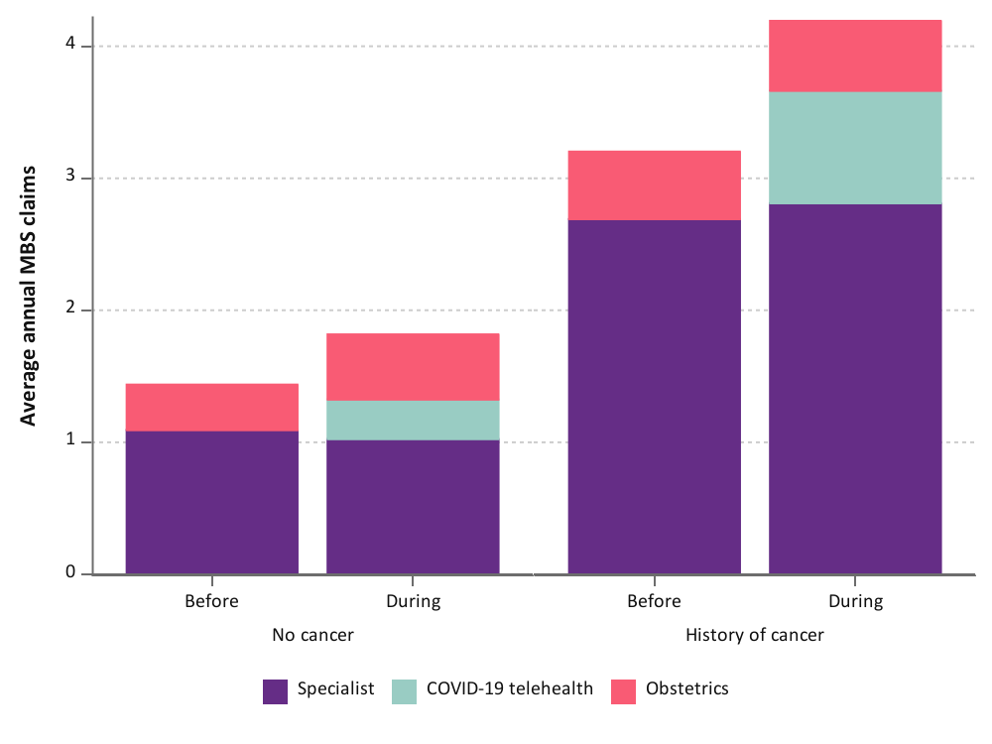
1973-78 cohort
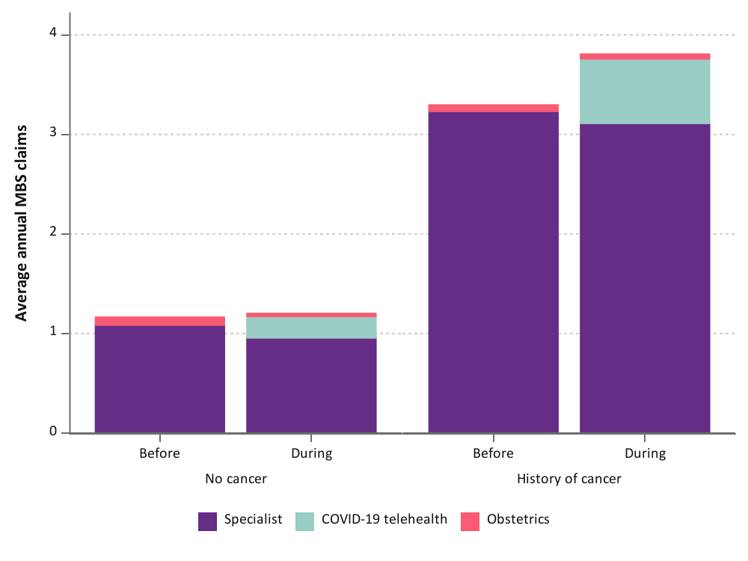
Figure 5-3 Mean annual number of specialist services used by women in the 1989-95 and 1973-78 cohorts before and during the COVID-19 pandemic, categorised by type of attendance and cancer status.

In the 1946-51 cohort, women with COPD used less specialist services during than before the COVID-19 pandemic (3.4 vs 3.8 specialist services per year, respectively) whereas there was little difference for women who did not have COPD (Figure 5-4). COPD is one of the underlying conditions that increases the risk of SARS-CoV-2 virus infection, COVID-19 severity, and subsequent hospitalisation [31, 32]. As it is listed as a risk factor for severe COVID-19 disease in public awareness campaigns [30], women with COPD may have opted to reduce their exposure to the virus by attending specialist appointments.

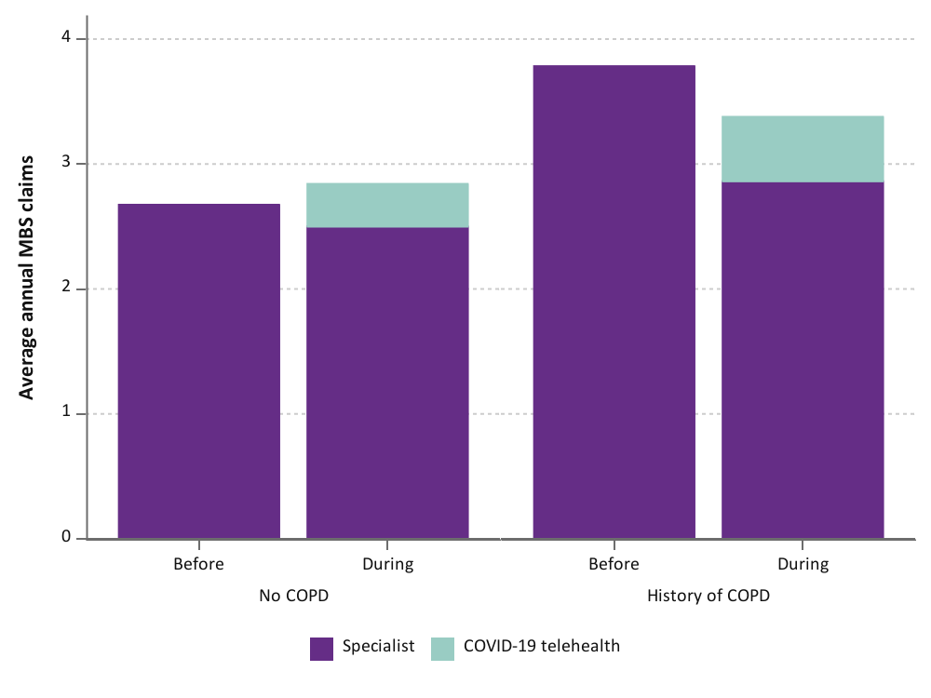
Figure 5-4 Mean annual number of specialist services used by women in the 1946-51 cohort before and during the COVID-19 pandemic, categorised by type of service and chronic obstructive pulmonary disorder (COPD) status.

Conditions associated with changes in obstetric service use during the pandemic
As described earlier in this report, women in the 1989-95 cohort used more specialist services, largely due to increased obstetric consultations during the COVID-19 pandemic (see Section 4.3). However, for women with a history of diabetes and cancer, the mean annual rate of obstetric services used did not change before and during the pandemic, whereas the rate of obstetric services used increased for women without diabetes (Figure 5-5) or cancer (Figure 5-3).
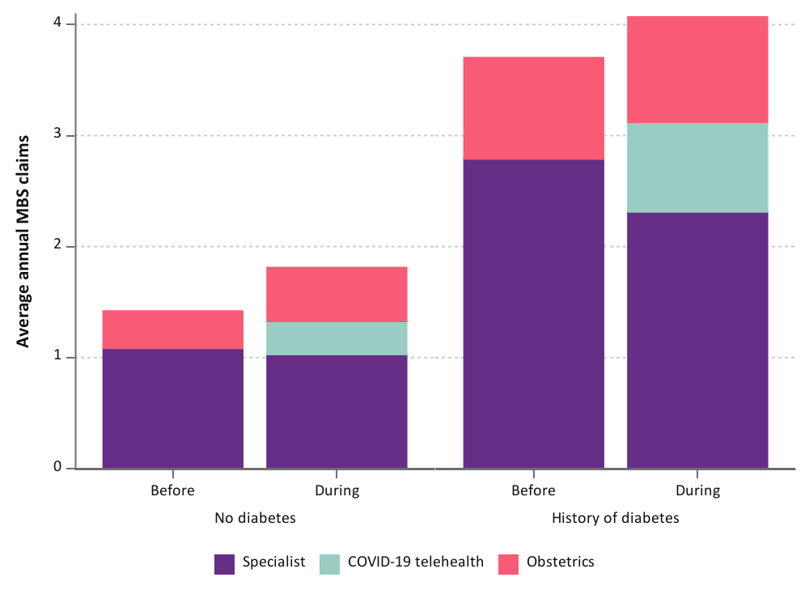
Figure 5-5 Mean annual number of specialist services used by women in the 1989-95 cohort before and during the COVID-19 pandemic, categorised by type of service and diabetes status.

Conditions associated with changes in telehealth service use during the pandemic
For the 1989-95 cohort, women with cancer were more likely to use GP telehealth services than women who did not have cancer, comprising 37% and 32% of their total GP service use, respectively (Table 5-1; Figure 5-1, bottom panel). There was no difference in GP telehealth service use between women who did or did not have a condition in the 1973-78 cohort.
In the 1946-51 cohort, women who have a history of stroke or COPD had greater use of GP telehealth services (25% of their total GP service use for both conditions) than women who did not have stroke or COPD (20-21% of total GP services; Table 5-1). An example of the increased GP telehealth service use amongst women who have a history of stroke is shown in Figure 5-2.

Table 5-1 Comparison of the proportion of total GP services delivered by telehealth during the COVID-19 pandemic for women with or without a history of specific conditions.
 | No | Yes
1989-95 cohort
Cancer | 32.1 | 36.9
1946-51 cohort
Stroke | 20.6 | 24.6
Chronic obstructive pulmonary disorder | 20.0 | 24.7

Mental health was associated with the greatest uptake of specialist telehealth services for women in the 1989-95 and 1973-78 cohorts; the proportion of total specialist services delivered by telehealth was approximately 7% higher for women with a mental health problem than for women without in both cohorts (Table 5-2). Women in the 1989-95 and 1946-51 (but not the 1973-78) cohorts who have a history of musculoskeletal conditions also used more specialist telehealth services than women who did not have musculoskeletal conditions. Other conditions associated with greater uptake of telehealth services for specialist consultations include cancer for the 1989-95 cohort, diabetes for the 1973-78 cohort, and COPD for the 1946-51 cohort.
Table 5-2 Comparison of the proportion of total specialist services delivered by telehealth during the COVID-19 pandemic for women with or without a history of specific conditions.
 | No (%) | Yes (%)
1989-95 cohort
Cancer | 16.7 | 21.4
Musculoskeletal conditions | 13.3 | 18.5
Mental health | 13.3 | 20.8
1973-78 cohort
Diabetes | 16.7 | 23.1
Mental health | 11.1 | 17.6
1946-51 cohort
Musculoskeletal conditions | 7.1 | 12.5
Chronic obstructive pulmonary disorder | 10.7 | 14.7

Multimorbidity
For the 1989-95 cohort and 1946-51 cohort, the magnitude by which GP consultations increased during the pandemic did not differ by multimorbidity (Figure 5-6). Women in the 1973-78 cohort who had two or more conditions had almost one additional GP consultation on average per year during the pandemic whereas women who had no common conditions only had a slight increase in GP services (0.3 mean annual GP claims more) during the pandemic (Figure 5-6).
For all cohorts, GP telehealth service use increased with the number of common conditions. Comparing women with no conditions to women with three or more conditions, the percentage of telehealth GP consultations ranged from 31% to 36% for women in the 1989-95 cohort, 26% to 31% for the 1973-78 cohort, and 16% to 22% for the 1946-51 cohort.
The number of common conditions did not affect the average MBS claims for COVID-19 vaccinations at the GP clinic (~0.7 claims per year across all groups) for the 1946-51 cohort (Figure 5-6).
In the 1989-95 cohort, the elevated specialist consultations during the COVID-19 pandemic did not differ by the number of chronic conditions experienced by women (Figure 5-7). Similar to the GP consultations, the proportion of telehealth specialist services was up to two-fold higher for women in the 1989-95 cohort with chronic conditions than for women without common conditions. Furthermore, the proportion of specialist visits for obstetric care increased during the pandemic for women without a chronic condition (38% before vs 46% after) or one chronic condition (23% before vs 28% after), however there was little change for women with two or more conditions.
In contrast, there was little difference in the number of specialist consultations before and during the pandemic for women in the 1973-78 and 1946-51 cohort. Additionally, telehealth delivery of specialist services did not differ by the number of common conditions experienced by women in these two cohorts (Figure 5-7).

1973-78 cohort
1989-95 cohort
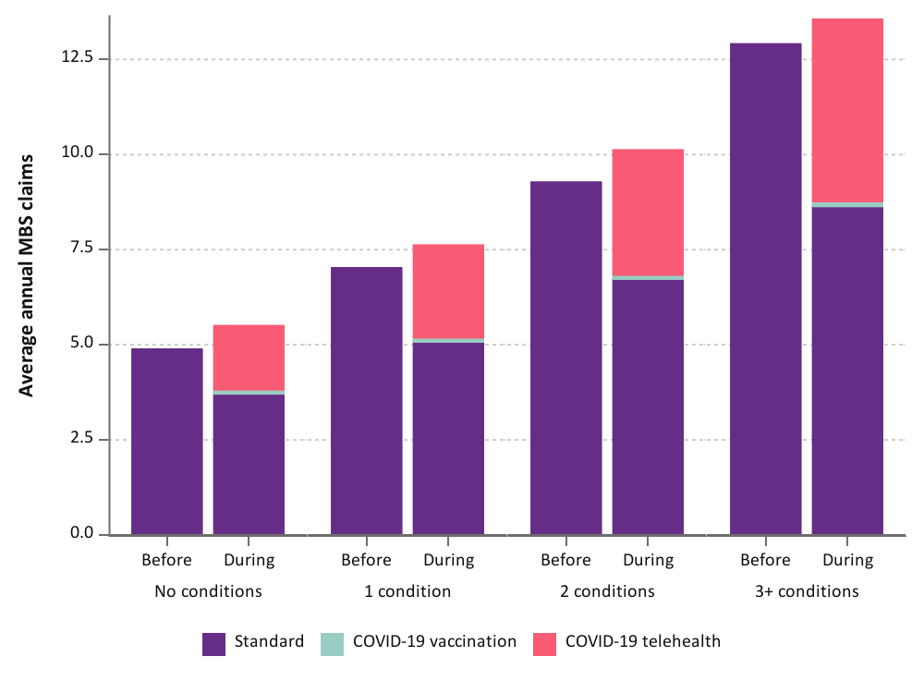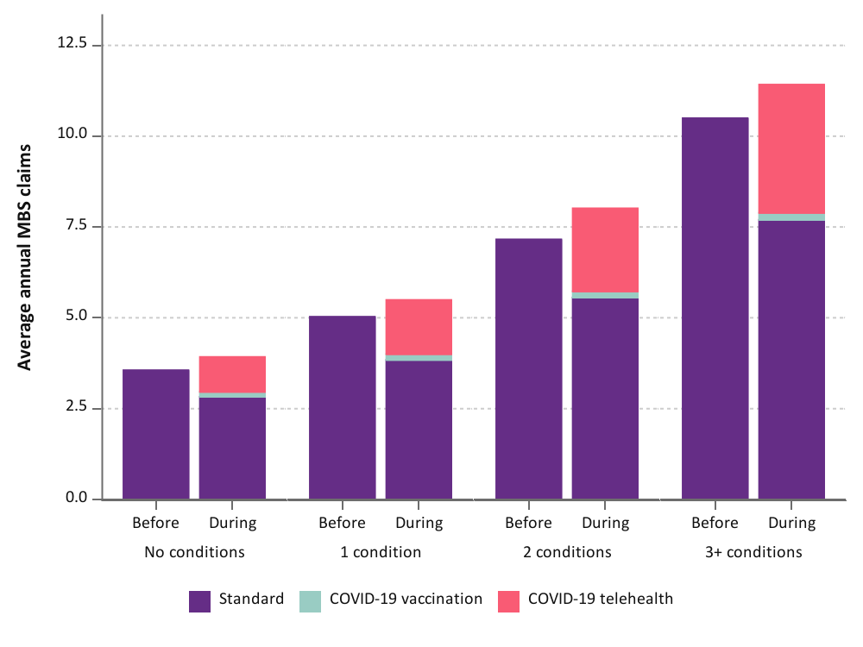
1946-51 cohort

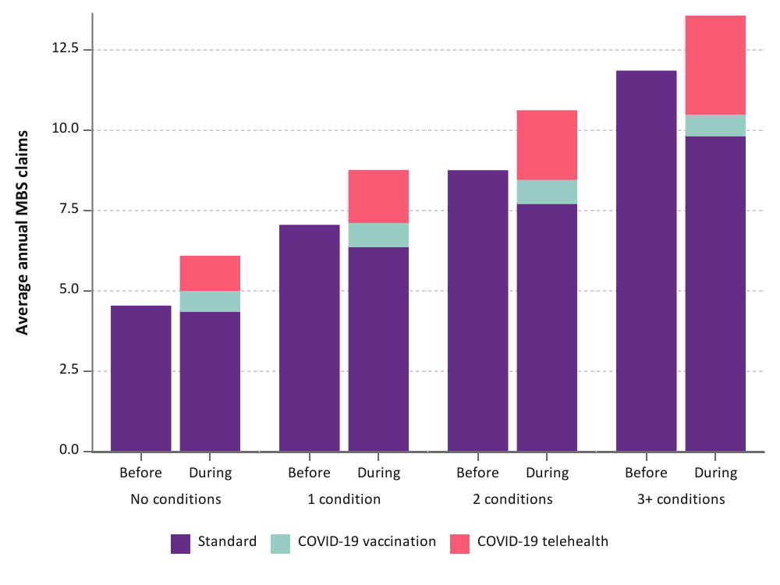
Figure 5-6 Mean annual number of GP services used by women in the 1989-95, 1973-78, and 1946-51 cohorts before and during the COVID-19 pandemic, categorised by type of attendance and number of conditions.
1989-95 cohort
1973-78 cohort
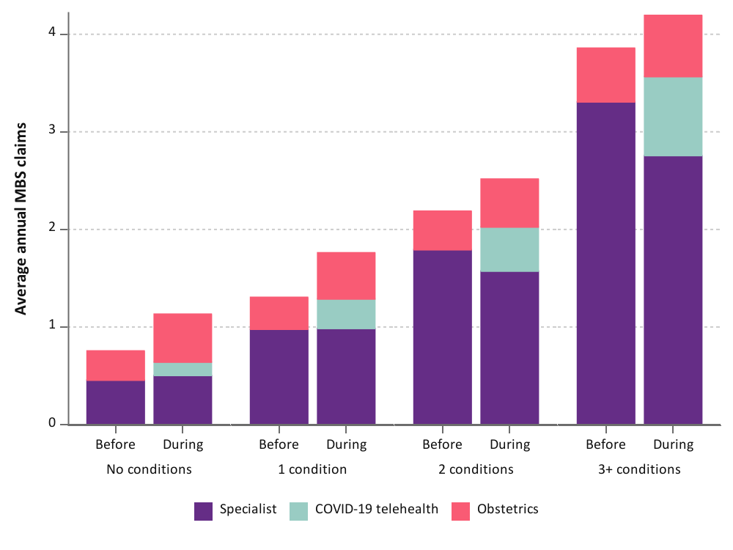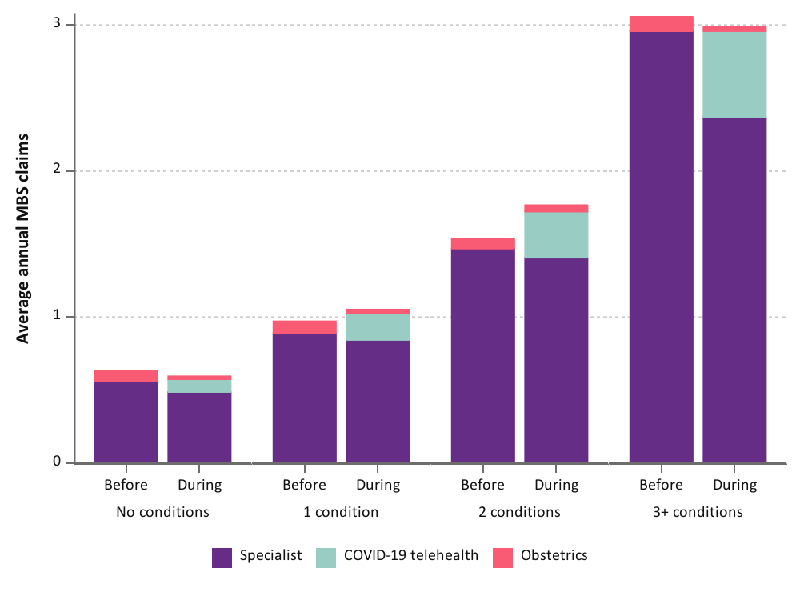

1946-51 cohort
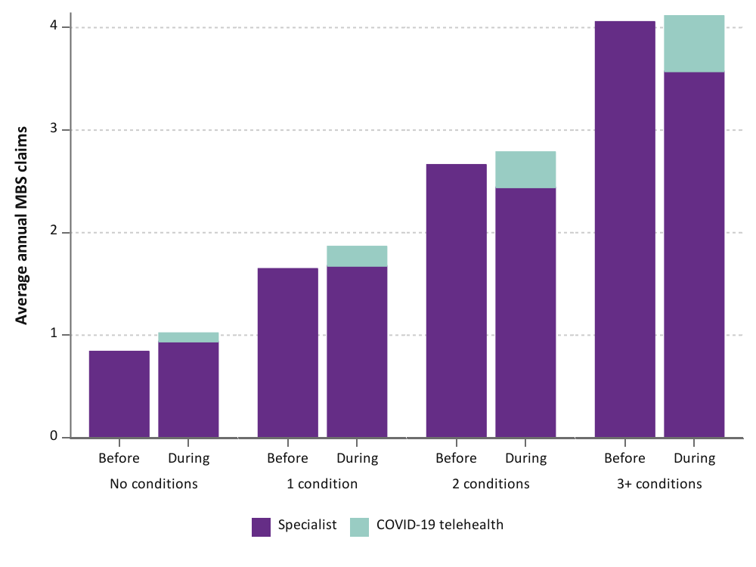
Figure 5-7 Mean annual number of specialist services used by women in the 1989-95, 1973-78, and 1946-51 cohorts before and during the COVID-19 pandemic, categorised by type of service and number of conditions.

Women’s experiences accessing health care during the COVID-19 pandemic in 2020-21

Key points
- Women described unmet health care needs and reduced quality of care during the pandemic, with disruptions to routine care and difficulty engaging with health services.
  - COVID-19 related restrictions resulted in disruptions to routine care and difficulty engaging with health services.
  - Telehealth services were described as inadequate for certain conditions and health concerns, such as those requiring physical assessments and mental health services.
  - Some women felt there was insufficient support available from medical practitioners and family members or friends due to restrictions and the subsequent changes to health services – particularly pregnant women, new mothers, and those with chronic conditions.
- Some women were reluctant to seek health care during the pandemic due to a fear of COVID-19, consideration of others’ health needs, and concern for an overburdened health system.
- Women were presented with various sources of health information during the pandemic. This information was often perceived as confusing which led to feelings of frustration. This affected women’s trust in public health messaging, decisions about receiving a COVID-19 vaccine, and their mental health and wellbeing.
- Women appreciated having options for health care during the pandemic (e.g., telehealth services), allowing them to make decisions based on their unique health needs and access trusted practitioners.

Introduction
The quantitative data in this report provide insights into health service use patterns and related factors among Australian women before, and during the COVID-19 pandemic (see Chapter 3). The aim of this chapter is to describe women’s experiences accessing health care during the COVID-19 pandemic in 2020-21, in their own words. All comments are reported verbatim (i.e., unedited quotes in the words of the women).

Results
Four major themes arose from the qualitative analysis. These were: Unmet needs and reduced quality of care, reluctance to seek care and concern for an overburdened health system, confusion and frustration surrounding health information, and convenience and improved choices for care.

Unmet needs and reduced quality of care
Among the comments included in this analysis, women described unmet needs and reduced quality of care in relation to health services during the pandemic. This major theme included three subthemes:
- Disruptions to regular care and difficulty engaging with services
- Appropriateness of telehealth services
- Lack of support in health journey

Disruptions to regular care and difficulty engaging with services
This theme captured the disruptions to routine care and difficulty engaging with health services for illness and injury during the pandemic. Across all cohorts, women described difficulty obtaining appointments for health care during the pandemic. Long wait times were reported for a range of services, including GPs, allied health practitioners, and specialist doctors.
Currently in need of a specialist consultation but no appointments available until January, February and March, depending on the specialist. The reason given is people have not been for tests because of the pandemic but now feel confident or are desperate and waiting lists are lengthy. – 1946-51 cohort participant
I tried to make an appointment with the psychologist I researched in June, only to be told she's booked out until NEXT YEAR. I have now booked with my second choice, but the wait time is 6 weeks. My first appointment will be Telehealth and the next one 2 weeks later will be face-to-face. So much for the government's talk of focus on mental health and making it more accessible and giving people easier ways to deal with their lives. It's never been more difficult to get help. My anxiety was so bad last week, due to a relationship breakdown, that I had to take a Valium - which had expired 3 years ago. – 1973-78 cohort participant
Inability to be able to get an appointment with local gp. Foot problem and bladder infection. Dr booked out for 2 weeks. Placed on waiting list. Meantime I used my initiative to book a consult with a podiatrist who organised an ultrasound etc. – 1946-51 cohort participant
Some women reported experiencing significant delay in receiving care for their health concerns, with previously scheduled appointments cancelled and postponed due to the COVID-19 pandemic.
My hospital appointment has been moved again. Was supposed to be back in March but has moved 3 times. Extremely frustrating as had tests done back last November. Looks like we will be going into lock down again. – 1973-78 cohort participant
Have been waiting for gynaecologist appointment for 3 months... Disappointed at having to wait so long for gynaecologist appointment especially after making several calls to local hospital consultation rooms over a period of 3 months. – 1946-51 cohort participant
Also, my dentist appointment for a check up was delayed for a few weeks - hopefully restrictions will allow it by the time the appointment comes, if not, it will be delayed again. – 1973-78 cohort participant
Women’s comments also revealed the disruptions to health care plans for chronic conditions and major illnesses throughout the pandemic. Some women explained that, due to COVID-19 related restrictions, they had difficulty accessing much needed services, with some forced to pause treatment plans during this time.
My medical treatment for pre stage leukemia is on hold (difficult to get there due to C-19). – 1973-78 cohort participant
I have been unable to access allied health professionals (podiatrist and chiropractor) who have been managing some of my physical problems – 1946-51 cohort participant
Limiting access to health care. Chronic health conditions don't just go away, yet access to care has decreased and made most normal visits inaccessible. – 1989-95 cohort participant
I'm experiencing a lot of muscular pain and migraines but cannot see my regular myotherapist who would usually support me with this. – 1989-95 cohort participant
The impact on preventive screening, diagnostic procedures, and elective surgical operations was also evident among women’s comments. Women described experiencing long waiting times and difficulty in arranging these services. Further, many women explained that this delay led to an exacerbation of their health issues and a worsening of their condition throughout the pandemic.
Extended stress and experienced depression due to ivf treatment being postponed. – 1973-78 cohort participant
GP treatment/procedure room was closed during COVID restrictions and I an overdue for new implanon insertion. – 1989-95 cohort participant
No surgery to address chronic injury due to covid-19 and uncertainty about when i can have surgery lead to worsening mental health. – 1989-95 cohort participant
Just before the pandemic I was diagnosed with a gallstone and was scheduled for surgery. That was delayed due to COVID-19. Have had some gallstone 'attacks' during lockdown/biliary colic. – 1973-78 cohort participant
haven't been able to have a smear test as my gp is only doing phone consultations. – 1946-51 cohort participant
Women also reported disruptions to regular care that involved complementary therapies, such as remedial massage and hydrotherapy pool use. Some women explained that, due to COVID-19-related restrictions, these services were inaccessible. Consequently, injury recovery and rehabilitation plans were impacted for these women.
The main drawback I have had is not being able to get into the hospital hydro pool which is detrimental to my recovery from being hit by a car. – 1946-51 cohort participant
I have been disappointed that my biomechanical alignment/treatment is classified as a remedial massage and cannot be open during this time. I have suffered increasing pain/bodily misalignment over 3 months and am finding that my muscular discomfort is distressing other parts of my life (sleep, emotions, happiness and wellbeing). I am treated every 3 weeks on average and find it a vital part of managing both my rheumatoid arthritis, depression and anxiety… – 1973-78 cohort participant
I had to cease appointments with my manual lymphatic drainage therapist and attempt self massage which isn't as effective but adequate. I also had to cease hydrotherapy exercises because the public pool closed…– 1946-51 cohort participant
In addition to the difficulties accessing health services throughout the pandemic, women’s access to regular medication was also impacted. While some of these issues were attributed to difficulty arranging an appointment with a GP for a prescription, other comments revealed nationwide issues with supply of some medications. As a result, these women reported having to make changes to their regular medication plans.
… my antidepressants ran out. Trying to get a new prescription in an unfamiliar public health system that is also stressed by pandemic measures was easily the most stressful thing that has happened to me this year... – 1989-95 cohort participant
I'm unable to access my birth control pill as it is out of stock Australia wide ... Trying to get a doctors appointment to see if I can start on a different pill has been difficult. I am finally able to see a doctor… Four days before I run out completely… – 1973-78 cohort participant
I have asthma and my last prescription was out of date for my Ventolin. So I went to the chemist to get some and was told I need a script due to a shortage to prove I needed it… the local doctors wouldn't prescribe me over the phone because they had to meet me first, which I didn't feel comfortable going into a busy doctors office during the peak of COVID-19. When I called my old GP, I was told they won't do a phone consult. This was incredibly stressful and frustrating to get my medication for a life threatening illness. – 1989-95 cohort participant
Comments also highlighted the financial strain faced by women during the pandemic and how this impacted their access to health care. This was particularly evident for younger women. Women with reduced income during the pandemic reported struggling to cover or justify medical costs during this time. Others explained that the COVID-19 pandemic had worsened conditions and they could not afford to sustain or increase regular care.
My husband lost hos job so we are living on just my JobKeeper allowance - which is not enough to cover our bills and my medical appointments. – 1989-95 cohort participant
Delayed accessing psychology due to cost. With a reduced income I was reluctant to spend $130+ on the service, where I would usually have ensured I could cater to that cost. – 1989-95 cohort participant
I have an ongoing mental health issue, which has been exacerbated by covid, but because of the increased stressors I have used my rebated psych appointments already and I can't afford to keep going. I'm very worried with how I am going to cope with the next 6 months… I have been relying very heavily on my psychology appointments to help me cope with the pandemic, and had already used half of my rebated sessions before the pandemic… I am concerned about how I will cope long term. – 1989-95 cohort participant
Further, as a result of the economic impacts of the pandemic, many women explained that they had made the decision to give up private health insurance. This led to these women relying on the public health system and face delays in accessing health services.
The main impact on me has been financial, and having to give up private health insurance. I am on the disability support pension, and my husband went down to 3.5 days of work a week. We had to dig into every cent we owned just to get through the past few months. And although I am in need of multiple surgeries soon, we had to cancel our insurance because it just wasn't affordable any more. This has put a lot of stress on me, as I wait on the public list to see the orthopedic surgeon, knowing that when I finally do see them, I'll have to wait on another list to get my hip replaced. It has been a stressful time. – 1989-95 cohort participant
Whilst we've never run out of money to buy food, we have had to sacrifice money from other things to afford it. For example, I had to cancel my private health insurance and postpone my hip replacement surgery because we needed the money for food more. – 1989-95 cohort participant
Finally, this theme also captured the difficulty engaging with health services faced by those who needed to travel for regular medical care and those living in border towns. Women’s comments highlighted the impact of state- and territory-based border and travel restrictions throughout the COVID-19 pandemic, which introduced barriers and additional challenges for accessing health services.
I have had to cancel some medical appointments e.g. eye specialist because of the need to travel 100 kms . ( although the doctor was only seeing urgent cases anyway) – 1946-51 cohort participant
Breast cancer diagnosis affects my sleep more than Covid. i live in the NSW/VIC border zone and have to go outside the safe zone for medical treatment but then cannot go to NSW for 2 weeks. – 1946-51 cohort participant
Living in a border town without a doctor we need to travel to Victoria… at one stage it looked like we may not be able to visit our doctor or get to the hospital. We have to renew our permit every 14 days & do worry about changes that may stop us again from getting medical aid if necessary. – 1946-51 cohort participant
I need surgery which needs to happen in QLD - across the border. I live in an area with no COVID cases but I am not allowed to go to Brisbane for my surgery. Instead they want to send me to Sydney (to a hot spot) where I would be more at risk of getting COVID. The hard QLD border closure is directly impacting my health. – 1973-78 cohort participant
Similarly, women living in rural and remote areas described a noticeable lack of services in their local region, the need for special permissions to cross state and territory borders for services, and poor telecommunication service impacting telehealth appointments.
It has been very difficult in regional areas to obtain specialist medical appointments, most are done via telehealth, some of my appointments and tests in Sydney have been cancelled due to hotspots. I am still waiting for an operation that has been postponed due to the Virus and I have heard nothing about rescheduling since even though elective surgery has supposedly recommenced... Health care has become very stressful to manage. – 1973-78 cohort participant
Telehealth not an option in our area due to unreliable internet. – 1973-78 cohort participant
Vic state government's restrictions are too restrictive for rural areas, because we are unable to access medical appointments across borders. or have specialists fly from Melbourne, to [location] where there are now 800 patients on the surgical waiting list. many of these patients are living with life threatening conditions. – 1946-51 cohort participant
I have a serious chronic illness which COVID has made difficult to manage because of access from regional areas to the city or across the border for care. I need to have surgery across the border and can't because of the hard closure of the QLD border. – 1973-78 cohort participant

Appropriateness of telehealth services
Women’s comments provided insight into the appropriateness of telehealth appointments for certain health conditions. In particular, women engaging with mental health services tended to find telehealth services to be unsatisfactory and preferred face-to-face appointments. Common reasons for this included a perceived lack of personal connection with the practitioner over the phone or video call, and difficulty discussing intimate issues using these modes of contact.
speaking on phone with a psychiatrist feels less effective than in person because it is more detached and difficult to generate rapport, which is so important in this field. – 1973-78 cohort participant.
When you have to have Telehealth consultations I don't get the same relief as face to face because when you suffer from depression at times one needs to see the other person ,it feels like being locked up in a house and never being allowed out side. The only positive from all of this is that one is saving money on petrol. – 1946-51 cohort participant
Telehealth GP services have been much easier than in person for simple issues with a known practitioner. I hope this option continues going forward. Telehealth psychology is much more difficult than face-to-face. If I hadn't already been seeing my Psychologist, I would not have been willing to talk so intimately with a new practitioner over telehealth... – 1989-95 cohort participant
Women also highlighted the difficulty faced when trying to discuss sensitive topics without sufficient privacy in their homes throughout the pandemic.
During the most restrictive stages of lockdown, I was still able to see my GP and psychologist face-to-face, but as I was staying with my family and I didn't feel able to disclose my mental health issues to them, it made it quite difficult to come up with reasons to be leaving the house for regular appointments, which was really stressful. – 1989-95 cohort participant
zoom psychologist sessions are awful and awkward, it's tricky finding a place at home to have a confidential session over zoom and also it's difficult to connect about sensitive issues online. – 1989-95 cohort participant
Similarly, those with physical ailments or conditions requiring physical health checks and assessments described feeling neglected in their care, as certain services were not possible to receive through telehealth.
I have a dislocated finger which the nearest public hospital is treating on telehealth which seems inadequate to me as it need someone to look at it properly and assist why it has not repaired after 2 months in a splint. – 1946-51 cohort participant
It is convenient being able to get test results over the phone rather than take a sick Day and attend an appointment in person. However, for antenatal appointments, it is difficult to describe things that are happening to your body without being able to show someone (eg swelling, sudden appearance of rashes). – 1989-95 cohort participant
Telehealth definitely was t a replacement for in person appointments particularly with a newborn. It was difficult to explain things like rashes and behaviours over the phone. I was lucky to have a in person lactation consultant appointment in early April. A phone consult would have been a nightmare and not as thorough. – 1989-95 cohort participant
Women’s comments also highlighted other challenges that they had experienced with Telehealth appointments conducted via video and phone call. These included technical difficulties, a lack of visual cues and body language, and a sense of dissatisfaction with the care provided.
unknown health care nurse made me aware of how much I rely on body language and visual cues to reach a positive outcome. – 1946-51 cohort participant
Psychology sessions difficult due to Zoom continually freezing. We now Zoom on mute while talking via phone. – 1973-78 cohort participant
Telehealth was a bit of a waste of time as seeing a doctor in person is so much more effective and it's hard for a doctor to properly do their job just over the phone. Seeking medical advice shouldn't feel like such a chore/hassle – 1989-95 cohort participant
Some women described feelings of vulnerability and anxiousness as a result of their telehealth consultations, explaining that face-to-face services would have been more reassuring for their specific health needs.
Overall few negative impacts but I did feel vulnerable having telehealth for my annual breast cancer surgery review with the surgeon... – 1946-51 cohort participant
A degree of anxiety in keeping medical appointments. Phone consultations just not the same as one on one and without actual ECG and blood pressure checks not as reassuring. – 1946-51 cohort participant
During my pregnancy I found it a bit unsettling to have Tele health appointments. I felt much more at ease when I was able to meet them face to face just for leave of mind that everything was going ok with my pregnancy. – 1989-95 cohort participant
Some women also indicated that they had ceased attending their appointments indefinitely while telehealth was the only option being provided, while others felt the need to change providers during the pandemic so they could access face to face services that better suited their needs.
I feel that Telehealth is fine for my GP appointments as they are usually only for quick things, but do not feel comfortable doing Telehealth with my psychologist so all of my mental health appointments have been postponed (by my choice) so I have not accessed my regular mental health assistance since January. – 1989-95 cohort participant
I've been to the GP in person as i normally would, but on one occasion I should have sought medical help and didn't because i was unwell with hayfever and asthma and the GP would only do telehealth. – 1989-95 cohort participant
I have had to change GP as very unwell and usual GP only did Telehealth ( this was unsuitable for illnesses stemming from my anxiety which contributed to mental health symptoms. – 1946-51 cohort participant
This related to women’s appreciation for having options to choose from to suit their own health care needs during the pandemic, which is further explored within the major theme Convenience and improved choices for care (Section 6.3.4).

Lack of support in health journey
This theme highlighted a sense of feeling that there was insufficient support available from medical practitioners and family members or friends due to restrictions and the subsequent changes to health services during the COVID-19 pandemic. Women’s comments revealed dissatisfaction and perceived reduced quality of care when engaging with health practitioners throughout the pandemic. Some women described feeling that their appointments were rushed and that their concerns were not heard as they had been prior to the pandemic.
GP appointments seem rushed, confused and they can't help as much- one time I ended up having to go to emergency instead. – 1989-95 cohort participant
… GP wasn't very good. Didn't ask anything about my chronic condition management. Not sure if they were under the pump, but the call was made on time. – 1989-95 cohort participant
I have PTSD from my first pregnancy/birth, and have found the differences in antenatal care this time around quite challenging and anxiety inducing. Not all appointments are face to face, the appointments I do have seem quite brief to try and limit the time spent with each patient… – 1989-95 cohort participant
… Over the phone I have been told three times that I sound "fine" (despite coughing and wheezing) and to increase my asthma treatment dosage. – 1973-78 cohort participant
These unmet needs also related to the lack of face-to-face appointments and shortfalls of Telehealth services, as explored previously in Appropriateness of telehealth services (Section 6.3.1.2). Some women described feeling unsupported by practitioners they met or spoke with over the phone or video call during the pandemic.
I find my GP is very disinterested over the phone and sounds like she just wants to rush me off to get to the next consult and I've had a few connection issues with my specialist. – 1989-95 cohort participant
I don't find the appointments with my counselor over telehealth very helpful. Half the time she's late or cuts my appointment short. Or my "appointment" doesn't end up being an appointment at all and it's just her talking then after 10 minutes the "appointment" is over and I have no idea if she's put those down as used from my mental health care plan. It sucks because she actually helped me a lot over the past 8 ish years but during this, with the telehealth especially, I'm not finding her help as useful… – 1989-95 cohort participant
The doctor's appointments via telehealth obviously lacked the opportunity for the doctor to physically assess me which I think was an important aspect of my care that was omitted due to Covid. I felt to some extent that I had to provide my own care and assessment which is not ideal when you're not well. I have referred to my local pharmacist who has been very helpful in assisting me with my queries. – 1973-78 cohort participant
Many women also provided insight into the experience of accessing quality health care while presenting with COVID-19 symptoms during the pandemic. Their comments explained the difficulties of managing chronic respiratory conditions, such as asthma, in a climate where they are discouraged from seeking regular face-to-face services, or where their symptoms are assumed to be contagious. These women described feeling marginalised and unsupported by practitioners in their disease management throughout the pandemic.
Trying to manage and maintain a physical condition like asthma during a respiratory pandemic has been like trying to navigate a nine field. Not offending receptionists by wheezing or coughing, or trying to pretend that you can breathe okay to see a doctor about the condition that causes you to not be able to breathe, because they send you away the second they think you can't breathe. This causes me to have anxiety about seeking medical care. My mental health is affected by the way that medical staff treat me, and assume without checking my history what's wrong with me. They treat you like you have plague. My mental health has been adversely affected by trying to pretend daily that I don't have the permanent and disabilitating condition that I have. It is like living a lie and walking on egg shells all the time. My referral for the respiratory specialist will expire soon and I don't know how I'll get another one in the current state of things. – 1989-95 cohort participant
I have some allergies - have been dealing with them for 30 years. Having an outbreak last week was an issue because of doctors' propensity to go, "aaagghh covid!" and not actually listen. I've been avoiding the doctor since this started and managing by myself because of it. ... Other than the usual issue of doctors treating you like you're stupid and not listening to you because you're female, getting someone to pay attention to the actual issue is a struggle. If that's our experience and we're all women who'll be somewhat pushy, how many people will be getting seriously ill or dying because of this? – 1973-78 cohort participant
This theme also revealed insufficient emotional and moral support from family and friends as women accessed health care, as a result of restrictions and regulations imposed during the pandemic. For example, limitations on the number of visitors allowed in emergency departments and clinics left women without the support of their family and friends whilst unwell. This also appeared to have a negative impact on women’s mental health and wellbeing.
I've had surgery, due to restrictions I had to go all by myself. It was weird and more stressful, but ok in the end I guess. – 1973-78 cohort participant
Have spent most of the time in hospital or in my house due to cancer and problems relating to that. The way that covid has effected me is not being able to see my family while in hospital at my end of life. – 1973-78 cohort participant
…I faced miscarriage news and surgery in hospital without him [husband] able to visit – 1989-95 cohort participant
For others, the travel restrictions in place throughout the COVID-19 pandemic meant that they lacked practical support that they needed to access health care. For example, some women reported having to postpone appointments and procedures until their family and friends could assist them.
One impact is my gastroscopy had to be rescheduled because I didn't have anyone to bring me to the hospital and take me home, as my family are interstate are cannot fly back. – 1973-78 cohort participant
underwent surgery to have my ovaries removed in the last 3 weeks and the lead up to as well as the aftermath has been very unusual in this environment. For instance would have asked the in-laws to help mind the kids whilst I recovered or while my partner picked me up from hospital but we shouldn't be having contact with them, so suddenly our support network for the logistics for pre and post surgery support were gone. – 1973-78 cohort participant
This theme also highlighted the challenges faced by pregnant women and new mothers while accessing maternity and perinatal health services throughout the COVID-19 pandemic. These women described not receiving the level of care and support that they required and would have had access to prior to the pandemic, with limited access to professional care and advice.
First baby born 20/04/20. CAFHS (Child and Family Health Service) not currently doing home visits and the drop in centres are closed to the public. I have had to weigh my baby at the local chemist and have had no guidance/education from CAFHS. This has been a significant impact on my new Mum journey as I feel like I am navigating this with no medical/best practice support and am relying heavily on friends (fellow mums) experiences. – 1989-95 cohort participant
I was pregnant gave birth on 25th august and having face to face appointments during pregnancy was hard as doctors preferred phone appt i feel i did not get a very personal/intimate journey. Also fear of getting the virus whilst being pregnant as there was little know about affects of fetuses or expecting mothers. – 1989-95 cohort participant
Stress, mental health decline, feeling unsupported by medical professionals… As a new mother this is all extremely daunting and unsupportive. – 1989-95 cohort participant
The lack of social support available to pregnant women, as a result of restrictions imposed throughout the pandemic, was also evident. Women reported having to attend appointments or hospital emergency rooms on their own and not being able to have visitors in hospitals after they had given birth. Many described feelings of isolation and increased anxiety as a result of this.
It has been difficult to be pregnant during COVID… in the hospital I'm not allowed more than one visitor. I've had to do all my anti natal classes online and can't do a tour of the hospital. I feel like I've missed out on preparing for my first child during this time. I understand that the midwives are doing the best they can at the moment. – 1989-95 cohort participant
The main impact covid-19 has had on me is the fact that I am currently pregnant (22weeks).It has eliminated all support for me. I am having a high risk pregnancy after complications with my first. They fact that my husband cannot attend appointments, doctors have set time limits and things have changed to over the phone where possible makes me feel very anxious and alone in this process. – 1989-95 cohort participant
Partner hasn't been allowed to attend appointments. I was admitted to hospital this week due to reduced movement of baby and my partner was not allowed to enter the hospital with me. This was extremely stressful and difficult for us both. – 1989-95 cohort participant
Further, women’s comments also revealed the impact of COVID-19 related restrictions on new and first-time mothers. These women described feeling unsupported without access to mothers’ groups and home nurse visits.
I had a baby during the COVID-19 lockdown period in NSW. This meant I've had no visitors at the hospital, minimal visitors at home and no access to mothers groups or other social networks. – 1989-95 cohort participant
Bringing up a baby during this time has been very difficult with lack of face to face social networking such as playgroup, meeting other parents, and seeing medical professionals for progress checkups and specialist appointments... – 1989-95 cohort participant
Bringing a newborn baby home just as lockdown started was very hard because the midwives and nurses weren't able to do home visits so it was very stressful as a first time mum trying to get help over the phone... – 1989-95 cohort participant

Reluctance to seek care and concern for an overburdened health system
This theme revealed intentional delay of routine appointments by the women and a reluctance to access health care for sickness and injury. Some women’s comments indicated hesitation towards visiting medical settings during the pandemic, with concern towards and fear of the danger imposed by the COVID-19 virus.
… I worry about going to doctors offices, to hospitals, etc, where I must be in contact with more people than I normally would. – 1946-51 cohort participant
My overall health has been relatively ok, but I am definitely more stressed than I was previously and not going to the doctor as much as I would have normally, due to worries about Covid. – 1946-51 cohort participant
I am overdue for a pap test because of Covid/fear of covid. – 1973-78 cohort participant
I've put my back out from working from home in not suitable chairs, it's so painful but getting treatment concerns me. – 1989-95 cohort participant
Women explained that they had delayed appointments in an effort to isolate during the pandemic, both to protect themselves and to prevent the spread of COVID-19 cases in the community. Some indicated that they intended to make arrangements for health care once the COVID-19 situation had ‘settled down’.
Am more concerned now there is so much community transmission. Had started to make appointments etc again but have now cancelled some in order to stay home more. – 1946-51 cohort participant
I have postponed a dental check-up and a check-up visit to the optometrist - I don't feel ready to attend these appointments yet. – 1946-51 cohort participant
Due for Pap smear but decided not to go to clinic during this time. Risk of going into clinic when self isolating felt better than putting it off a few months. – 1973-78 cohort participant
My cataracts have ripened but I will wait until the new year to see how the situation infection wise is going before seeking a consultation. – 1946-51 cohort participant
I technically can get my IUD replaced- but the barriers are higher eg more difficult to access appointments, and the risks are greater. I am avoiding it... – 1989-95 cohort participant
Despite recognising symptoms and impaired health, some women’s comments demonstrated a change in their perception of whether their condition was urgent and warranted attention, or whether it could wait until risk of infection and transmission to others was not as high.
Have had severe mental health issues over last fortnight or so... Because of COVID, there has been a hesitancy on my part to access medical/mental health services (it feels like there are bigger things to worry about; as well as a reluctance to engage with the outside world). – 1989-95 cohort participant
I am definitely more stressed than I was previously and not going to the doctor as much as I would have normally, due to worries about Covid. If anything was really serious then of course I would go. – 1946-51 cohort participant
This theme also captured the concern for others’ health and safety that appeared to influence women’s reluctance to access health care. Some women described prioritising family and friends’ wellbeing and others,
… If staying at home and getting the jab help get everything back on track, and my family and friends and everyone else are once again managing financially and mentally then that's a very small price to pay. – 1973-78 cohort participant
… there is the concern that these symptoms may in fact be another serious illness and with the current virus restrictions you feel more reluctant to access medical care as it may put yourself or others at risk... – 1973-78 cohort participant
The concern for community wellbeing also related to women’s eagerness to comply with COVID-19 vaccine mandates once these were implemented, as indicated in women’s comments.
If we have no contrary health issues, it is time for us to be responsible citizens and care for others by being vaccinated. Vaccination helps protect self and others from COVID, reduces symptoms of COVID, and minimises risk of death from COVID. – 1946-51 cohort participant
Many comments also revealed consideration of the burden of COVID-19 cases on the health system, which influenced women’s decisions to seek and access care for other issues.
I have struggled to reach out and address non-covid medical issues for fear of an overwhelmed system… – 1989-95 cohort participant
I don't talk to my psychologist or gp about my mental health because I worry they are overloaded already and also I don't want to get COVID – 1973-78 cohort participant
Some women, despite identifying the need to access health care in their comments, demonstrated concern over ‘wasting time’, or ‘bothering’ medical practitioners during the pandemic.
I would probably have visited my GP as my arthritis is getting worse. I have put it off as I feel that I do not want to bother them at the moment. – 1946-51 cohort participant
I would like to get a few things checked out with my doctor, but because of Covid feel that it needs to be serious otherwise I am wasting people's time. Usually I wouldn't be afraid to bring up my concerns. – 1946-51 cohort participant
I was due for a new prescription for the pill during the crisis. I didn't want to waste the GPs time or take up any appointments when other people might be more in need. – 1989-95 cohort participant
Some women’s comments demonstrated exacerbation of chronic conditions and worsening of illness and injury as a result of such delays, in addition to increased stress about their health and a negative impact on wellbeing.
I hurt my foot and didn't seek an xray, just had tele health appointments - in hindsight, i should have had it seen too as i think i fractured it (back in march) and it is still healing now. – 1973-78 cohort participant
I would like to have another discussion with a practitioner… about changing my birth control because I am having issues with it again. I have delayed this discussion and am making-do with the side-effects, when I probably would have made active plans had the COVID-19 pandemic not affected Victoria like this. – 1989-95 cohort participant

Confusion and frustration surrounding health information
Women’s comments revealed a strong sense of confusion and frustration toward the health information provided by the media, public health officials, government representatives, and health practitioners, which appeared to influence their decisions to engage or not engage with health services. Women mainly wrote about this within the context of the COVID-19 vaccine rollout. There was a strong sense of frustration towards the health advice being circulated about the different brands of vaccine (e.g., Pfizer, AstraZeneca, etc.), their associated risks, and the eligibility criteria to receive these.
Everyone has become an expert!! People either forget or have not lived through past diseases like Polio, Whooping Cough, Smallpox, Measles, Chickenpox, Mumps, TB & more. I can't remember in recent times, anyone asking what type of 'Flu vaccine they were receiving each year. From what I am hearing, the young ones are not afraid of Covid-19 but very confused & afraid of all the conflicting information they are given about the different vaccines.– 1946-51 cohort participant
The politicisation of the COVID vaccine, especially concerning Pfizer vs AZ, should be considered criminal. No reasonable person knows the manfacturer of their paracetamol, or the brand of oil a mechanic uses to service their car. We live in blissful ignorance most of the time relying on science to help us through the day in both small and remarkable ways. A vaccine is a vaccine, there are always risks… – 1973-78 cohort participant
I think aspiration of the A-Z injection should be optional for concerned patients regarding clots. The first GP REFUSED to aspirate claiming she was "not allowed" to do so. The second NURSE did so without hesitation. Such mixed messages do not inspire confidence. – 1946-51 cohort participant
Among women’s comments, frustration towards the availability of the COVID-19 vaccines was also evident. Some women described feeling confused as to why there was such persistent and strong public health messaging encouraging uptake of the vaccine, despite insufficient supply and service availability. Many of these comments were from women living in isolated regions and rural and remote areas.
The government can't keep telling people to get vaccinated but not have enough vaccine to go around. Or push back second doses beyond the recommended timeframes because you just want to get a good news story about first jab vaccination rates. – 1973-78 cohort participant
Live in rural nsw. Kept hearing that we had high vaccine hesitancy but I feel it was more a lack of access to vaccine. We only got access to phizer several months after metro got it and the at times had to wait several months for an appointment. – 1973-78 cohort participant
I am concerned about the Sydney-centric roll out of Pfizer as it is still not readily available for those aged to 60 in my area or the adjacent western LGA. Pouring vaccines into Sydney has not as yet made any difference to active cases (5 September) so time to cover the West of NSW before it develops cases. – 1946-51 cohort participant
Women’s comments also highlighted the difficulty that some faced in making appointments for their COVID-19 vaccination, despite being eligible and encouraged to receive the vaccine. Some experiences included long wait times, insufficient supply, and lack of clear and consistent information about eligibility.
In many cases trying to get vaccinated has required turning your quest into a full time job! You have to know someone who knows someone, or have a sneaky link to a booking site, or see a random social media post that says vaccines are available at a certain location and then there's an insane rush to book. I've likened it to a black market. – 1973-78 cohort participant
Some comments also revealed a sense of uncertainty toward the safety of the available COVID-19 vaccines. It was clear that potential long-term side effects were a major concern and cause of some women’s reluctance to receive the COVID-19 vaccine. Women also spoke about the short-term effects of the vaccine, reporting confusion about how to respond to reactions and whether they should report symptoms.
I'm also concerned that it is still a fairly new vaccine and any long term effects are yet to be learnt from having the vaccine… – 1973-78 cohort participant
… I have recently seen my husband have his first AZ shot and he is now dealing with blood clotting problems with ongoing treatment . Prior to the vaccine, he never had DVT. Medical professionals say his problem is not related to the vaccine but we both believe otherwise. This combined with my family history has made me extremely wary of getting A/Zeneca. I feel at risk both from the virus and the vaccine…. – 1946-51 cohort participant
This theme also captured women’s perceptions of the circulation of misinformation, irresponsible messaging, and ‘fear mongering’ related to the COVID-19 vaccines in the media. Many women expressed their disappointment in mainstream media outlets for promoting scepticism towards the public health initiative by focussing their messaging on the side effects of the vaccines rather than their efficacy.
My biggest concern is with the misinformation that gets spread. I believe everyone has a right to their own choice, but they need to be fully aware of the facts and not follow along without checking reliable sources for correct information. The media has a lot to answer for when it comes to spreading misinformation and fearmongering. – 1973-78 cohort participant
Similarly, many women conveyed their annoyance and concern towards anti-vaccination sentiments being shared on social media platforms. Women often expressed a fear that COVID-19 cases would worsen due to the spread of misinformation and non-compliance with vaccine mandates.
I live in a low socioeconomic area and the misinformation (ie. non-evidence based) being shared by peers on social media regarding the vaccine is troubling, so much so it's causing anxiety attacks. I believe our community leaders/government really need to implement public health strategies in these areas to combat this problem, before it gets too out of hand. – 1989-95 cohort participant
So angry and frustrated at the media and social media and anti vaxers for spreading lies, misinformation and pedalling anxiety. THis has caused slow vaccination rates, more infections, more deaths and longer lock downs for all of us. – 1973-78 cohort participant
Other women expressed their views on the health information provided by the Government throughout the pandemic, particularly in relation to the advice about COVID-19 vaccination. There was a sense of disappointment when reflecting on how federal leaders approached the vaccine rollout and its associated messaging, with criticisms about scare tactics, mixed messaging, and a lack of clear information. Further, some women suggested that the Government should have played a larger role in overseeing the media’s portrayal of the COVID-19 vaccines.
The issue is supply and the federal governments refusal to use systems already in place for mass vaccination. I have faith in the state leaders, not the federal government. THe mixed messaging and the failure to manage the pandemic is squarely the fault of the federal government. We are a rich country with the services and infrastructure to cope if proper systems and processes are followed. – 1973-78 cohort participant
Among women’s comments, there were also several remarks about the ‘politicisation’ of the COVID-19 vaccine rollout, with views that government leaders should have had less of an involvement in the provision of health advice.
politicians should not provide health advice. the assumption has been that they will provide leadership but nothing could be further from the truth. We need true leadership within our elected membership. Politicising public health has been a very bad outcome of this pandemic,. ignoring the needs of the Aboriginal communities in the west of NSW is a disgrace. Plenty of ads but insufficient attention to supply needs to be addressed urgently, politicians at the federal level saw this as a marketing exercise. Bad idea. – 1946-51 cohort participant
I'm seeing quite a bit of hesitancy (some of it legitimate, which I think has not been helped by some pretty ordinary communication from the federal government and health authorities) and some outright anti-vaxx sentiment and disinformation. Unfortunately it is becoming apparent that the latter is diverging along political and religious lines. – 1973-78 cohort participant
Women’s comments also suggested that the varying types of health information and messages had potential to impact on vaccine uptake. Some women explained that the perceived lack of clear, consistent, and trustworthy information contributed to a lack of confidence and, in turn, hesitancy to receive the COVID-19 vaccine.
I got AZ and even as an extremely pro vaccine person it took me a while to decide to get it. I think the gov/media scared people off with the blood clot stuff. It was numbers without enough context to highlight how small the chances of clots were – 1989-95 cohort participant
I am disappointed in the media's unrelenting negativity around anything to do with government strategies in response to the pandemic. Vaccine hesitancy is understandable in view of inconsistent messages from government which give the appearance of being motivated by considerations other than the individual's personal safety. I was very anxious in the lead up to my first Astrazeneca dose due to being bombarded with negative messages… – 1946-51 cohort participant
Finally, women’s comments highlighted the negative impact that the circulating health information had on their mental health and wellbeing. Some women explained that, not only did they disagree with some messaging, but it was also causing them stress and anxiety. Others described feeling overwhelmed by the sheer volume of information that they were exposed to.
I'm finding the constant media coverage and government messaging around getting vaccinated is causing me more distress than the virus ever did. – 1973-78 cohort participant
The vaccine is not causing me stress - people who distrust the vaccine for no good medical reason causes me stress. People believing in conspiracies causes me stress and I am scared that these people will slow down the return to normal for everyone. – 1973-78 cohort participant
I am not particularly anxious about COVID itself. I am not particularly depressed about being in lockdown, despite being alone in a hotspot LGA with no one around to be in my single bubble… But let me be 100% clear: the NSW government's response to this crisis, the continually changing and often mixed messages, the constant gaslighting of citizens by the Premier and Health Ministers and the Prime Minister, have done far more to damage both my short and long-term mental health than COVID or lockdown ever could. – 1989-95 cohort participant

Convenience and improved choices for care
This theme captured the benefits of changes to health services throughout the pandemic and women’s satisfaction with the care they were being provided. Women’s comments revealed a sense of appreciation for the increased options they had in relation to health services. For some, telehealth appointments suited their needs and offered more convenience than face-to-face appointments.
It has been helpful to be able to access psychologist via Telehealth when my physical mobility was impacted by a fall recently. Although remote sessions are not my usual preference because of the COVID pandemic I was able to get psychological support during a time when my physical health was also impacted – 1973-78 cohort participant
I think Telehealth is great (when no need to physically attend). I could do things at home rather than wait in a room full of people coughing. Dr did zoom or what's app or face time and saw the ailment and was able to fax or email script to chemist. Easy and much preferred by me - as didn't need to drag kids with me or organise a babysitter. – 1973-78 cohort participant
While some women reported difficulty accessing medication, as explored in the subtheme Disruptions to regular care and difficulty engaging with services (Section 6.3.1.1), others were impressed with their ability to easily access prescription medication during the pandemic. Women’s comments described the positive way in which GPs and pharmacies were working together to provide patients with medication in a convenient and efficient manner, including streamlining processes through e-prescriptions which were sent directly from doctors to pharmacists.
…This telehealth service is also fully funded, which is fantastic, as it has (pre-covid) been costing me around $40 to see my gp just for a 5 minute repeat prescription appointment. This service is brilliant: no driving, no finding parking, no waiting, and no paying so much money for such an elementary service. – 1946-51 cohort participant
Other women described appreciating having options for health care during the pandemic and the ability to make choices based on their own preference and needs – for example, the option for a face-to-face or telehealth appointment. Comments demonstrated the positive impact of this flexibility and acknowledgement of unique and personal health situations.
Really lucky that my psychologist was still offering in person (as well as tele-health sessions) because the process of getting out of the house and having something to go to was a good thing in itself for my mental health. – 1989-95 cohort participant
… it's been easy to make timely medical appointments . telephone consultations have worked well . Specialist did follow up calls after surgery- very reassuring. When a face to face appointment was advised , I felt we were able to do it safely keeping to COVID restrictions. – 1946-51 cohort participant
Some women reported experiences of practitioners accommodating their unique needs, including making special arrangements for face-to-face or telehealth appointments, or providing extra follow-up contact in lieu of regular care. This was seen as extremely valuable and beneficial for women’s wellbeing. These women’s comments suggested that they felt supported by their practitioners.
The most outstanding impact to me from covid is the introduction by my gp clinic of a regular telehealth check monthly for their patients with chronic illnesses. – 1946-51 cohort participant
Telehealth isn't great for me, it makes my mental health worse because of the lack of connection I feel. I am INCREDIBLY grateful for my doctors who have acknowledged this and made arrangements to see me in person or check in with me via text while appointments were exclusively Telehealth. – 1989-95 cohort participant
The importance of continuity of care and the ability to access practitioners with whom patients had developed rapport was also captured within this theme. Many women expressed feelings of relief and gratitude for having access to their regular GPs, specialist doctors, and psychologists for ongoing care during the COVID-19 pandemic.
Accessing my psychologist who has now moved to WA through telehealth has been a godsend since I couldn't have faced getting to know a new psychologist over Skype. It's not as good as face to face but it's better than someone new/not seeing her. – 1989-95 cohort participant
Using telehealth has enabled me to access a phsycologist on the sunshine coast who already knows my history even though I have moved away form my home town. This has made a huge positive difference for my mental health – 1989-95 cohort participant
Further, some women reflected on the challenges they would likely face if they were forced to see a different practitioner during this time. These women’s comments suggested it would be difficult to establish a new relationship with a practitioner, especially while engaging using telehealth services.
I would like Telehealth options to continue after Covid eases. I am also appreciative of the extra 10 psych sessions that have been made available to people in lockdown. I am lucky I had a good GP and psych before this who I say regularly. If I had not it would have been extremely difficult to find these services and a psych that I "bonded" with – 1973-78 cohort participant
This was also evident in relation the uptake of the COVID-19 vaccine. Women’s comments revealed the positive influence of their long-term GP’s advice on their willingness to receive the vaccine. Further, some explained their preference to have their usual GP administer the vaccine.
I trusted my doctor of over 30 years to give me honest information which is why I wanted my GP to vaccinate me. He preferred to give me Pfizer but it's still not available at his surgery which is frustrating for us all. We had a great, detailed discussion about AstraZeneca and were both happy for me to proceed with the vaccination. I feel relief having had my first one and am booked in for my second one soon. – 1973-78 cohort participant
The only downside to my vaccination experience, is that my GP couldn't administer the vaccine. He has been my GP for 26years, and knows my family history in and out. I booked in with another GP, who tried to talk me out of the decision I had made to have the AZ vaccine. Even after explaining that it was the recommendation of my GP, and telling me about my families medical history, he vehemently told me I should go for the phizer vaccine. I would prefer to trust the opinion of my own GP, and would have liked the GP administering the vaccine to respect my decision. – 1989-95 cohort participant
This advice about and attitudes towards the COVID-19 vaccine related to the various sources of health information conveyed to women during the pandemic, as explored in the major theme Confusion and frustration surrounding health information (Section 6.3.3).

Conclusion
The qualitative data examined for this chapter provided insight into women’s experiences of accessing health care during the pandemic in 2020-2021, in their own words. Women described varied experiences and drew from unique health circumstances, however leading to four major themes arose from their comments: Unmet needs and reduced quality of care, reluctance to seek care and concern for an overburdened health system, confusion and frustration surrounding health information, and convenience and improved choices for care.
Women’s comments highlight unmet needs and a reduced quality of health care during the COVID-19 pandemic. Women reported disruptions to routine care and challenges accessing health services, with delays to appointments and procedures. Telehealth services that were introduced during the pandemic were considered unsuitable for certain health conditions, such as mental health concerns and those requiring physical assessments. Additionally, some women felt there was inadequate support for their health available from medical practitioners and family members or friends due to the COVID-19 related restrictions – this was especially evident for pregnant women, new mothers, and those with chronic health conditions.
The analysis also revealed intentional delay of routine appointments by the women and a reluctance to access health care for sickness and injury. Women’s comments suggested that this was due to a fear of COVID-19 infection, consideration of others’ health needs, and/or concern about burdening health care workers and the health care system more broadly.
The confusion and frustration towards the various sources of health information provided during the pandemic was also evident among women’s comments. Women reported uncertainty and hesitancy, particularly toward messaging about the COVID-19 vaccine rollout. This appeared to negatively affect their mental health and wellbeing, as well as impact their decisions to receive the vaccine.
Women’s comments revealed an appreciation for options for health care throughout the pandemic. For example, some women preferred telehealth services for the convenience, while others valued the option of face-to-face to ensure their health needs were met. Additionally, the importance of continuity of care was evident. Women’s comments demonstrated the value of their ability to access their regular practitioners with whom they had established rapport, and the positive impact this had on their health and wellbeing.
This chapter explored women’s experiences accessing health care during the pandemic, including the challenges in doing so, satisfaction with services, and the impact on their health and wellbeing. Barriers introduced, such as cost and unavailability of health services due to COVID-19 related restrictions, negatively impacted women and left their health needs unmet. It was also clear that insufficient support from practitioners and family and friends in the health journey left women feeling neglected and dissatisfied with their health care. Further, consideration of others’ health needs and the burden on the health system, and a lack of clear and consistent health advice led to women being hesitant to engage with health services.
Having regular access to quality health care provided by trusted practitioners benefited women throughout the pandemic. Women’s comments demonstrated the importance of considering unique health situations, and the value of having choices for personalised health care was evident.

References
1. World Health Organization WHO Director-General's opening remarks at the media briefing on COVID-19 - 11 March 2020 2020, World Health Organization: Geneva.

2. Hunt, G. and B. Murphy First confirmed case of novel coronavirus in Australia 2020, Australian Government: Canberra.

3. NSW Health Coronavirus cases confirmed in NSW 2020, NSW Government: Sydney.

4. Australian Institute of Health and Welfare. 2021. The first year of COVID-19 in Australia: direct and indirect health effects. AIHW: Canberra.

5. Australian Institute of Health and Welfare. 2021. Cancer screening and COVID-19 in Australia. AIHW: Canberra.

6. Australian Institute of Health and Welfare COVID-19 disruptions led to lowest number of public elective surgeries performed in over a decade - 07 Dec 2022 2022, AIHW: Canberra.

7. Australian Longitudinal Study on Women's Health, Technical Report #44, November 2021, 2021.

8. Malatzky, D.C., J. Gillespie, D.D.L. Couch, and D.C. Cosgrave, Why place matters: A rurally-orientated analysis of COVID-19’s differential impacts. Social Sciences & Humanities Open, 2020. 2(1): p. 100063.

9. Australian Institute of Health and Welfare. 2022. Australia’s health 2022: data insights. Australian Institute of Health and Welfare: Canberra.

10. Australian Bureau of Statistics. 2021. Household Impacts of COVID-19 Survey. February 2021. ABS: Canberra.

11. Byles, J., G. Mishra, R. Hockey, A. Adane, H.-W. Chan, X. Dolja-Gore, P. Forder, M. Harris, T. Majeed, D. Loxton, et al., Use, access to, and impact of Medicare services for Australian women: Findings from the Australian Longitudinal Study on Women’s Health, 2017.

12. Loxton, D., N. Townsend, P. Forder, I. Barnes, E. Byrnes, A. Anderson, D. Cavenagh, N. Egan, K. Tuckerman, and J. Byles, Australian women’s mental health and wellbeing in the context of the COVID-19 pandemic in 2020, 2021.

13. Boxall, H. and A. Morgan, Intimate partner violence during the COVID-19 pandemic: A survey of women in Australia, 2021.

14. Loxton, D., X. Dolja-Gore, A.E. Anderson, and N. Townsend, Intimate partner violence adversely impacts health over 16 years and across generations: A longitudinal cohort study. PLOS ONE, 2017. 12(6): p. e0178138.

15. Dobson, A., P. Forder, R. Hockey, N. Egan, D. Cavenagh, M. Waller, Z. Xu, A. Anderson, E. Byrnes, I. Barnes, et al., The impact of multiple chronic conditions: Findings from the Australian Longitudinal Study on Women’s Health, 2020.

16. Australian Longitudinal Study on Women's Health. CCMS datasets. Last update unknown date [cited 13 November 2022]; Available from: https://alswh.org.au/for-data-users/linked-data-overview/ccms-datasets/.

17. COVID-19 National Incident Room Surveillance Team. 2021. COVID-19 Australia: Epidemiology Report 47. Reporting period ending 1 August 2021. Australian Government Department of Health: Canberra.

18. Mishra, G., I. Barnes, E. Byrnes, D. Cavenagh, A. Dobson, P. Forder, R. Hockey, D. Loxton, N. Townsend, and J. Byles, Health and wellbeing for women in midlife: Findings from the Australian Longitudinal Study on Women's Health, 2022, Report prepared for the Australian Government Department of Health, May 2022.

19. Snoswell, C.L., L.J. Caffery, M.L. Taylor, H.M. Haydon, E. Thomas, and A.C. Smith. Telehealth and coronavirus: Medicare Benefits Schedule (MBS) activity in Australia. Last update 4 November 2022 [cited 22 November 2022]; Available from: https://coh.centre.uq.edu.au/telehealth-and-coronavirus-medicare-benefits-schedule-mbs-activity-australia.

20. Snoswell, C.L., L.J. Caffery, H.M. Haydon, E.E. Thomas, and A.C. Smith, Telehealth uptake in general practice as a result of the coronavirus (COVID-19) pandemic. Australian Health Review, 2020. 44(5): p. 737-740.

21. NPS MedicineWise, General Practice Insights Report July 2019–June 2020 including analyses related to the impact of COVID-19, 2021, NPS MedicineWise: Sydney.

22. Roder, C., C. Maggs, B.J. McNamara, D. O'Brien, A.J. Wade, C. Bennett, J.A. Pasco, and E. Athan, Area-level social and economic factors and the local incidence of SARS-CoV-2 infections in Victoria during 2020. Medical Journal of Australia, 2022. 216(7): p. 349-356.

23. De Guzman, K.R., L.J. Caffery, A.C. Smith, and C.L. Snoswell, Specialist consultation activity and costs in Australia: Before and after the introduction of COVID-19 telehealth funding. Journal of Telemedicine and Telecare, 2021. 27(10): p. 609-614.

24. Australian Government Department of Health and Aged Care. Better Access initiative. Last update 20 May 2022 [cited 8 November 2022]; Available from: https://www.health.gov.au/initiatives-and-programs/better-access-initiative#who-can-access-better-access-rebates.

25. Australian Institute of Health and Welfare. Mental health services in Australia: Mental health impact of COVID-19. Last update 10 November 2022 [cited 23 November 2022]; Available from: https://www.aihw.gov.au/reports/mental-health-services/mental-health-services-in-australia/report-contents/mental-health-impact-of-covid-19.

26. Australian Government Department of Health and Aged Care. About the National Cervical Screening Program Last update 1 July 2022 [cited 23 November 2022]; Available from: https://www.health.gov.au/initiatives-and-programs/national-cervical-screening-program/about-the-national-cervical-screening-program.

27. Australian Institute of Health and Welfare. Cancer screening programs: quarterly data. National Cervical Screening Program. Last update 26 October 2022 [cited 24 November 2022]; Available from: https://www.aihw.gov.au/reports/cancer-screening/national-cancer-screening-programs-participation/contents/national-cervical-screening-program/cervical-screening-participation.

28. Loxton, D., A. Anderson, D. Cavenagh, N. Townsend, G. Mishra, L. Tooth, and J. Byles, ALSWH COVID-19 Survey Report 12: Survey 12, 30 September 2020, 2020, Australian Longitudinal Study on Women's Health: Australia.

29. Izcovich, A., M.A. Ragusa, F. Tortosa, M.A. Lavena Marzio, C. Agnoletti, A. Bengolea, A. Ceirano, F. Espinosa, E. Saavedra, V. Sanguine, et al., Prognostic factors for severity and mortality in patients infected with COVID-19: A systematic review. PLOS ONE, 2020. 15(11): p. e0241955.

30. Australian Government Department of Health and Aged Care. Risk factors for more serious illness. Last update 15 March 2022 [cited 24 November 2022]; Available from: https://www.health.gov.au/health-alerts/covid-19/advice-for-groups-at-risk/risk-factors-for-more-serious-illness.

31. Gerayeli, F.V., S. Milne, C. Cheung, X. Li, C.W.T. Yang, A. Tam, L.H. Choi, A. Bae, and D.D. Sin, COPD and the risk of poor outcomes in COVID-19: A systematic review and meta-analysis. eClinicalMedicine, 2021. 33.

32. Fang, X., S. Li, H. Yu, P. Wang, Y. Zhang, Z. Chen, Y. Li, L. Cheng, W. Li, H. Jia, et al., Epidemiological, comorbidity factors with severity and prognosis of COVID-19: a systematic review and meta-analysis. Aging, 2020. 12(13): p. 12493-12503.

33. Australian Government Department of Health and Aged Care. Modified Monash Model. Last update 14 December 2021 [cited 7 October 2022]; Available from: https://www.health.gov.au/health-topics/rural-health-workforce/classifications/mmm.

34. Fitzgerald, D., Adding the Modified Monash Model variable for Remoteness classification, 2016, Australian Longitudinal Study on Women's Health.

35. Australian Longitudinal Study on Women's Health. Data Book for the 1973-78 Cohort.ALSWH: Australia.

36. Australian Longitudinal Study on Women's Health. Data Book for the 1989-95 Cohort.ALSWH: Australia.

37. Australian Longitudinal Study on Women's Health. Data Book for the 1946-51 Cohort.ALSWH: Australia.

38. Kessler, R.C., G. Andrews, L.J. Colpe, E. Hiripi, D.K. Mroczek, S.L.T. Normand, E.E. Walters, and A.M. Zaslavsky, Short screening scales to monitor population prevalences and trends in non-specific psychological distress. Psychological Medicine, 2002. 32(6): p. 959-976.

39. Australian Bureau of Statistics. 4817.0.55.001 - Information Paper: Use of the Kessler Psychological Distress Scale in ABS Health Surveys, Australia, 2007-08 Last update 11 July 2012; Available from: https://www.abs.gov.au/ausstats/abs@.nsf/Lookup/4817.0.55.001Chapter92007-08.

40. Braun, V. and V. Clarke, Using thematic analysis in psychology. Qualitative Research in Psychology, 2006. 3(2): p. 77-101.

41. QSR International Pty Ltd, NVivo, 2018.

42. Australian Government Department of Health. 2021. MBS changes factsheet - COVID-19 Temporary MBS Telehealth Services: GPs and Other Medical Practitioners. Australian Government Department of Health and Aged Care: Canberra.

43. Australian Government Department of Health. 2021. MBS changes factsheet - COVID-19 Temporary MBS Telehealth Services: Specialists, consultant physicians, psychiatrists, paediatricians, geriatricians, public health physicians, neurosurgeons, and anaesthetists. Australian Government Department of Health and Aged Care: Canberra.

44. Australian Government Department of Health. 2021. MBS changes factsheet - COVID-19 Temporary MBS Telehealth Services: Obstetric Attendances. Australian Government Department of Health and Aged Care: Canberra.

45. Australian Government Department of Health. 2020. COVID-19 Temporary MBS Telehealth Services: Mental Health Services. Department of Health and Aged Care: Canberra.

46. Rowlands, I., J. Abbott, G. Montgomery, R. Hockey, P. Rogers, and G. Mishra, Prevalence and incidence of endometriosis in Australian women: a data linkage cohort study. BJOG: An International Journal of Obstetrics & Gynaecology, 2021. 128(4): p. 657-665.

47. Rowlands, I.J., R. Hockey, J.A. Abbott, G.W. Montgomery, and G.D. Mishra, Body mass index and the diagnosis of endometriosis: Findings from a national data linkage cohort study. Obesity Research & Clinical Practice, 2022. 16(3): p. 235-241.

Appendix A – ALSWH retention rate
Table 8-1 Participation and retention across surveys between 1996 and 2019 for women from the 1989-95, 1973-78, and 1946-51 cohorts.
 | Wave 2 | Wave 3 | Wave 4 | Wave 5 | Wave 6 | Wave 7 | Wave 8 | Wave 9
1989-95 cohort: 17,012 women aged 18-23 years at Wave 1 (2013)
Year | 2014 | 2015 | 2016 | 2017 | 2019 | - | - | -
Age (years) | 19-24 | 20-25 | 21-26 | 22-27 | 24-28 | - | - | -
Deceased* | <5 | 6 | 8 | 13 | 20 | - | - | -
Non-respondents | 5,667 | 8,046 | 6,242 | 6,545 | 6,574 | - | - | -
Respondents | 11,344 | 8,961 | 9,007 | 8,495 | 8,346 | - | - | -
% response† | 69.5 | 54.9 | 59.0 | 56.4 | 55.9 | - | - | -
1973-78 cohort: 14,247 women aged 18-23 years at Wave 1 (1996)
Year | 2000 | 2003 | 2006 | 2009 | 2012 | 2015 | 2018 | -
Age (years) | 22-27 | 25-30 | 28-33 | 31-36 | 34-39 | 37-42 | 40-45 | -
Deceased* | 22 | 33 | 51 | 59 | 79 | 103 | 125 | -
Non-respondents | 4,537 | 5,133 | 5,052 | 5,989 | 6,160 | 6,961 | 5,189 | -
Respondents | 9,688 | 9,081 | 9,145 | 8,199 | 8,010 | 7,186 | 7,121 | -
% response† | 69.2 | 66.3 | 68.3 | 62.0 | 61.6 | 56.6 | 57.3 | -

 | Wave 2 | Wave 3 | Wave 4 | Wave 5 | Wave 6 | Wave 7 | Wave 8 | Wave 9
1946-51 cohort: 13,715 women aged 45-50 years at Wave 1 (1996)
Year | 1998 | 2001 | 2004 | 2007 | 2010 | 2013 | 2016 | 2019
Age (years) | 47-52 | 50-55 | 53-58 | 56-61 | 59-64 | 62-67 | 65-70 | 68-73
Deceased* | 50 | 119 | 216 | 328 | 475 | 674 | 876 | 1,171
Non-respondents | 1,327 | 2,370 | 2,594 | 2,749 | 3,230 | 3,893 | 1,218 | 1,206
Respondents | 12,338 | 11,226 | 10,905 | 10,638 | 10,011 | 9,151 | 8,622 | 7,956
% response† | 91.7 | 85.4 | 84.9 | 85.3 | 83.0 | 81.1 | 80.5 | 77.0
Based on participant status data as at 2nd July 2021
*numbers for deceased are cumulative over surveys

Appendix B – ALSWH survey questions

Area of residence
The Monash Modified Model (MMM) was introduced in 2015 by the Australian Government Department of Health to help improve health workforce distribution to rural and remote areas [33]. The model classifies locations according to geographical remoteness and population size. In the ALSWH, an MMM category was determined for respondents based on their postcodes [34]. Due to the small participant numbers in the rural and remote areas, we combined Modified Monash (MM) categories, MM4 and MM5 (medium and small rural towns) and MM6 and MM7 (remote and very remote communities; Table 9-1).
Table 9-1 Categories and descriptions for area of residence used in this report.
Category | Description
Metropolitan areas | Major cities accounting for 70% of Australia’s population
Regional centres | e.g., Ballarat, Mackay, Toowoomba, Kiama, Albury, Bunbury
Large rural towns | e.g., Dubbo, Lismore, Yeppoon, Busselton
Medium & small rural towns | e.g., Port Augusta, Charters Towers, Moree, Mount Buller, Moruya, Renmark, Condamine
Remote & very remote communities | e.g., Cape Tribulation, Lightning Ridge, Alice Springs, Mallacoota, Longreach, Coober Pedy, Thursday Island

Ability to manage on income
In the ALSWH, participant’s ability to manage on income was determined for every cohort in every survey, except in survey 2 of the 1973-78 cohort, using the following question:
“How do you manage on the income you have available?”
The survey response options and the groupings used in this report is shown in Table 9-2.

Table 9-2 Response options for ability to manage on income.
Survey response options | Groups for analysis
It is impossible | Impossible/always difficult
It is difficult all the time
It is difficult some of the time | Sometimes difficult
It is not too bad | Not too bad/easy
It is easy

Experience of domestic violence
Women who have responded ‘yes’ to the question “Have you ever been in a violent relationship with a partner/spouse?” in any survey were categorised as having ever experienced domestic violence. This question is asked in every survey, except survey 1 for the 1973-78 cohort and surveys 2 and 3 for the 1946-51 cohort. For all cohorts, approximately one in six women have ever reported being in a violent relationship with a partner/spouse [35-37].

Appendix C – COVID-19 mini surveys

Participant response rate
Table 10-1 Number of participants in the ALSWH COVID-19 surveys
Wave | Date deployed | Born 1989-95 (aged 25-31 years) | Born 1973-78 (aged 42-45 years) | Born 1946-51 (aged 69-74 years) | All cohorts
1 | 29 April | 3,408 | 2,965 | 2,589 | 8,962
2 | 13 May | 2,897 | 2,987 | 3,028 | 8,912
3 | 27 May | 2,630 | 2,753 | 2,433 | 7,816
4 | 10 June | 2,403 | 2,879 | 2,918 | 8,200
5 | 24 June | 2,246 | 2,538 | 2,659 | 7,443
6 | 8 July | 2,035 | 2,472 | 2,497 | 7,004
7 | 22 July | 2,091 | 2,594 | 2,884 | 7,569
8 | 5 Aug | 2,120 | 2,652 | 2,619 | 7,391
9 | 19 Aug | 2,057 | 2,575 | 2,859 | 7,491
10 | 2 Sept | 1,972 | 2,253 | 2,161 | 6,386
11 | 16 Sept | 1,982 | 2,172 | 2,163 | 6,317
12 | 30 Sept | 1,911 | 2,383 | 2,755 | 7,049
13 | 14 Oct | 1,843 | 2,296 | 2,702 | 6,841
14 | 28 Oct | 1,862 | 2,358 | 2,695 | 6,915
*restricted to main study participants only (i.e., no pilot participants included)

Survey questions

General health
At each COVID-19 mini-survey, participants were asked, “How would you say your health has been?” with five response options to choose from: Excellent; Very good; Good; Fair; Poor. For the first mini-survey, the time frame of the question was “In the last 7 days…” while the time frame for the question in all subsequent mini-surveys was “In the last 14 days…” to align with survey frequency.
Participants were asked the same question (with the same response options) about their general health in their regularly scheduled cohort survey prior to the pandemic, although no time frame for this question is specified in the main surveys.

Stress
Participants were asked at each COVID-19 mini-survey, “How stressed have you felt?” with five response options to choose from: Not at all stressed; Somewhat stressed; Moderately stressed; Very stressed; Extremely stressed. For the first mini-survey, the time frame of the question was “In the last 7 days…” while the time frame for the question in all subsequent mini-surveys was “In the last 14 days…” to align with survey frequency.
In the regularly scheduled cohort surveys prior to the pandemic, participants were asked about stress in relation to a number of life domains (such as work, money, relationships, etc). Across life domains, the average stress score was calculated. Using the mean stress score, the top 25% of scores were classified as high stress, while the lower 75% of mean scores were considered not to be at high stress.

Psychological distress
This was measured at the fifth COVID-19 mini-survey in 2020 (24 June – 7 July) using the Kessler-10 scale for psychological distress [38, 39]. With this scale, psychological distress was measured with 10 questions, each with five response options scored 1-5. The final score is a summation of the items, with summed scores ranging from 10-50. A score of 10-15 is considered indicative of low psychological distress, 16-21 is indicative of moderate psychological distress, 22-29 is considered indicative of high psychological distress, while a score of 30-50 is considered indicative of very high psychological distress.

Living arrangements
At the third COVID-19 mini-survey (27 May – 9 June), women were asked about their current living arrangements with various response options to choose from, including: living alone; living with a partner/spouse, living with children, living with grandchildren, living with parents, living with grandparents, living with other relatives, living with friends, or living with others. Responses were then classified into two groups: (1) living alone; (2) living with others.

Social support
In the regularly scheduled cohort surveys prior to the pandemic, participants were asked about the level of support they receive from family, friends, and the community. The MOS Social Support scale measures three domains of social support – namely, tangible support (e.g., someone to take you to appointments or help with tasks when needed), emotional support (e.g., someone to listen to your concerns and worries) or companionship (e.g., someone to do social activities with). For each item, response options included: All of the time; Most of the time; Some of the time; Little of the time; None of the time. For the purposes of this report, the mean social support response options were collapsed into two categories: “All / Most / Some of the time” versus “None / little of the time” (See the ALSWH Data dictionary supplement for the MOS Social Support scale for full derivation details of this scale). At their most recent main survey prior to the pandemic, around 5% of each cohort reported social support as “None/little of the time”.

Delaying access to health services
The fourth COVID-19 mini-survey (10-23 June) included a question about delaying access to health services – “During the COVID-19 crisis, what health services did you delay accessing?”. Women were able to indicate multiple services: General Practitioner (GP) or family doctor; Midwife; Specialist doctor; Hospital Emergency department; Hospital stay; Psychologist, counsellor or social worker; Allied health (e.g., physiotherapist/podiatrist); Other practitioner (please specify below); None.
At the 12th COVID-19 mini-survey (30 September – 13 October), women were asked if they had delayed health screening checks during the pandemic – “Have you had to delay any of the following due to the COVID-19 crisis?” with check boxes for the following screening services: Cervical cancer screening (a pap test or HPV test); Mammogram; Skin check.

Mental health services
Women were asked about their access to mental health supports and services at the 12th COVID-19 mini-survey in 2020 (30 September – 13 October).
Women were asked “During the COVID-19 crisis, have you accessed any of the following services?” with women able to select multiple services, including: A mental health hotline or online chat service (e.g., Lifeline, beyondblue, HeadSpace, MindSpot, SANE Australia, Suicide Call Back service); A psychologist; A counsellor; Other mental health professional or service; None. Any report of a psychologist, a counsellor, or other mental health professional or service was considered access of a mental health professional.
Finally, women were asked “How has the COVID-19 pandemic impacted your access to mental health services?” with women able to indicate any of the following response options: Appointments changed to Telehealth; Appointment delays; Appointment cancellations; Unable to access needed medication; Unable to access needed mental health services; No impact, I access mental health services as I usually do; Not applicable.

Telehealth services
Questions concerning the use of Telehealth services were included in the 12th COVID-19 mini-survey in 2020 (30 September – 13 October). Women were asked how many times they had used a Telehealth consultation for their own health with respect to the following health professionals: a GP or family doctor; a midwife, a specialist doctor; a psychologist of counsellor; a social worker; an allied health professional; or other practitioner. Based on responses, women were classed as a user of the Telehealth service if they indicated at least one Telehealth consultation. Women were also asked to rate their experience of Telehealth consultation/s with the seven nominated health professionals as one of the following: Very positive; Positive; Neutral; Negative; Very negative.

Qualitative methodology

Sampling frame
At the end of each COVID-19 survey (Surveys 1-14 deployed fortnightly from April to October 2020, Survey 15 deployed August 2021), ALSWH participants were asked a free-response question “Is there anything you would like to add? You may wish to note down the main impacts (positive and/or negative) that COVID-19 has had on you.” in Surveys 1-14, and “Is there anything you would like to add?” in Survey 15. The free-text comments from Surveys 1-15 were searched using keywords relating to the aim (see Appendix D – Section 10.3.3) for a full list of keywords). Comments from women born 1989-95, 1973-78, and 1946-51, who provided at least one comment in a COVID-19 survey that included one or more of the keywords were included in the search.
The keyword search identified 10,247 comments. These comments were then screened for relevance to the aim. Four screeners identified a total of 1,839 relevant comments. Of these, a random sample of 900 comments (300 comments from each of the three cohorts) was drawn for analysis. In keeping with Braun and Clarke [40], all comments were analysed and reported verbatim (i.e., unedited quotes in the words of the women).

Analysis
The 900 free-text comments were thematically analysed according to the approach detailed in Braun and Clarke [40]. This process involved: familiarisation with the data, generating initial codes using an inductive coding technique, searching for themes, reviewing the themes, defining and naming the themes, and documenting the analysis and findings. In keeping with Braun and Clarke [40], all comments were analysed and reported verbatim.
The coding process was completed by one coder using QSR International’s NVivo 12 [41] qualitative data analysis software. A second coder analysed a random 10% sample of the included participants. The primary and secondary coder met to discuss and resolve disparities in coding through consensus and further develop the codebook definitions. After coding was completed, themes were reviewed, defined, and named. The analysis and findings were then documented and included in this chapter.

List of terms for qualitative keyword search
Comments from COVID-19 Surveys 1-15 were searched using the following keywords and truncation symbols:
Doctor* | Pap* | Occupational therap*
Dr* | Smear* | OT
GP* | Mam* | Osteo*
Practitioner* | Med* | Physio*
*health* | *script* | Podiatr*
Service* | Drug* | Dietician*
Treatment* | Obstetrician* | Counsel*
Appointment* | Obgyn* | Psych*
Medical | Midwi* | Mental*
Specialist* | Nurse* | Therap*
Surge* | *natal | Social work*
Hospi* | *birth | Speech path*
Tele* | Labour* | Chiro*
Screen* | Optometr* | Acup*

Appendix D – Linked data sources
This section describes the ALSWH survey questions and data sources used in this report.

Data coverage
Medicare is Australia’s universal health insurance scheme that was established in 1984 to ensure all Australians had access to affordable health care. Services that are fully or partially subsidised under Medicare via the Medicare Benefits Schedule (MBS) include GPs, specialists, optometry, dental, allied health, public hospital treatment, and pathology. The MBS data coverage period for the ALSWH is February 1984 to August 2021.
The number of women in the ALSWH for whom we have MBS data is 16,990 (1989-95 cohort), 13,503 (1973-78 cohort), and 12,953 (1946-51 cohort).

Medicare items for general practitioner services
Use of general practitioner (GP) services (unreferred attendances) includes the following Medicare categories:
Broad Type of Service (BTOS)/Group | Description
BTOS 0101 | Unreferred attendance to vocationally registered general practitioner
BTOS 0102 | Unreferred attendance for enhanced primary care/chronic disease management
BTOS 0103 | Unreferred attendance other
Group A44 | General practice attendance for assessing patient suitability for a COVID-19 vaccine

Use of telehealth GP services includes the following Medicare categories:
Group | Description
Group A30, Subgroup 1 and 2 | Medical practitioner (including a general practitioner, specialist or consultant physician) telehealth attendances
Group M12, Subgroup 1 and 2 | Practice nurse or aboriginal health worker telehealth attendance provided on behalf of a medical practitioner
Note that there were very few claims for these telehealth items due to the rural and remote eligibility requirement.
From 13 March 2020 to 31 December 2021, temporary MBS telehealth (phone and videoconference) service items (Group A40) were introduced to reduce the risk of COVID-19 transmission within the community and between patients and health care providers [42]. For use of GP services, the following Medicare categories are included:
Group | Description
Group A40, Subgroup 1 | General practice telehealth services
Group A40, Subgroup 2 | General practice phone services
Group A40, Subgroup 5 | Consultant physician telehealth services
Group A40, Subgroup 8 | Consultant physician phone services
Group A40, Subgroup 11 | Health assessment for Aboriginal and Torres Strait Islander People – Telehealth Service
Group A40, Subgroup 12 | Health assessment for Aboriginal and Torres Strait Islander People – Phone Service
Group A40, Subgroup 29 | GP and Other Medical Practitioner – Urgent After-Hours Service in Unsociable Hours – Telehealth Service
Group A40, Subgroup 30 | GP and Other Medical Practitioner – Urgent After-Hours Service in Unsociable Hours – Phone Service
Group A40, Subgroup 39 | GP Sexual and Reproductive Health Consultation – Telehealth Service
Group A40, Subgroup 40 | GP Sexual and Reproductive Health Consultation – Phone Service

Medicare items for specialist services
Use of specialist services includes the following Medicare categories:
Broad Type of Service (BTOS) | Description
0200 | Specialist attendances
0300 | Obstetrics

From 13 March 2020 to 31 December 2021, temporary MBS telehealth service items were introduced to reduce the risk of COVID-19 transmission within the community and between patients and health care providers [43, 44]. For use of specialist services, the following Medicare categories are included:
Group | Description
Group A40, Subgroup 4 | Specialist attendances telehealth services
Group A40, Subgroup 7 | Specialist attendances phone services
Group T4, subgroup 1 | Obstetric telehealth services
Group T4, subgroup 2 | Obstetric phone services

Better Access initiative
Medicare items for the Better Access initiative include the following:
Group | Description
Group A20 | GP Mental Health Treatment
Group M6 | Psychological Therapy Services
Group M7 | Focussed Psychological Strategies (Allied mental Health)

Commencing 13 March 2020, new temporary MBS telehealth items were made available to help reduce the risk of community transmission of COVID-19 and provide protection for patients and health care providers [45]. These items included:
Group | Description
Group A40 | Telehealth and phone attendance services
Subgroup 3 | Focussed Psychological Strategies telehealth services
Subgroup 10 | Focussed Psychological Strategies phone services
Subgroup 19 | GP Mental Health Treatment Plan – Telehealth service
Subgroup 20 | GP Mental Health Treatment Plan – Phone service
Group M18 | Allied health telehealth services
Subgroup 1 | Psychological therapies telehealth services
Subgroup 2 | Psychologist focussed psychological strategies telehealth services
Subgroup 3 | Occupational therapist focussed psychological strategies telehealth services
Subgroup 4 | Social worker focussed psychological strategies telehealth services
Subgroup 6 | Psychological therapies phone services
Subgroup 7 | Psychologist focussed psychological strategies phone service
Subgroup 8 | Occupational therapist focussed psychological strategies phone services
Subgroup 9 | Social worker focussed psychological strategies phone services
Subgroup 10 | Nurse practitioner phone services
Subgroup 11 | General allied health telehealth services
Subgroup 12 | General allied health phone services
Subgroup 13 | Pregnancy support counselling telehealth services
Subgroup 14 | Pregnancy support counselling phone services
Subgroup 15 | Autism, pervasive developmental disorder and disability telehealth services
Subgroup 16 | Autism, pervasive developmental disorder and disability phone services
Subgroup 17 | Telehealth attendance to person of Aboriginal and Torres Strait Islander descent
Subgroup 18 | Phone attendance to person of Aboriginal and Torres Strait Islander descent
Subgroup 19 | Eating disorder dietetics telehealth services

National cervical cancer screening
Cervical cancer screening is covered by the following MBS items:
- Human Papillomavirus testing on a cervical specimen collected by a health care practitioner (Item 73070)
- Human Papillomavirus testing on a self-collected cervical specimen (Item 73071)

Common Conditions from Multiple Sources
Developed for the ALSWH 2020 Major Report on the impact of multiple chronic conditions [15], the Common Conditions from Multiple Sources (CCMS) used multiple data sources (questionnaire and external linked data) to identify women with a range of conditions. More information can be found at https://alswh.org.au/for-data-users/linked-data-overview/ccms-datasets/.
The conditions analysed in this report include:
- Diabetes
- Heart disease
- Stroke
- Asthma
- Chronic obstructive pulmonary disorder
- Musculoskeletal conditions
- Mental health problems
- Eating disorders
- Cancer
Cohorts that have a low prevalence of particular conditions (less than 5%) were not included in the analyses.

Endometriosis
Questionnaire and linked data (MBS, PBS, and Admitted Patient Data Collection) were used to identify endometriosis cases within the 1989-95 and 1973-78 ALSWH cohorts. In this report, endometriosis cases include clinically-confirmed and clinically-suspected endometriosis. Briefly, women with clinically-confirmed endometriosis were admitted to hospital for endometriosis or were recorded as having a diagnosis of endometriosis upon hospital discharge. Women with clinically-suspected endometriosis reported diagnosis of endometriosis by a doctor in an ALSWH survey or were prescribed medication for endometriosis. More details about the methodology for identifying endometriosis cases are described elsewhere [46, 47].

Multimorbidity
From the CCMS and endometriosis datasets, the multimorbidity categories of no condition, 1 condition, 2 conditions, and 3 or more conditions were calculated. The conditions used to define multimorbidity differed between the cohorts due to prevalence (Table 11-1).
Table 11-1 Conditions used to define multimorbidity for the 1989-95, 1973-78, and 1946-51 cohorts.
 | 1989-95  cohort | 1973-78  cohort | 1946-51  cohort
Diabetes
Heart disease
Stroke
Asthma
COPD
Musculoskeletal conditions
Mental health disorders
Cancer
Endometriosis

There were low numbers of women in the sample who reported no or little social support prior to 2020 (aged 25-31: n=103, 4.8%; aged 42-47: n=114, 4.8%; aged 69-74: n=124, 4.8%).
Each proportion uses a different denominator based on the number of women who reported use of the Telehealth service in that cohort.
COVID-19 telehealth refers to telehealth delivery of specialist, not obstetric, services.
COVID-19 telehealth refers to telehealth delivery of specialist, not obstetric, services.
COVID-19 telehealth refers to telehealth delivery of specialist, not obstetric, services.
COVID-19 telehealth refers to telehealth delivery of specialist, not obstetric, services.

